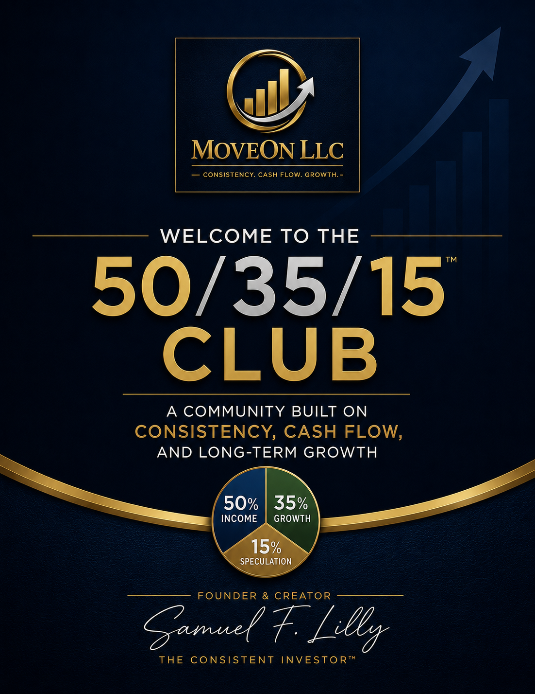

Welcome to the 50/35/15™ Investors Club

Consistency • Cash Flow • Growth
Congratulations and welcome.
By joining the 50/35/15™ Investors Club, you have taken an important step toward building a more intentional and disciplined approach to investing.
The purpose of this club is simple: to help everyday investors build consistency, generate cash flow, and pursue long-term growth through practical financial education.
The 50/35/15™ Framework was created to provide a straightforward approach to portfolio construction. Rather than chasing trends, reacting to headlines, or attempting to predict short-term market movements, the framework encourages balance, discipline, and long-term thinking.
As a member, you now have access to tools and resources designed to help you better understand investing and make more informed financial decisions.
Your membership package includes:
✅ Dividend Income Calculator™
✅ 50/35/15™ Quick Start Guide
✅ 50/35/15™ Investors Club Membership Certificate
✅ The Consistent Investor™ Newsletter
✅ Future educational tools, resources, and updates from MoveOn LLC™
This guide will introduce the basic principles of the 50/35/15™ Framework and help you take the first steps toward building a portfolio aligned with your financial goals.
Welcome aboard.
We are glad you are here.
Samuel F. Lilly
Founder, MoveOn LLC™
Creator of The Consistent Investor™

Understanding the 50/35/15™ Framework
The 50/35/15™ Framework is a simple portfolio allocation strategy designed to help investors balance income, growth, and opportunity.
Rather than placing all of your money into a single investment category, the framework divides a portfolio into three distinct areas, each serving a specific purpose.

50% Income
The Income portion of the portfolio is designed to generate cash flow.
These investments may include dividend-paying stocks, real estate investment trusts (REITs), business development companies (BDCs), income-focused ETFs, and other investments that distribute regular income.
The objective of this portion of the portfolio is to create a steady stream of cash flow that can be reinvested or used to support future financial goals.

35% Growth
The Growth portion of the portfolio is designed to build long-term wealth through appreciation.
These investments may include established companies, broad market ETFs, technology companies, and other businesses with strong long-term growth potential.
The objective of this portion of the portfolio is capital appreciation and long-term portfolio growth.

15% Speculation
The Speculation portion of the portfolio is reserved for higher-risk opportunities.
These investments may include emerging technologies, innovative companies, cryptocurrencies, or other opportunities with the potential for significant returns.
Because speculative investments carry greater risk, this portion is intentionally limited to a smaller percentage of the portfolio.

Why the Framework Works
The 50/35/15™ Framework seeks to create balance.
Income provides cash flow.
Growth provides long-term appreciation.
Speculation provides opportunity.
Together, these three components work to create a portfolio focused on consistency, cash flow, and growth.
The goal is not perfection.
The goal is to develop a disciplined investment strategy that can be followed consistently over time.

Why This Approach Works
One of the biggest challenges investors face is maintaining consistency.
Many people begin investing with good intentions, but emotions, market headlines, and short-term volatility often cause them to abandon their plans. Investors frequently move from one strategy to another, chasing performance instead of following a disciplined process.
The 50/35/15™ Framework was created to provide a simple structure that encourages balance and consistency.

Income Provides Stability
The Income portion of the portfolio focuses on generating cash flow through dividends, distributions, and other income-producing investments.
Regular income can help investors stay engaged during market fluctuations and may provide capital that can be reinvested to purchase additional investments over time.

Growth Builds Wealth
The Growth portion of the portfolio focuses on companies and investments that have the potential to increase in value over the long term.
While markets will experience periods of volatility, quality businesses and broad market investments have historically been important drivers of long-term wealth creation.

Speculation Creates Opportunity
Innovation often creates opportunities that can produce significant returns. However, these opportunities can also involve substantial risk.
By limiting speculation to a smaller portion of the portfolio, investors can participate in potential upside while protecting the majority of their portfolio from excessive risk.

A Balanced Approach
The strength of the 50/35/15™ Framework is not found in any single investment.
Its strength comes from balance.
Income helps generate cash flow.
Growth helps build wealth.
Speculation provides exposure to future opportunities.
Together, these components create a framework designed to help investors remain focused on their goals rather than reacting to short-term market noise.
The objective is simple:
Stay consistent.
Build cash flow.
Pursue long-term growth.

Sample Portfolio Allocation
One of the advantages of the 50/35/15™ Framework is its simplicity.
Rather than trying to predict which investment will perform best next year, the framework focuses on maintaining a balanced allocation between income, growth, and opportunity.
The following example illustrates how a $10,000 portfolio might be allocated using the 50/35/15™ Framework.

Example: $10,000 Portfolio
Category | Allocation | Dollar Amount
Income | 50% | $5,000
Growth | 35% | $3,500
Speculation | 15% | $1,500
Total Portfolio | 100% | $10,000

Income Allocation – $5,000
The Income portion focuses on investments designed to generate cash flow.
Examples may include:
- Dividend-paying stocks
- Income-focused ETFs
- REITs
- BDCs
- Energy infrastructure investments
The objective is to create a stream of income that can be reinvested or used to support future financial goals.

Growth Allocation – $3,500
The Growth portion focuses on long-term appreciation.
Examples may include:
- Broad market ETFs
- Technology companies
- Established businesses
- Innovation-driven companies
The objective is to build wealth over time through capital appreciation.

Speculation Allocation – $1,500
The Speculation portion is reserved for higher-risk opportunities.
Examples may include:
- Emerging technologies
- Cryptocurrency
- Small-cap growth opportunities
- Innovative companies
Because these investments can experience significant volatility, this portion remains limited to a smaller percentage of the overall portfolio.

The Key Takeaway
The exact investments you choose are less important than maintaining a disciplined allocation strategy.
The purpose of the framework is not to eliminate risk.
The purpose is to create balance.
As your portfolio grows, periodically review your allocations and make adjustments when necessary to maintain your desired mix of income, growth, and speculation.
Consistency over time is often more important than attempting to find the perfect investment.

Your Member Benefits and Next Steps
Welcome once again to the 50/35/15™ Investors Club.
By joining the club, you have become part of a community focused on practical investing, financial education, and long-term wealth building through the principles of Consistency, Cash Flow, and Growth.
Your membership provides access to resources designed to help you build knowledge, stay organized, and remain focused on your financial goals.

Your Member Benefits

Dividend Income Calculator™
Use the Dividend Income Calculator™ to estimate:
- How much capital may be required to reach your income goals
- Potential monthly dividend income
- Potential annual dividend income
- Progress toward your financial objectives
This tool is designed to help transform financial goals into measurable targets.

Membership Certificate
Your 50/35/15™ Investors Club Membership Certificate recognizes your commitment to becoming a more disciplined and informed investor.
Display it proudly as a reminder of your commitment to consistency and long-term financial growth.

The Consistent Investor™ Newsletter
As a member, you will receive ongoing financial education through The Consistent Investor™ newsletter.
Topics may include:
- Investing fundamentals
- Dividend investing
- Market structure
- Economic trends
- Portfolio management
- Wealth-building strategies
The goal is to help simplify complex financial concepts and make investing easier to understand.

Future Member Resources
As MoveOn LLC™ continues to grow, club members may receive access to additional tools, calculators, guides, educational resources, and special announcements.
Your membership today helps build the foundation for tomorrow.

Your Next Steps
- Download and use the Dividend Income Calculator™.
- Review your current investment goals and determine what income, growth, and speculation mean for your situation.
- Begin applying the 50/35/15™ Framework to your investment decisions.
- Follow The Consistent Investor™ newsletter for continued education and insights.
- Stay focused on consistency rather than short-term market noise.

Final Thoughts
Building wealth is rarely the result of a single investment decision.
More often, it is the result of small actions repeated consistently over long periods of time.
The purpose of the 50/35/15™ Framework is to provide a simple structure that helps investors stay disciplined, remain balanced, and continue moving forward regardless of market conditions.
Thank you for joining the 50/35/15™ Investors Club.
We look forward to being part of your investing journey.
Samuel F. Lilly
Founder, MoveOn LLC™
Creator of The Consistent Investor™
Consistency • Cash Flow • Growth

