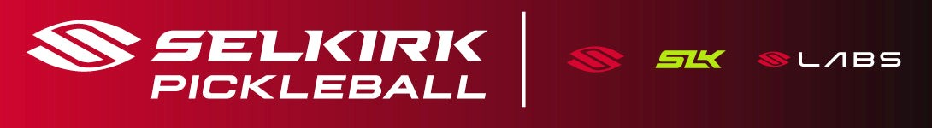
Which Selkirk Pickleball Brand
Is Right For YOU?

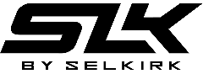
SLK by Selkirk – Entry & Mid-Level Performers
SLK by Selkirk combines the latest developments in paddle technology with comfort, balance, and affordability. Because performance, value, and accessibility matter, SLK is committed to bringing pickleball to a larger community by delivering high-quality equipment at an unbeatable price.

Selkirk Sport – Premium & High Performance
The flagship brand, offering premium, made-in-the-USA pickleball paddles. Selkirk Sport invests in pickleball technology to offer high-quality, cutting-edge equipment. Engineered to enhance your game, Selkirk Sport offers equipment and paddles for every skill level and player preference.

Selkirk LABS – Experimental & Cutting-Edge
Selkirk Labs is a first in the industry. Through player involvement and beta testing, Labs invites enthusiasts to join in the quest for pickleball perfection. Selkirk Labs is designed for players who care about pilot testing the latest technology and offering their insights to shape the future of pickleball. Pioneers of US-made pickleball paddles, Selkirk Labs is known for uncompromising quality, revolutionary innovation, and unrivaled creativity.


Ask me about

Summary at a Glance
Feature | SLK by Selkirk | Selkirk Main Line | Selkirk LABS
Audience | Beginner → Intermediate | Intermediate → Pro | Tech enthusiasts
Price Range | Budget-friendly | Premium | Varies
Warranty | ~1 year | Lifetime | ~2 years
Manufacturing | Designed in USA,  made overseas | Made/assembled in USA | Made/assembled in USA
Innovation Level | Standard performance | High performance | Experimental, cutting-edge
When to Pick | Great value & solid performance | Competitive play & feel | Try new tech  and be ahead of the curve

Visit Selkirk.com to use the Paddle Fit Assistant Use Discount Code ADV-SMILEWSKI at checkout

