Which Lifetime Warranty Suits Your Game?

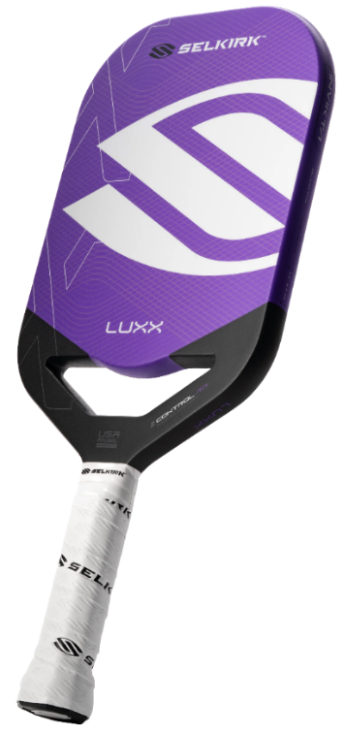
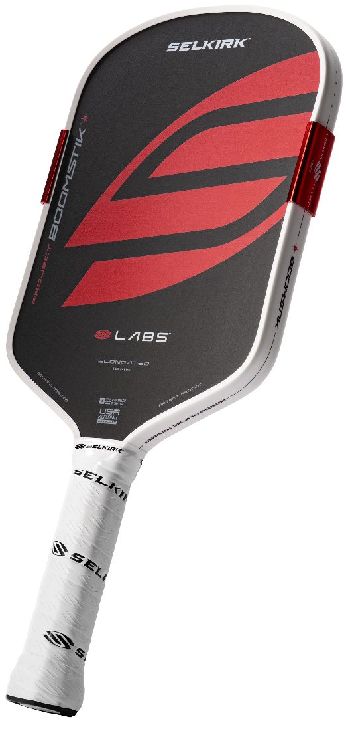
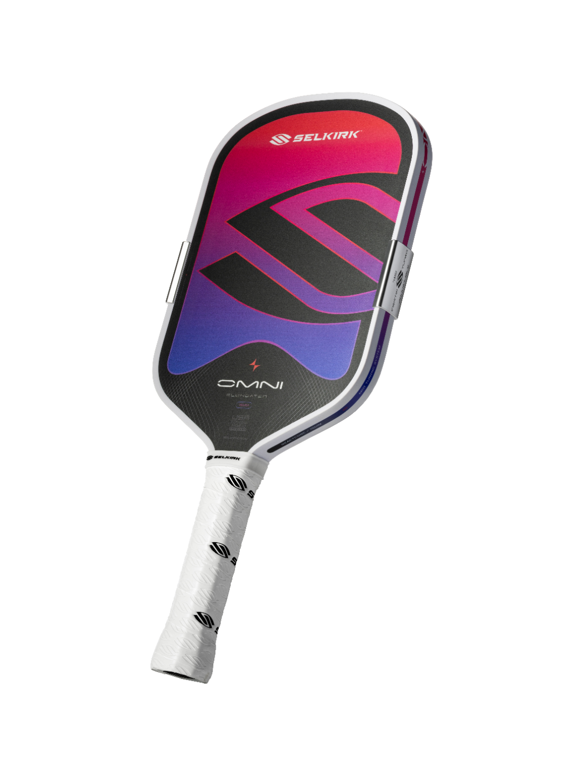
Ultimate Control | 
- InfiniGrit™ Surface for 3x Spin Durability
- EVA Foam Handle and Throat for Less Vibrations and More Flex
- Florek Carbon Fiber for More Control
- X7 Thikset Honeycomb Core for Maximum Sweet Spot
- 360° Proto Molding for Power and Consistency
- Aero-DuraEdge Edgeless Technology for Durability and Maneuverability
- FlexFoam Perimeter to Add Weight and Enlarge the Sweet Spot
- CM Anti-Torque Technology for Added Stability
- Updated Wing Design Air Dynamic Throat for Quicker Swing Speed
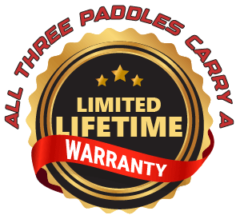
- Available in Invikta (Elongated) and Epic (Widebody) shapes
Ratings: | Power: 6.5 | Spin: 10 | Control: 10 | Sweet Spot: 8

Cost: $280 NOW $200 (Be sure to use Discount Code: ADV-SMILEWSKI for your
Selkirk Bonus Bucks)

Transformative  All Court  Performance |   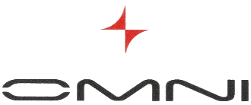
The Selkirk OMNI™ redefines an all-court paddle (formerly referred to as a Hybrid) for the modern fast-paced game.
Power. Control. Spin. Durability. | React. Adapt. Win.
- ReactCore consists of a PureFoam™ floating center with a new PureFoam™ Ring surrounded by an EVA Power Ring for a dynamic core with adaptive flexibility.
- (New!) Adjustable MOI Tuning System for Maximum Sweet Spot and Balance, With the Ability to Customize.
- InfiniGrit™ Surface for 3x Spin Durability.
Ratings: | Power: 9 | Spin: 10 | Control: 9 | Sweet Spot: Spot: 9 (estimated)


- Multistrata Face for Balanced Performance.
- Octagonal Handle for Better Control.
- Available in Elongated and Widebody shapes
We always
recommend you
try a paddle before you buy it.
However, if you buy a Selkirk paddle and you do not play better with it, return it within 30 days for a FULL refund!
Cost: $300 (Be sure to use Discount Code: ADV-SMILEWSKI to receive your Selkirk Bonus Bucks)

Staggering Power | 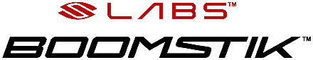
- BoomCore™ for Explosive Power and Relentless Durability.
- Pre-Installed Semi-Permanent MOI Tuning System for Maximum Sweet Spot and Balance
- InfiniGrit™ Surface for 3x Spin Durability Over Raw Carbon.
- Octagonal Handle for Better Control
Ratings: | Power: 10 | Spin: 10 | Control: 8 | Sweet Spot: Spot: 9

- Multistrata Face Material of T700 Carbon (3 layers)
- Available in Elongated and Widebody shapes
Cost: $333 (Be sure to use Discount Code: ADV-SMILEWSKI and submit a paddle review to receive your Selkirk Bonus Bucks)

