
Selkirk Demo Day Checklist

SLK by Selkirk Paddle Options
by


Check the paddles which will fit your needs.
 | Latitude  $70 | 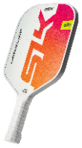 |  |  | HALO Control  $150  $100 | 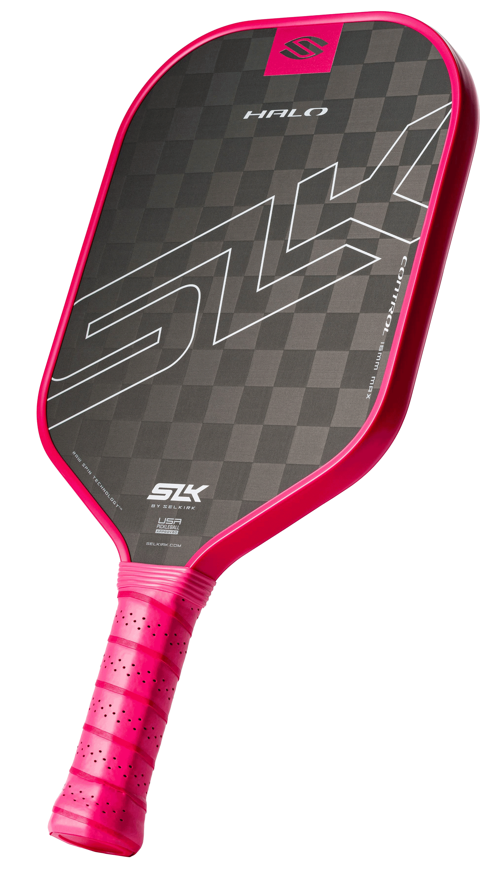
 | Valkyrie  $80 | 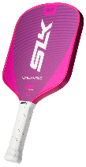 |  |  | HALO Power  $150  $100 | 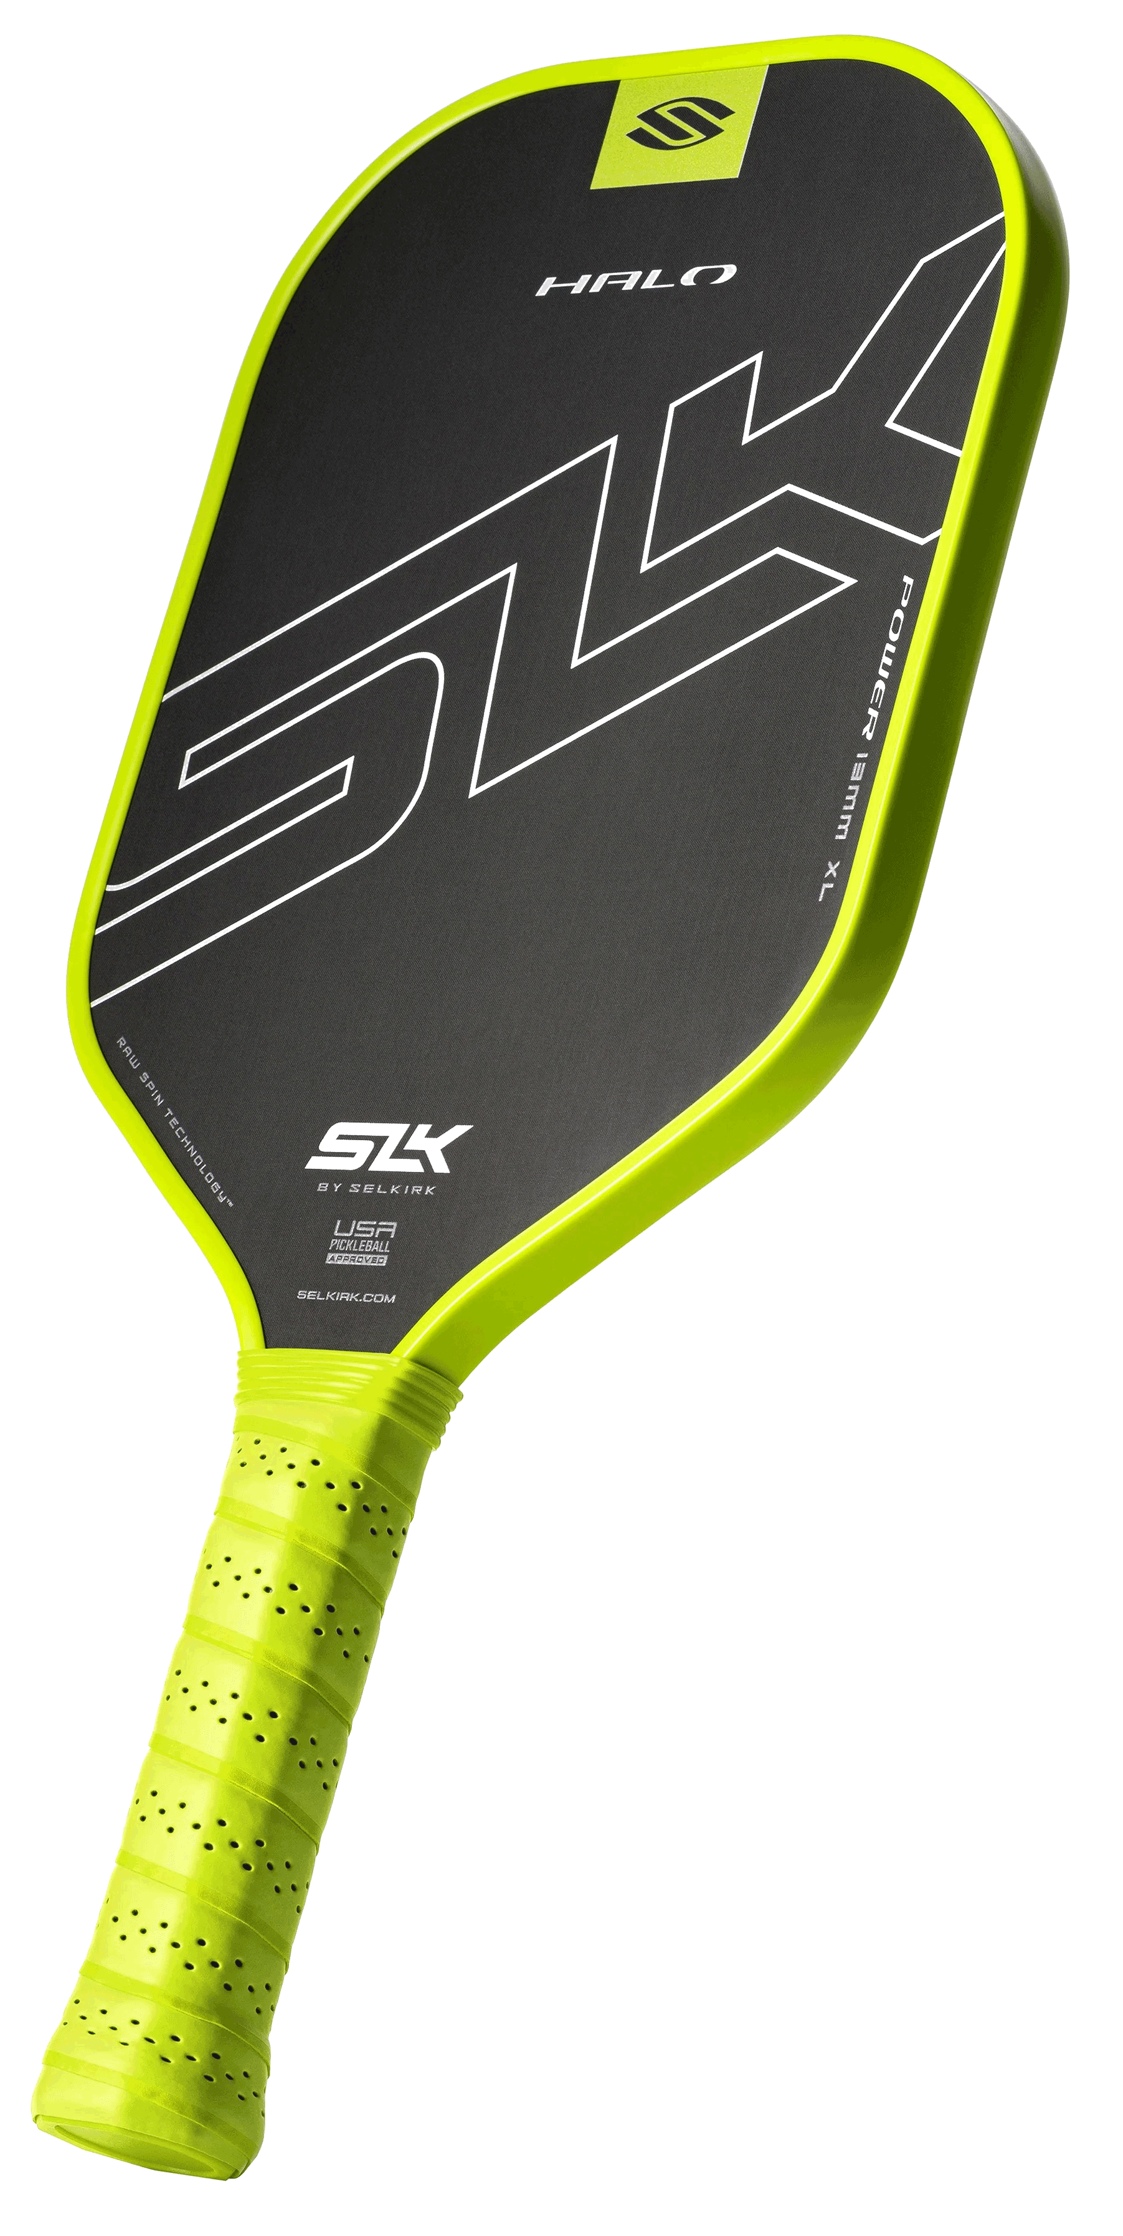
 | Atlas  $80 | 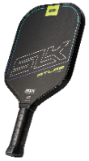 |  |  | HALO Pro  $150  $100 | 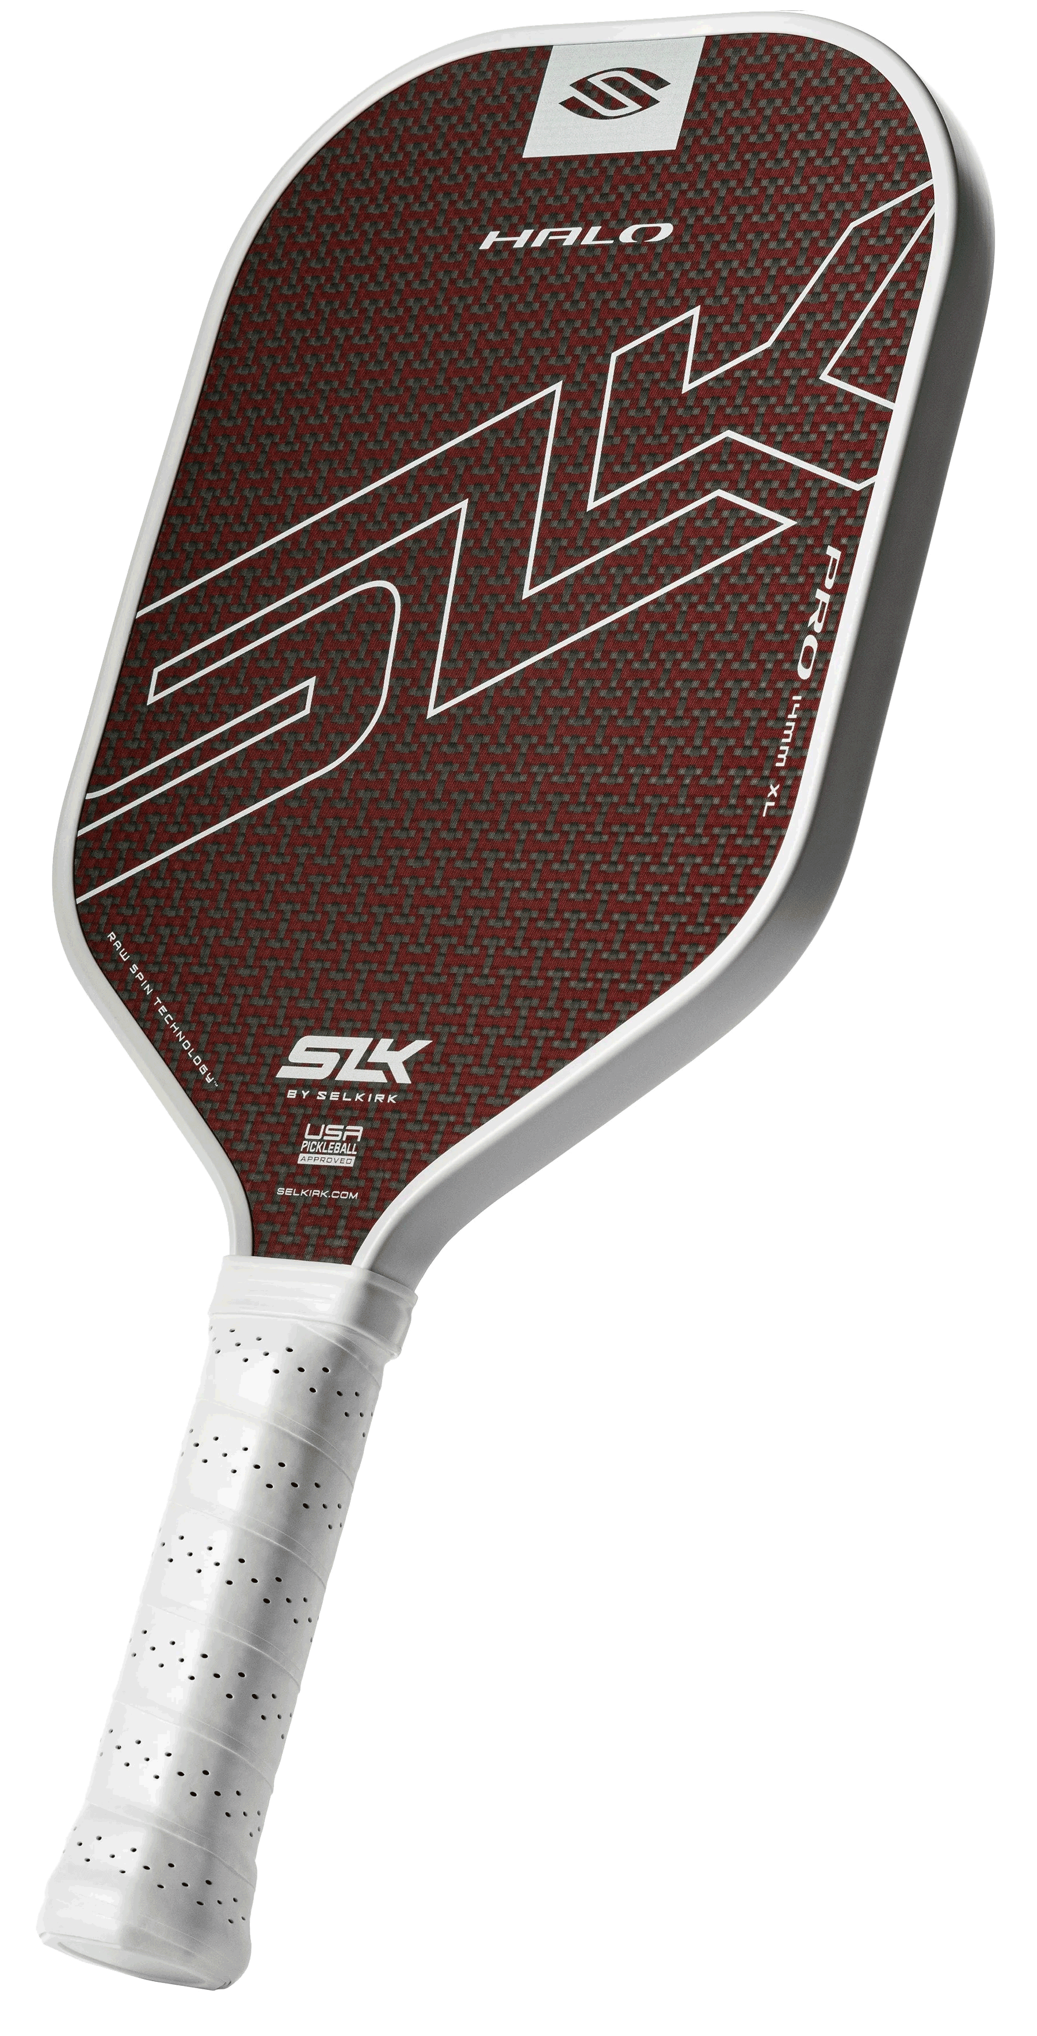
 | EVO Control  $100  $80 | 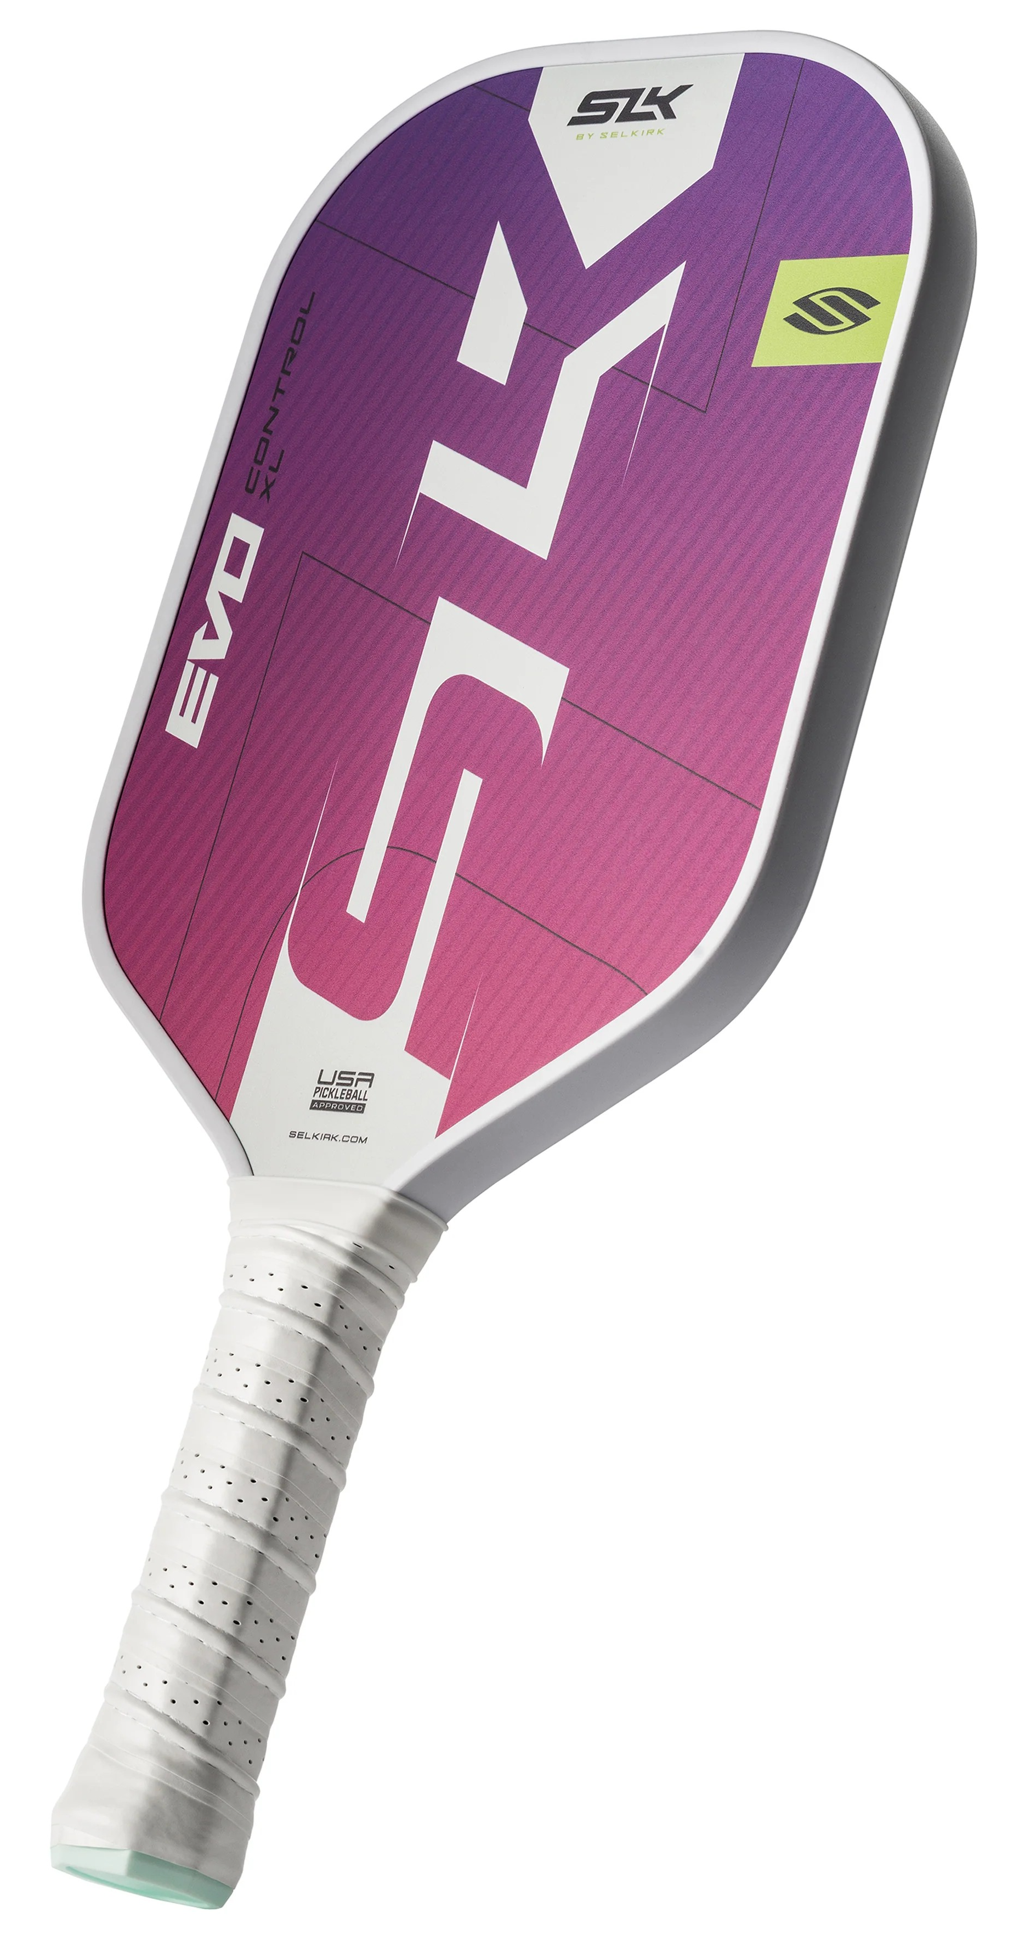 |  |  | Geo  $100 | 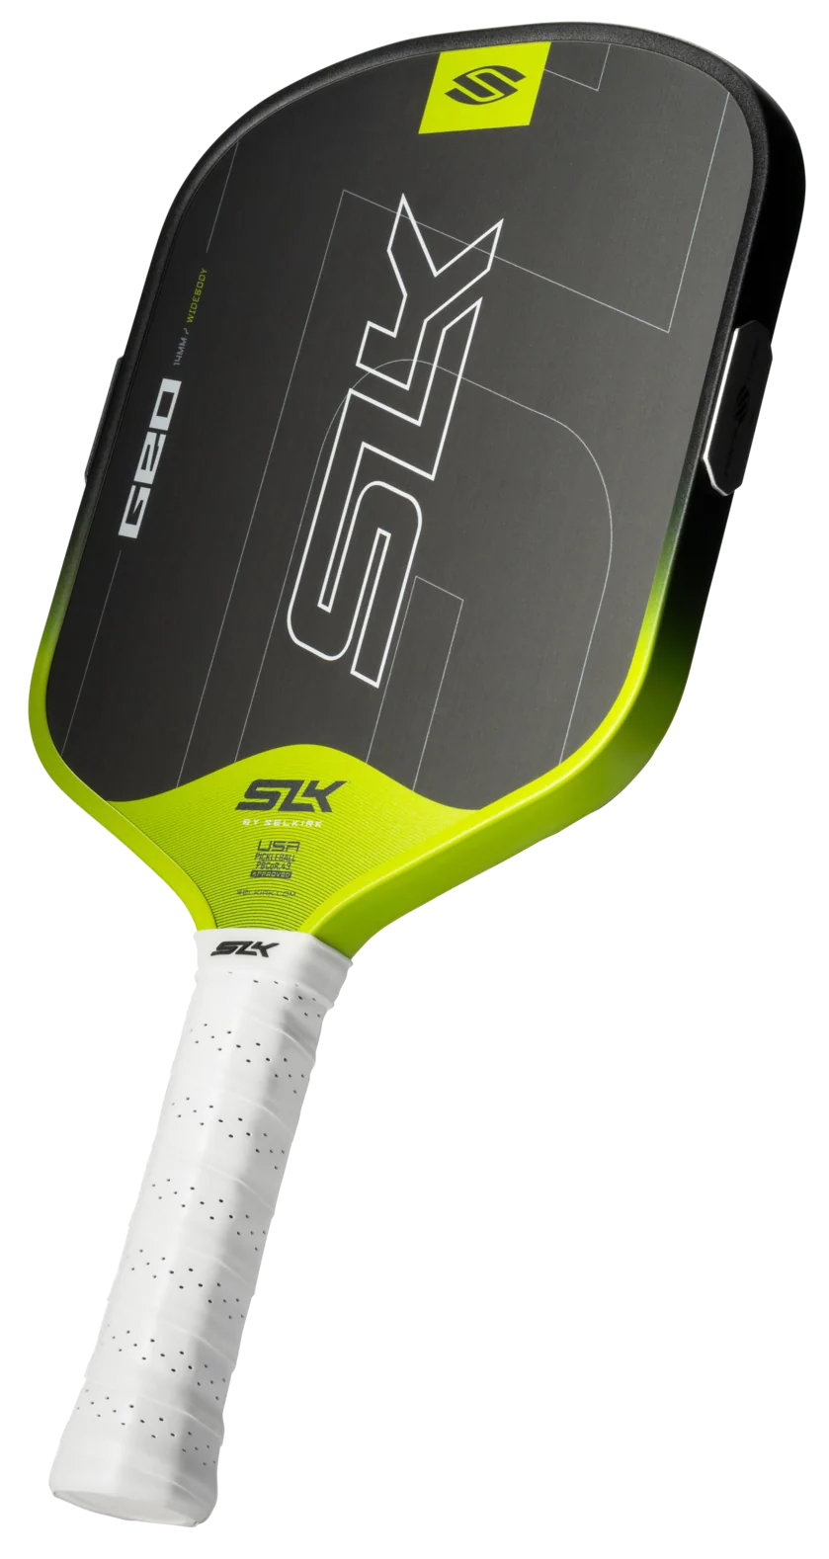
 | OMEGA Hybrid Air  $120  $90 | 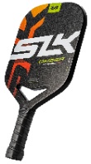 |  |  | Dauntless  $180 | 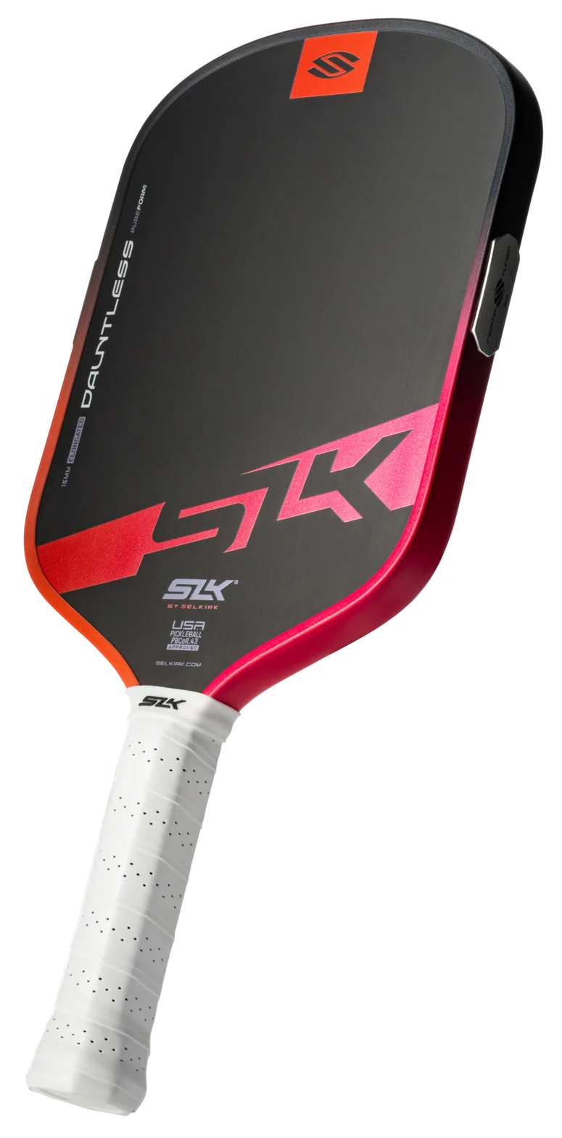
 |  | Selkirk Sport Paddles Now on Sale  - AMPED Control $100  - AMPED Pro Air $150  - Vanguard Pro $120  - Vanguard Power Air $130 |  |  | ERA Power  $200 | 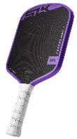
Please feel free to contact me with any questions/concerns
Pickleball.Scott@outlook.com Discount Code: ADV-SMILEWSKI
Selkirk Demo Day Checklist
SLK by Selkirk Paddle Options
by

Check the paddles which will fit your needs.
 | Latitude  $70 |  |  |  | HALO Control  $150  $100
 | Valkyrie  $80 |  |  |  | HALO Power  $150  $100
 | Atlas  $80 |  |  |  | HALO Pro  $150  $100
 | EVO Control  $100  $80 |  |  |  | Geo  $100
 | OMEGA Hybrid Air  $120  $90 |  |  |  | Dauntless  $180
 |  | Selkirk Sport Paddles Now on Sale  - AMPED Control $100  - AMPED Pro Air $150  - Vanguard Pro $120  - Vanguard Power Air $130 |  |  | ERA Power  $200
Please feel free to contact me with any questions/concerns
Pickleball.Scott@outlook.com Discount Code: ADV-SMILEWSKI

