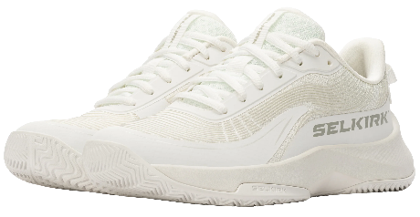

When playing pickleball, there are only three surfaces we can hope to control:
- Paddle Face/Surface (Paddle to Ball)
Quality Shoes, are in fact, the Most Important pickleball piece of equipment you can own.

- Grip (Player’s Hand to Paddle)
- Shoes (Player’s Feet to the Playing Surface)

Sure, we spend most of our time talking about the best paddle, but that is just part of the equation! You can have a Selkirk Labs Project BoomStik, but if you cannot get into position to hit the ball, or even worse, get hurt making the attempt, what was the point of the paddle purchase.
Legacy Classic and Legacy Pro Pickleball Shoes

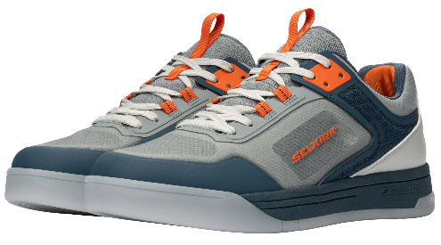

The Selkirk Legacy Pro was created for the new generation of pickleball — players who want a shoe that performs on the court, but also carries confidence, style, and cultural energy off it.
The limited-edition Legacy Classic is designed for players who live by the mantra of “look good, play good,” choosing gear that’s stylish while still delivering genuine performance benefits.
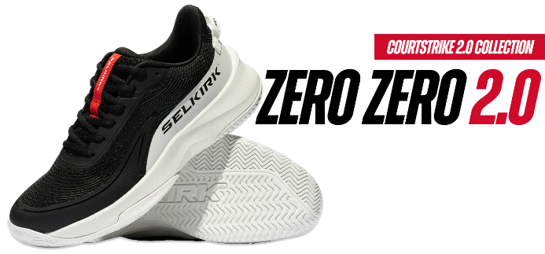
CourtStrike 2.0 and Courtstrike Pro 2.0 Pickleball Shoes

The CourtStrike Pro 2.0 Pickleball Shoe is a performance-driven shoe designed for the competitive player looking to elevate stability, comfort, and responsiveness. It features a more advanced breathable mesh, 3D printing for secure lateral stability, and has industry-leading side-to-side quickness due to the responsive top-loaded EVA midsole.
The CourtStrike 2.0 Pickleball Shoe is designed for the all-around player seeking
a quick, well-balanced, and comfortable pickleball shoe. The performance mesh upper is lightweight to allow airflow and is engineered to form to your foot.
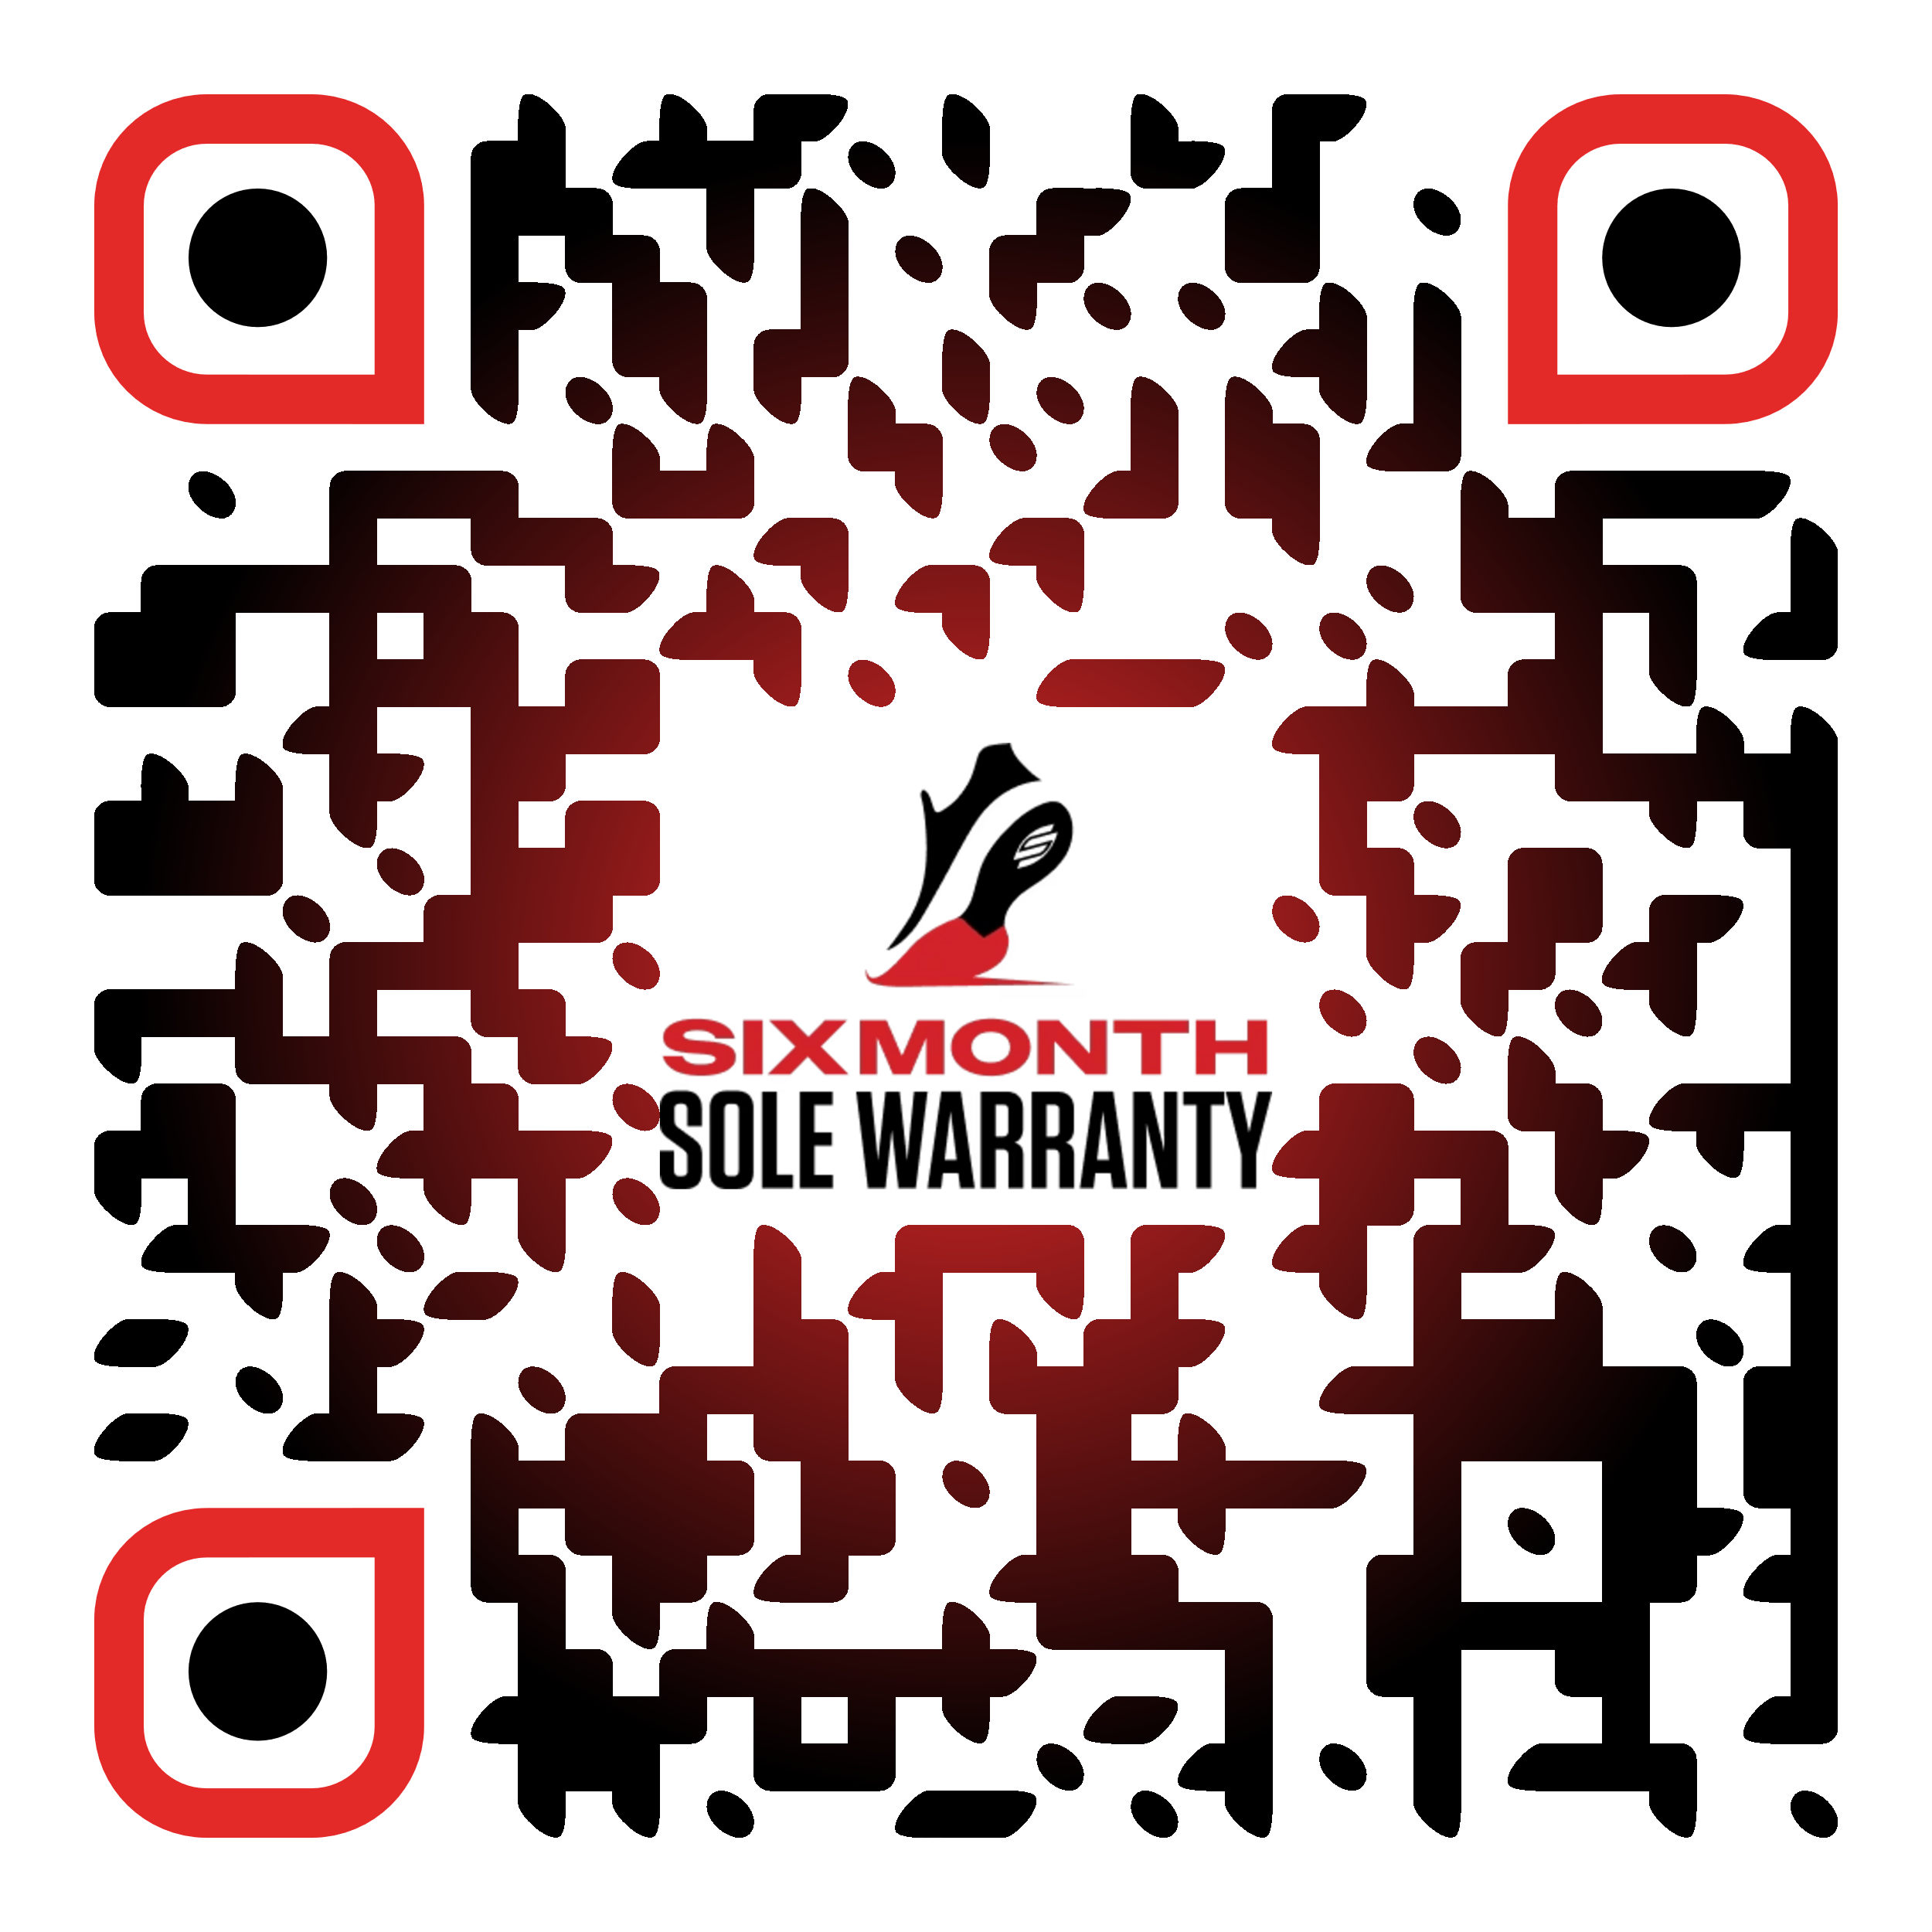Learn more about Selkirk shoe warranty!

Be sure to register you Selkirk shoes!
Eligible returns and exchanges can be made within 30 days
from the date of purchase, subject to conditions (https://www.selkirk.com/pages/warranty).

