Selkirk Paddle Prices (as of 4/2/2026)

Brand / Model Price Savings Discount
Selkirk Labs
Selkirk Labs Project Boomstik $333‡
Selkirk Labs Project 007† $333 NOW $130‡ $203 61% Off
Selkirk Sports
Selkirk LUXX Control Air with InfiniGrit $280 NOW $200‡ $80 29% Off
Selkirk VANGUARD Power Air $250 NOW $130‡ $120 48% Off
Selkirk VANGUARD Pro† $230 NOW $120‡ $110 48% Off
Selkirk AMPED Pro Air† $200 NOW $100‡ $100 50% Off
Selkirk AMKPED Control† $160 NOW $100‡ $60 38% Off
SLK by Selkirk
SLK ERA Power $200‡
SLK Dauntless $180‡
SLK Geo $100‡
SLK Halo† $150 NOW $100‡ $50 33% Off
SLK OMEGA Hybrid Air† $120 NOW $90‡ $30 25% Off
SLK EVO† $100 NOW $80‡ $20 20% Off
(Bundle now only $99‡)
SLK Valkyrie $80‡

† - Please visit Selkirk.com to verify model and shape availability.
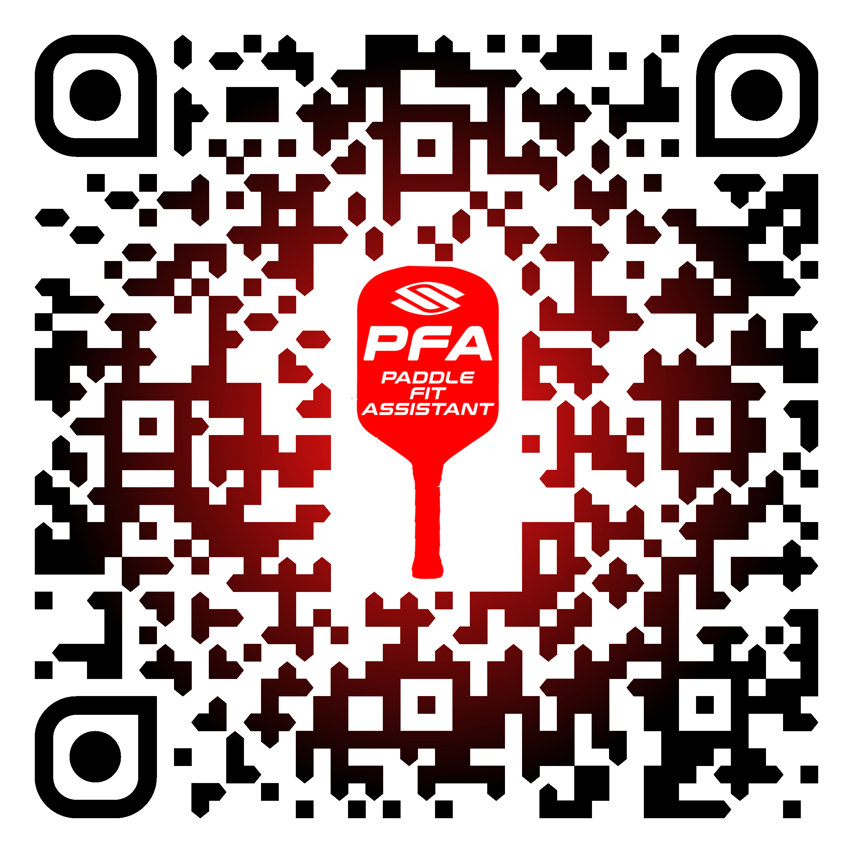
Selkirk Paddle Fit Assistance
‡ - By purchasing your paddle at Selkirk.com and using Discount Code: ADV-SMILEWSKI, you will receive bonus bucks for a future purchase. The amount received depends on the amount spent. You will not see the bonus bucks in your cart at checkout, but our team will send your bonus bucks via email, 7-10 business days after their order has been completed.

