Selkirk Paddle Mini Stand Paddle Cards

20 Piece Mini L Shape Acrylic Clear Sign Stand Card Holder
https://www.amazon.com/dp/B07XQ5DCXH?ref_=ppx_hzsearch_conn_dt_b_fed_asin_title_30

    LUXX Control Air  Invikta  $250 |   LUXX Control Air  Epic  $250 | LUXX Control Air  S2  $250 | 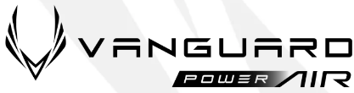  Epic  $250
Invikta  $250 | S2  $250 | 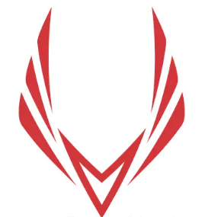  VANGUARD Control  Invikta  Lightweight  $200 | VANGUARD Control  Epic  Lightweight  $200
VANGUARD Control  S2  Lightweight  $200 | VANGUARD Control  Invikta  Midweight  $200 | VANGUARD Control  Epic  Midweight  $200 | VANGUARD Control  S2  Midweight  $200
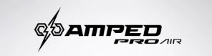    Invikta  $180 | Epic  $180 | 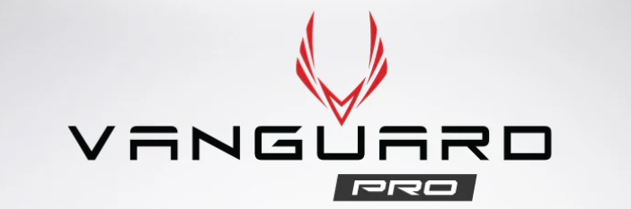  Epic  $230 | Invikta  $230

  SLK HALO Power  XL  $130 | SLK HALO Power  Max  $130 | SLK HALO Control  XL  $130 | SLK HALO Control  Max  $130
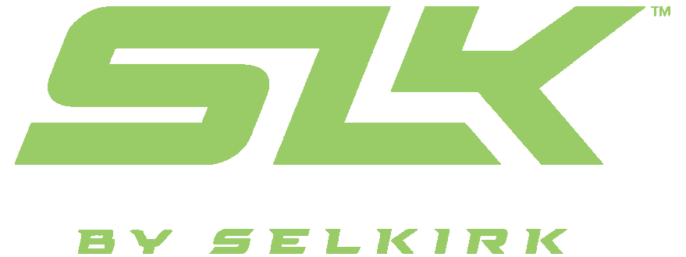  SLK OMEGA Hybrid Air  Max  $120 | SLK OMEGA Hybrid Air  XL  $120 | SLK HALO Pro  Max  $150 | SLK HALO Pro  XL  $150
SLK EVO Control  Max  $130 | SLK EVO Control  XL  $130 | SLK EVO Power  Max  $130 | SLK EVO Power  XL  $130
SLK Atlas  Max  $80 | SLK Atlas  XL  $80 | 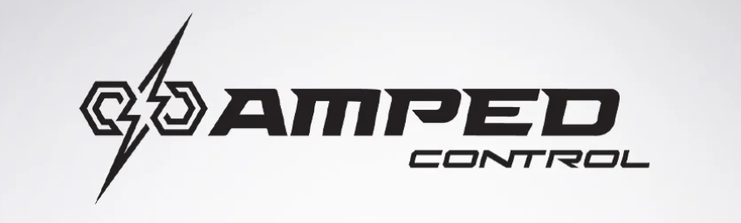    Invikta  $180 | Invikta  $180

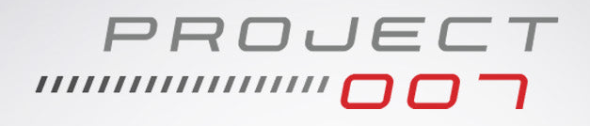  Invikta – 10mm  $333   | Epic – 10mm  $333 |  | 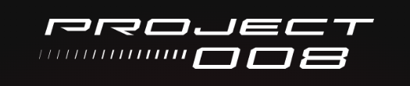  Invikta – 10mm  $288
Invikta – 13mm  $288 | Epic – 13mm  $288 | Tour – 13mm  $288 | Tour – 16mm  $288
Invikta – 14mm  $333 | Epic – 14mm  $333 |  | SLK Latitude  Max  $70

Scott Milewski (Pickleball.Scott@outlook.com) Promo Code: ADV-SMILEWSKI

