
Demo Day Checklist
Check the paddles that will fit your needs.
 |  | Price
   | Shape | Power | Control | Spin | Sweet spot
AMPED Control  - Fiberglass FiberFlex+ Face for Control  - 16mm X5 Core for Consistent Sweet Spot  Available in Lightweight and Midweight | 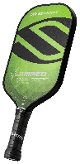 | $100
   | S2 | 6 | 8 | 8 | 8
   | Epic | 6 | 8 | 8 | 8
   | Invikta | 7 | 7 | 8 | 7
AMPED Pro Air  - FiberFlex+ Fiberglass Face for Power and Consistency  - X5+ Honeycomb 16mm Core for Consistent Sweet Spot  - ProSpin+ NextGen Micro Texture | 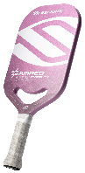. | $180  $150
   | Epic | 7 | 7 | 10 | 8
   | Invikta | 8 | 7 | 10 | 7
Vanguard Pro  - 4 Layer 12k Raw Carbon Fiber Face  - X5+ 16mm Polypropylene Honeycomb Core  - Thermoformed Foam Edge | 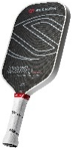 | $230  $120
   | Epic | 6 | 8 | 10 | 9
   | Invikta | 7 | 7 | 10 | 8
Vanguard Power Air  - ProSpin+ NextGen Texture  - QuadFlex 4 Layer Hybrid Face  - SuperCore Polymer Honeycomb Core | 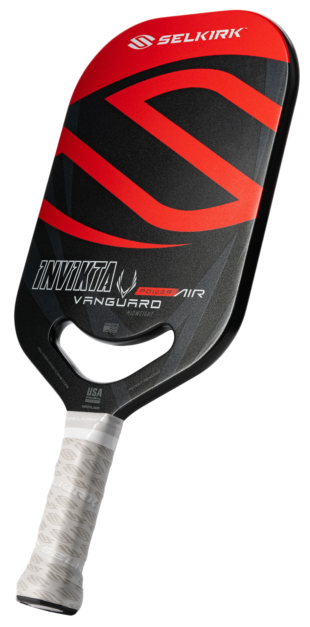 | $250  $130
   | S2 | 9 | 7 | 10 | 7
   | Epic | 9 | 7 | 10 | 7
   | Invikta | 10 | 6 | 10 | 6
LUXX Control Air with InfiniGrit  - InfiniGrit Surface for 3x Spin Durability Over Raw Carbon Fiber  - 19mm X7 Thikset Honeycomb Core for Maximum Sweet Spot  - Aero-DuraEdge Edgeless Technology for Durability/Maneuverability  - FlexFoam Perimeter to Add Weight and Enlarge the Sweet Spot | 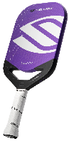 | $280
   | Epic | 6 | 10 | 10 | 10
   | Invikta | 6.5 | 10 | 10 | 10
Selkirk Labs Project Boomstik  - 16mm BoomCore™  - InfiniGrit Surface  - MOI Tuning System  - Multistrata T700 Carbon (3 layers) Paddle Face | 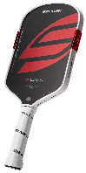 | $333
   | Widebody | 10 | 8 | 10 | 10
   | Elongated | 10 | 8 | 10 | 9
Please feel free to contact me with any questions/concerns | * Be sure to ask about applicable Bonus Bucks
Pickleball.Scott@outlook.com Discount Code: ADV-SMILEWSKI
Demo Day Checklist
Check the paddles that will fit your needs.
 |  | Price
   | Shape | Power | Control | Spin | Sweet spot
AMPED Control  - Fiberglass FiberFlex+ Face for Control  - 16mm X5 Core for Consistent Sweet Spot  Available in Lightweight and Midweight |  | $100
   | S2 | 6 | 8 | 8 | 8
   | Epic | 6 | 8 | 8 | 8
   | Invikta | 7 | 7 | 8 | 7
AMPED Pro Air  - FiberFlex+ Fiberglass Face for Power and Consistency  - X5+ Honeycomb 16mm Core for Consistent Sweet Spot  - ProSpin+ NextGen Micro Texture | . | $180  $150
   | Epic | 7 | 7 | 10 | 8
   | Invikta | 8 | 7 | 10 | 7
Vanguard Pro  - 4 Layer 12k Raw Carbon Fiber Face  - X5+ 16mm Polypropylene Honeycomb Core  - Thermoformed Foam Edge |  | $230  $120
   | Epic | 6 | 8 | 10 | 9
   | Invikta | 7 | 7 | 10 | 8
Vanguard Power Air  - ProSpin+ NextGen Texture  - QuadFlex 4 Layer Hybrid Face  - SuperCore Polymer Honeycomb Core |  | $250  $130
   | S2 | 9 | 7 | 10 | 7
   | Epic | 9 | 7 | 10 | 7
   | Invikta | 10 | 6 | 10 | 6
LUXX Control Air with InfiniGrit  - InfiniGrit Surface for 3x Spin Durability Over Raw Carbon Fiber  - 19mm X7 Thikset Honeycomb Core for Maximum Sweet Spot  - Aero-DuraEdge Edgeless Technology for Durability/Maneuverability  - FlexFoam Perimeter to Add Weight and Enlarge the Sweet Spot |  | $280
   | Epic | 6 | 10 | 10 | 10
   | Invikta | 6.5 | 10 | 10 | 10
Selkirk Labs Project Boomstik  - 16mm BoomCore™  - InfiniGrit Surface  - MOI Tuning System  - Multistrata T700 Carbon (3 layers) Paddle Face |  | $333
   | Widebody | 10 | 8 | 10 | 10
   | Elongated | 10 | 8 | 10 | 9
Please feel free to contact me with any questions/concerns | * Be sure to ask about applicable Bonus Bucks
Pickleball.Scott@outlook.com Discount Code: ADV-SMILEWSKI

