
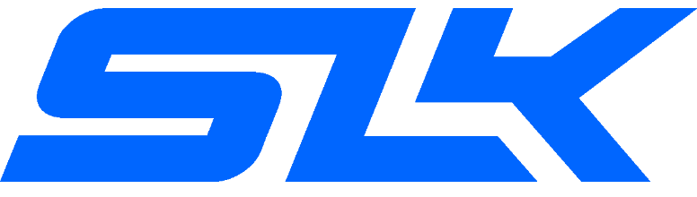
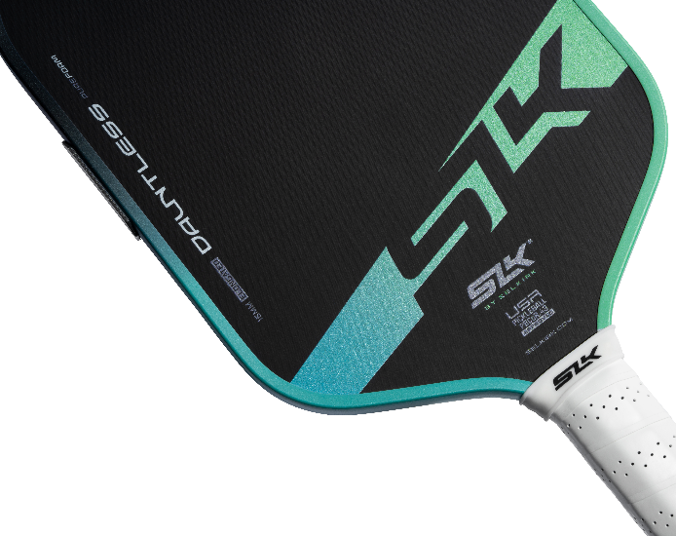
Be sure to use Discount Code:
ADV-SMILEWSKI
Just 100 days after its Launch

BY SELKIRK

An all-court foam hybrid-style paddle with a control lean for open plays and tournaments.
The Dauntless is for those players looking for a versatile paddle to incorporate next-gen performance technology into their game, while still giving reliable power when its needed.
Featuring Patent-Pending Innovations Like:
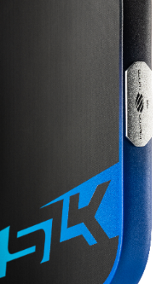
- PureFoam™ - Debuting on the SLK Dauntless, the SoloCore combines a one-piece PureFoam™ structure with the new IsoFlex technology. The SoloCore has lasting consistency, a comfortable feel, and a versatile blend of power and control

- MOI Tuning System - Configured from the Dauntless’ birthplace to have the maximum sweet spot & balance (resulting in less paddle twist during mishits.)
SLK Comparison
SLK Paddle | Designed For | What to Expect
VALKYRIE | Starting Out | Quality beginner paddle in fun colors.
GEO | Playing Socially | Versatile performance as you develop your game.
DAUNTLESS | Playing More | Upgraded foam technology for rec play & tournaments.
ERA POWER | Hit Harder | Lively power to play more aggressively.

30-Day Guarantee!
Limited 1-Year Warranty!
Free Shipping!

Scan to shop the Dauntless

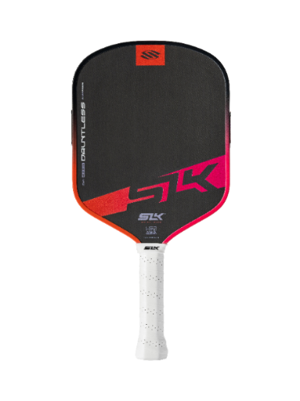
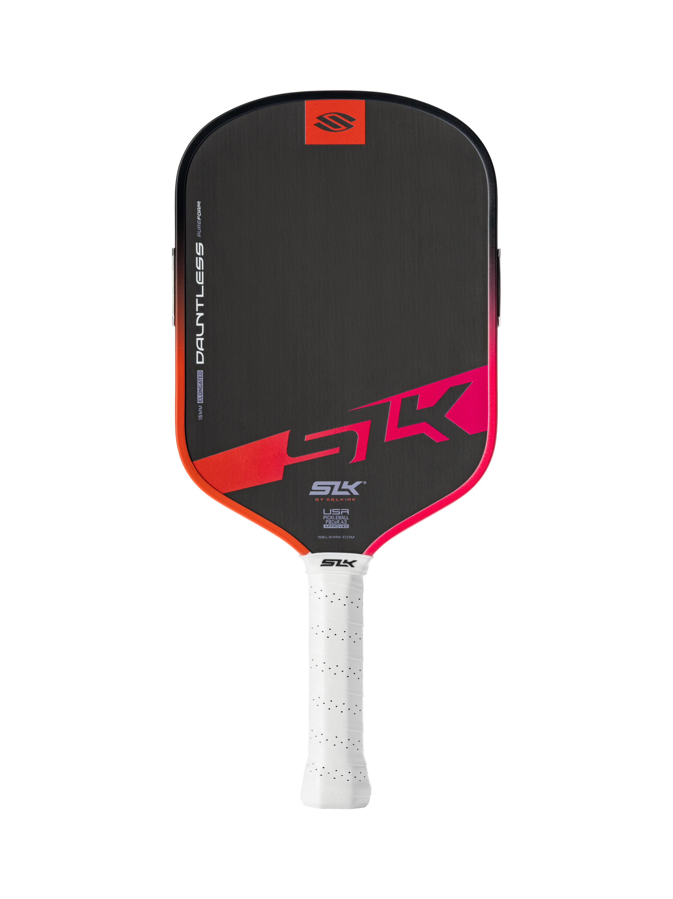
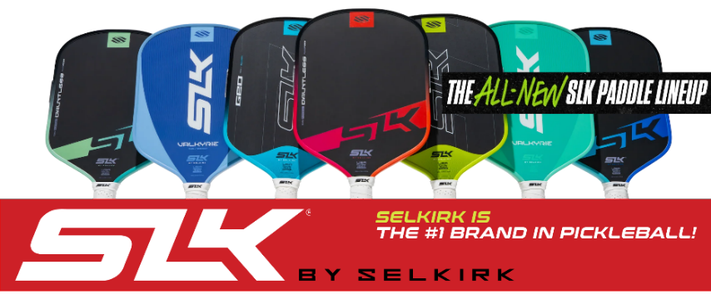
Widebody Elongated
The Dauntless is part of the recently released SLK lineup
Only 100 days after its launch, the Dauntless’ price has dropped 17% from $180 to $150
Play with Confidence. Play with Dauntless.
The SLK Dauntless allows players looking for a versatile paddle to incorporate next-gen performance technology into their game. With patent-pending innovations like the PureFoam™ core structure and MOI Tuning System, the Dauntless delivers all-court / hybrid-style performance with a control lean — while still giving you reliable power when you need it.
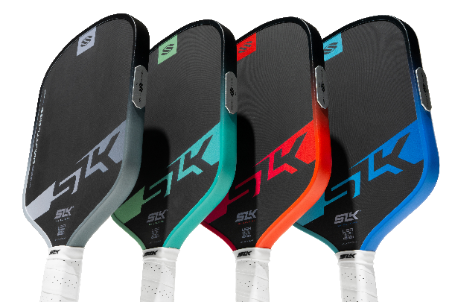
The Dauntless is a great fit for:
- Playing multiple times per month.
- Those who have outgrown their entry-level paddle.
- Players who want versatility, but still prioritize consistency & control.
- When entering leagues, tournaments, or are an open-play regular.
- Performance-minded players who are looking for paddles which are
designed with next-gen PureFoam™ performance, getting them ready
for more competitive play.
Key Features:
- PUREFOAM™ SOLOCORE+
  - Debuting on the SLK Dauntless, the SoloCore combines a one-piece PureFoam™ structure with the new IsoFlex technology — a perimeter cutout that loosens the core structure. The SoloCore has lasting consistency, a comfortable feel, and a versatile blend of power and control.
- MOI TUNING SYSTEM
  - Maximum sweet spot & balance, so the paddle avoids twisting.
  - Selkirk’s MOI Tuning System is an overall design approach. Putting the weight exactly where it will shift mass toward the outer regions of the paddle and increasing the moment of inertia (twist weight) — it stabilizes the paddle during off-center hits. The result: a larger and more forgiving sweet spot!
- RAW SPIN TECHNOLOGY SURFACE FOR ENHANCED SPIN.
  - The Raw Spin Technology is a raw, textured surface designed to enhance spin and improve ball control.
- T700 RAW CARBON FACE FOR MORE POWER AND DWELL TIME

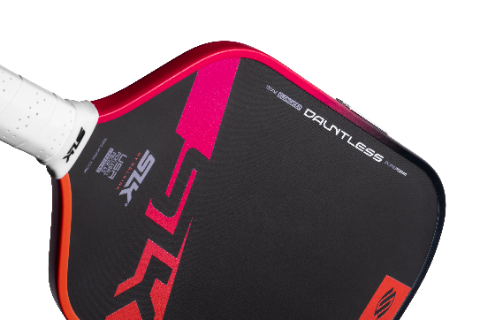
  - A unique T700 carbon-fiber system with variable face orientation tunable for added power and dwell time and engineered to integrate seamlessly with PureFoam™ technology. Together, they deliver optimized flexibility, consistent energy return, and rock-solid durability.
 | Widebody Dauntless | Elongated
Skill level | Beginner-Advanced | Beginner-Advanced
Grip length | 5.6” | 5.8”
Average swing weight | 109 | 118
Average twist weight | 7.4 | 6.9
Paddle height | 15.95” | 16.50”
Paddle width | 8” | 7.45”
Face material | T700 Raw Carbon Fiber
Surface Texture | Raw Spin Technology
Core thickness | 16mm
  Power
  Spin
  Control
  Sweat Spot
Core material | SoloCore (PureFoam with IsoFlex cutout)
U.S Warranty | 1 Year
  7.5 | 9 | 8 | 9
  7.5 | 9 | 8 | 8

