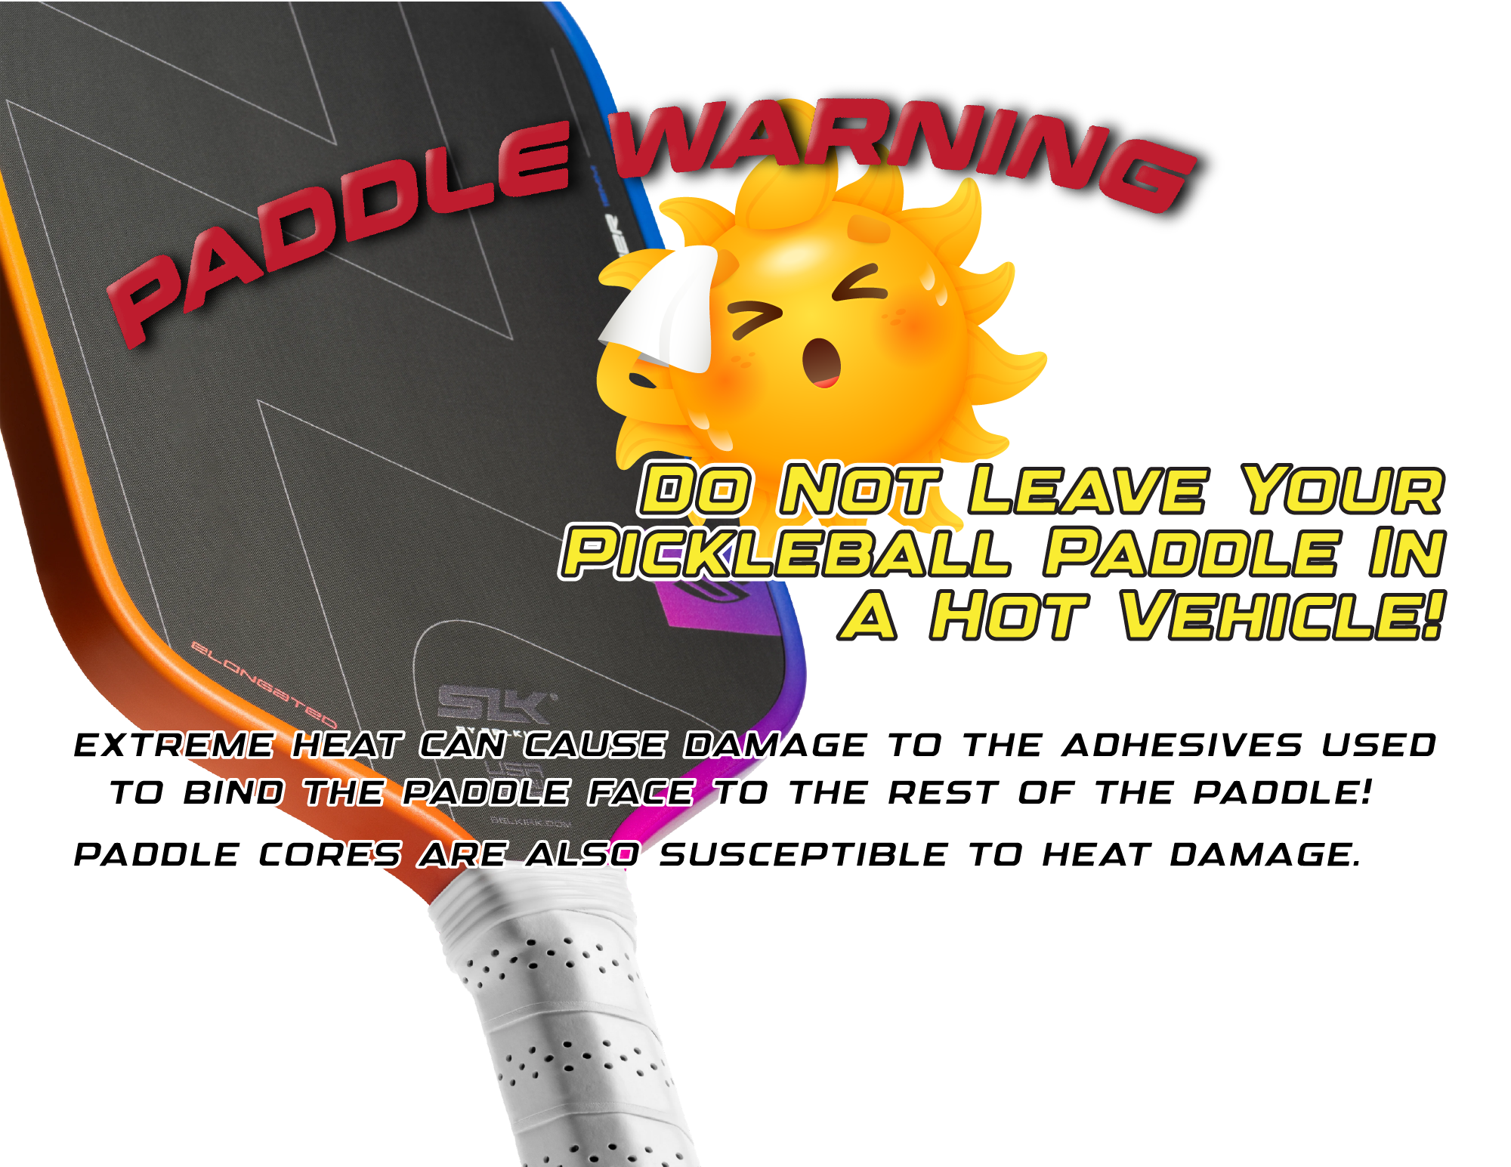

Scott Milewski
Pickleball.Scott@outlook.com
Discount Code: ADV-SMILEWSKI

