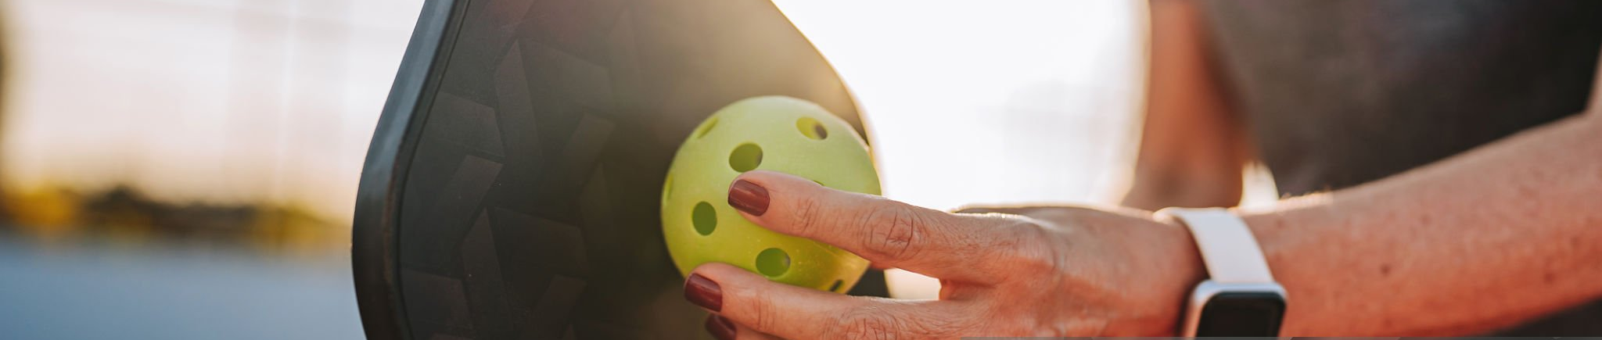
FREE!
For
Learn to Play Pickleball!
Join in on the FUN of the
Fastest Growing Sport in the U.S.!

What Level Is Right For YOU?

Getting Started – Focusing on getting the ball over the net and basic play flow
Learn the Basics of:
Beginner – Focusing on consistency & court awareness
If you already know the Basics, Learn to:
- Consistently Serve
- Basic Returns
- Maintain short rallies
- Beginning to aim shots
- Understand Non-Volley Zone (NVZ/Kitchen) Basics
- Approaching the Net

- The Rules
- Areas of the Court
- Striking the Ball & Serves
- Scoring
- And More!


Email Me For More Information
Intermediate – Focusing on control, patience, & shot selection
Improve your:
- Serves and returns with direction and depth
- Consistent dinking (soft shots into the non-volley zone)
- Ability to sustain longer rallies
- Volleys & overheads with control
- Start using third-shot drops or drives
- Improved footwork & net positioning
- Recognize opponent weaknesses

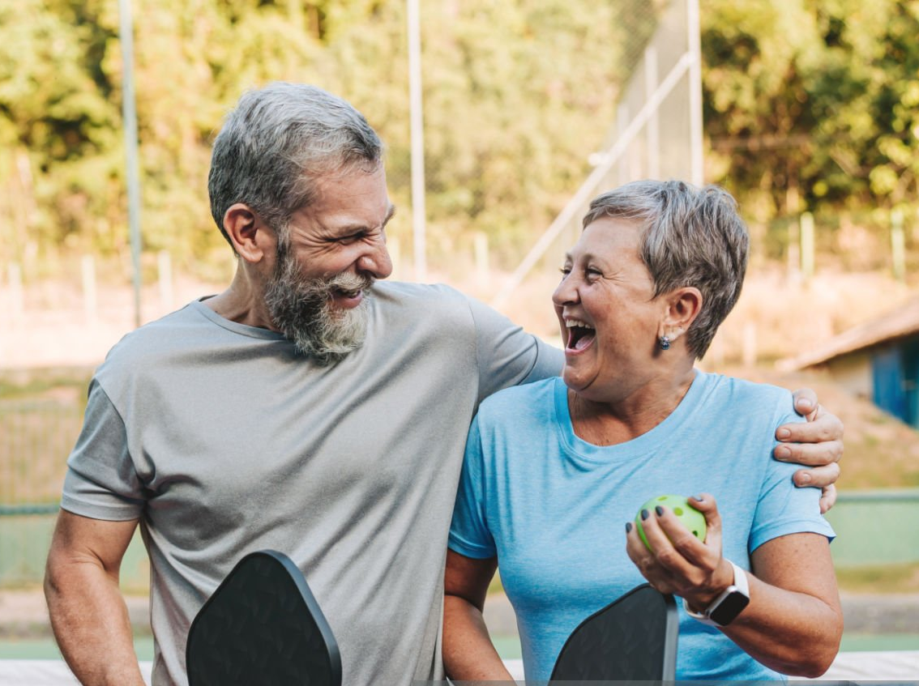

Additional Pickleball Clinics:
- Investment Planning – Selecting Your Next Paddle
- Pickleball Equipment Augmentation & Care

Contact Scott Milewski
For lesson times and locations
Pickleball.Scott@outlook.com

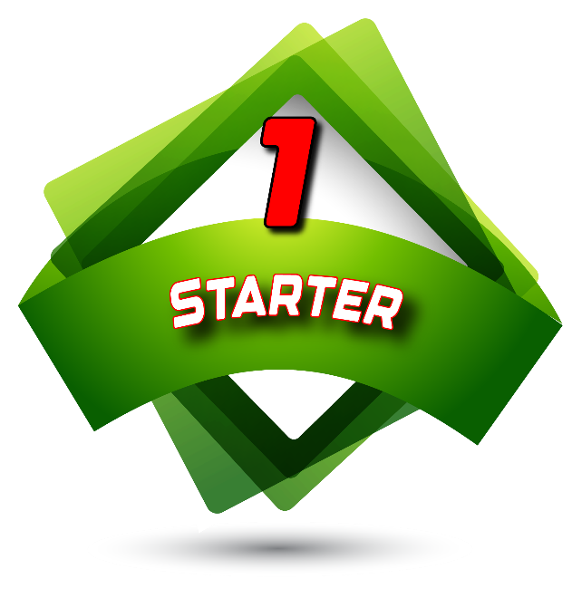
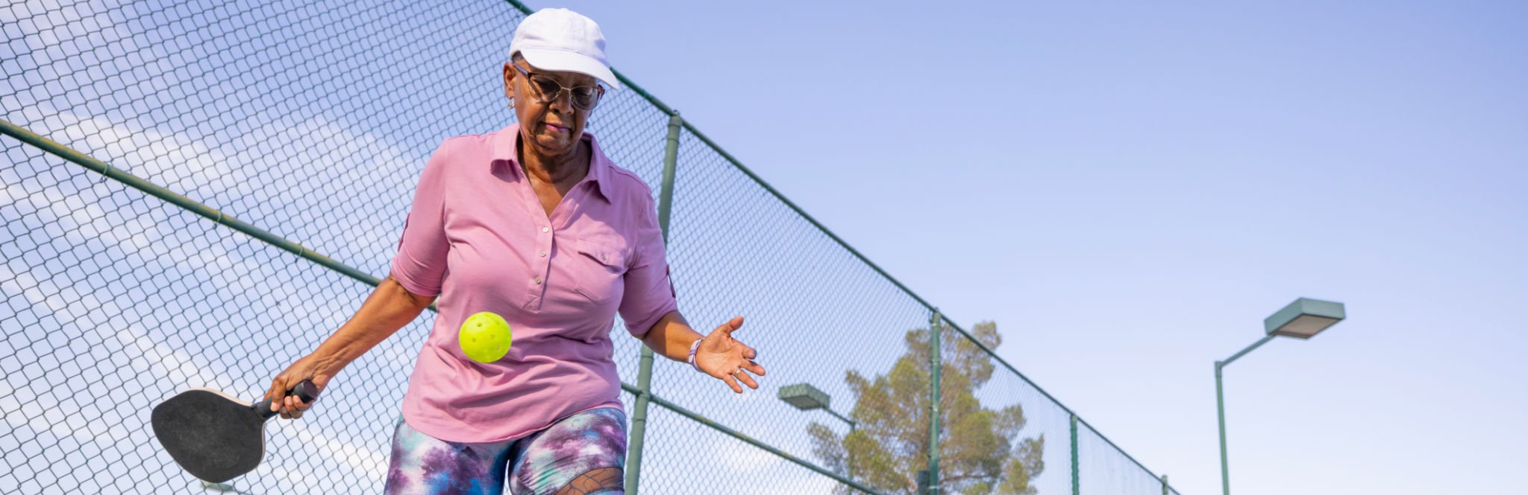
Getting Started Playing Pickleball Lessons
- Have you NEVER Played a Sport?
- Think you are TOO Old to Play?
- Don’t Know Anyone to Play With?
- Not Sure How to Get Started?

In the Starter Lessons, you will learn:
With Your Instructor
Scott Milewski
(Pickleball.Scott@outlook.com)
Selkirk Advocate
(Discount Code: ADV-SMILEWSKI)

- The essential USA Pickleball rules
- The Areas of the court
- The proper way to strike the ball
- Two types of servers
- How to keep score
- And Much More!

When: Where: Cost:
Saturday, June 6th Floren Recreation Center
FREE!
9am to Noon 1549 Florin Dr
Guilder, OH 43210
What to Bring
- Preferably ‘court shoes’, but any sports shoe will be fine to start
- Comfortable workout cloths, appropriate for the weather
- A refreshment (water is always a good choice) – No ‘adult beverages’ on or during court time
- Your paddle, if you have one (Not required). Paddles will be available for you to use.
Email Me for More Information
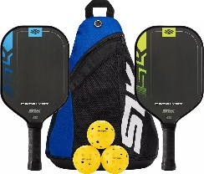
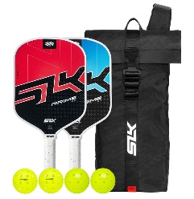
SLK Catalyst Raw Carbon Bundle
Available at Dick’s Sporting Goods - $99.99

SLK Prime 2.0 Max Bundle
Available at Costco/Costco Online - Prime 2.0: $79

Starter
Paddle
Options

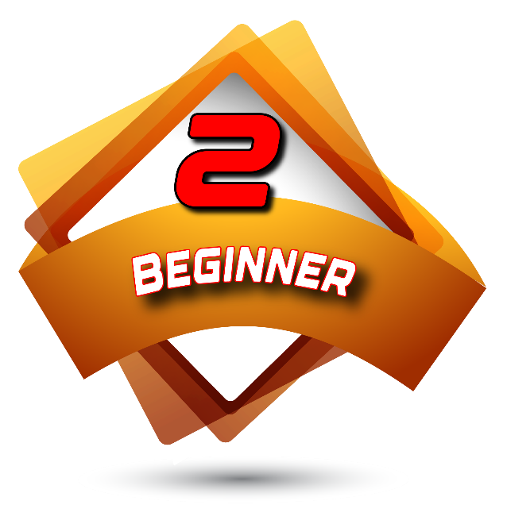
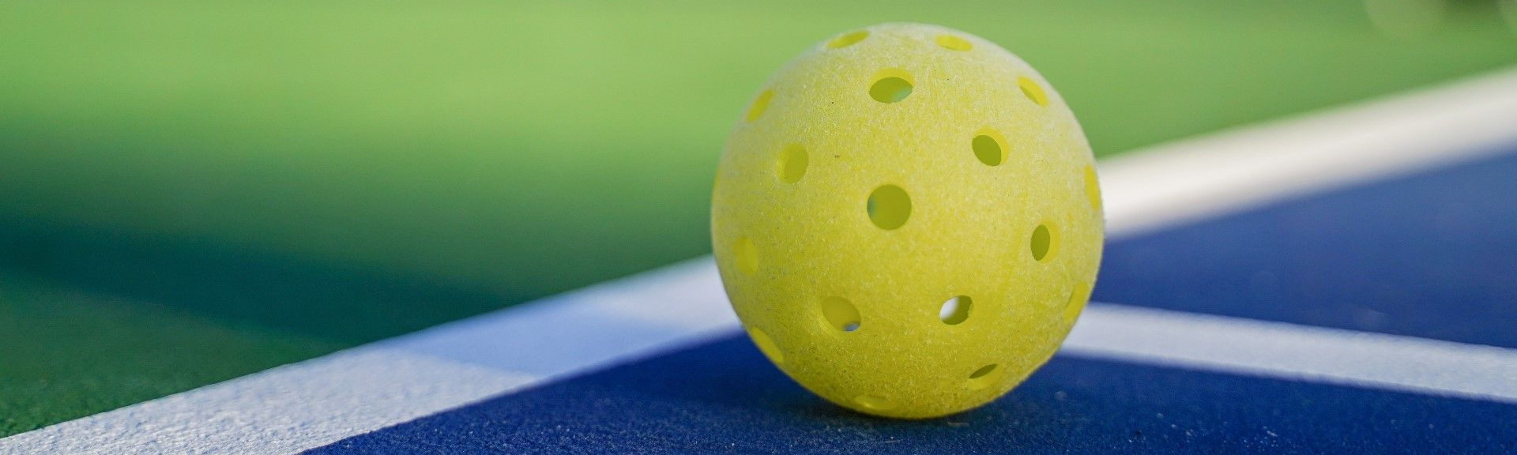
Beginner Pickleball Lessons
The Beginner Lessons Cover:
- Serving Consistency
- Basic Returns
- Maintaining short rallies
- Beginning to aim shots
- Understand Non-Volley Zone (NVZ/Kitchen) Basics
- Approaching the Net

When: Where: Cost:
Saturday, June 13th Floren Recreation Center
FREE!
9am to Noon 1549 Florin Dr
Guilder, OH 43210

With Your Instructor
Scott Milewski
(Pickleball.Scott@outlook.com)
Selkirk Advocate
(Discount Code: ADV-SMILEWSKI)
* Use my Discount Code to receive Selkirk Bonus Bucks which may be redeemed at Selkirk.com.
Email Me for More Information


Featuring: Pro Lessons, Live Stream Matches, Past Tournaments, Podcasts, and On-Demand Shows.
Available on: cell phones (Android, iPhone), Apple TV, Android TV, Roku, iOS.

Great Beginner Paddle Options
Additional Training Opportunities

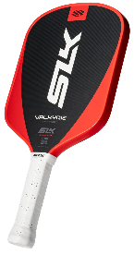
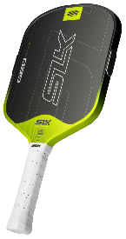
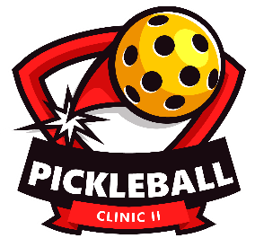
Investment Planning
Selecting Your Next Paddle
(Please ask for more details)
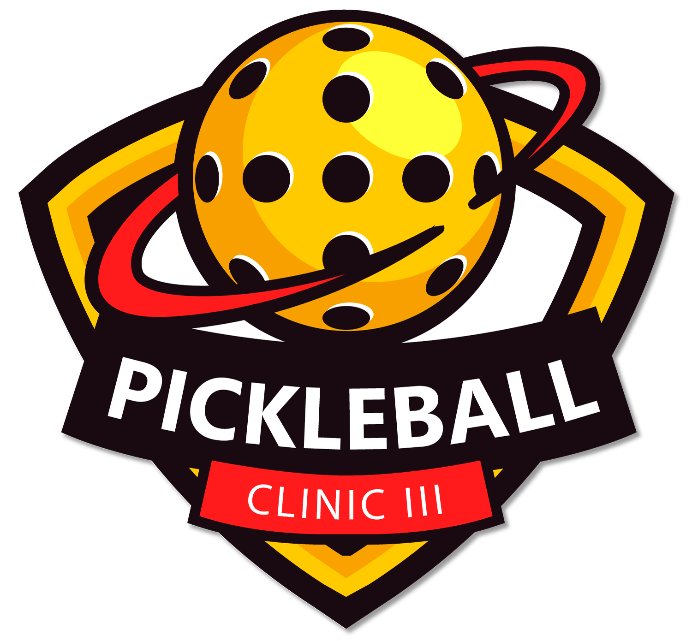
Pickleball Equipment
Augmentation & Care
(Please ask for more details)

SLK Valkyrie
Widebody
$80*

Available at
Selkirk.com

SLK Geo
Widebody & Elongated
$100*

Available at
Selkirk.com

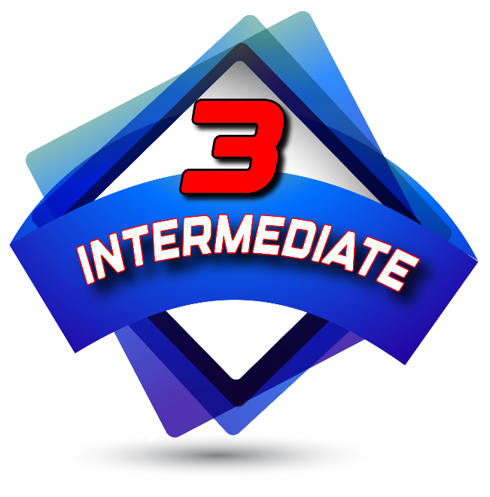
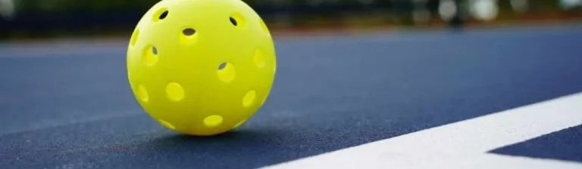
The Intermediate Lessons Cover:
- Serves and returns with direction
and depth
- Consistent dinking
(Soft shots into the non-volley zone)
- Ability to sustain longer rallies
- Volleys & overheads with control
- Start using third-shot drops or drives
- Improved footwork & net positioning
- Recognize opponent weaknesses

Intermediate Pickleball Lessons

Email Me For More Information

When: Where: Cost:
Saturday, June 20th Floren Recreation Center
FREE!
9am to Noon 1549 Florin Dr
Guilder, OH 43210
With Your Instructor
Scott Milewski
(Pickleball.Scott@outlook.com)
Selkirk Advocate
(Discount Code: ADV-SMILEWSKI)
* Use my Discount Code to receive Selkirk Bonus Bucks which may be redeemed at Selkirk.com.
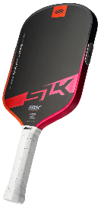
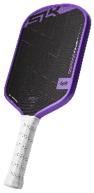
Additional Training Opportunities
Terrific Intermediate Paddle Options
SLK Dauntless
Widebody & Elongated
$180*

Available at
Selkirk.com

SLK ERA
Widebody & Elongated
$200*

Available at
Selkirk.com

Pickleball Equipment
Augmentation & Care
(Please ask for more details)

Investment Planning
Selecting Your Next Paddle
(Please ask for more details)
Featuring: Pro Lessons, Live Stream Matches, Past Tournaments, Podcasts, and On-Demand Shows.
Available on: cell phones (Android, iPhone), Apple TV, Android TV, Roku, iOS.

-+

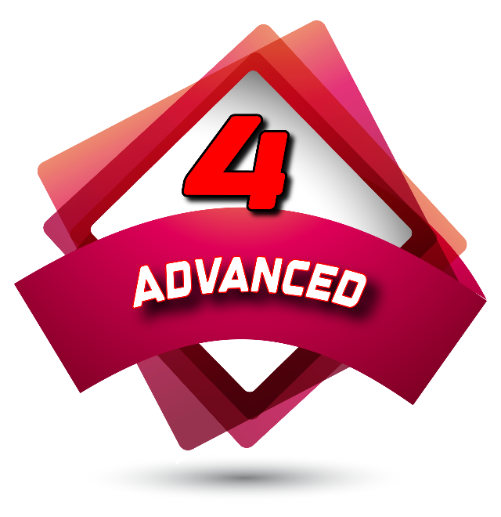
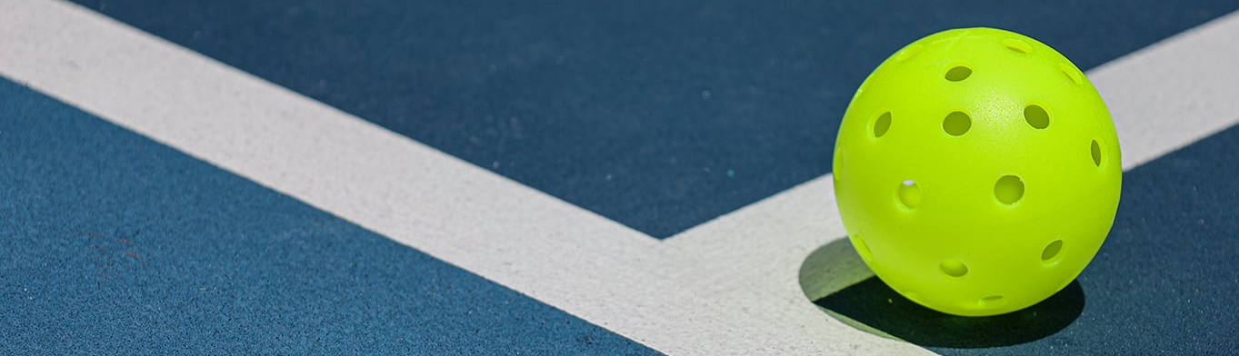
The Advanced Lessons Cover:
- Enter
- Your
- Lesson
- Goals
- Here
Advanced Pickleball Lessons

When: Where: Cost:
Saturday, June 27th Floren Recreation Center
FREE!
9am to Noon 1549 Florin Dr
Guilder, OH 43210

With Your Instructor
Scott Milewski
(Pickleball.Scott@outlook.com)
Selkirk Advocate
(Discount Code: ADV-SMILEWSKI)
* Use my Discount Code to receive Selkirk Bonus Bucks which may be redeemed at Selkirk.com.
Email Me for More Information
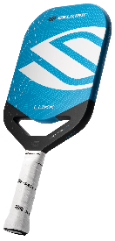
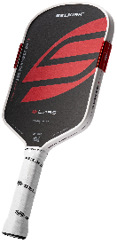
Pickleball Equipment
Augmentation & Care
(Please ask for more details)

Investment Planning
Selecting Your Next Paddle
(Please ask for more details)
Selkirk LUXX Control Air with
InfiniGrit
Widebody
$200*
Available at
Selkirk.com

Selkirk Labs Project Boomstik
Widebody &
Elongated
$333*

Available at
Selkirk.com

Excellent Advanced Paddle Options
Additional Training Opportunities
Featuring: Pro Lessons, Live Stream Matches, Past Tournaments, Podcasts, and On-Demand Shows.
Available on: cell phones (Android, iPhone), Apple TV, Android TV, Roku, iOS.

