 | Paddle Selection Considerations
Use the following to help determine the best Selkirk/Selkirk Labs/SLK paddle for you!
HYBRID
CONTROL
POWER
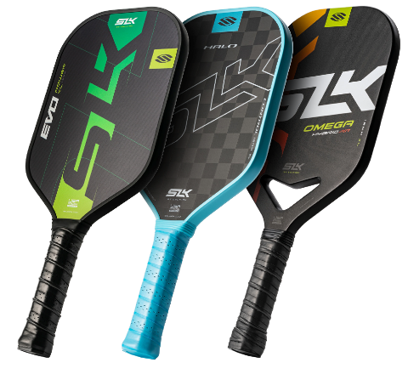
Power vs. Control

Pickleball paddles are typically categorized for power or control, suiting different styles of play.
- Power: Provides more pop off the paddle for explosive shots.
- Control: Allows players to make more precise shots.
- Hybrid: Mix of both control and power.

CARBON FIBER
FIBERGLASS
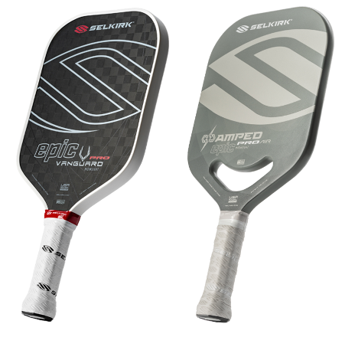
Paddle Face Materials

The material used on your paddle face can affect your ability to create spin and hit powerful shots.
- Carbon Fiber: Provides excellent control and a soft feel.
- Fiberglass: Balances power and control for well-rounded play.
HINT: Keep the surface of your paddle clean with a Selkirk Raw Carbon Fiber Pickleball Paddle Cleaning Block or disposable alcohol wipes.

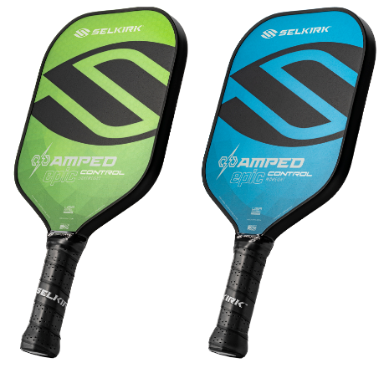
MIDWEIGHT
LIGHTWEIGHT
Weight

Now picture the paddle in your hand. Do you prefer a light feel for faster swings or a more substantive feel that adds subtle resistance?
- Lightweight: Easier to maneuver for quick reactions at the net.
- Midweight: Offers a balance of power and control, suitable for most players.
HINT: Be sure to visit Selkirk University to learn how to properly weight your paddle so it plays right for YOU!
https://www.selkirk.com/pages/selkirk-u

EPIC
INVIKTA
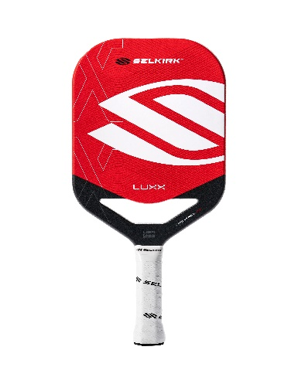
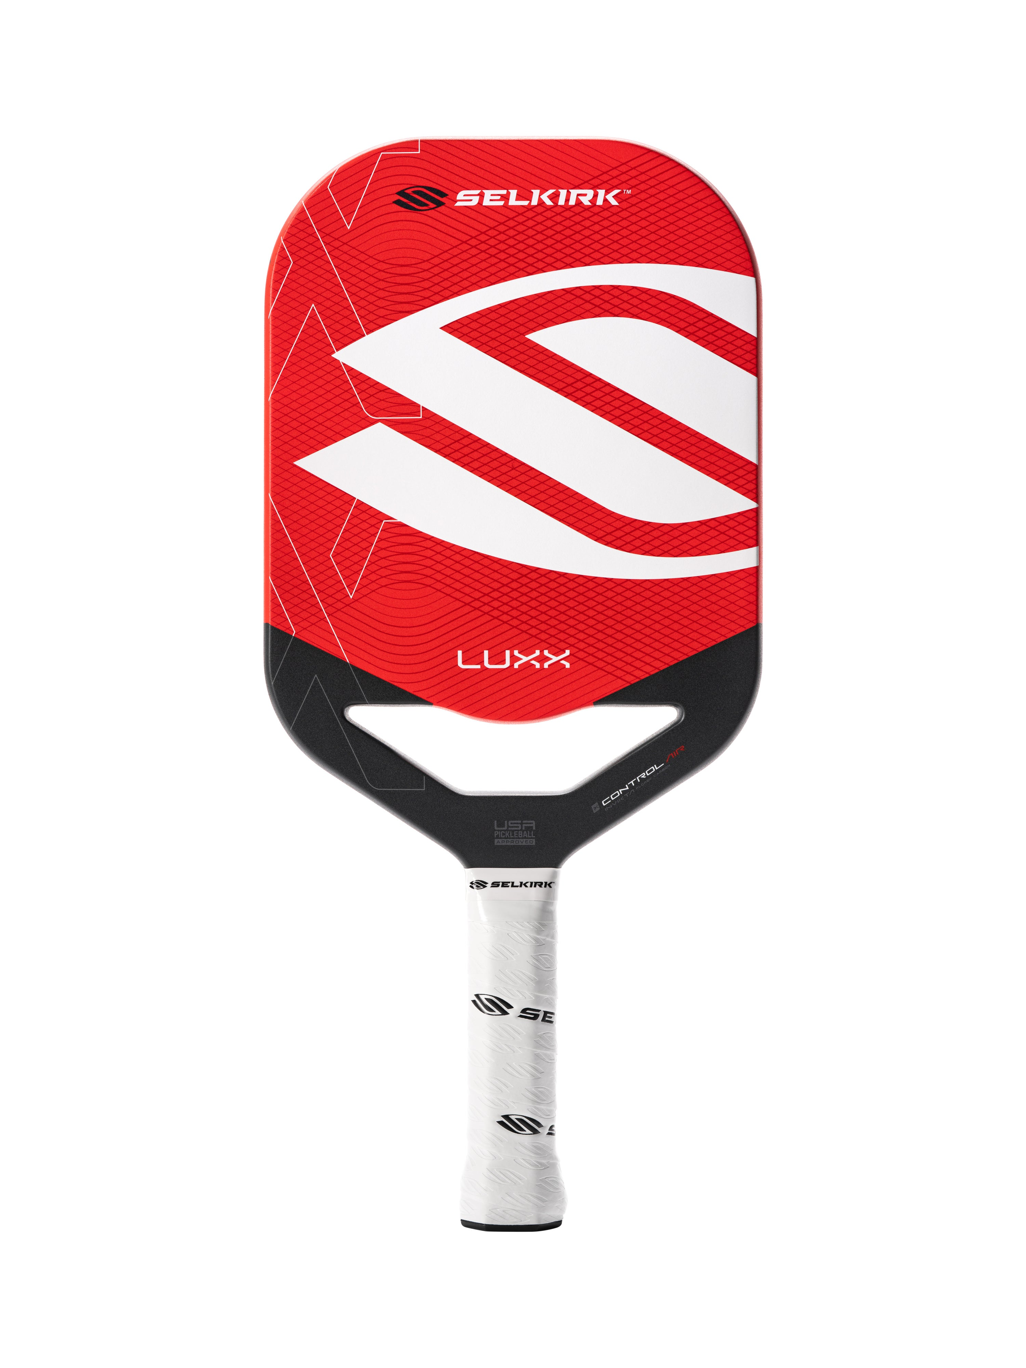
Shape

There are different shapes for pickleball paddles, with each serving a different purpose.
- Epic (Selkirk)/Max (SLK): Offers a balanced sweet spot, ideal for beginners and well-rounded play.
- Invikta (Selkirk)/XL (SLK): Provides more reach and power but requires more precision.

To make your purchase, please visit Selkirk.com and use Promo Code: ADV-SMILEWSKI to receive your rebate.
