Help Us in Welcoming
the New Arrivals to Our Selkirk Family!

Get Ready For:
- The SLK Dauntless, built to be the next step up to elevate your game.
- The SLK Geo meets you where you are and helps take your game a little further.
- The most approachable way to start playing pickleball. The Valkyrie delivers a fun, forgiving experience at a budget-friendly price.

 |  | 
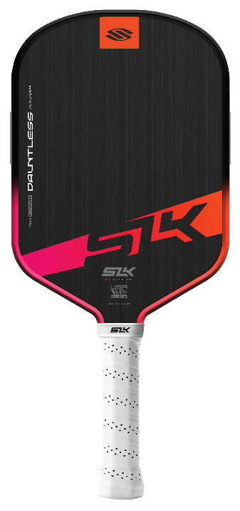 | 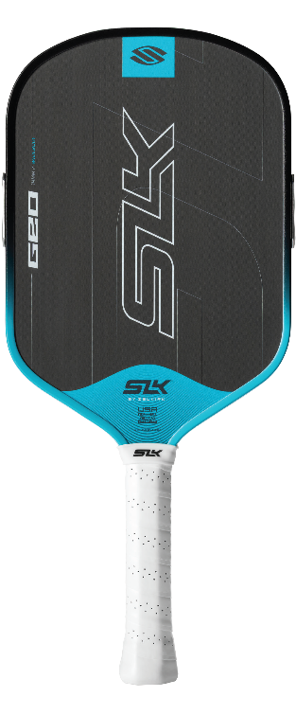 | 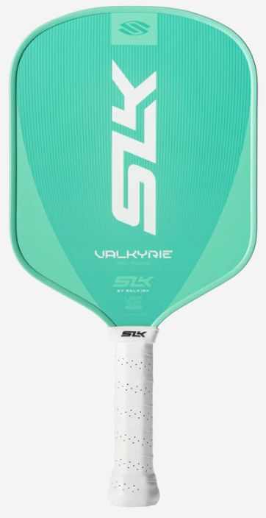
Featuring:  - SOLOCORE  - MOI TUNING SYSTEM | Featuring:  - T700-GRADE RAW CARBON FIBER  - MOI TUNING SYSTEM | Features:  - FIBERFLEX FIBERGLASS TECHNOLOGY  - X5 POLYMER CORE
Ideal For:  - The Rising Competitor  - The Tech Enthusiast  - The All-Court Player  - The Reliable Hitter | Ideal For:  - The Developing Player  - The Value-Seeker  - The Social Regular  - The Practical Athlete | Ideal For:  - The Newcomer  - The Social Player  - A Brand-Conscious Buyer  - A "Plug-and-Play" Athlete

Grab these brand-new paddles at Selkirk.com!
Be sure to use Discount Code: ADV-SMILEWSKI to receive your Selkirk Gift Card.
000

