Help Us in Welcoming
the New Arrivals to Our Selkirk Family!

 |  | 
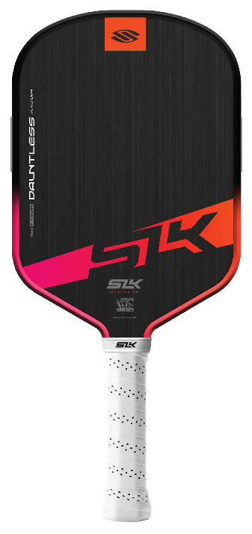 | 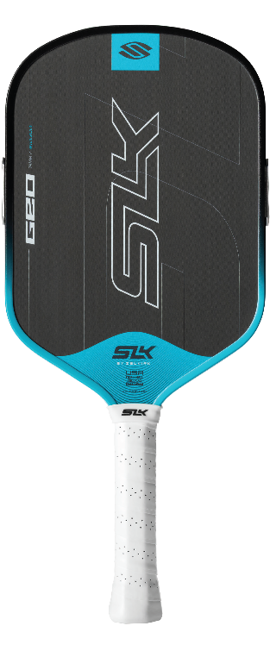 | 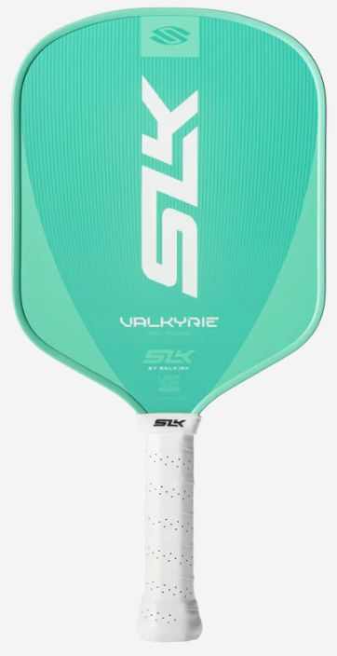
Featuring:  - SOLOCORE  - MOI TUNING SYSTEM | Featuring:  - T700-GRADE RAW CARBON FIBER  - MOI TUNING SYSTEM | Features:  - FIBERFLEX FIBERGLASS TECHNOLOGY  - X5 16 mm POLYMER CORE
Ideal For:  - The Rising Competitor  - The Tech Enthusiast  - The All-Court Player  - The Reliable Hitter | Ideal For:  - The Developing Player  - The Value-Seeker  - The Social Regular  - The Practical Athlete | Ideal For:  - The Newcomer  - The Social Player  - The Brand-Conscious Buyer  - The "Plug-and-Play" Athlete
Grab these brand-new paddles from Selkirk.com! Be sure to use Discount Code: ADV-SMILEWSKI to receive your Selkirk Gift Card.


