Selkirk IS the #1 Brand in Pickleball!  The VIP program is an annual paid membership for players who want Selkirk’s most exclusive perks and discounts, plus early access to select product launches. It’s designed for dedicated players to get the most value out of their Selkirk experience.    Become a Selkirk VIP member and instantly receive $40 in Bonus Bucks to use on anything! You'll also enjoy free FedEx 2Day® shipping* on $55+ orders,10% off gear and accessories.  *Some exclusions apply. See terms and conditions at  selkirk.com/products/selkirk-vip-membership.  Be sure to use Discount Code ADV-SMILEWSKI during  check out at Selkirk.com to earn your Bonus Bucks |  | Selkirk IS the #1 Brand in Pickleball!  The VIP program is an annual paid membership for players who want Selkirk’s most exclusive perks and discounts, plus early access to select product launches. It’s designed for dedicated players to get the most value out of their Selkirk experience.  Become a Selkirk VIP member and instantly receive $40 in Bonus Bucks to use on anything! You'll also enjoy free FedEx 2Day® shipping* on $55+ orders,10% off gear and accessories.  *Some exclusions apply. See terms and conditions at  selkirk.com/products/selkirk-vip-membership.  Be sure to use Discount Code ADV-SMILEWSKI during  check out at Selkirk.com to earn your Bonus Bucks
  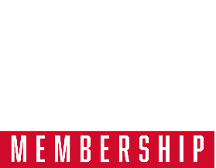 | 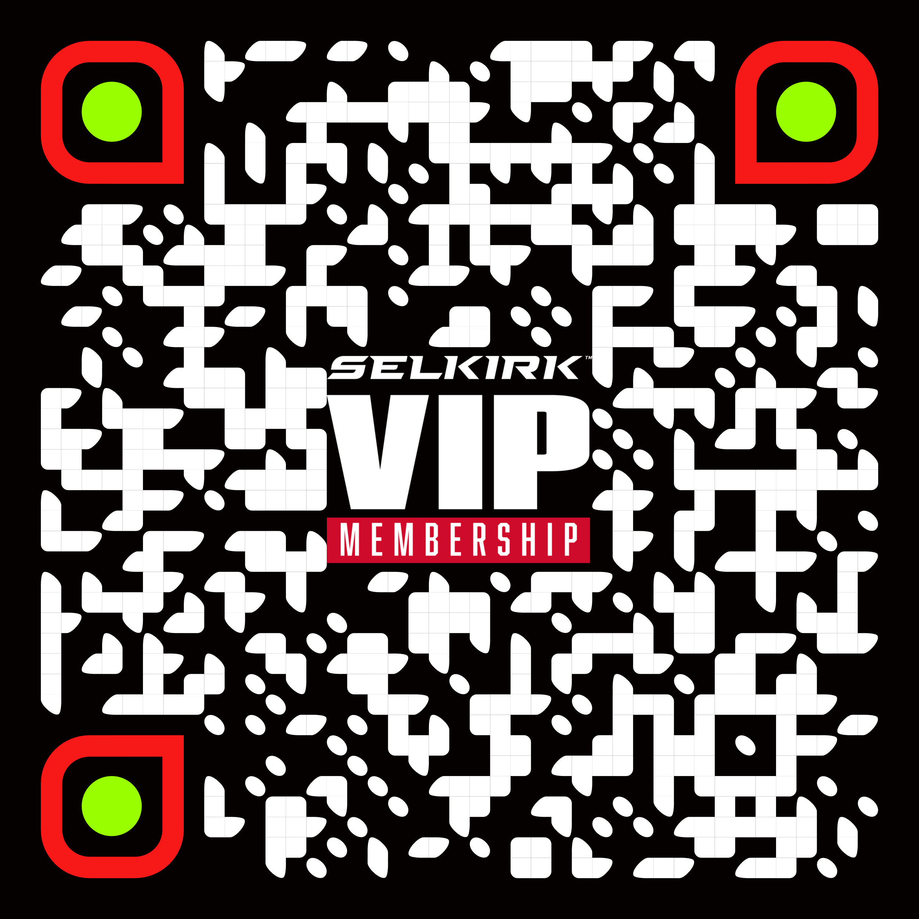
Selkirk IS the #1 Brand in Pickleball!  The VIP program is an annual paid membership for players who want Selkirk’s most exclusive perks and discounts, plus early access to select product launches. It’s designed for dedicated players to get the most value out of their Selkirk experience.  Become a Selkirk VIP member and instantly receive $40 in Bonus Bucks to use on anything! You'll also enjoy free FedEx 2Day® shipping* on $55+ orders,10% off gear and accessories.  *Some exclusions apply. See terms and conditions at  selkirk.com/products/selkirk-vip-membership.  Be sure to use Discount Code ADV-SMILEWSKI during  check out at Selkirk.com to earn your Bonus Bucks |  | Selkirk IS the #1 Brand in Pickleball!  The VIP program is an annual paid membership for players who want Selkirk’s most exclusive perks and discounts, plus early access to select product launches. It’s designed for dedicated players to get the most value out of their Selkirk experience.  Become a Selkirk VIP member and instantly receive $40 in Bonus Bucks to use on anything! You'll also enjoy free FedEx 2Day® shipping* on $55+ orders,10% off gear and accessories.  *Some exclusions apply. See terms and conditions at  selkirk.com/products/selkirk-vip-membership.  Be sure to use Discount Code ADV-SMILEWSKI during  check out at Selkirk.com to earn your Bonus Bucks

The VIP program is an annual paid membership for players who want Selkirk’s most exclusive perks and discounts, plus early access to select product launches. It’s designed for dedicated players to get the most value out of their Selkirk experience.  Become a Selkirk VIP member and instantly receive $40 in Bonus Bucks to use on anything! You'll also enjoy free FedEx 2Day® shipping* on $55+ orders,10% off gear and accessories  .*Some exclusions apply. *Free FedEx 2Day® shipping excludes nets, 100-packs of balls, ball carriers, ball blockers, and is only available in the contiguous United States. Not available in Hawaii, Alaska, or U.S. territories See terms and conditions at selkirk.com/products/selkirk-vip-membership.  Be sure to use Discount Code ADV-SMILEWSKI during  check out at Selkirk.com to earn your Bonus Bucks |  | The VIP program is an annual paid membership for players who want Selkirk’s most exclusive perks and discounts, plus early access to select product launches. It’s designed for dedicated players to get the most value out of their Selkirk experience.  Become a Selkirk VIP member and instantly receive $40 in Bonus Bucks to use on anything! You'll also enjoy free FedEx 2Day® shipping* on $55+ orders,10% off gear and accessories  .*Some exclusions apply. *Free FedEx 2Day® shipping excludes nets, 100-packs of balls, ball carriers, ball blockers, and is only available in the contiguous United States. Not available in Hawaii, Alaska, or U.S. territories See terms and conditions at selkirk.com/products/selkirk-vip-membership.  Be sure to use Discount Code ADV-SMILEWSKI during  check out at Selkirk.com to earn your Bonus Bucks
  Selkirk IS the #1 Brand in Pickleball!
  SELKIRK VIP PERKS | VIP Members | Non-VIPs
  Welcome gift | ✅ | ❌
  $40 Bonus Bucks | ✅ | ❌
  Free FedEx 2Day® shipping* on $55+ orders | ✅ | ❌
  $15 Birthday Reward | ✅ | ❌
  Extra 10% OFF select categories | ✅ | ❌
  FREE 4-pack of pickleballs every season | ✅ | ❌
  Early access to select product launches | ✅ | ❌
  Priority Order Processing | ✅ | ❌
  45-day returns | ✅ | ❌
  Exclusive Partner discounts | ✅ | ❌
  Selkirk IS the #1 Brand in Pickleball!
  SELKIRK VIP PERKS | VIP Members | Non-VIPs
  Welcome gift | ✅ | ❌
  $40 Bonus Bucks | ✅ | ❌
  Free FedEx 2Day® shipping* on $55+ orders | ✅ | ❌
  $15 Birthday Reward | ✅ | ❌
  Extra 10% OFF select categories | ✅ | ❌
  FREE 4-pack of pickleballs every season | ✅ | ❌
  Early access to select product launches | ✅ | ❌
  Priority Order Processing | ✅ | ❌
  45-day returns | ✅ | ❌
  Exclusive Partner discounts | ✅ | ❌

