Guaranteed To Make You Play Better
Or Get Your Money Back!
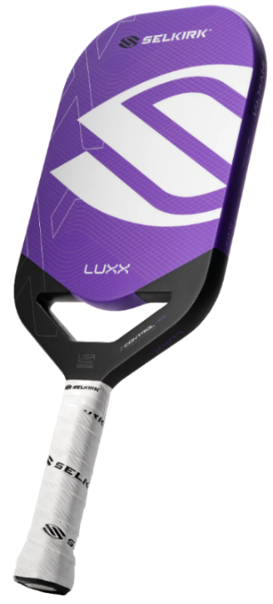
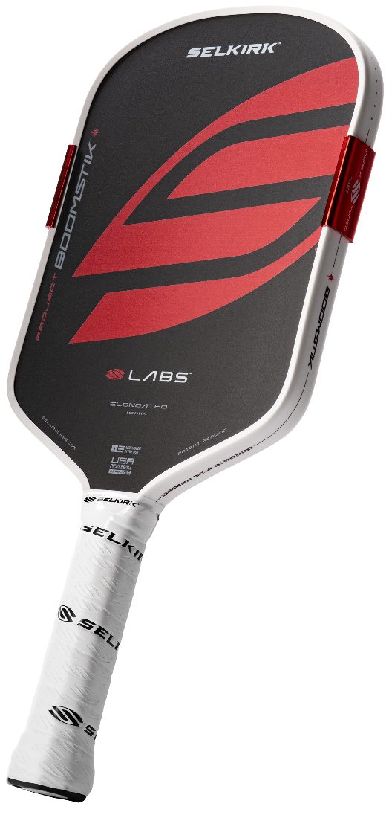
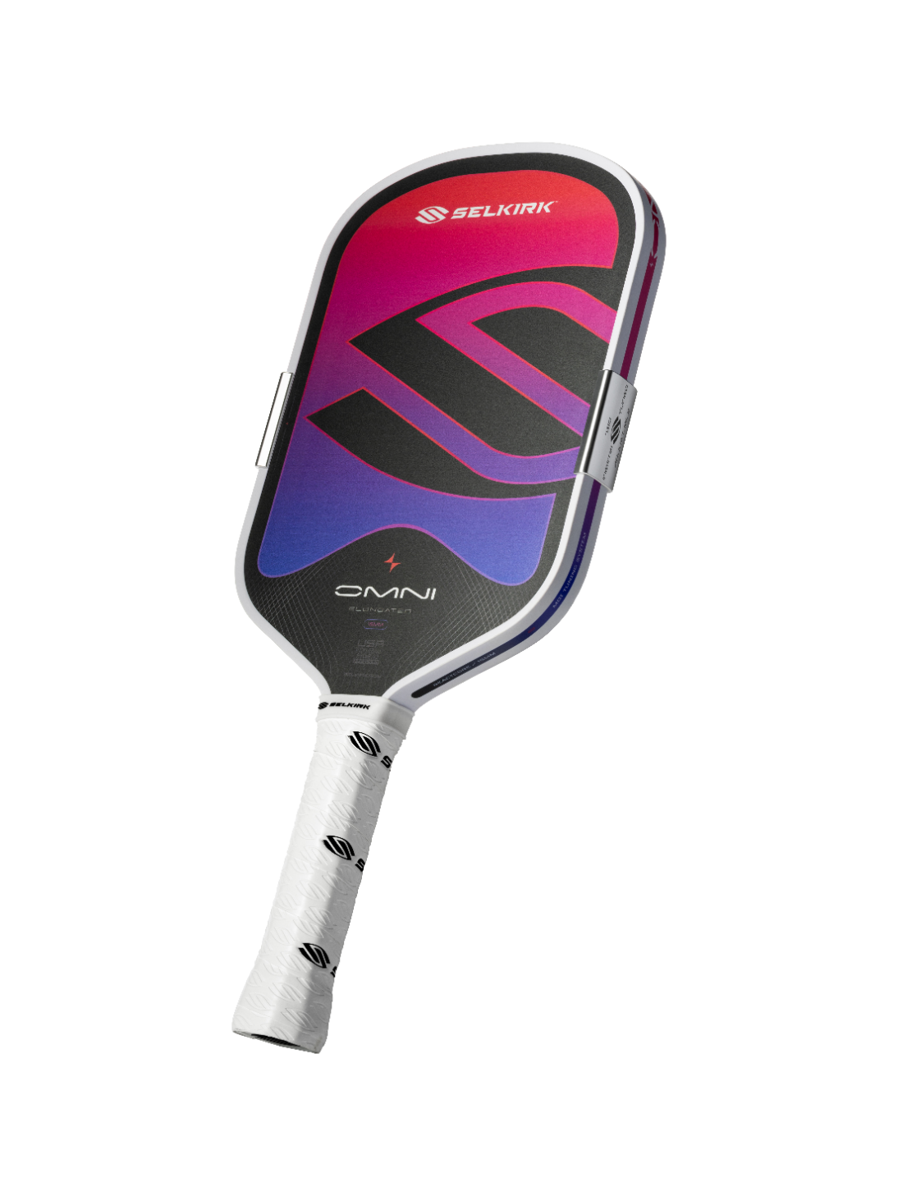
Selkirk offers a 30-day hassle-free return policy from the delivery date. If your purchase isn’t right, return it for a full refund* or exchange it. Access the Return Portal to start the process.
Buy with Confidence!
Play with Conviction
When you are ready to put that paddle in your bag, it is the right one with an S on it.
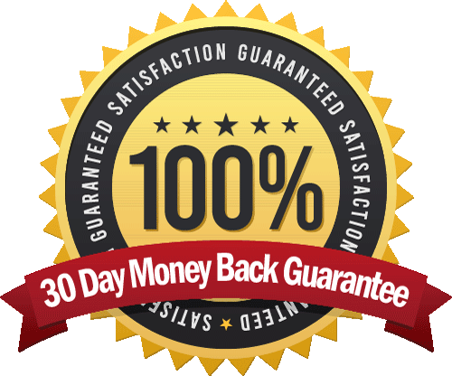
Feel free to play with it to make sure it improves your game and fits your style of
play before deciding to return it.
* Unlike most every other brand, Selkirk will even pay
for the return postage. So, you get ALL your money back.

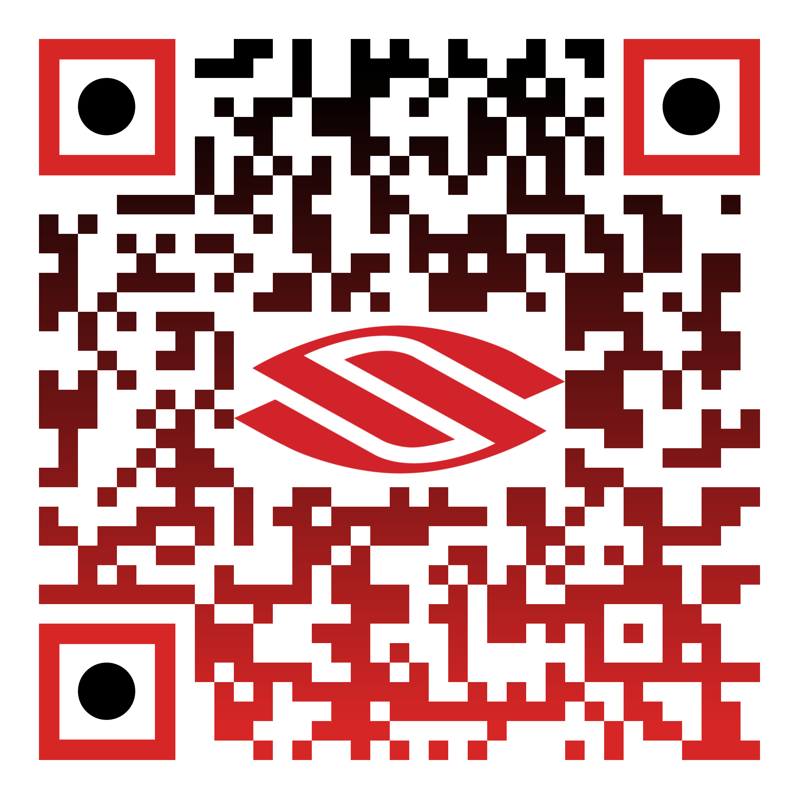
Start a Return
How do I return a paddle?
Visit https://selkirksport.loopreturns.com/#/ to start your return.
All you need is your order number and email address.

