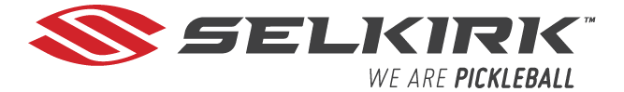

Guaranteed To Make You Play Better
Or Get Your Money Back!

Selkirk offers a 30-day hassle-free return policy from the delivery date. If your purchase isn’t right, return it for a full refund or exchange it. Access the Return Portal to start the process.
Feel free to play with it to make sure it improves your game and fits your style of play.

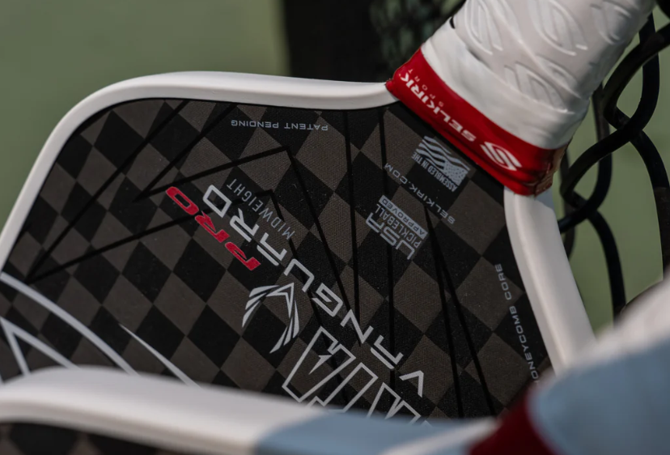

How do I return a paddle?
Visit https://selkirksport.loopreturns.com/#/ to start your return. You will just need your order number and email address.

