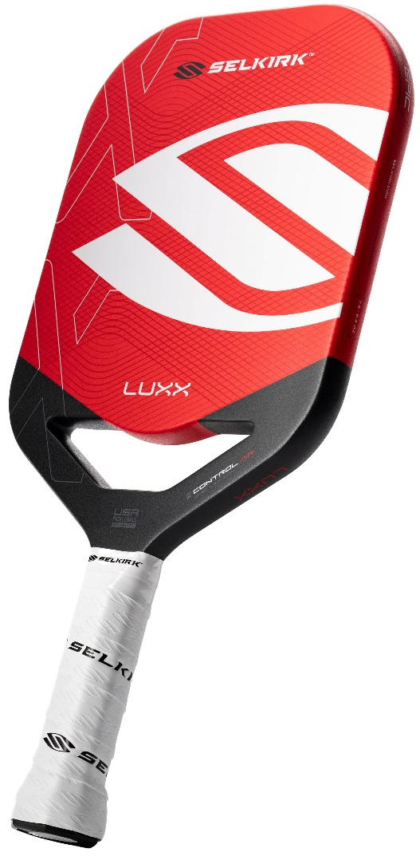


Demo Your Next Paddle
at this Demo Day Event!

Be Sure to Attend this Selkirk Demo Day to
Find the Best Paddle for You and
Try Before You Buy!

There is No cost to participate.

Keep in mind Selkirk paddles are guaranteed to improve
your game or you will get a full refund within 30 days.

Demo Event:
June 1, 2025 from 8:00 am to Noon
at the McGill Park Pickleball Courts
(6725 Lithopolis-Winchester Road, Canal Winchester)

Please complete the online Paddle Demo Survey before the event to ensure we can get the information to make your visit the best it can be.
https://www.surveymonkey.com/r/HL8MWLM

If you cannot make the event, but are still interesting in getting a Selkirk, SLK, or Selkirk Labs paddle, be sure to get your rebate by using code: ADV-SMILEWSKI at checkout.


Selkirk doesn’t just make the best paddles on the market; they are here to make you the best player you can be by creating sites to assist in your pickleball development and enjoyment!
Selkirk TV
https://www.selkirk.com/pages/tv https://www.selkirk.com/pages/selkirk-u

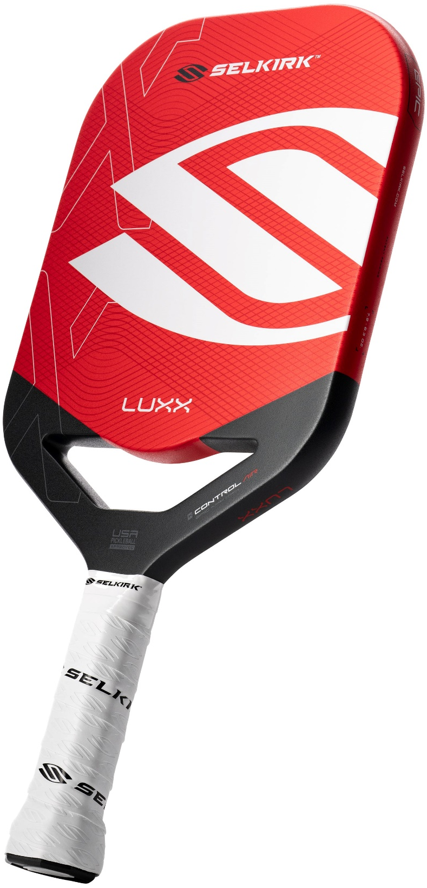

Demo Your Next Paddle
at this Demo Day Event!

Be Sure to Attend this Selkirk Demo Day
to Find the Best Paddle for You and
Try Before You Buy!

There is No cost to participate.

Keep in mind Selkirk paddles are
guaranteed to improve your game or
you will get a full refund within 30 days.

Demo Event:
June 1, 2025 from 8:00 am to Noon
at the McGill Park Pickleball Courts
(6725 Lithopolis-Winchester Road, Canal Winchester)
Please complete the online Paddle Demo Survey before the event to ensure we can get the information to make your visit the best it can be.
https://www.surveymonkey.com/r/HL8MWLM

If you cannot make the event, but are still interesting in getting a Selkirk, SLK, or Selkirk Labs paddle, be sure to get your rebate by using code: ADV-SMILEWSKI at checkout.

Selkirk doesn’t just make the best paddles on the market; they are here to make you the best player you can be by creating sites to assist in your pickleball development and enjoyment!
Selkirk TV
https://www.selkirk.com/pages/tv https://www.selkirk.com/pages/selkirk-u

