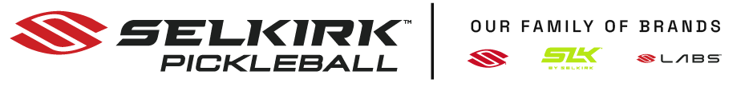


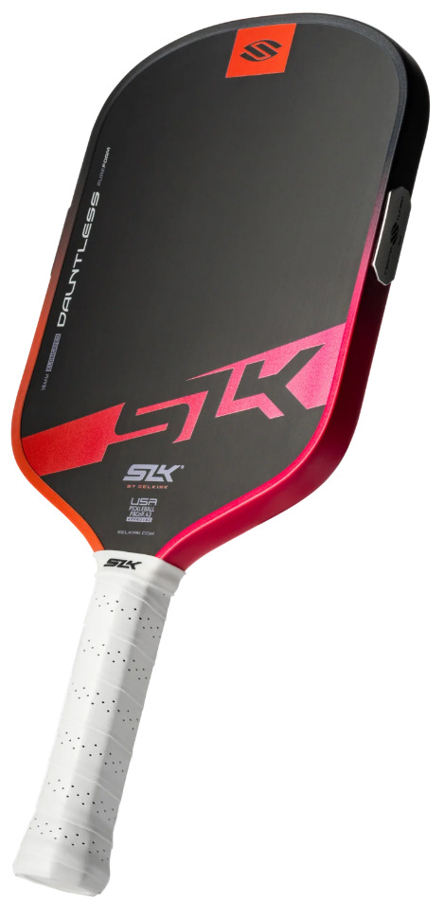
The SLK Dauntless allows players looking for a versatile paddle to incorporate next-gen performance technology into their game.
Definition:
DAUNTLESS
Incapable of Being Intimidated or Subdued; Fearless!

With patent-pending innovations like the PureFoam™ core structure and MOI Tuning System, the Dauntless delivers all-court performance.

A hybrid-style paddle which leans to control, it doesn't sacrifice power when you need it.
PLAY FEARLESS | PLAY DAUNTLESS

Visit the DAUNTLESS

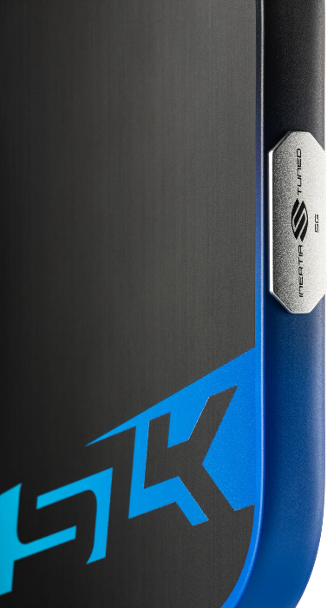
An All-Court, Next-Gen Paddle Costing Only:
$180 | Be sure to use Discount Code:  ADV-SMILEWSKI  to receive a Selkirk gift card.

MOI TUNING SYSTEM
Giving a maximum sweet spot & balance, so your paddle avoids twisting. Contact doesn't have to be perfect — this paddle features Selkirk's breakthrough MOI Tuning System to dial in
your paddle's all-court performance. The MOI Tuning System maximizes your sweet spot and improves balance, so your paddle is weighted to win right out of the box.

