
 | 7 REASONS TO  USE A POWER PADDLE | Ask Me About  
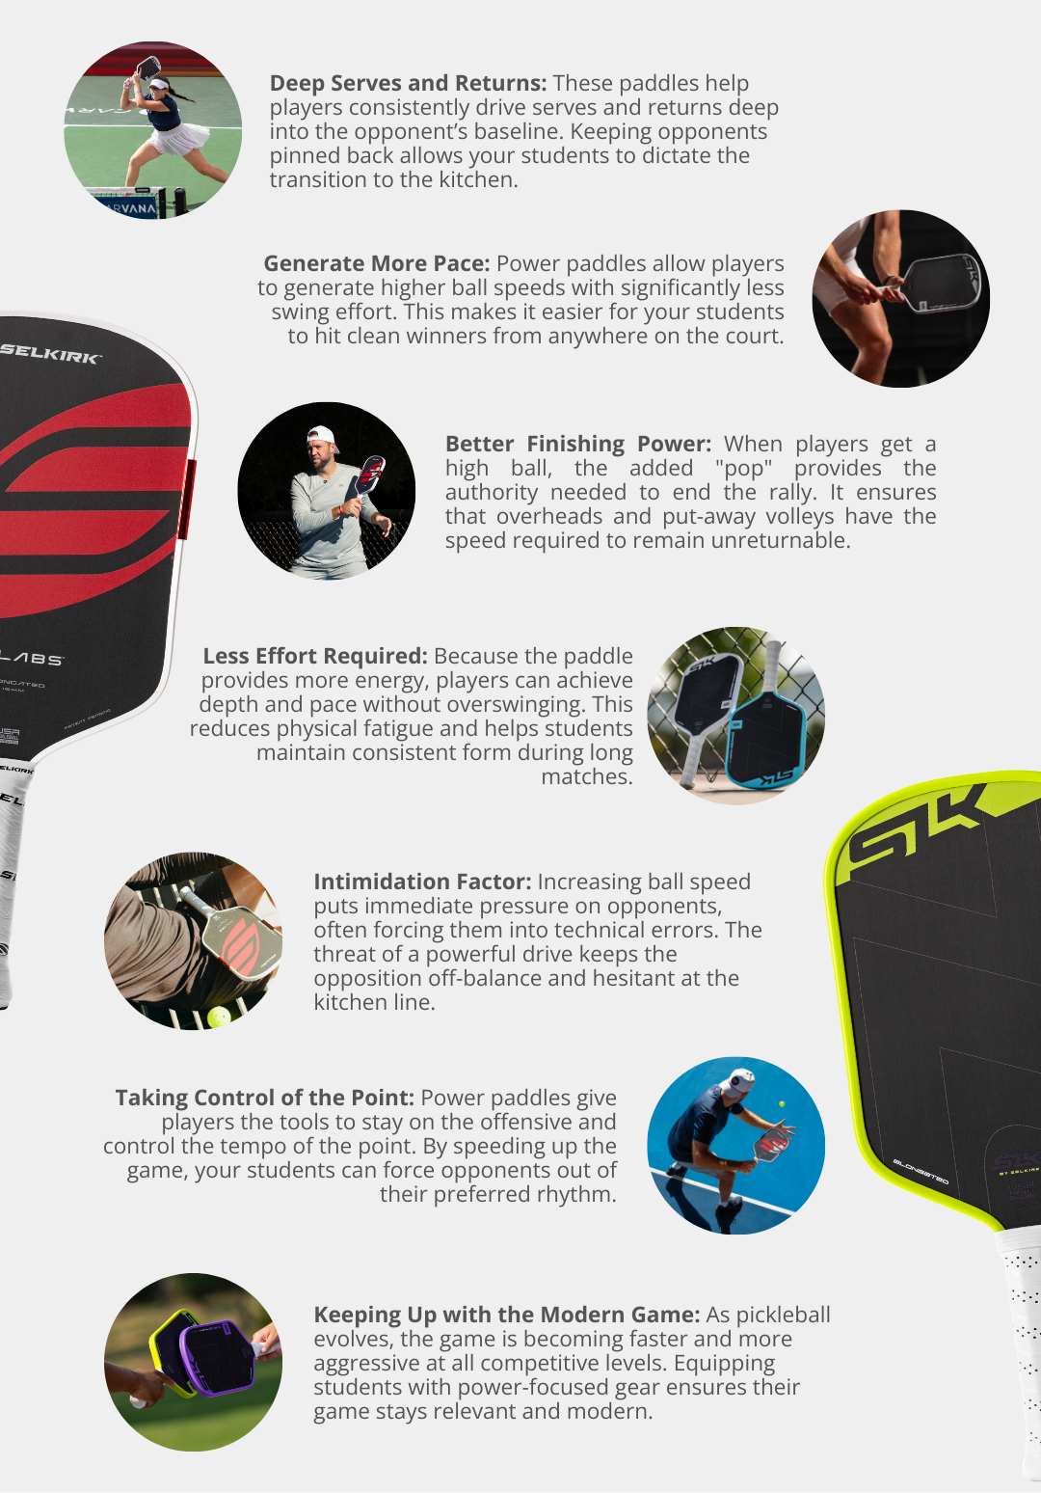
Please feel free to contact me with any follow-up questions at:
Pickleball.Scott@outlook.com
 | Find Your Power Paddle at: Selkirk.com Discount Code: ADV-SMILEWSKI

