Company Vision & Mission
Vision:
"To become a global leader in sustainable technology and intelligent automation."
Mission:
"To transform industries through AI, renewable energy, automation, and advanced engineering solutions that create a safer, smarter, and greener world."
Values :
"Smart Technology. Sustainable Future."
Product 1
Vayu-Optimize AI
Tagline: Recover Every Lost Megawatt.
core value in 3 words
Predict. Optimize. Maximize.
Simple idea:
Wind gives power. AI makes that power smarter and bigger.

Problem
Wind farms in India lose 10–20% power output due to:
- reactive turbine controls
- inaccurate wind forecasting
- unplanned downtime

Solution
Vayu-Optimize AI is an OEM-agnostic SaaS platform that plugs into existing SCADA systems and uses AI to:
✅ optimize blade pitch & yaw in real time
✅ predict energy generation 36 hours ahead
✅ detect failures before breakdowns using digital twins
3. TAM / SAM / SOM
TAM (Total Addressable Market)
Global wind O&M software market estimated:
~ $15B+
India wind market:
~ 48+ GW installed base.
India is one of the world’s top wind producers.

SAM (Serviceable Available Market)
Focus:
India + GCC
Target:
- 500+ wind farms
- Avg annual spend = ₹20 Lakhs
SAM:
500 × ₹20L = ₹1000 Cr

SOM (Serviceable Obtainable Market)
First 3 years realistic:
Target:
50 clients
Average ACV:
₹10 Lakhs
SOM:
50 × ₹10L = ₹5 Cr ARR
Your first milestone:
₹1 Cr ARR = only ~10 clients.
4. Competitor Analysis
Company | Strength | Weakness
GE Vernova | OEM integration | expensive
Siemens Gamesa | large installed base | closed ecosystem
Vestas | strong tech | only own turbines
SparkCognition | AI strong | generic platform
Uptake | industrial AI | broad focus

Your Advantage
You are:
✅ OEM agnostic
✅ India-first pricing
✅ Faster deployment
✅ SaaS + services hybrid
✅ SME & mid-market focused

5. Product Market Fit
Who feels pain most?
Tier 1:
Independent Power Producers
Example:
ReNew Energy Global
Pain:
downtime cost

Tier 2:
Wind farm operators
Need:
monitoring + reporting

Tier 3:
Turbine service vendors
Need:
predictive maintenance

PMF Validation Signals
You have PMF when:
- clients renew yearly
- referrals increase
- churn < 5%
- ROI proven
Example:
“Saved ₹30L downtime on one site”
That sells.

6. Go-To-Market Strategy
Phase 1: Beachhead (Tamil Nadu + Karnataka)
Since you’re in South India, target:
Tamil Nadu
and
Karnataka
Large wind corridors:
- Coimbatore
- Tirunelveli
- Chitradurga
- Tumakuru

Sales Motion
Direct Enterprise Sales
Meet:
- plant head
- operations head
- maintenance head

Pilot-first strategy
Offer:
“30-day AI audit”
Price:
₹50K–₹1L
Convert into:
AMC

Channel Partners
Partner with:
- EPC firms
- drone companies
- sensor providers
6. Traction (Pre-Revenue Stage)
We are currently in the pre-revenue stage and building the foundation for launch.
✅ Problem validated through market research with wind industry stakeholders
✅ Product concept and MVP defined
✅ Core AI solution architecture completed (SCADA + AI + Digital Twin)
✅ Initial conversations started with wind farm operators and industry partners
✅ Pilot customer outreach underway in Tamil Nadu and Gujarat
✅ Goal: launch first pilot within 6 months

7. Market Strategy (Simple)
Step 1: Start with Pilot Projects
Offer a small pilot to wind farms to prove ROI.
Goal:
show 5–10% more power generation.

Step 2: Convert to Annual Contracts
After successful pilot, convert customers into yearly SaaS subscriptions.

Step 3: Focus on Key Markets
Start in:
- Tamil Nadu
- Gujarat
- Karnataka
These are India’s biggest wind energy markets.

Step 4: Scale Internationally
Expand to GCC markets like:
- United Arab Emirates
- Saudi Arabia

Our Goal
10 customers = ₹1 Crore ARR within Year 1
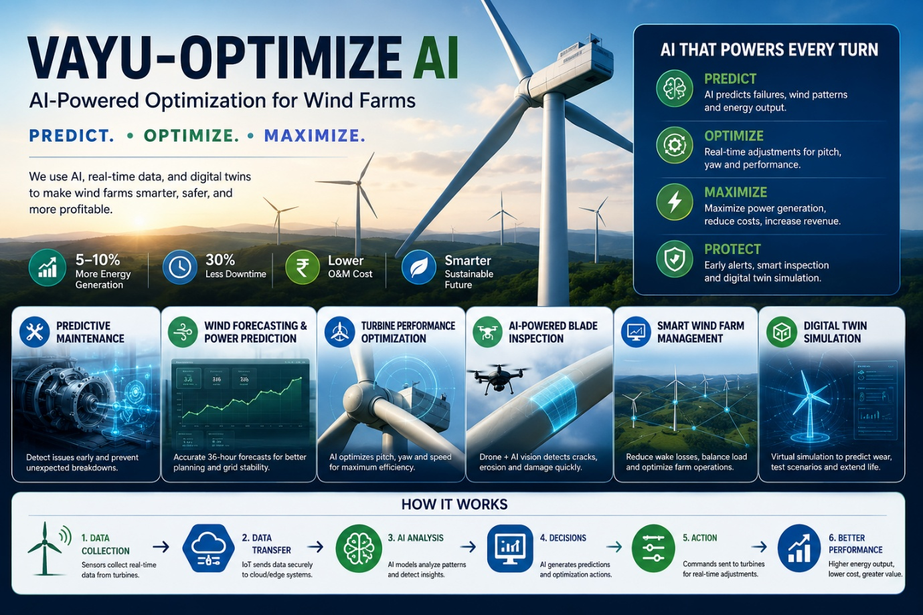

Product 2
Product Name: Solar AI Farm
Tagline: “Autonomous AI for Solar Farm Monitoring & Maintenance”
Core Value (3 words)
Detect → Predict → Optimize
Here’s a simple startup pitch structure for Solar AI Farm that investors and customers can understand easily.

Solar AI Farm
Tagline
AI-powered autonomous maintenance for solar farms

1. Problem
Solar farms lose 10–20% energy due to:
- Dirty solar panels (dust)
- Hotspots / overheating
- Broken or cracked panels
- Manual inspections are slow and costly
- Failures detected too late
Pain: Lower energy output + higher maintenance cost.

2. Solution
Solar AI Farm uses:
- Drones for automated inspection
- Thermal cameras for hotspot detection
- AI for fault detection & prediction
- Dashboard for decision making
- Mobile app for technician execution
Outcome: More energy, less downtime, lower cost.

3. TAM / SAM / SOM
TAM (Total Addressable Market)
Global solar O&M market: ~$30B+
(Every solar farm globally needs monitoring)

SAM (Serviceable Available Market)
India + Middle East + SE Asia utility-scale solar:
~$5B
(Target markets first)

SOM (Serviceable Obtainable Market)
Capture just 1% in 5 years:
= $50M ARR opportunity

4. Competitor Analysis
Company | What they do | Gap
Raptor Maps | Solar analytics | expensive
DroneDeploy | Drone mapping | not solar-specific
Aurora Solar | Solar design | not maintenance
Solar AI Farm | Full AI maintenance loop | cheaper + autonomous
Advantage: End-to-end platform.

5. Product-Market Fit
Customers need:
✅ lower O&M cost
✅ higher energy generation
✅ faster fault detection
✅ automated reporting
Our fit:
direct ROI improvement
Example:
Recovering 5% energy on 100 MW = huge value.

6. Traction (Pre-Revenue)
Current stage:
- MVP design complete
- Product architecture validated
- Pilot discussions with solar farms
- Building AI fault detection model
Next milestone: first pilot customer

7. Go-To-Market Strategy
Phase 1: Pilot
Offer 1 pilot free / discounted
Goal:
prove energy gain

Phase 2: Convert
Turn pilot into annual SaaS contract

Phase 3: Partnerships
Partner with:
- EPC companies
- Drone operators
- Solar O&M firms

Phase 4: Scale
Expand to:
- India
- UAE
- US utility market

Revenue Model
- SaaS subscription → ₹/MW/month
- Drone inspection fee → per scan
- Enterprise annual license

Why Now?
- Solar farms growing fast
- AI cheaper and better
- Drone regulations improving
- Strong need to reduce O&M costs

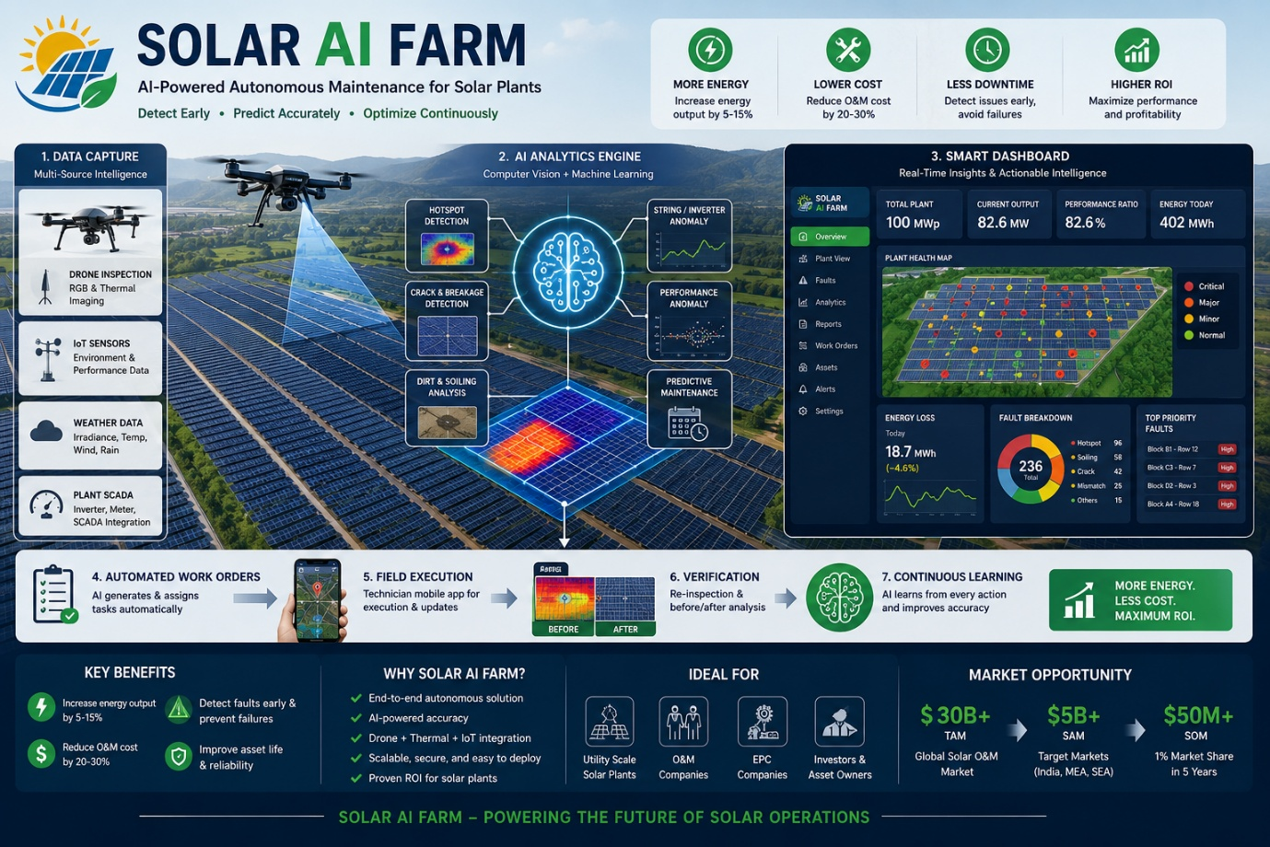
Product 3
HydroGrid AI
1. Problem
Current thermal & hydrogen power plants face major issues:
- High downtime due to unexpected equipment failures
- Energy waste because systems are manually controlled
- High operating cost (fuel + maintenance)
- No real-time visibility into plant health
- Low efficiency in electrolysis-to-power conversion
- Rural/small plants lack smart automation

2. Solution
IoT + AI powered Electrolysis Thermal Power Plant
What it does:
- Smart sensors monitor temperature, pressure, flow, voltage
- AI predicts machine failures before breakdown
- Optimizes hydrogen production via electrolysis
- Automates thermal power generation
- Mobile dashboard for remote monitoring
- Reduces downtime and improves efficiency
One-liner:
"Turn traditional thermal plants into smart, self-optimizing power plants."

3. TAM (Total Addressable Market)
Global market opportunity:
- Smart energy market: $300B+
- Hydrogen market: $250B+
- Industrial IoT market: $500B+
Total TAM = ~$1 Trillion

4. SAM (Serviceable Available Market)
Target segment:
- Small/medium thermal plants
- Green hydrogen plants
- Industrial captive power plants
- Rural microgrids
Estimated:
$50B

5. SOM (Serviceable Obtainable Market)
What you can capture in 5 years:
India + Asia pilot markets
Target:
- 500 plants
- Avg contract = $100k/year
SOM = $50M/year

6. Competitor Analysis
Competitor | Strength | Weakness
Siemens | Big industrial clients | Expensive
GE Vernova | Large infrastructure | Slow deployment
Honeywell | Strong automation | Less AI-focused
Schneider Electric | Good energy tools | Limited hydrogen focus
Your Advantage:
✅ Affordable
✅ AI-first
✅ Built for rural + emerging markets
✅ Electrolysis + thermal combined

7. Product Market Fit
Who needs it?
Primary customers:
- Thermal power plants
- Hydrogen producers
- Solar/wind hybrid plants
- Government rural electrification programs
- Industrial factories
Pain solved:
“Reduce downtime + improve output + lower cost”

8. Traction (Pre-revenue stage)
If early stage, show this:
- MVP architecture completed ✅
- Prototype dashboard ready ✅
- 2–3 pilot discussions underway
- Industry expert validation
- Patent/IP under preparation
- Target first pilot in 6 months
Say:
“Pre-revenue, pilot-ready.”

9. Market Strategy (Go-To-Market)
Phase 1: Pilot
Target:
- 3 pilot plants
- free/low-cost demo
Goal:
prove ROI

Phase 2: B2B Sales
Sell to:
- power plants
- industrial parks
- hydrogen companies
Revenue:
annual SaaS + hardware

Phase 3: Government Partnerships
Partner with:
- state energy boards
- smart village projects
- renewable ministries

Phase 4: Scale
Expand:
India → Southeast Asia → Africa

Revenue Model
- Hardware setup fee ($20k–100k)
- SaaS subscription ($1k/month)
- Maintenance contract
- Data analytics premium

Core Value (3 words)
Smart. Clean. Reliable.
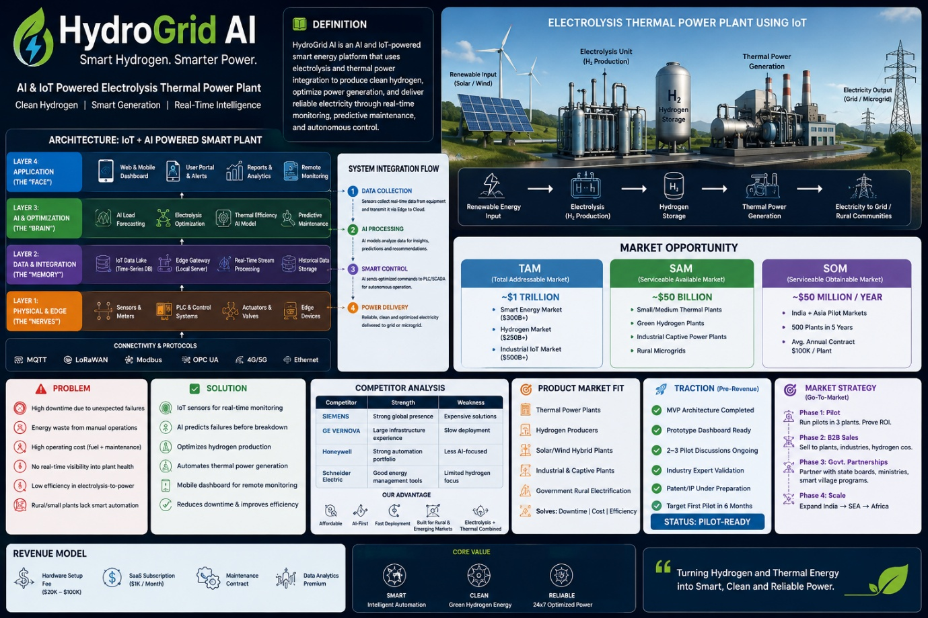

Product 4
OilMind AI
Tagline
“Autonomous Intelligence for Oil & Gas”
Core Value (3 words)
Predict. Automate. Optimize.

1. Problem
Oil & Gas companies face:
- Equipment failures causing shutdowns
- High maintenance costs
- Unsafe field inspections
- Manual paperwork/reporting
- Energy wastage
- Production inefficiency
- Difficult decision making from scattered data

2. Solution
OilMind AI is an AI-powered industrial automation platform for Oil & Gas.
It combines:
- AI analytics
- IoT sensors
- Digital Twins
- Computer Vision
- Workflow automation
- Predictive maintenance
to automate field and plant operations.

3. Product Modules
A. Predictive Maintenance AI
Predict pump/compressor/turbine failures before breakdown.
B. Smart Inspection Drone
Autonomous drone for:
- pipeline inspection
- flare stack monitoring
- leak detection

C. Digital Twin Platform
Virtual model of refinery/plant for simulation and optimization.
D. AI Command Center
Real-time dashboard:
- alerts
- recommendations
- KPI monitoring
E. Workflow Automation
Automates:
- maintenance tickets
- compliance reports
- approvals

4. Target Customers
- Saudi Aramco
- Shell
- BP
- ONGC
- Indian Oil Corporation
- Midstream pipeline operators
- Refineries
- LNG plants

5. TAM / SAM / SOM
TAM
Global Oil & Gas digital transformation market:
$120B
SAM
AI + automation market in oil & gas:
$18B
SOM
Initial target:
India + Middle East
$500M

6. Competitor Analysis
Company | Strength | Weakness
Schneider Electric | Large enterprise | Expensive
Siemens | Strong OT | Complex
Honeywell | Established | Slow innovation
C3.ai | Strong AI | Costly
OilMind AI | Vertical focused | Fast deployment

7. Product Market Fit
Why customers buy:
✅ Reduce downtime 30%
✅ Reduce maintenance cost 25%
✅ Increase production 10%
✅ Improve safety
✅ Faster ROI (<12 months)

8. Revenue Model
SaaS Subscription
₹50L–₹5Cr/year per site
Implementation
₹1Cr one-time setup
Monitoring Support
AMC recurring

9. Traction (Pre-revenue)
- MVP ready
- 2 pilot refinery customers target
- 1 digital twin demo
- 1 drone inspection prototype
- LOIs from energy partners

10. Go-To-Market
Phase 1:
India refineries
Phase 2:
Middle East oil fields
Phase 3:
Global expansion
Sales:
- direct enterprise sales
- channel partners
- EPC partners
- 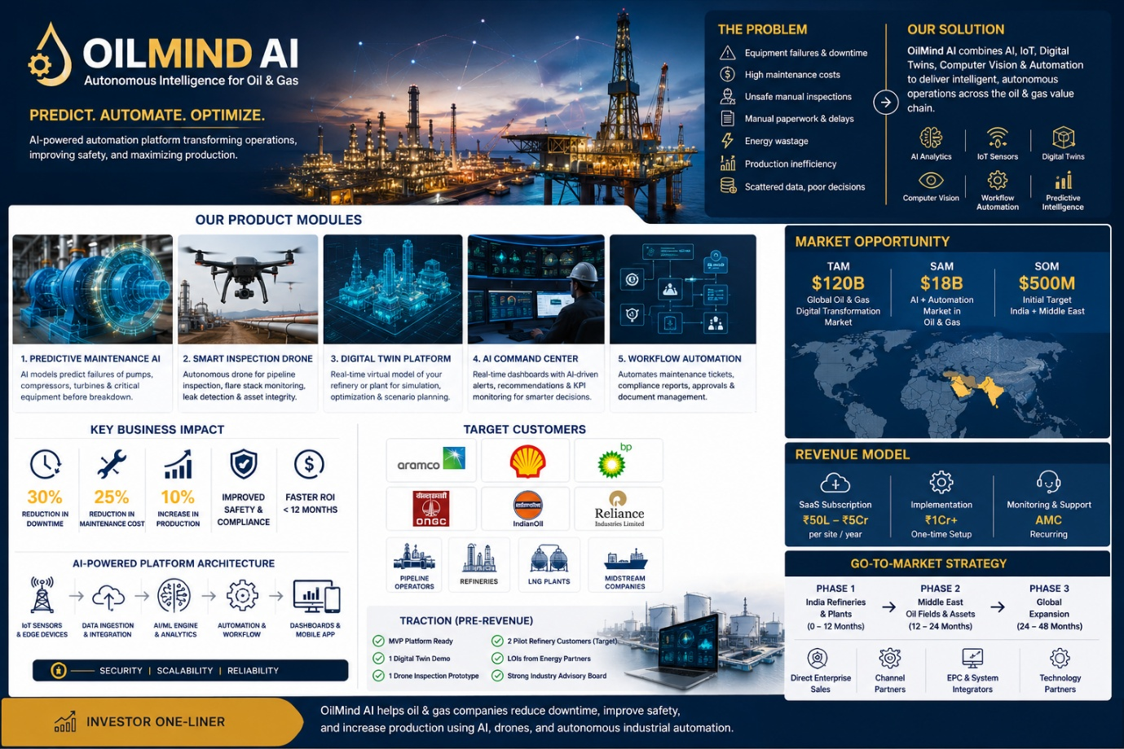

Product 5
This is a strong concept. I’d tighten the wording and investor positioning like this:
SolarAutoX AI
AI + Automation Platform for Solar Car & EV Manufacturing

1. Problem
Solar vehicle manufacturers face major challenges:
- High manufacturing cost
- Manual production errors
- Battery inefficiency
- Solar panel degradation over time
- Slow prototyping & testing cycles
- Unexpected machine failures and downtime

2. Solution
SolarAutoX AI provides an end-to-end smart factory platform:
✅ AI Factory Automation — automate solar car assembly lines using robots and AI
✅ Digital Twin Simulation — test and optimize vehicles before physical production
✅ Predictive Maintenance — predict battery, motor, and equipment failures early
✅ Computer Vision Inspection — automatic defect detection for better quality
✅ Smart Supply Chain Automation — optimize parts, inventory, and logistics

3. TAM (Total Addressable Market)
🌍 Global Electric Vehicle Manufacturing market opportunity: $1T+
(Entire global EV + solar vehicle manufacturing ecosystem)

4. SAM (Serviceable Available Market)
⚙️ Factory automation for EV/solar mobility: $50B
(Target EV manufacturers and solar mobility OEMs)

5. SOM (Serviceable Obtainable Market)
🇮🇳 India + Asia initial market: $500M
(Focused on early pilots and enterprise factory deployments)

6. Competitor Analysis
Company | Focus
Siemens | Smart factory automation
Bosch | Automotive AI
ABB | Robotics
DTskill | General industrial automation
SolarAutoX AI | Solar automobile automation

7. Product Market Fit
Solar vehicle companies need:
✅ Faster production
✅ Lower manufacturing cost
✅ Smarter factories
✅ Longer battery performance
✅ Better quality control
Strong PMF in the emerging solar mobility market

8. Traction (Pre-Revenue)
- MVP under development
- Digital twin prototype completed
- 2 pilot customers targeted
- OEM partnership discussions started

9. Market Strategy
Phase 1: Target Indian EV startups India
Phase 2: Partner with solar vehicle OEMs
Phase 3: Pilot → annual SaaS + automation contracts
Phase 4: Expand to Asia and Europe

Revenue Model
- SaaS subscriptions (AI platform)
- Factory automation deployment fees
- Annual maintenance contracts
- Digital twin licensing
- Custom AI integration services

Core Value
Automate. Optimize. Electrify.
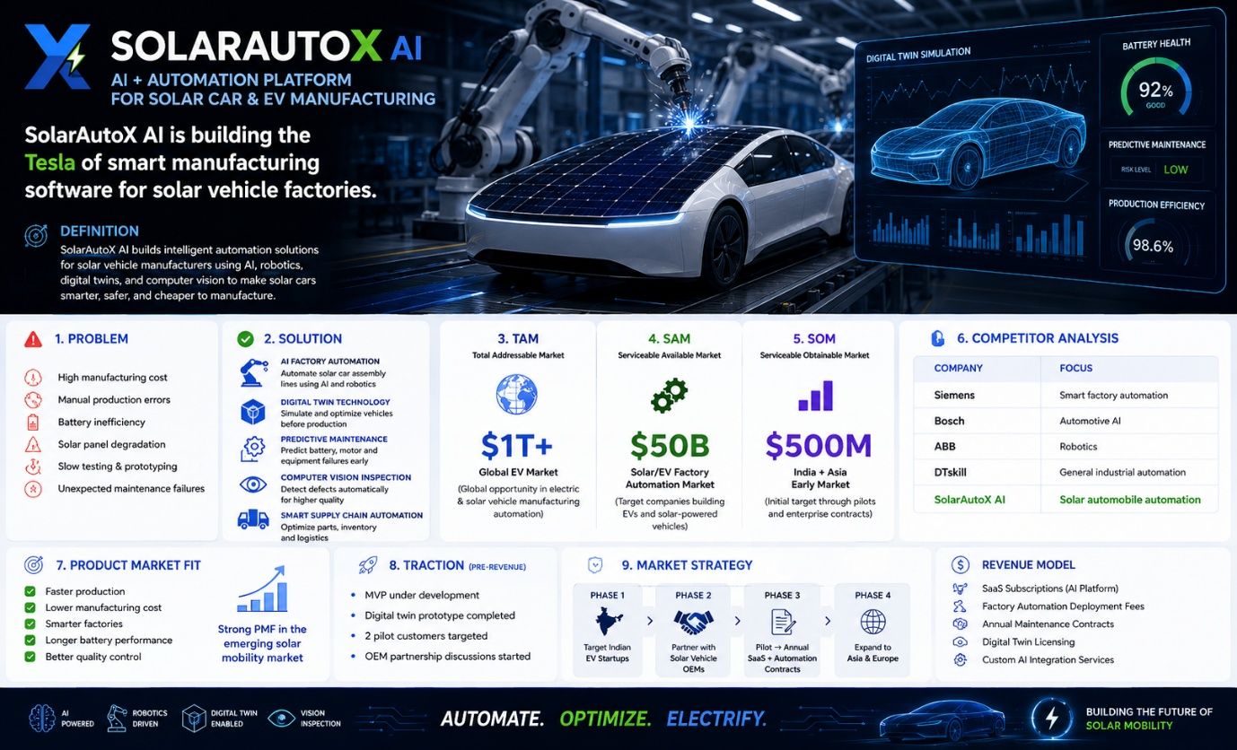

Financial Ask for five products
Investment Required
₹4 Cr for product development, pilot deployment, team expansion, and market scaling.
Use of Funds
- 40% – Product & Technology Development
- 30% – Manufacturing / Deployment
- 20% – Sales & Marketing
- 10% – Operations & Team

Revenue Projection (4 Years)
Year | Revenue
Year 1 | ₹1 Cr
Year 2 | ₹4 Cr
Year 3 | ₹8 Cr
Year 4 | ₹18 Cr
Total Growth: 4.5x from Year 2 to Year 4

Break-even
Expected Break-even in 1.2 years (14 months)

Investor ROI
Estimated 3–5x return in 4–5 years

