What is “Open Heart Surgery”?
By Donald L. Bricker, M.D.

What is “open heart surgery” exactly? This question is often asked perhaps more of patients who have experienced “open heart surgery” than of physicians. It is sometimes asked in an argumentative way, questioning whether all cardiac procedures should be considered “open heart surgery.” The confusion surrounding the use of the term is quite understandable since the term “open heart surgery” was coined over two decades ago. It is now simply used as a vague way to describe different types of cardiac surgery.
Understanding the Methodology:
Perhaps the term was coined originally because the heart surgeon was concerned with the methodology of the surgery. The methodology involved understanding how to correct congenital heart defects in people. It entailed opening the cardiac chambers for repair. The methodology of “open heart surgery” overlooks an area of common ground regarding the risks during operation. This area of common ground was simply the need to relieve the heart of its physical burden while operating on it.
The Heart-Lung Machine: What is it?
In other words, heart operations of great magnitude are best grouped together by the necessity of providing an external mechanical support system. The external mechanical support system functions the heart and lungs by pumping and oxygenating blood during surgery. Any heart operation, therefore, which requires that the heart be stopped for the procedure would fit this classification. The external mechanical support system referred to is the “heart-lung machine.” Simply put, “open heart surgery” is any cardiac operation requiring the use of the “heart-lung machine.”
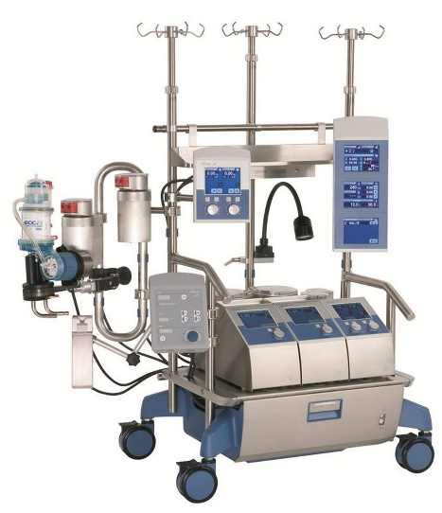
Cardiopulmonary Bypass: The fancy term for the “heart-lung machine”
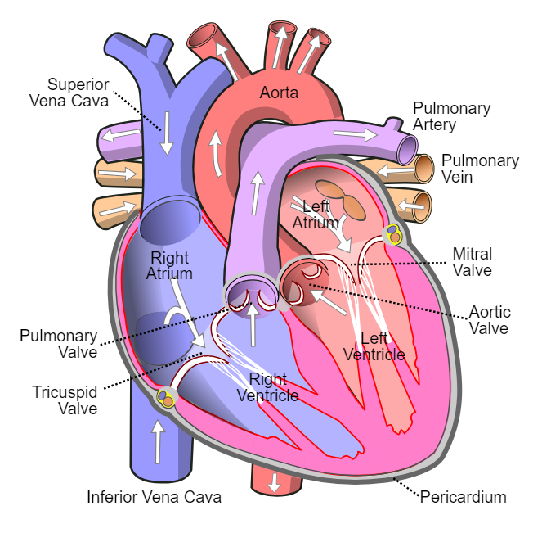
What does the “heart-lung machine” do? First, let us exchange that term for “cardiopulmonary bypass” to aid in our understanding. Basically, cardiopulmonary bypass removes the heart and lungs as a unit from the circulatory system (the system that circles blood throughout the body) and temporarily bypasses them while performing their function. To accomplish this, blood is diverted from the heart by tapping into the great veins delivering blood from the upper and lower extremities. This blood flows by gravity into an oxygenating device which performs the lungs’ function of adding oxygen and dissipating carbon dioxide. This blood is then pumped back into the circulatory system through a convenient artery, usually the aorta, the great artery that comes immediately from the heart.
As the machine is working, the surgeon will place clamps on the venous (veins in the pulmonary artery) and arterial sides of the heart and lungs to separate them. Clamping allows the surgeon to stop the heart if they wish and perform their operation precisely. The “heart-lung machine” cannot do this job indefinitely, but sufficient time is safely at hand with today’s equipment. This ever-improving equipment has led to numerous successes daily on the job for cardiac procedures.
Blood Supply During the Procedure:
One question frequently asked by patients and family members is about the blood supply to the heart and lungs during the bypass period. The patient’s blood supply is reduced since they are removed from their own circulatory system. However, their body is resting during the procedure, so oxygen requirements are minimal. This means that for the duration of most procedures no problems should be posed regarding the blood supply to the heart and lungs.
Concluding Thoughts:
“Open heart surgery” is the common term used to describe a cardiac surgical procedure requiring use of cardiopulmonary bypass, the “heart-lung machine.” If your operative procedure was or is to be done under cardiopulmonary bypass, rest assured you have undergone or will undergo “open heart surgery” in the best hands possible. With the combined factor of steady-handed surgeons and available technology, cardiac surgery has never been safer.
From Rude, Technical Editing, (2011), Pearson Education. Pages 28 and 29.

