NUTS & BOLTS CITY SKYLINE

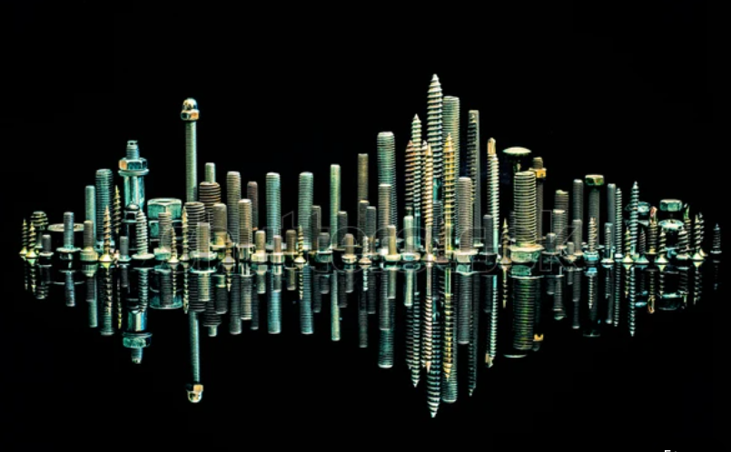
We’re going to make an image using random items like Staples, Nuts & Bolts and Screws to recreate a metal City Skyline.

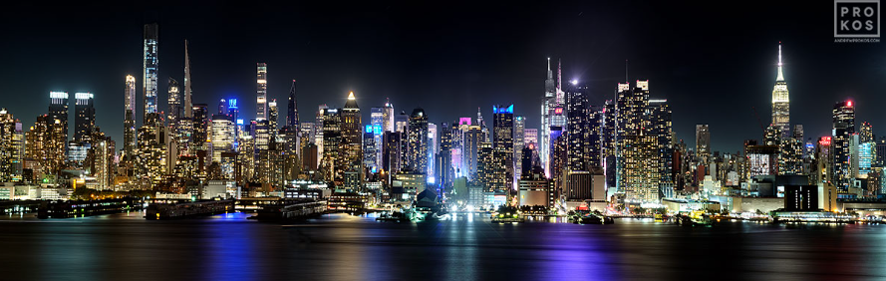

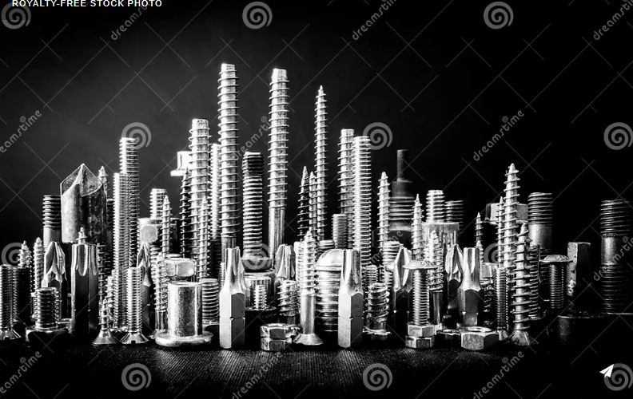

Here’s some examples to give you inspiration…

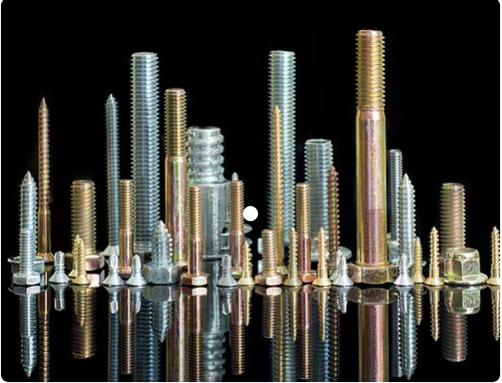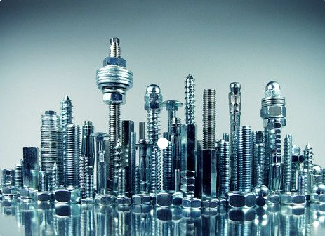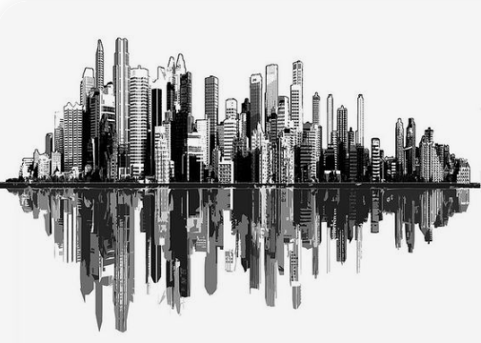

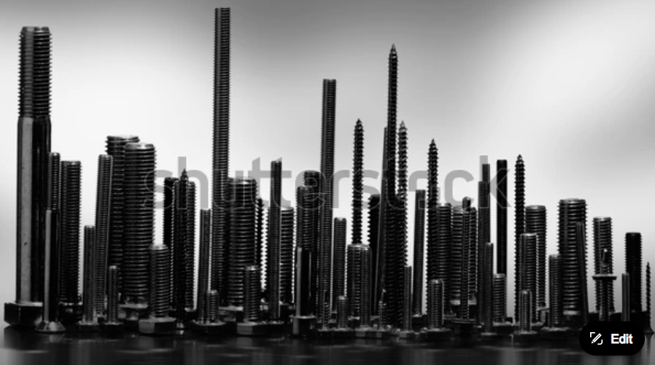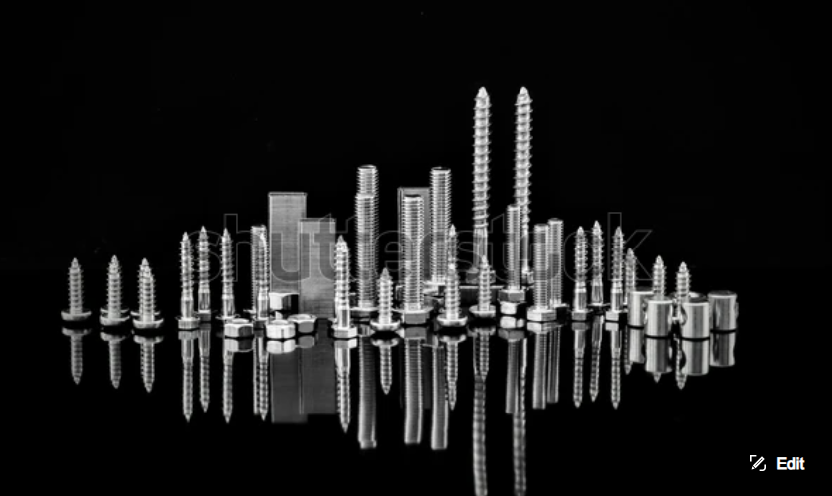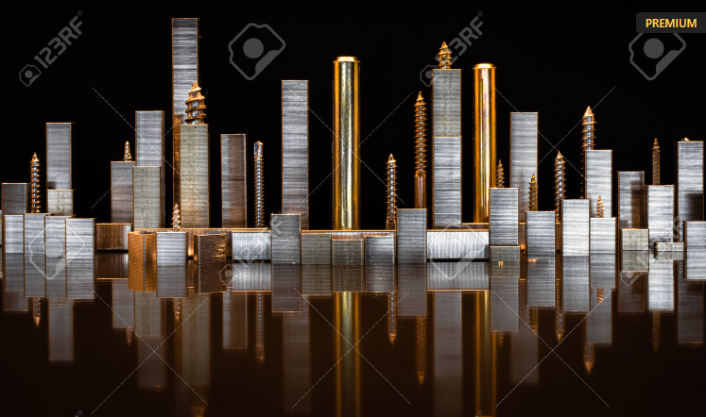

What do you need to think about for this photo?

- LIGHTING
What angle will the light come from?

- CAMERA ANGLE
Will a lower angle or a higher angle be better?

- BACKGROUND AND TABLE SURFACE
Will you try and create a nighttime or daytime scene?

- LOW LIGHT CAMERA SETTINGS
Which settings bring in more photons (light) to the camera sensor?
Wide (f2.8) or narrow (f16) aperture?
Faster (1/1500) or slower (1/50) shutter speed?

