MULTIPLICITY PHOTO

Cloning yourself in a photo

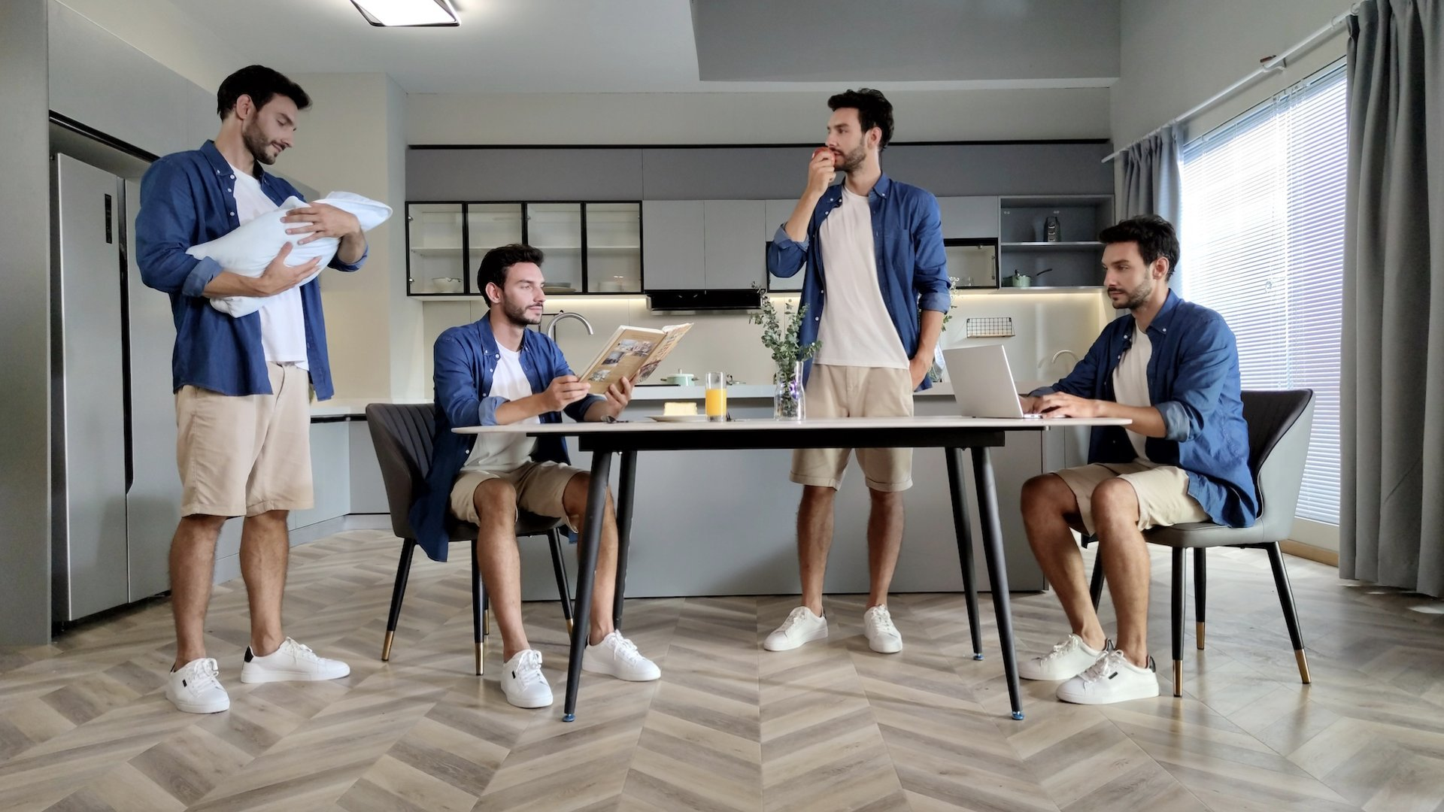

AN EXAMPLE OF MULTIPLICITY A PHOTO

=

You’ll create an image that has you in multiple places.

This means you’ll take several photos, then use Adobe Photoshop to edit them together.

*Some examples to give you ideas…*

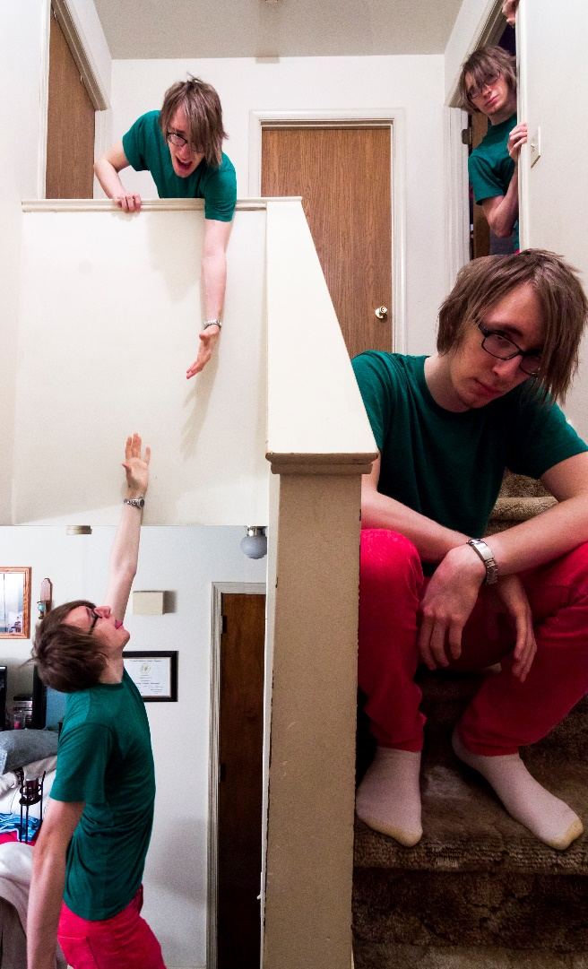

Where do you start?

* Think up a scene and decide where it’s set.  
  *(think of somewhere close by: the studio, carpark or town centre).*
* Think of how many clones of you there will be (probably 2-5).

To create a convincing image, all the photos must be consistent (same position, depth of field and lighting).

*Do you know why this means…?*

* You’ll be using a tripod.
* You’ll be working in full manual mode.
* You’ll be setting the lens to MF after initial focus is set.
* You’ll use a narrow aperture (big f number).