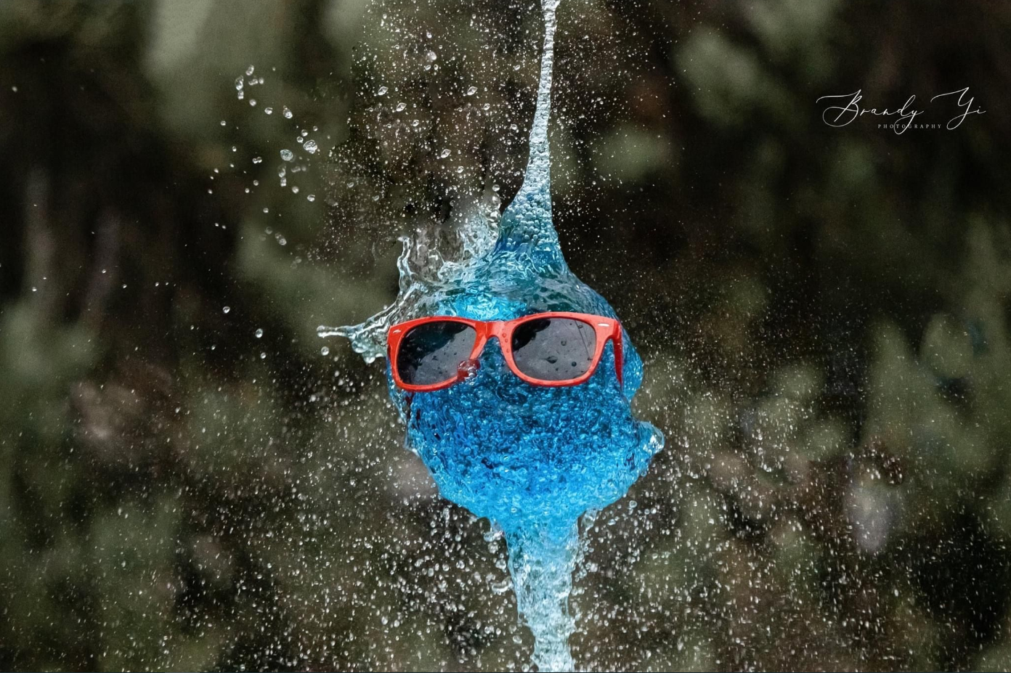
Water Balloon Burst
Photography
A photograph of water bursting from a popped balloon.
Which setting is the most important to consider?

SHUTTER SPEED
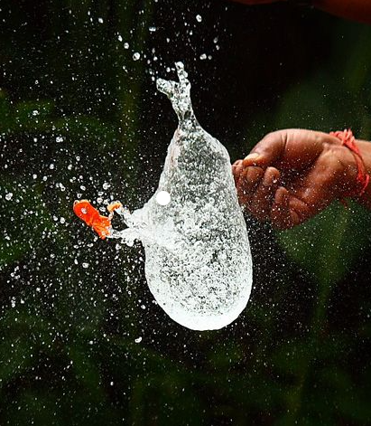
What speed will work for a bursting balloon?
How will a slow shutter speed affect the photo?
How will a fast shutter speed affect the photo?

APERTURE
What aperture will be needed?
What happens if you pick a wide aperture?
What happens if you pick a narrow aperture?

ISO
Will the ISO be higher or lower?
Today we’ll use settings similar to these…

SHUTTER SPEED
From 1/1000 up to 1/4000
We need a fast shutter speed to catch the water particles as they escape. While freezing the action, we will change shutter speed to control the ambient light.

APERTURE
A wide aperture; this is a smaller number.
Probably f3.5 or f4.
We need a wide aperture to take in as much light as possible and allow us a faster shot.

ISO
ISO 100 - 400 or as low as possible while maintaining the exposure.
Trying to keep ISO as low as possible helps stop the image getting noise.

OTHER CONSIDERATIONS

CONTINUOUS SHUTTER
We’ll need set the Drive Mode to continuous shutter (burst mode) so we can take rapid photos in succession.
The balloon burst will be over in half a second and it will be harder to capture with a camera using a Single Shutter mode.
Continuous shutter will take around 5-10 photos per second, so there is a higher chance we catch exact moment the balloon bursts.

TRIPOD
A tripod will be useful.

