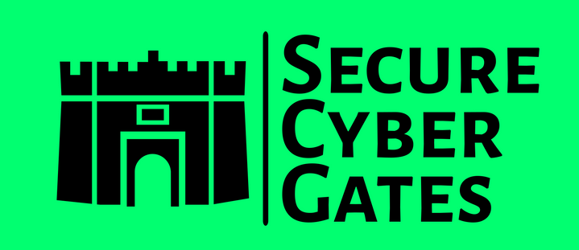

SOC2 GAP ASSESMENT REPORT



**DOCUMENT CONTROL PAGE**

|  |  |
| --- | --- |
| **Document ID** | SCG/BASEWORD/002/1.0 |
| **Security Classification** | Confidential |
| **Date Issued** | 30-Jul-2025 |
| **Version** | 1.0 |
| **Project Name** | NA |
| **Author** | [AJ KHAN](https://www.linkedin.com/in/aj57/) |

**VERSION HISTORY / CHANGE HISTORY**

|  |  |  |  |
| --- | --- | --- | --- |
| **Version** | **Date Issued** | **Issued to** | **Comments** |
| 0.1 | 30-Jul-2025 |  | Issued for internal review |
| 1.0 | 30-Jul-2025 |  | Final version |
|  |  |  |  |
|  |  |  |  |
|  |  |  |  |
|  |  |  |  |

**REVIEWERS**

|  |  |  |  |
| --- | --- | --- | --- |
| **Version** | **Review Date** | **Reviewed By** | **Comments** |
| 0.1 | 30-Jul-2025 |  | Issued for internal review |
| 1.0 | 30-Jul-2025 |  | Final version |
|  |  |  |  |
|  |  |  |  |
|  |  |  |  |
|  |  |  |  |

**APPROVERS**

|  |  |  |  |
| --- | --- | --- | --- |
| **Version** | **Date Approved** | **Approved By** | **Comments** |
| 0.1 | 30-Jul-2025 |  | Issued for internal review |
| 1.0 | 30-Jul-2025 |  | Final version |
|  |  |  |  |
|  |  |  |  |
|  |  |  |  |
|  |  |  |  |

**DISTRIBUTION LIST**

|  |  |  |
| --- | --- | --- |
| **Date** | **Name / Distribution List** | **Comments** |
| 30-Jul-2025 | Customer_DL_ABC | Published to Customer ABC |
|  |  |  |
|  |  |  |
|  |  |  |
|  |  |  |
|  |  |  |

**DOCUMENT CONTROL PAGE**

**RELATED DOCUMENTS**

|  |  |  |  |
| --- | --- | --- | --- |
| **DOC_ID** | **DOC Version#** | **DOC Link** | **Comments** |
|  |  |  |  |
|  |  |  |  |
|  |  |  |  |
|  |  |  |  |
|  |  |  |  |
|  |  |  |  |

**CONFIDENTIALITY STATEMENT**

This document is the exclusive property of [[SecureCyberGates](https://securecybergates.com/)]. This document contains proprietary and confidential information. Duplication, Redistribution, or use, in whole or in part, in any form, requires consent of [[SecureCyberGates](https://securecybergates.com/)].

[[SecureCyberGates](https://securecybergates.com/)] may share this document with auditors under non-disclosure agreements [NDA] to demonstrate Security Audit requirement compliance.

**Contents**

**1) Objective** 6

**2) Scope** 6

**3) Data Backup Process** 6

**4) Asset Inventories** 6

**4.1) Control Objective** 7

**4.2) Guidelines** 7

**5) Roles & Responsibilities** 7

# **1) Objective**

Our Data Backup Policy establishes the activities that need to be carried out by each Business Unit, Technology Unit, and Corporate Units (departments) within [SecureCyberGates].

All departments must utilize this methodology to properly backup and store media that contains critical data and information. All electronic records existing on [SecureCyberGates] data processing systems must be backed up and sent to an offsite location according to Offsite Storage Requirements of this policy. Retention standards must be defined and put into action to support business and regulatory requirements.

# **2) Scope**

Data Backup activities are performed to protect against the loss or damage of critical data contained on [SecureCyberGates]’s data processing systems. All departments using electronic data, critical data, regulatory data, etc., must determine and document their information availability requirements.

# **3) Data Backup Process**

Data backups can be accomplished in various ways. However, not all methods of backups are appropriate for data that contains customer or confidential information. Only secure and authenticated resources can be used for the storage and backup of confidential data. Some practices that can be implemented for backup of daily data (not confidential data) like forms, reports, templates, etc. are as follows: (this type of data would be located on your PC, department PC, etc.)

**Compact Disk:** CDs are low-cost storage media and have a higher storage capacity than floppy diskettes. If you choose this method, you will need a PC equipped with a CD-RW drive (rewritable CD).

# **4) Asset Inventories**

All assets including but not limited to laptops, displays, storage etc are tagged and documented. An up-to-date inventory and asset control is maintained to ensure efficient tracking of equipment.

Our intellectual property is tracked internally by our legal compliance team. We also track third-party licenses, compliance with licenses, compliance with data privacy requirements of customers and acceptable usage of data.

## **4.1) Control Objective**

The organization develops, documents, and maintains an inventory of system components that: Valid access authorization from the immediate supervisor or system owner.

* Accurately reflects the current system;
* Is at the level of granularity deemed necessary for tracking and reporting;
* Includes organization-defined information deemed necessary to achieve effective property accountability; and
* Is available for review and audit by designated organizational officials.

## **4.2) Guidelines**

The organization develops, documents, and maintains an inventory of system components that: Valid access authorization from the immediate supervisor or system owner.

* Accurately reflects the current system;
* Is at the level of granularity deemed necessary for tracking and reporting;
* Includes organization-defined information deemed necessary to achieve effective property accountability; and
* Is available for review and audit by designated organizational officials.

# **5) Roles & Responsibilities**

|  |  |
| --- | --- |
| **Roles** | **Responsibilities** |
| Employee / Contractor | * Read this Physical Security Policy * Ask questions * Report possible or actual violations of this Physical Security Policy. |
| IT Team / Security Team | Create, Manage, Monitor, Maintain, Audit Physical Security Policy |
| Management | Review and Approve Physical Security Policy |



[**https://www.linkedin.com/in/aj57/**](https://www.linkedin.com/in/aj57/)

[**https://www.linkedin.com/company/securecybergates**](https://www.linkedin.com/company/securecybergates)

**https://www.youtube.com/@SECURECYBERGATES**

**https://securecybergates.com/services**

[**https://hackerone.com/crypto-khan**](HTTPS://HACKERONE.COM/CRYPTO-KHAN)

[**https://x.com/securecybergate**](HTTPS://X.COM/SECURECYBERGATE)

[**securecybergates@gmail.com**](mailto:SECURECYBERGATES@GMAIL.COM)

**THANK YOU!**

**FOR CYBER-SECURITY RELATED UPDATES, KINDLY FOLLOW BELOW PAGES...**

