DATA CLASSIFICATION POLICY

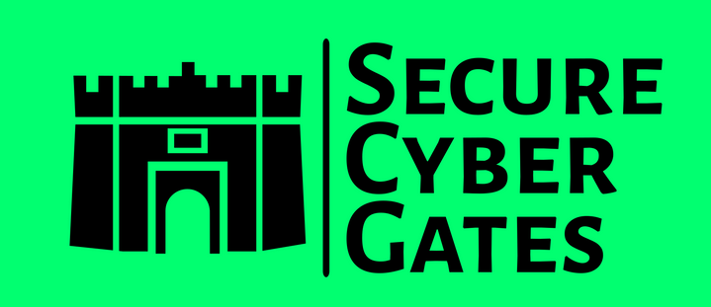

**DOCUMENT CONTROL PAGE**

|  |  |
| --- | --- |
| **Document ID** | SCG/DCP/020/1.0 |
| **Security Classification** | Confidential |
| **Date Issued** | 30-Jul-2025 |
| **Version** | 1.0 |
| **Project Name** | NA |
| **Author** | [AJ KHAN](https://www.linkedin.com/in/aj57/) |

**VERSION HISTORY / CHANGE HISTORY**

|  |  |  |  |
| --- | --- | --- | --- |
| **Version** | **Date Issued** | **Issued to** | **Comments** |
| 0.1 | 30-Jul-2025 |  | Issued for internal review |
| 1.0 | 30-Jul-2025 |  | Final version |
|  |  |  |  |
|  |  |  |  |
|  |  |  |  |
|  |  |  |  |

**REVIEWERS**

|  |  |  |  |
| --- | --- | --- | --- |
| **Version** | **Review Date** | **Reviewed By** | **Comments** |
| 0.1 | 30-Jul-2025 |  | Issued for internal review |
| 1.0 | 30-Jul-2025 |  | Final version |
|  |  |  |  |
|  |  |  |  |
|  |  |  |  |
|  |  |  |  |

**APPROVERS**

|  |  |  |  |
| --- | --- | --- | --- |
| **Version** | **Date Approved** | **Approved By** | **Comments** |
| 0.1 | 30-Jul-2025 |  | Issued for internal review |
| 1.0 | 30-Jul-2025 |  | Final version |
|  |  |  |  |
|  |  |  |  |
|  |  |  |  |
|  |  |  |  |

**DISTRIBUTION LIST**

|  |  |  |
| --- | --- | --- |
| **Date** | **Name / Distribution List** | **Comments** |
| 30-Jul-2025 | Customer_DL_ABC | Published to Customer ABC |
|  |  |  |
|  |  |  |
|  |  |  |
|  |  |  |
|  |  |  |

**DOCUMENT CONTROL PAGE**

**RELATED DOCUMENTS**

|  |  |  |  |
| --- | --- | --- | --- |
| **DOC_ID** | **DOC Version#** | **DOC Link** | **Comments** |
| SCG/BASEINS/005/1.0 |  |  | Base Template Instructions |
| SCG/PXF/008/1.0 |  |  | Policy Exception Form |
| SCG/RXT/037/1.0 |  |  | Risk Exception Template |
|  |  |  |  |
|  |  |  |  |
|  |  |  |  |

**CONFIDENTIALITY STATEMENT**

This document is the exclusive property of [[SecureCyberGates](https://securecybergates.com/)]. This document contains proprietary and confidential information. Duplication, Redistribution, or use, in whole or in part, in any form, requires consent of [[SecureCyberGates](https://securecybergates.com/)].

[[SecureCyberGates](https://securecybergates.com/)] may share this document with auditors under non-disclosure agreements [NDA] to demonstrate Security Audit requirement compliance.

**Contents**

**1) Objective** 6

**2) Roles &Responsibilities** 6

**3) Scope** 6

**4) Data Classification Description** 7

**4.1) Public Data** 7

**4.2) Internal Use Only Data** 8

**4.3) Confidential Data** 8

**4.4) Highly Confidential Data/ Restricted** 8

**5) Data Labelling** 9

**6) Periodic Asset Recertification and Reclassification** 9

**7) Data Handling Guidelines** 9

**8) Employee Training and Awareness** 9

**9) Compliance and Monitoring** 10

**10) Escalation Matrix** 10

**11) Policy Exceptions** 10

**12) Policy Review and Updates** 11

**13) Conclusion** 11

# **1) Objective**

The objective of this policy is to assist **Data Owners** in the evaluation of information (data) to determine, what level of security is required to protect data for which they are responsible.

Data Classification and Safeguard Standard:

* Outlines a data classification scheme used to define an appropriate level of protection
* Describes the overall process for classifying data and applying appropriate security controls
* Lists the security controls required based on the determined level of classification

# **2) Roles &Responsibilities**

|  |  |
| --- | --- |
| **Roles** | **Responsibilities** |
| CISO | Accountable - Overseeing the implementation and enforcement of this policy [Review and Approve Policy] |
| DPO [Data Privacy Officer] | Responsible for creating ,updating, and maintaining this policy. |
| IT/Security Team | 1. Responsible for ensuring Data classification protection requirements are in place 2. Responsible for enforcing these Data classification requirements |
| BU Heads or Project Managers | Ensuring that employees under their supervision comply with this policy. [Review and Approve this Policy] |
| Employees / Contractors | 1. Read this this Policy 2. Ask questions /Provide Feedbacks 3. Report possible or actual violations of this Policy. |

# **3) Scope**

All **Employees/Contractors/Vendors** who come into contact with sensitive [SecureCyberGates] information are expected to familiarize themselves with this **data classification policy** and to consistently use these same ideas in their daily [SecureCyberGates] business activities. As stated in the introduction, both the data owners and data end users play a role in protecting [SecureCyberGates] information assets, and as such, they should become familiar with the data classification definitions and follow appropriate steps to ensure adequate data protection. All [SecureCyberGates] information assets should be accounted for and have a data owner whose role and responsibilities are clearly defined. Clearly defined accountability for all assets helps to ensure that appropriate levels of protection are identified, implemented, and consistently maintained. It is the responsibility of each [SecureCyberGates] data owner to classify his or her data appropriately to ensure adequate protection. Security controls implementation may be delegated, but the accountability remains with the data owner.

# **4) Data Classification Description**

A data classification framework will define sensitivity levels for data, categorizing it into **4 different classes** such as:

* Public
* Internal Use Only [Company-Wide use]
* Confidential
* Highly Confidential [Restricted]

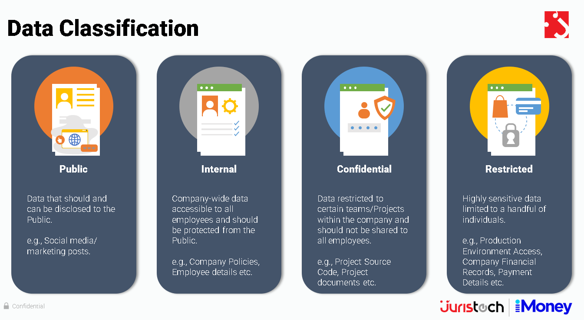

## **4.1) Public Data**

Access Controls

* Public data may be accessible to all General Public as well as all employees.
* Access should be controlled through authentication but can be less restrictive.

**Encryption**

* Encryption in transit is recommended for data integrity.

## **4.2) Internal Use Only Data**

**Access Controls**

* Internal use data is limited to authorized employees. [All Company Employees]
* Access controls should ensure that only approved personnel can access this data.

**Encryption**

Encryption in transit is recommended for internal use data to prevent unauthorized interception.

## **4.3) Confidential Data**

**Access Controls**

* Confidential data should have strict access controls, limited to individuals with a need-to-know.
* Accessible **ONLY to Some Employees** [e.g. Employee Working in Project A / Department A Should have access to only Data/Resources of Project A [And NOT any other Projects until required]
* Access must be carefully monitored and audited.
* MFA should be enabled for confidential data.

**Encryption**

* Confidential data should be encrypted both in transit and at rest to protect it from unauthorized access.

## **4.4) Highly Confidential Data/ Restricted**

**Access Controls**

* Access to highly confidential data should be **tightly restricted and monitored.**
* **ONLY Few Employees have access**[e.g. Production Environment , Company Financial Records]
* Only personnel with specific authorization should have access.
* MFA should be enabled for highly confidential data.

**Encryption**

* Highly confidential data must be encrypted in transit and at rest with the strongest encryption protocols and key management.
* Transparent Data Encryption or Tokenization is required for column level encryption.

# **5) Data Labelling**

**Data owner** shall label the data as follows:

* Public data do not require any labels
* All Electronic/Digital Documents MUST contain “Security Classification” Row under Document Control Page that should state **Public , Internal , Confidential , Restricted**
* All markings shall be displayed or stamped in the upper portion of each unbound page containing sensitive data. Data defined as Restricted, confidential, internal requires security labelling such as ‘Restricted’ or ‘Confidential’ or ‘Internal use Only’
* Computer printouts and electronic materials shall have security labels in the footer
* Electronic media (disks, tapes, etc.) shall be clearly marked with the label
* Security Labels shall be in the front and outside back cover of printed materials
* Each data asset will have an assigned data owner responsible for determining its classification. Data assets will be labeled with their assigned classification levels, making it easy for users to identify and handle data according to its sensitivity.

# **6) Periodic Asset Recertification and Reclassification**

The infrastructure, Security and legal compliance teams **periodically verify the asset inventory** to document latest updates, process for recertification’s or upgrades or renewal of subscriptions where necessary. This procedure ensures validity of both physical assets & intellectual property over time. If asset characteristics change, including data sensitivity or hardware criticality, reclassification will be conducted. Reclassification will reflect the asset's current status.

# **7) Data Handling Guidelines**

* Access control policies and procedures will align with data classification, ensuring that only authorized individuals can access sensitive data.
* Data classification will guide encryption requirements, with highly confidential data requiring strong encryption in transit and at rest.

# **8) Employee Training and Awareness**

8.1) All [SecureCyberGates] employees SHOULD undergo training and assessment on this policy during their initial induction [Onboarding].

8.2) Security team to conduct periodic trainings **ATLEAST ONCE** a year.

# **9) Compliance and Monitoring**

9.1) Compliance with this policy is **MANDATORY**. Employees violating this policy will be subject to disciplinary action up to and including termination.

9.2) Third-party users, contractors, and vendors who **FAIL** to comply with this policy may have their access to [SecureCyberGates]systems , Application and networks revoked or suspended until compliance is achieved. Repeated or severe violations may result in the termination of their contracts or business relationships with [SecureCyberGates].

9.3) Periodic Audits and Assessments : [SecureCyberGates]'s IT department, in collaboration with the Information Security team, will conduct periodic audits and assessments to evaluate compliance with this security policy.

# **10) Escalation Matrix**

10.1) In case of any policy violations issues, the following escalation structure shall be followed to ensure timely resolution and appropriate accountability:

|  |  |  |
| --- | --- | --- |
| **Level** | **Role** | **Contact** |
| Level 1 | Team Lead /Reporting Manager | First-level escalation: Email / Any Ticketing Tool  [info@securecybergates.com] |
| Level 2 | Group Manager / Senior Managers | Second-level escalation: Email / Any Ticketing Tool  [info@securecybergates.com] |
| Level 3 | CISO | Final-level escalation: Email / Any Ticketing Tool  [info@securecybergates.com] |

10.2) Employee SHOULD provide sufficient evidences and details , Clear description of the issue.

10.3) Security team to define issue severity and proper SLA for issue resolution as per severity.

# **11) Policy Exceptions**

11.1) There may be requirements where Employee needs policy exception for legitimate reasons, In such cases, employee should follow POLICY EXCEPTIONS template and approval process. **[Kindly refer Policy exception form [Document ID SCG/PXF/008/1.0]]**

# **12) Policy Review and Updates**

12.1) This policy shall be periodically reviewed **[Atleast Once in a YEAR]**and updated to ensure its effectiveness, relevance, and alignment with [SecureCyberGates]objectives,legal requirements and industry best practices.

12.2) Feedback from employees, stakeholders, and external audits shall be solicited and considered for continuous improvement of the policy and associated procedures.

12.3) Regular audits and inspections shall be conducted to assess compliance with this policy and associated procedures, with non-conformances addressed through corrective actions and preventive measures.

12.4) Any updates or revisions to this policy will be communicated to all employees and relevant stakeholders through appropriate channels. Employees are responsible for familiarizing themselves with the latest version of the policy and adhering to its requirements.

# **13) Conclusion**

By implementing and adhering to this comprehensive Incident Management policy, [SecureCyberGates]aims to resolve incident ASAP and protect its sensitive information, intellectual property, and critical systems from unauthorized access and data breaches. This policy aligns with industry best practices and incorporates robust requirements for password construction, protection, management, and system development standards.



[**https://www.linkedin.com/in/aj57/**](https://www.linkedin.com/in/aj57/)

[**https://www.linkedin.com/company/securecybergates**](https://www.linkedin.com/company/securecybergates)

**https://securecybergates.com/services**

**https://www.youtube.com/@SecureCyberGates**

[**https://hackerone.com/crypto-khan**](HTTPS://HACKERONE.COM/CRYPTO-KHAN)

[**https://x.com/securecybergate**](HTTPS://X.COM/SECURECYBERGATE)

[**securecybergates@gmail.com**](mailto:SECURECYBERGATES@GMAIL.COM)

**THANKYOU!**

**FOR CYBER-SECURITY RELATED UPDATES, KINDLY FOLLOW BELOW PAGES...**

