**Opportunities at Rapid City First This Week:**

|  |  |  |  |
| --- | --- | --- | --- |
| **Monday, 7 Apr:** | 9:30am | Staff Meeting | |
|  | 5:00pm  5:00pm  5:30pm  5:30pm | Men’s Bible Study, The Third Day  Karate  United in Faith, Evening Circle  Alcoholics Anonymous | |
| **Tuesday, 8 Apr:** | 9:00am  2:30pm  3:45pm  5:00pm  5:30pm 6:30pm | MMO- Photographer Day  Blood Drive  Suzuki-C,  Karate  Women’s Bible Group- The Bible in 52 Weeks  Narcotics Anonymous | |
| **Wednesday, 9 Apr:** | 4:00pm  5:45pm  7:00pm | S.T.E.A.M.  Adult Bible Study- The Final Days  Choir Rehearsal | |
| **Thursday,10 Apr:**  **Friday, 11 Apr:**  **Saturday, 12 Apr:**  **Sunday,13 Apr:** | 9:00am  3:00pm  3:30pm  5:00pm  6:00pm  6:30pm  7:30pm  9:00am | | MMO- Photographer Day  Suzuki-P  Adult Bible Study- The Final Days  Karate  Praise Team Practice  Narcotics Anonymous  Narcotics Anonymous  Al Anon Prayer group  Palm Sunday | |
|  |  |  | |

**Rapid City First United Methodist Church**

629 Kansas City St, Rapid City, SD 57701

Pastor: Richard Bensinger Cell: 703-402-0287 Email: [pastorrich@rapidcityfirst.org](mailto:pastorrich@rapidcityfirst.org)

Church Office: Phone: 605-342-4498 Email: [admin@rapidcityfirst.org](mailto:admin@rapidcityfirst.org)

*Office Hours: Monday – Thursday 8:00 am – 1:00 pm or by appointment*

|  |  |
| --- | --- |
| **Ways to give:** -online at www.rapidcityfirst.org -send a check to 629 Kansas City St., Rapid City, SD 57701-scan the QR code to give online  Place in offering box as you exit or enter services | Image preview |

**Amplify Media- Congregation access code: WFGMGX**

**Last chance to Order your Easter Lilies by Apil 7th.**

**CONTEMPORARY WORSHIP**

**April 6, 2025, 9:00 am**

***Order of* *Worship***

**April 6, 2025, 9:00am**

5th Sunday after Lent/ Color Purple

*\*Stand as you are able*

**\*Praise Song:** *“Your Grace is Enough”*

**Welcome and****Announcements**

**\*Praise Song:**  “Amazing Grace”

**\*Our Mission Statement: *Loving God, Loving People, Making a Difference***

**\* Sharing of the peace**

**Scripture Readings**  Philippians 3:4-14; John 12:1-8

**Children’s Message:** Anne Torgerson

**\*Praise Song:** “*Revelation Song”*

**\*Praise Song:** “Awesome God*”*

**Time of Prayer:** **Silent Prayer/Prayers For the People /Lord’s Prayer**

**Our Father, who art in heaven, hallowed be thy Name; thy kingdom come; thy will be done; on earth as it is in heaven. Give us this day our daily bread. And forgive us our trespasses, as we forgive those who trespass against us. And lead us not into temptation but deliver us from evil. For thine is the kingdom, the power, and the glory, forever and ever. Amen.**

**Message:** Extravagant Love Pastor Rich

**Sharing of Holy Communion:** Blessings

Janelle Scheper, Soloist/Piano

**\*Praise Song:** “You’re God Alone*”*

**Benediction/Closing prayer**

**Giving of Tithes and Offerings**

# **3RD SUNDAY OFFERING**

At Habitat for Humanity, we build. We build because we believe that everyone, everywhere, should have a healthy, affordable place to call home. When a family helps build or improve a place they can call home, they are also building a better community, a better life for themselves.



........................................................................................................................................

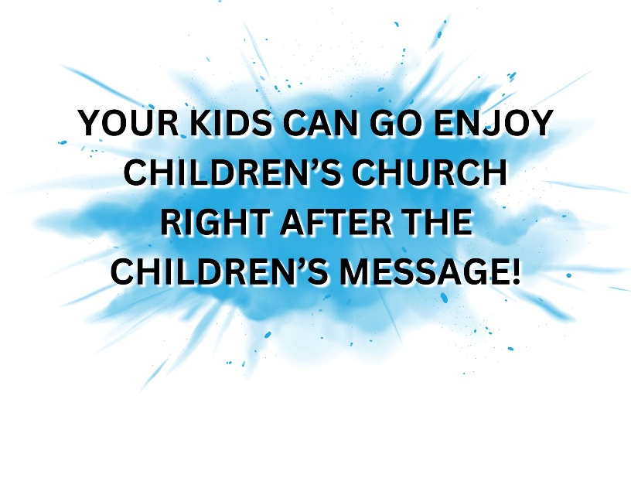

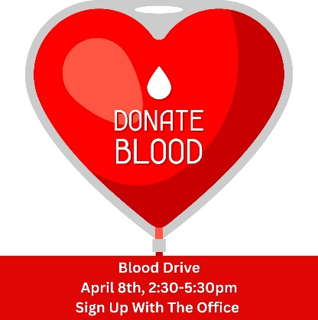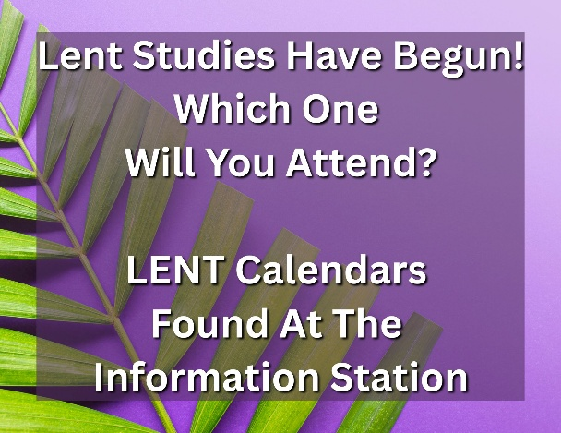

Congratulations to MMO teacher Kharley & Tanner on the birth of their son, Jackson Neuman, on Saturday, March 29th.