Monster Rush

Game Design Document

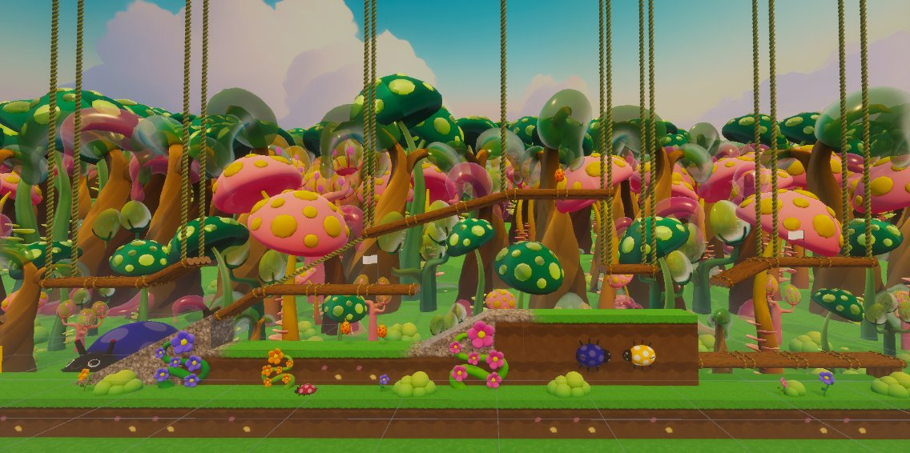

Table of Contents

Introduction 2

Concept & Game Loop 3

Controls 3

Camera 3

Mechanics 3

Movement 4

Pick-ups 4

Monster abilities 5

Placing obstacles 6

Interactable objects 8

Status effects 9

Scoring points 9

Level Design 10

Checkpoints 10

Building mode 10

Story 10

# Concept & Game Loop

A 2.5D multiplayer racing game where 2-4 players choose between 5 monsters and race through Mario Bros-like levels. Players can use pick-ups and their own monster’s ability to boost themselves or hinder other players.

# Controls

The game is primarily designed with the design and button layout of Xbox and Dualshock controllers in mind. The buttons the game uses the left joystick to move left & right, the A/X button to jump, and the B/□ button to use an ability.

# Camera

The game is played on a single screen and makes no use of split screen. This means all characters are always playing on the same screen. When more distance is created between characters, the camera zooms out to a certain degree. Though at some point, it stops following the character furthest back. A character in the back that goes off screen on the left disappears, with the player losing control of the character, and they only respawn when a new checkpoint is reached.

# Mechanics

## Movement

The game primarily uses handheld controllers for its inputs. Players can move leftwards and rightwards and can make a single jump from the ground. The movement takes momentum into consideration. So, it takes a small while before monsters can reach their max speed while running, and running into something resets or stops this momentum. Jump distance also takes the current momentum into consideration, with characters having more horizonal jump distance the higher their momentum was before the jump.

Coyote time is also implemented, giving players a small amount of time to jump while running off a platform to allow for more freedom of movement and a higher margin for error.

## Pick-ups

Placed throughout the level are pick-ups. When a player collides with a pick-up, it disappears for a couple of seconds, and the player gains one of three random abilities. Two of these abilities are not exclusive to certain monsters, with any monster having a chance to get one when they pick up, the third is specific to the monster the player is playing as, with only that monster having a chance to get it. A monster can only have one ability picked up or active at a time, with them being able to pick up a new one once the duration of the previous ability is over.

Visuals

The pick-ups look like berries, with popping colours contrasting the environment to help them stand out. They have a slight floating animation to help in this as well. When collided with, an ‘eating’ sound effect plays to signify that the berry has been picked up. When picked up, pickups appear as icons above the character's head, within a bubble icon.

**Sleep bottle**

Sleep bottle: The player throws a bomb in front of them which follows a straight, slightly upwards line in front of the player. The bomb explodes when it hits a player or terrain. Upon impact, the bottle explodes into an area of effect. Any characters caught in the blast fall asleep/are stunned for a small amount of time.

Visuals

The item’s icon is that of a bottle. Similarly, the item when thrown looks like a glass bottle that rotates as it is thrown forward. Upon impact, smokey VFX plays together with the sound effect of breaking glass to show that it has broken. Any character hit by the effect plays a short snoring sound effect and has some ‘ZZZ’ VFX above them while they are stunned.

**Speed boost**

A consumable that, when used increases the players speed by a set amount for a short duration.

Visuals

The Speed Boost icon is that of a yellow bolt of lightning. While active on the character, a yellow-to-blue trail follows behind them.

## Monster abilities

Monster abilities are abilities specific to each monster that only they can use. It’s one of the abilities that can be picked up when a character interacts with a pick-up item.

**Pinguino**

Wind blast: Shoots out a wind blast in the other direction which Pinguino faces, knocking other characters back and propelling Pinguino forward.

Visuals

Wind VFX appears behind Pinguino and he yells out the ability when he uses it together with sound effects of wind blowing.

**Ice Age**

Snow flight: Ice Age hovers in a horizontal line for a specified amount time. During this, sprinkles fall from under Ice Age, which turn the floor under it into slippery ice that make those who walk on it lose the ability to control their movement while on it.

Visuals

Sprinkle VFX falls from under Ice Age in a line that goes down until it hits the first object. There an ice layer is added on the object signifying an ice floor.

**Catfire**

Fireball: Catfire enters a state where their speed is increased similarly to the Speed Boost ability. In this state, they can also press the ability button again to throw a fireball which bounces a couple of times before fizzling out or hitting another character. Anyone hit by a fireball gets burned, stunning them for a brief period.

Visuals

While in this state, a trail similar to the Speed Boost trail follows Catfire, though it’s red to orange instead of yellow to blue. The fireball is a VFX that, when it’s fired, plays a fire blast effect, and plays a small sound effect whenever it bounces and when it sizzles out.

**Stinkozilla**

Fart boost: Blasts stinkozilla upward with high speed, leaving a gas cloud which stuns any enemy that walks through it for a short duration.

Visuals

When the ability happens, Stinkozilla squads down and a large fart line VFX plays under him, while a fart sound plays. At the location where Stinkozilla uses his ability, a fart cloud VFX appears.

**Catnap**

Jumpscare: Catnap scares all players in a circle around him. This reverses the player’s controls for a small period.

Visuals

When the ability happens, purple clouds appear around Catnap while a giggling sound effect plays. Any character hit by the effect has a purple haze around them while the ability is active.

## Interactable objects

**Bouncy leafpad**

A rectangular block that players can jump on to get a large jump boost. The jump/speed boost is not dependent on the player’s momentum.

Visuals

The jump pad looks like a giant leaf. When a player jumps on it, a sound effect similar to a coil plays.

Wind draft

A square zone where, while a character is within its borders, their speed is increased. After they leave the area, their speed boost gradually decreases until it is back to the normal running speed.

Visuals

The speed boost is a square area that is a line of red and yellow arrows that move forward within the area.

**Snared platforms**

Throughout the level are platforms that, when a player collides with the rope that is connected to it, will snap the rope and have half of the platform fall downwards in an arcing motion. These can be used to obstruct other paths or open up new ones.

Visuals

The platforms looks like a normal platform, but with a single rope attached to it, usually hanging at an angle different from the normal ropes. When triggered, the sound of a falling log is played.

## Status effects

**Stunned**

While a character is stunned, they quickly lose their momentum and lose access to all controls.

Visuals

When the stun is activated, the stun animation is played, which looks like the character falling on their butt. It also plays a sound effect of the character making a kind of ‘oof’ or ‘ouch’ sound.

**Fearful**

While a character is fearful, their joystick controls are reversed.

Visuals

A purple shroud hangs around the player while the effect is active.

## Scoring points

At the end of every round, each player is awarded points for what place they finished at as well as for how well they did during the race. Besides their end placement, players can gain or lose points for:

* Activating a checkpoint. The first player that crosses the vertical line that the checkpoint is on is awarded points.
* Going of screen on the left. When a player falls behind and goes off screen on the left, they reappear at the next checkpoints, but they lose points for this as well.

Visuals

Whenever a player loses or gains points during the race, a small popup appears above their head, showing how many points they gain or lose. Gained points are shown in blue, while lost points are shown in red.

# Level Design

Levels are a primarily 2D horizontal stretch with obstacles placed throughout that players need to run through. Its structure is similar to games like Mario Bros and 2D Kirby titles.

Visuals

The map uses visuals of a magical forest. Different kinds of trees and plants fill the background with a colourful blue sky. The ground consists of green grass, with stone to create varied grounds. The floating platforms take the form of logs tied together, with vine ropes to keep them hanging.

## Checkpoints

Throughout the level, checkpoints are placed where players can respawn if they go offscreen. A character at a checkpoint cannot move until another character activates it, which happens when they collide with the vertical line that the checkpoint is on.

Visuals

The checkpoints look like flags placed along the level. While a character is in the waiting state, they appear in a bubble, which bursts with a popping VFX the moment the checkpoints is activated, and they regain their ability to move.