Sautéed Shrimp with Lemon-Caper Dressing
By Sue Li, New York Times Cooking
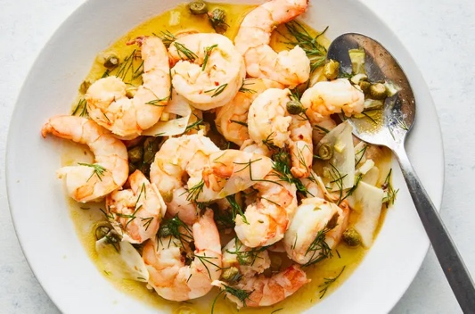
Yield: 2 to 4 servings
Ready In 30 min

This light and easy dish improves as the shrimp marinates in a bright and briny dressing that
uses both the rind and pulp of a lemon. The recipe calls for just a couple of thin slices of lemon
for verve; they provide vibrant acidity and subtle bitterness that create a harmonious balance.
Enjoy the shrimp with a light salad with butter lettuce, served in lightly toasted rolls as
sandwiches, or tossed with cooked pasta to make a quick pasta salad. It’s equally delicious with
bread.

INGREDIENTS
4 tablespoons olive oil, divided

¼ cup lemon juice, from 1 large
Lemon

2 very thin slices of lemon,
deseeded and coarsely chopped

2 tablespoons coarsely chopped
Dill

1 garlic clove, thinly sliced

1 tablespoon capers, coarsely
chopped1 pound large shrimp, peeled
and deveined

Kosher salt

½ teaspoon crushed red pepper

PREPARATION

Step 1
In a large bowl, whisk together 3 tablespoons olive oil with the lemon juice, chopped lemon, dill, garlic and capers; set
aside.

Step 2
In a medium bowl, season the shrimp with salt and the crushed red pepper.

Step 3
Heat the remaining 1 tablespoon olive oil in a medium skillet over medium. Add the shrimp and cook, stirring
occasionally, until pink and lightly browned on the edges, 3 to 4 minutes.

Step 4
Transfer the shrimp to the bowl with the lemon dressing and toss to coat. The shrimp can be served right away, or cooled
to room temperature and served. The cooked shrimp can marinate in the dressing for up to 1 day and can be served chilled or at room temperature.

