**Dear Colleague,**

We are pleased to announce that the 26th edition of our *Paleontology-Stratigraphy Workshop with International Participation*, which has been held continuously for 25 years and has hosted numerous scientists since its inception, will take place on **September 25–28, 2025** in **Yozgat, at Yozgat Bozok University**. We kindly invite you to participate in this workshop with your valuable work, which brings together national and international experts in the field.

Our main objective is to present and discuss the latest scientific developments in paleontology and stratigraphy at an international level. We would be honored to have you join us in this workshop.

Participants may contribute to the workshop with **oral or poster presentations**. Colleagues who wish to participate with a presentation are expected to prepare their abstracts and fill out the participation form according to the attached format, and send them to the email address below **by July 1, 2025**. All submissions will be subject to **double-blind peer review**.

Those who wish to attend without a presentation only need to submit the participation form by the same deadline.

As part of the workshop program, presentations will be held from **September 25 to 26, 2025**, followed by a **field trip on September 27**, and a **cultural excursion to the ancient city of Hattusha on September 28, 2025**. Further details will be shared with you in due course.

**Note:** General updates and announcements regarding the workshop can be followed on our official website.

**IMPORTANT DATES**

Deadlines for Submission of Registration Form and Abstracts: **July 1, 2025**

Announcement of Accepted Abstracts: **August 15, 2025**

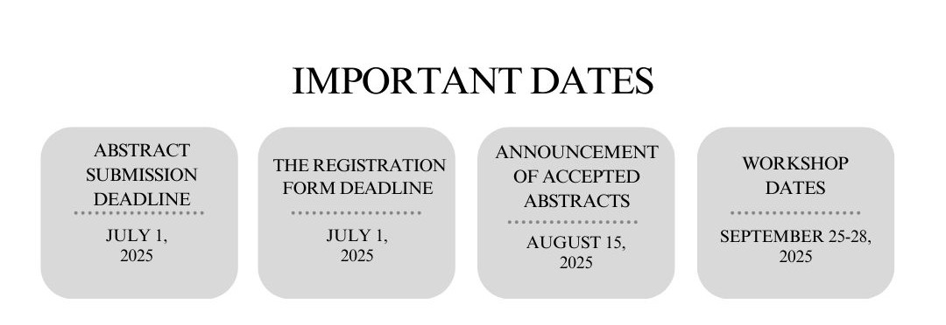

**Prof. Dr. Caner KAYA ÖZER**

**On Behalf of the 26th PÇG Organizing Committee**

**E-mail:** [26pcgduzenleme@gmail.com](mailto:26pcgduzenleme@gmail.com),

https://www.paleontolojistratigrafi.org/