A. Created subgroup and project in GitLab using the provided web link and the "GitLab How-To" web link by doing the following:

1.  Create a new branch named "Working" in GitLab.

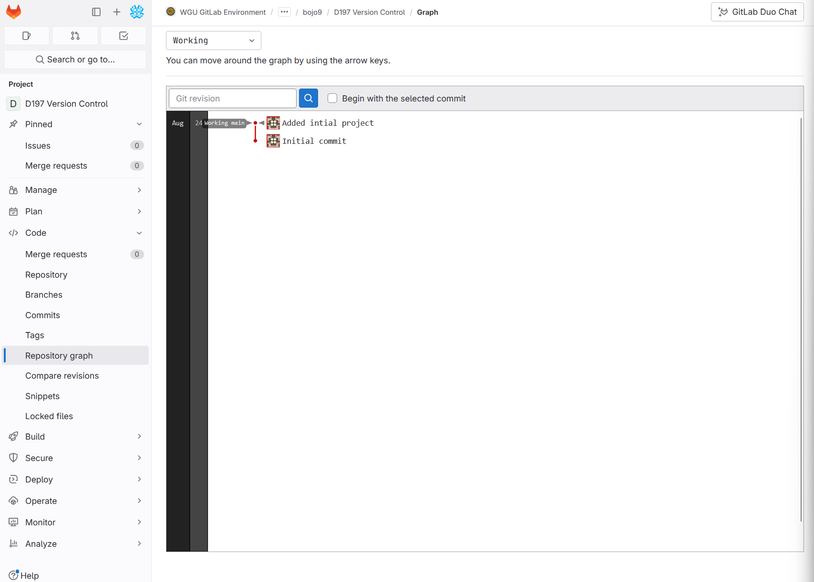

Clone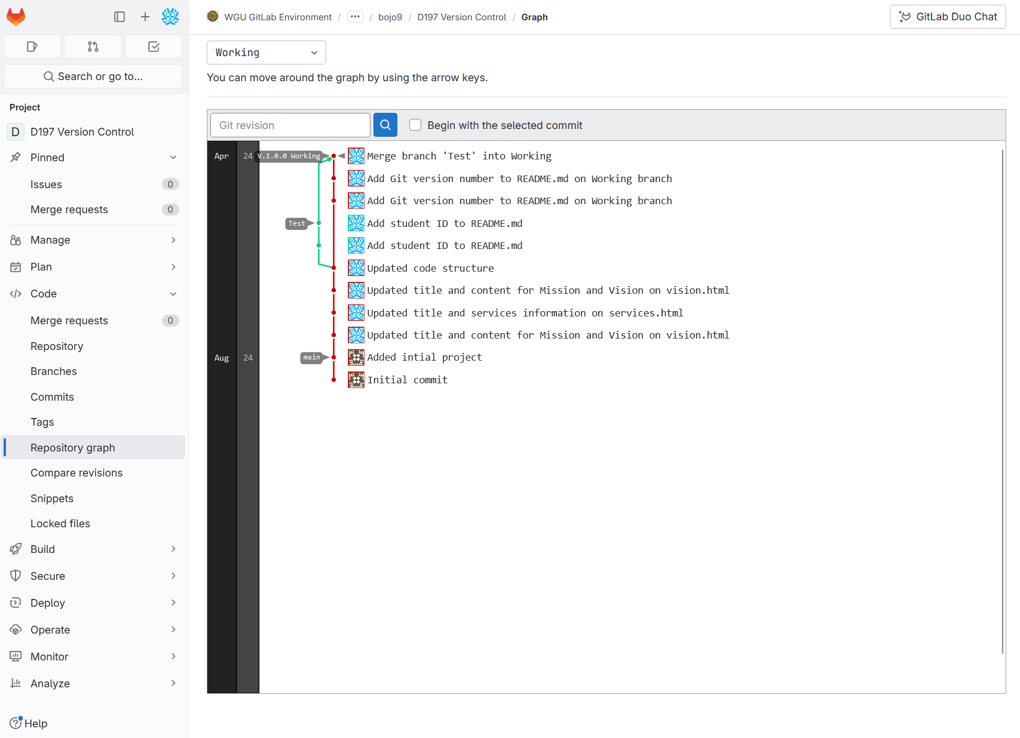

B. Cloned repository on Local Machine

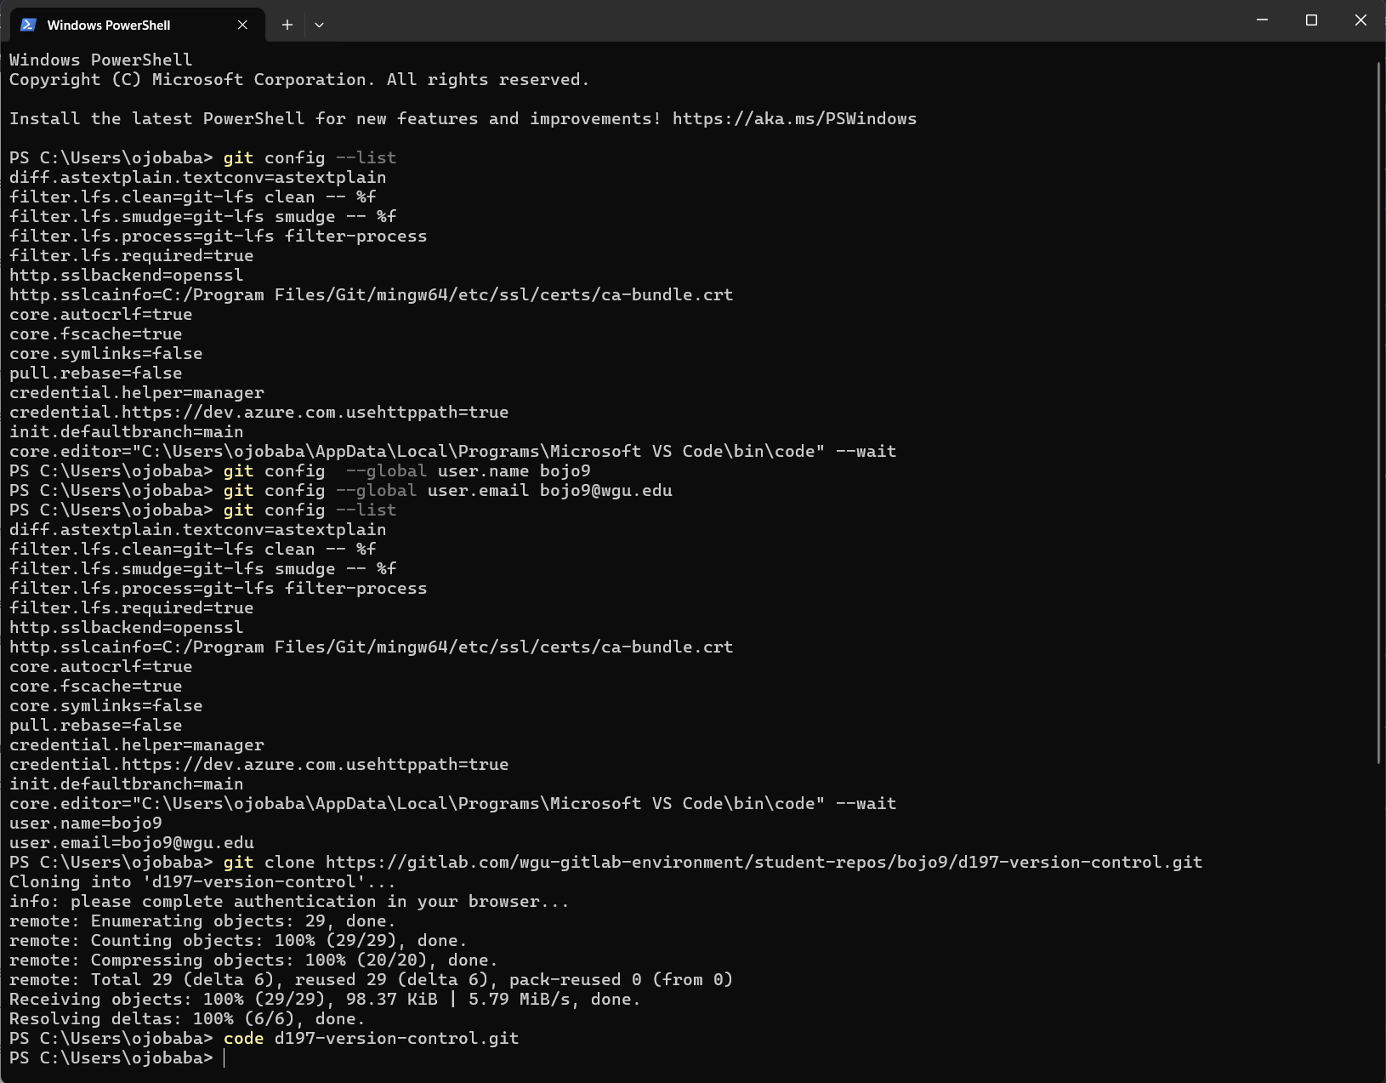

C. Modified 3 HTML files on the Working branch. The following files were modified:

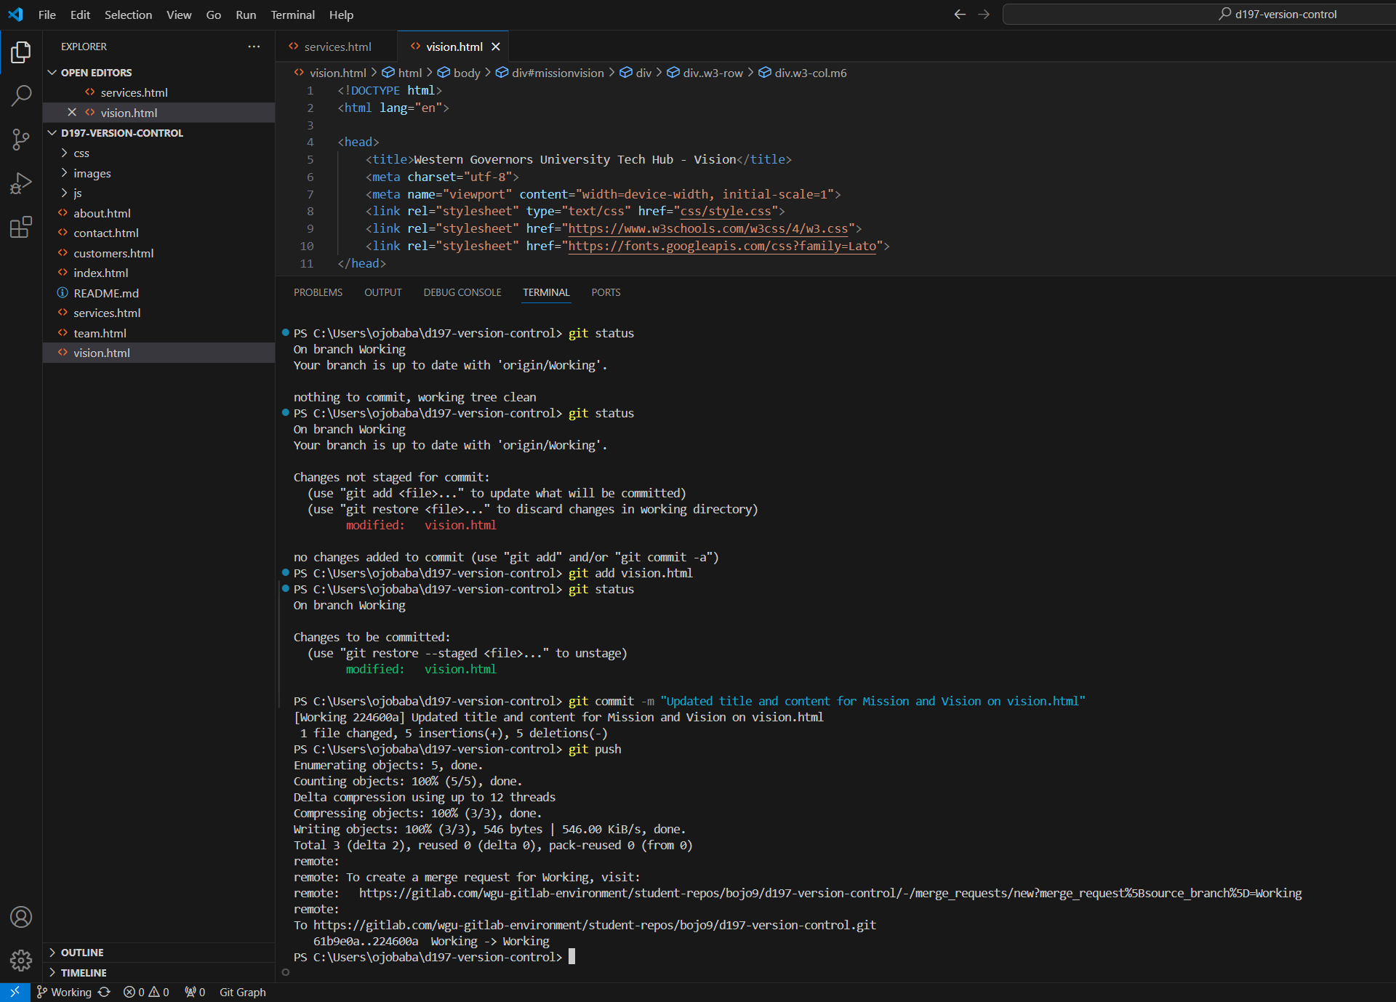 Vision.html, team.html, services.html

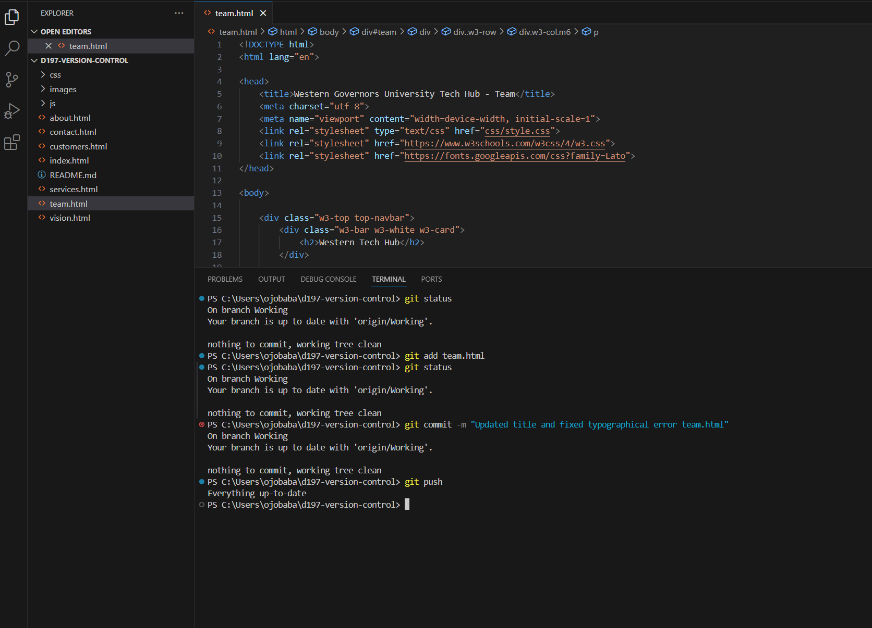

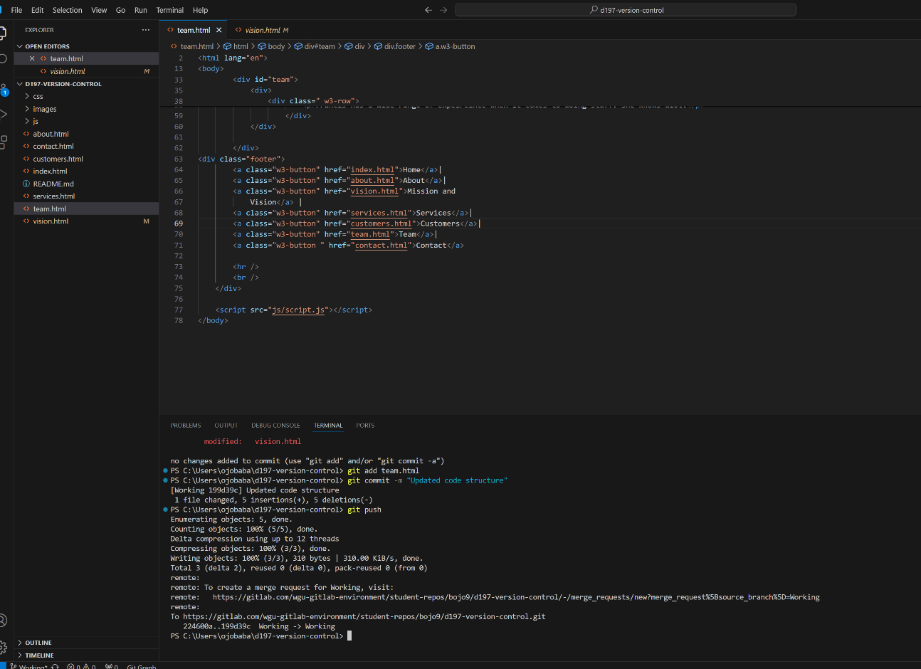

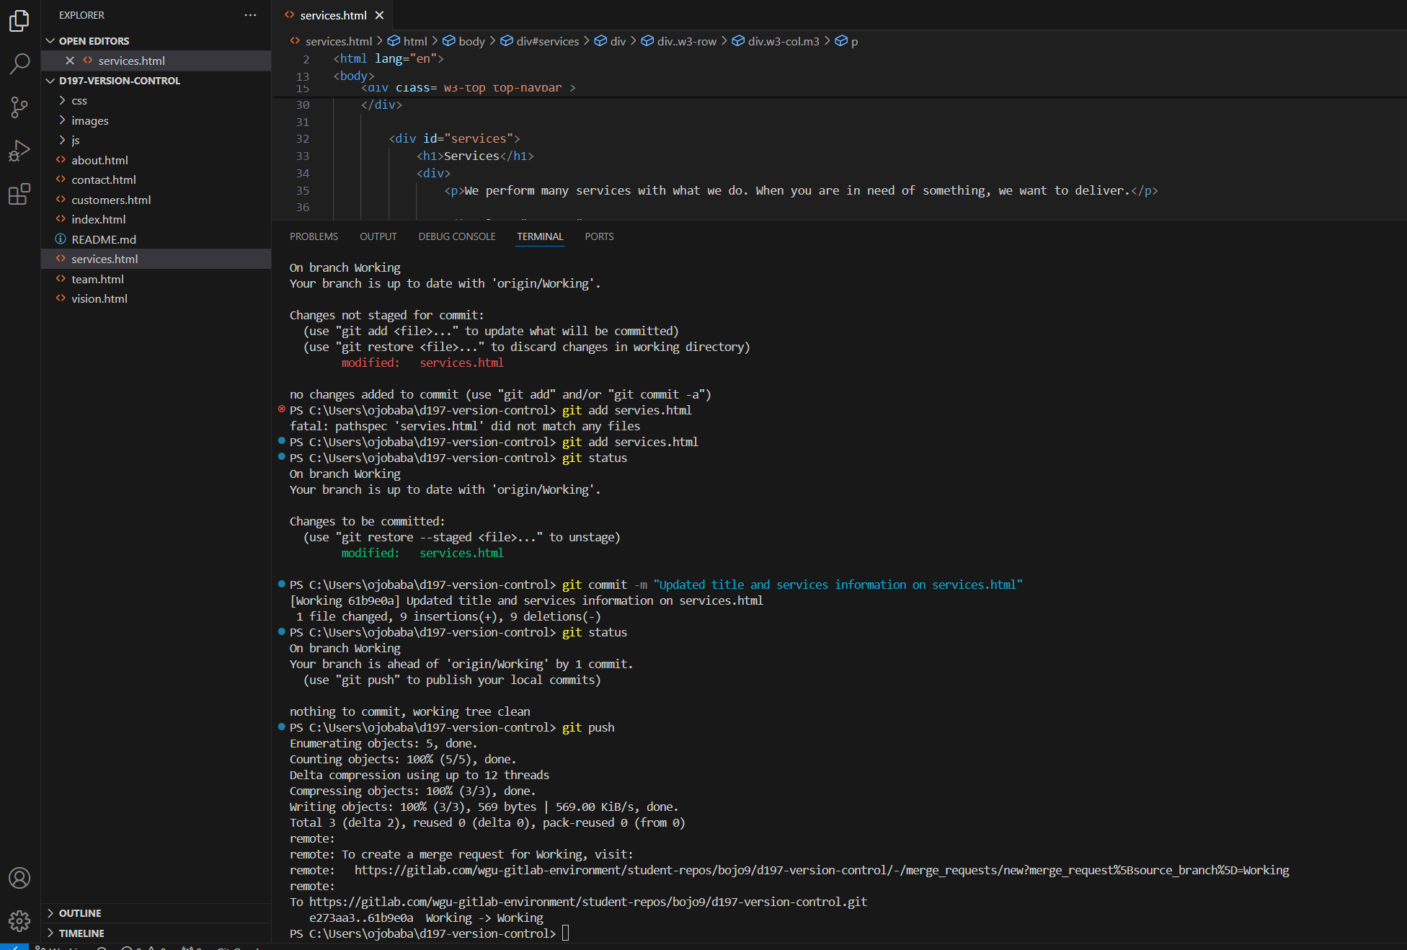

D – Created a new branch named “Test” Modified README.md file and pushed changes to remote repository

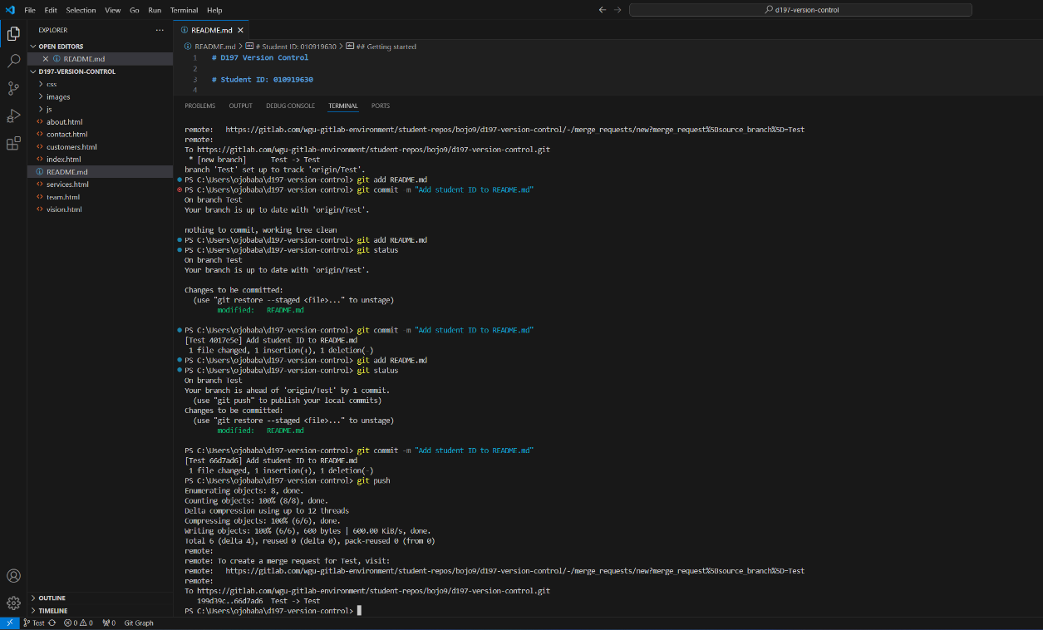

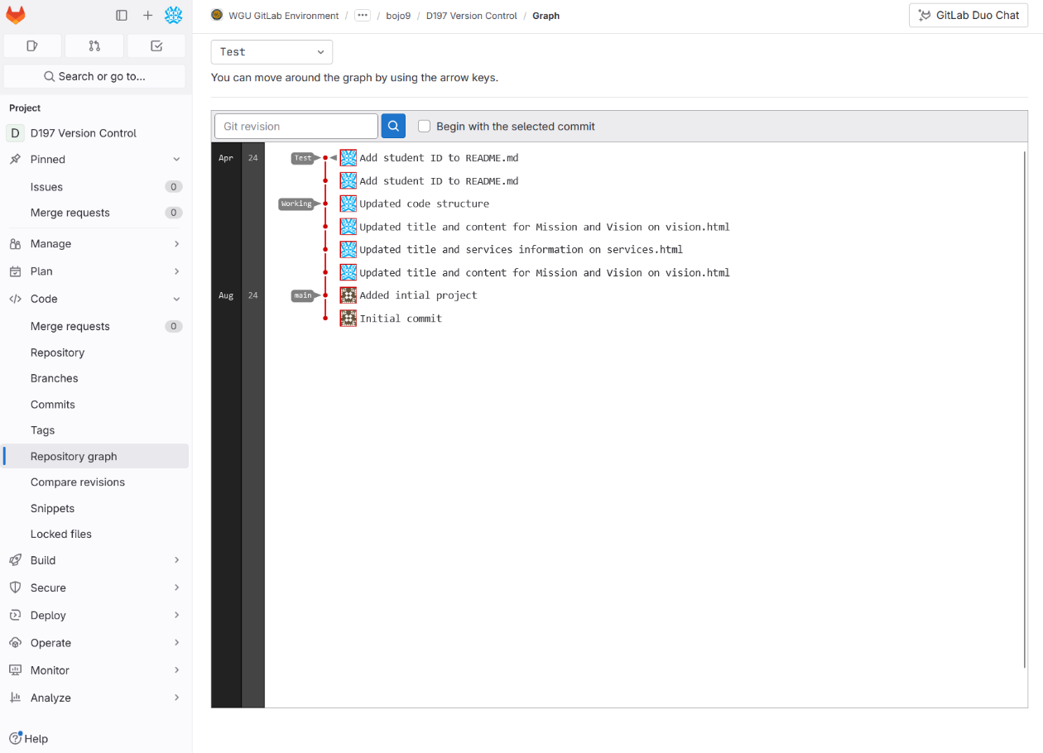

E. Introduced a merge conflict with the “Test” branch by adding the git version number to the README.md file on the Working branch. I then merged the Test branch to the Working branch in local repository

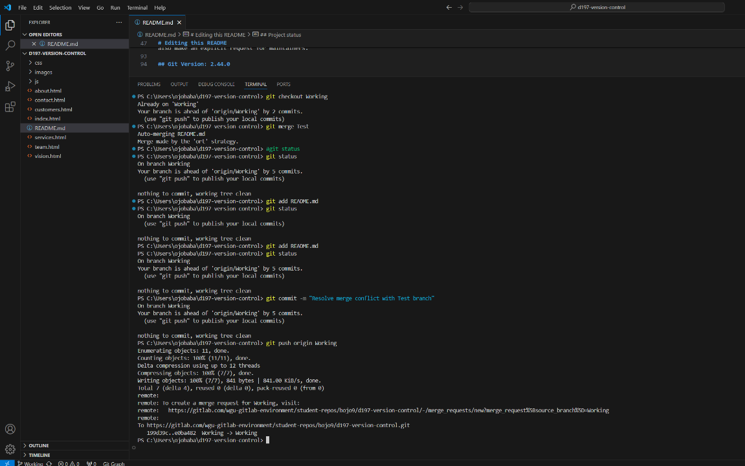

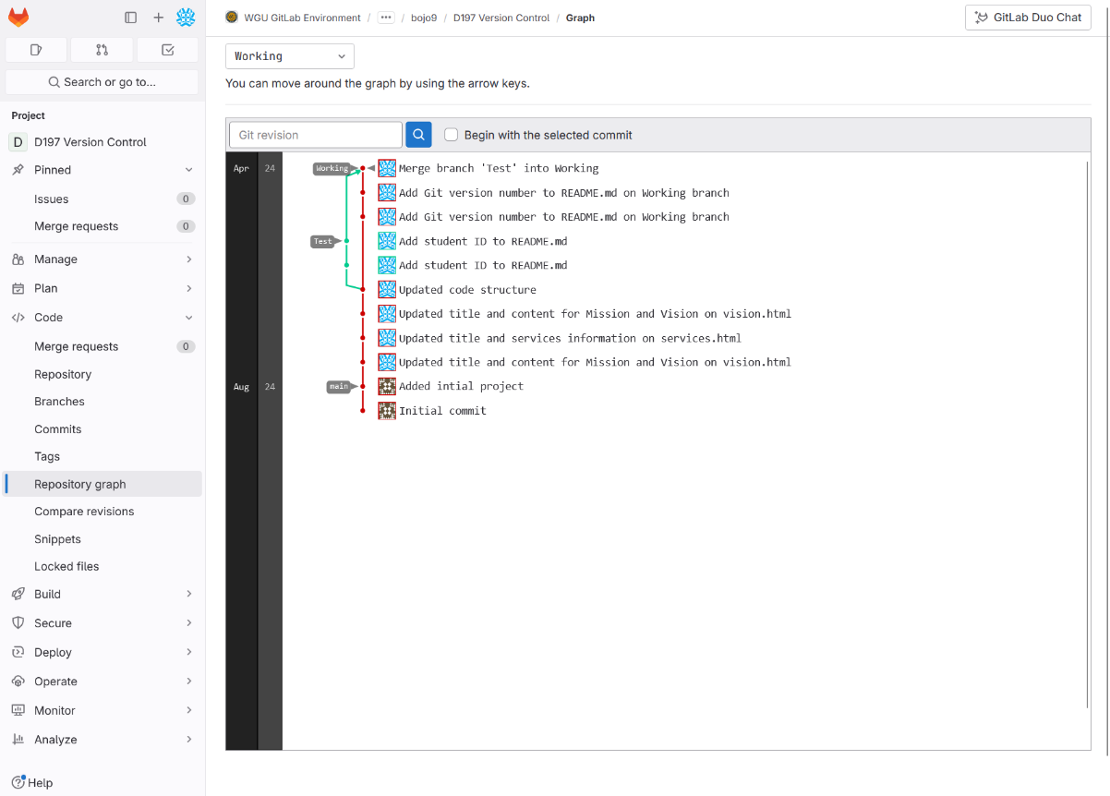

F. Specified a version for local repository by tagging the Working branch as version V.1.0.0 and pushing the tag to Gitlab

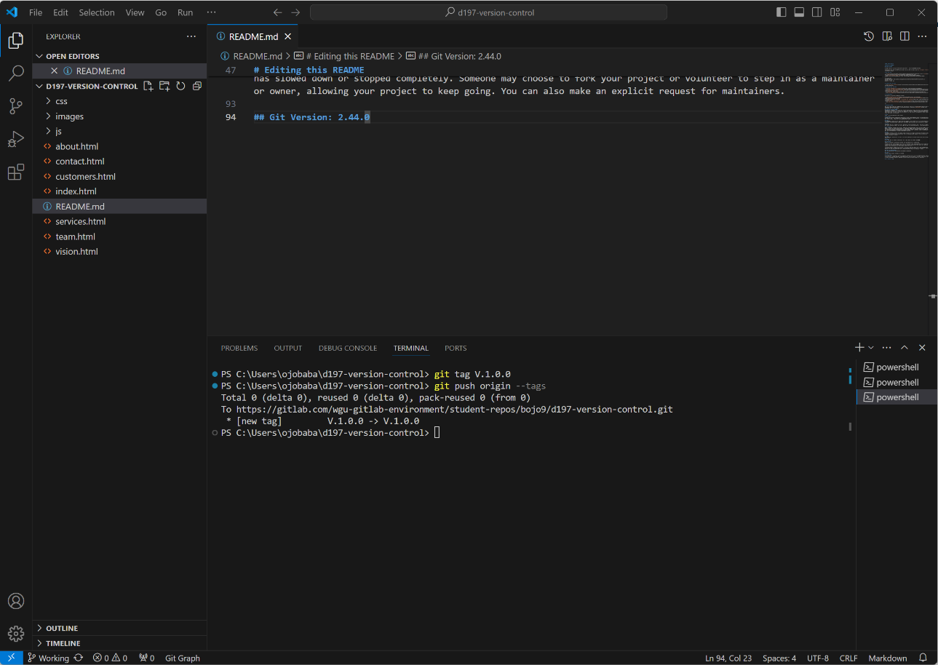

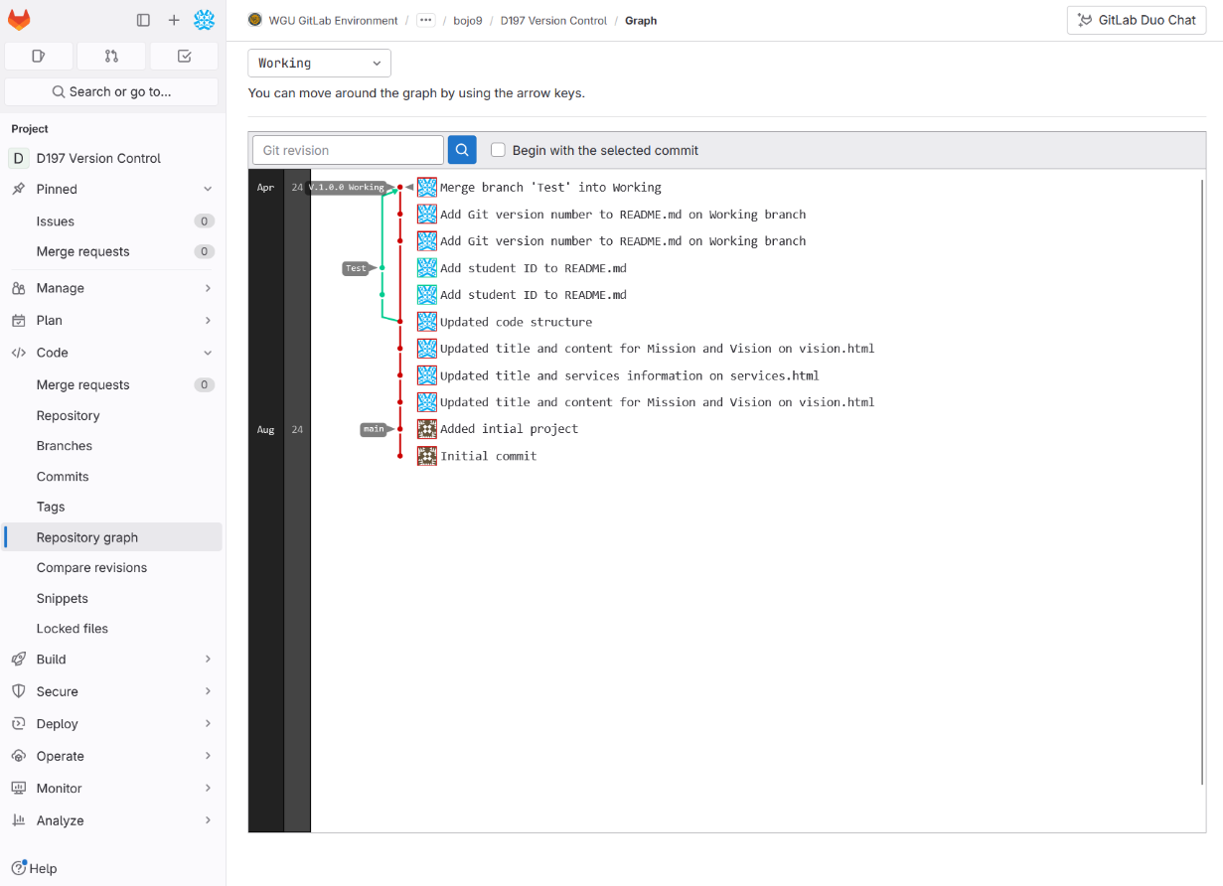

G. Added a Retrospective Directory to Repository by creating a directory on the working branch named “retrospective.” I created a log.txt file that contain the output of the git log command in the retrospective directory.

I created a “summary.txt” file in the retrospective directory detailing how merge conflict in part E1 was resolved and describing three changes that I made in part C1

