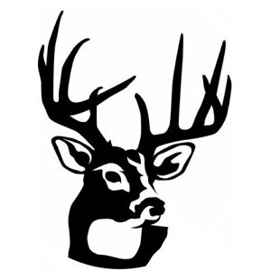 | LANARK AND DISTRICT FISH AND GAME CONSERVATION CLUB

Application for Membership
Name: ________________________________________________________________
Address: _____________________________________________________________
______________________________________________________________________
Phone #: ______________________________________________________________
Email Address:_________________________________________________________

Do you consent to your email address being included in Club email distributions (visible to all members)? [ ] Yes [ ] No
On occasion, pictures are taken at Club activities. Do you consent to your own, spouse & dependents' pictures being published in newspapers, on social media or the Club website? [ ] Yes [ ] No
Lanark & District Fish & Game Conservation Club dues are determined each year and are for the period January 1 to December 31.
Memberships available are: [ ] Adult [ ] Club Basic Adult [ ] Junior Under 18
[ ] Dynamic Family (Build to suit Adult $50, Spouse $25, Children’s categories: Adut Child 18-25 $15, Teen Child 13-17 $5, Child under 13)
Full name, Date of Birth and e-mail address are required for each person listed.
Spouse:___________________________________________________________
Child: ____________________________________________________________ Child: ____________________________________________________________ Child: ____________________________________________________________ Child: ____________________________________________________________

To belong to our Club, you must also belong to the Ontario Federation Of Anglers and Hunters. OFAH Membership No._____________________________
If you are not presently a member of the OFAH, you can join through our Club.
OFAH memberships are Adult, Dynamic Family (Adult, Spouse, Children), Club Basic Adult (No magazine, no Zone vote, no OOD Stream), Youth (Under 18)
For more information, or to submit a membership application, e-mail our Membership Chairperson Merrill Elliott at membership@lanarkfishandgame.com

