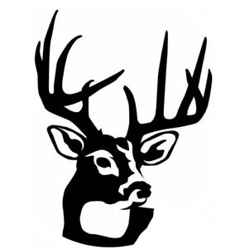 | LANARK AND DISTRICT FISH AND GAME CONSERVATION CLUB  2026 Dues  Revised January 12, 2026
Lanark & District Fish and Game Conservation Club dues for 2026 are:

Club Memberships: Adult $25.00, Family $30.00, Junior $10.00

OFAH Dues if paid through an Affiliated Club:

OFAH Membership Type | Details
Adult 18+ | Full membership benefits.  Add family members at a discount. | $50.00
Add  +Spouse/partner | Full membership benefits | $25.00
Add  +Adult Child 18-25 | Full membership benefits | $15.00
Add  +Teen Child 13-17 | Full membership benefits | $5.00
Add  +Child under 13 | Full membership benefits | $0.00
Basic Adult | Basic membership benefits  (individual insurance, discounts)  No Zone Vote  No Magazine,  No OFAH Stream (video library)  No family pricing or family additions | $35.00
Junior under 18 | Full membership benefits (except voting) | $30.00
Please note, when you submit your application and pay your dues through our Club, we must have sufficient time to process them and get them to OFAH within the appropriate time.

OFAH Dues for Non-affiliated Club Members are:
Adult $60.00, Add Spouse $30.00, Add Adult Child 18-25 $18.00, Add Teen Child 13-17 $6.00, Add Child under 13 $0.00
Junior under 18 $40.00

