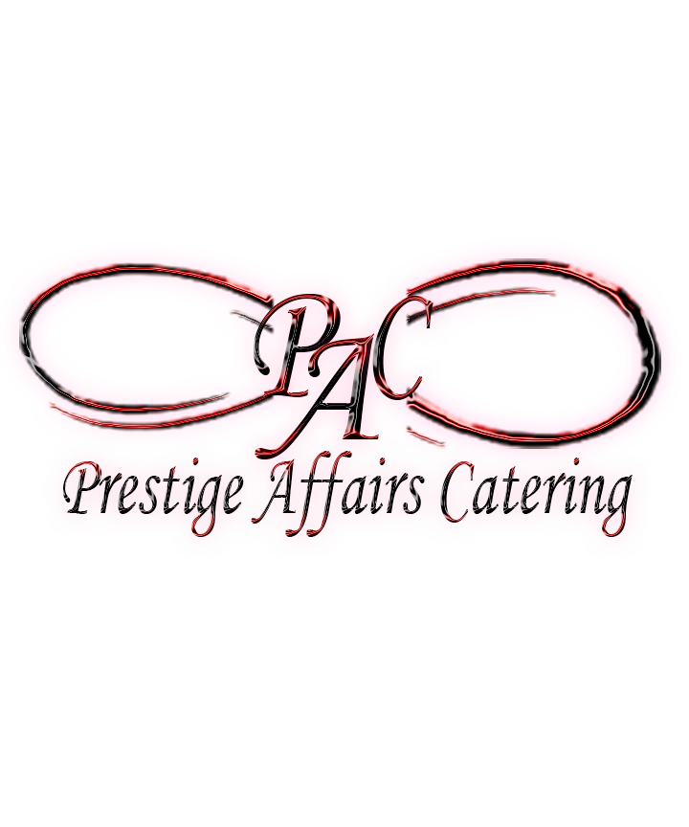

*Service w/Style & Grace*

*Open Mon - Sat 7am – 6pm*

*24hr notice for all orders*

*All orders 8-person minimum*

*www.PrestigeAffairsCatering.com*

*Email: info@prestigeaffairscatring.com*

*Houston – Atlanta – Dallas*

*Phone: 713-569-7628*

Custom Menus Available Please Call

Appetizers

Stuffed Mushrooms

A delicious blend of cheeses and spinach stuffed into a portabella mushroom

$8.75pp

Spinach Artichoke Dip

Our version of this classic favorite served with toasted French bread pieces

$8.50pp

Loaded Potato Wedges

Four cheeses, green onions and chives loaded onto each wedge. Sour cream and salsa for your dipping pleasure

$7.50pp

Wings/Chicken Tenders

Choice of plain, honey barbecue, lemon pepper, or buffalo style

Dipping Sauce / Carrots / Celery

$11.25pp

Southwestern Dip w/Chips

This PAC favorite is sure to start things off right

$7.75pp

Plum Salsa – Seasonal

Served with Cinnamon Pita Chips

$8.50pp

Stuffed Meatballs

Ground turkey seasoned just right and stuffed with mozzarella and jalapenos

$11.75pp

Seafood Dip

Shrimp, lump crab meat and scallops in a blend of cheeses

$14.75pp

***Appetizers – Cold***

*Chicken Lettuce Wraps - $8.50pp*

*Chicken Salad - $8.50pp*

*Tuna Salad - $8.50pp*

*Cucumber Shrimp Canapés - $9.25pp*

*Raspberry Salmon Canapés - $9.25pp*

*Crab Avocado Cups - $10.25pp*

*All cold appetizers are served with the appropriate chips or crackers.*

***Appetizers - Hot***

*Spinach Artichoke Dip Topped w/Crawfish - $11.50pp*

*Pulled Pork Sliders (Slaw & Sauce on the side) - $7.50pp*

*Fried Baby Back Ribs - $10.50pp*

*Chicken & Waffle Quarters - $8.50pp*

*Sliced Smoked Brisket - $10.50pp*

*Chicken Skewers - $8.75pp*

*Beef Skewers -$10.75pp*

*All hot appetizers are served with appropriate sauces, chips and/or crackers*

Entrée

***All entrees served with your choice of two sides, house salad and bread.***

Lasagna

A classic dish with many twists. Your choice of veggie, chicken or classic Italian meat sauce (turkey or beef)

$13.25pp

Pasta Zydeco

Grilled chicken, sausage, and gulf shrimp in a Cajun cream sauce served over penne pasta

$16.25pp

Chicken Fettuccini Alfredo

Char-grilled chicken breast served on a bed of fettuccini noodles, garnished with sautéed mushrooms and roasted tomatoes Shrimp can be added or substituted for $2.00 more

$14.50pp

Spaghetti Bake (Meat Sauce or Veggie) (Turkey or Beef)

Vermicelli topped with our homemade sauce and seasonal veggies

$12.50pp

Cheesy Chicken Pasta

Grilled Chicken – A blend of spices with a four-cheese blend, tomatoes, onions, mushrooms, tri-colored peppers

$13.50pp

Fried Chicken

Lightly battered and fried to a golden brown. White and dark meat options available. Price may vary

$12.50pp

Baked Chicken

Tender baked chicken breast smothered in a mushroom or ranch cream sauce

$12.75pp

Chicken Tuscany

Grilled Chicken in a creamy sauce of Prosciutto, sun-dried tomatoes and mushrooms

$15.25pp

Chicken Marsala

Grilled chicken breast in a Marsala wine reduction with mushrooms

$14.75pp

Chicken Florentine

Chicken breast strips in a cream sauce with sautéed fresh spinach & mushrooms

$14.50pp

Entrée Continued...

Meatloaf

Our own special recipe made with fresh ground beef or turkey, mild onions, green peppers and more

$13.75pp

Pot Roast

Beef or Pork with fresh vegetables cooked to a melt-in-the-mouth tenderness

$14.50pp

Beef and Broccoli Stir Fry

Tender strips of beef tossed with tender broccoli make for a great combination

Served over a bed of rice or noodles

$15.75pp

Beef Tips & Rice

Braised Sirloin Beef tips in a hearty sauce with zesty rice

$15.75pp

Fried or Baked Pork Chops

Enjoy this dish fried to a golden brown or baked with roasted onions and peppers

with a choice of brown or mushroom gravy

$13.50pp

Barbecued Ribs

Seasoned and grilled to perfection

$14.50pp - $30.00 Slab

Fried Catfish

Cornmeal battered fish fillets fried to perfection

$14.50pp

Tilapia

Cornmeal battered fish fillets fried to perfection. Or Baked fish fillets served with a Mango Plum Salsa

$12.25pp

Shrimp & Grits

Delicious blend of Peppers, Red Onions, Leeks, Prosciutto Ham and Shrimp in a delicious sauce over

Creamy Cheese Grits or Fried Grit Cakes

$16.75pp

*Vegetarian options available upon request.*

***All entrees served with your choice of .two sides, house salad and bread.***

Soups/Chili/Gumbo

*Potato $4.75pp*

*French Onion $5.25pp*

*Hearty Chicken Noodle $7.50pp*

*Vegetable Beef $8.75pp*

*Vegetable Chicken $6.50pp*

*Hearty Chili (Beef or Turkey) $9.50pp*

*Seafood Gumbo $11.50pp*

*Broccoli Cheese $6.25pp*

Other Offerings

**Signature Sandwiches Boxes**

Select deli meats and cheeses, roasted chicken salad or tuna salad served on artisan breads with your choice of dressings, pickle spear, cookie, pasta salad cup and chips. $10.95pp

***Signature Sandwich Trays***

Signature Meat Tray - $10.75pp

Signature Cheese Tray - $8.75pp

**If you don’t see it, talk to a rep about a custom menu.**

Salad

Spinach Salad

A bed of crisp spinach leaves topped with chopped eggs, mushrooms, walnuts, crumbled turkey bacon

and mandarin oranges. Served with balsamic vinaigrette dressing

$11.50pp

Grilled Chicken Caesar Salad

Fresh romaine lettuce, grilled chicken breast with Caesar dressing and parmesan cheese

$13.75pp - $

Strawberry Spinach/Shrimp Salad

Romaine and Spinach tossed with a raspberry vinaigrette and topped with fresh shrimp, red onions,

red peppers and strawberries. Served with Pita Bread

$15.75pp

Sides

Dirty Rice $5.75pp

Steamed Corn $3.25pp

Steamed Green Beans $4.50pp

Steamed Broccoli $4.25pp

Sweet Beans (BBQue Pinto Beans) $4.75pp

Vegetable Medley $4.75pp

Pasta Salad $5.50pp

Roasted Potatoes $4.75pp

Garlic Mashed Potatoes $3.75pp

3 Cheese Macaroni and Cheese $6.50pp

Chili Cheese Potatoes $7.75pp

Potato Salad $4.50pp

Candied Yams $4.50pp

Cucumber Tomato Goulash $4.25pp

Desserts

Cookies

Chocolate Chip - $13.50 per dozen

Chocolate Chip w/Walnuts - $13.75 per dozen

Oatmeal Raisin - $13.00 per dozen

Peanut Butter - $13.00 per dozen

Peanut Butter Chocolate Chip - $13.00 per dozen

Personalized Packaged Dozen - $25.00

Cheese Cake

New York Style (Plain) - $55.00

(Strawberry topping $6.50)

Chocolate (Raspberry Sauce Optional) $55.00

Cobblers/Pie – ½ Pan

Peach $45.00

Blueberry $45.00

Apple $45.00

Blueberry/Peach Cobbler $55.00

Cakes

Plain Yellow Cake with Choice of Icing - $35.00

Ultimate Chocolate $45.00

Lemon Pound $30.00

Plain Pound $25.00

Plain Pound with Strawberries $35.00

7Up $30.00 w/fruit $45.00

Lemon Cheesecake Cake $55.00

Chocolate Cheesecake Cake $60.00

Triple Chocolate - $60.00

Services

Delivery charges include set-up with chafers, serving ware, plates, napkins and silverware. If you don’t require full setup, please let us know when ordering as delivery charges will be adjusted.

Delivery Charges:

12 - 20 guest. $50.00

21 - 40 guest. $70.00

41 - 60 guest. $90.00

61 - 80 guest. $120.00

81 - 100 guest. $150.00

Over 100 guest. please call.

**Orders must be placed 24hrs before the event.**

**If you need servers for your event, they are available for $25 per hour.**

Breakfast

Continental Breakfast Bar

Fresh fruit, assorted muffins, danish and donuts

Make it festive with Mimosas

$7.95pp - Regular / $12.75 - Mimosas

Executive Continental Bar

Sliced fresh fruit, assorted bagels w/cream cheese, and muffins

Assorted Juices and Coffee

Make it festive with Mimosas

$9.95pp - Regular / $15.75 - Mimosas

Breakfast Additions

Assorted Yogurt

Granola upon request

$2.50pp

Assorted Cold Cereal

Choice of Whole, 2% or Fat free

$2.75pp

Mini Croissant Breakfast Sandwiches

(Filled with eggs, ham or bacon and cheese) (Turkey Options Available)

$4.50pp

Hot Breakfast

Create Your Own Meal

(Choose One Meat, Three Sides and Bread) (Fresh Cut Fruit please add $3.50pp)

Scrambled Eggs

Bacon (Turkey Available)

Sausage Patties or Links (Turkey Available)

Hash Browns or Home-style Potatoes

Grits or Oatmeal

Toast (White or Wheat)

Homemade Biscuits

Waffles

$10.95pp

**Coffee Traveler**

Regular or Decaf - $26.00 _ Serves 12ppl

***Fruit Trays w/ Fruit Dip***

*12in - $30.00 /Feeds 10 to 15ppl*

*16in - $38.00 /Feeds 20 to 25ppl*

*18in - $55.00 /**Feeds 30 to 35ppl*

***Vegetable Trays w/Veggie Dip***

*12in - $25.00 /Feeds 10 to 15ppl*

*16in - $35.00 /Feeds 20 to 25ppl*

*18in - $50.00 /Feeds 30 to 35ppl*

***Meat & Cheese Trays***

***(Comes with Bread & Crackers)***

*12in - $40.00 /Feeds 10 to 12ppl*

*16in - $55.00 /Feeds 15 to 20ppl*

*18in - $65.00 /Feeds 25 to 30ppl*

***Fruit Displays***

*Minimum order 50ppl for Fruit Displays*

*Fruit Display Basic*

*$6.50pp + $100 Set up fee.*

*Fruit & Cheese Display Basic*

*$9.50pp + $100.00 Set up fee.*

*Premier Fruit Display - Fruit, Cheese, Veggies, Meats & Veggies with hummus and other dipping sauces.*

*$12.50pp + $100 Set up fee.*

*(Refilled Once) (Onsite Service)*

*Prestige Affairs Catering* *brings Houston the perfect marriage of experience, a passion for food and presentation. With a commitment to high quality, homemade products, beautiful presentations and exemplary services, Prestige Affairs Catering makes every event unique and special.*

*Prestige Affairs Catering is a boutique, personal chef catering service. Whether casual or formal, we insist that each event receives the same attention to detail. Whether we come to your home, office or Houston area venue or we simply drop it off (catering to go) you can be assured that your guests will remember the food long after the last bite.*

*Don't see what you want on the menu, don't worry, we can customize a menu for your event.*