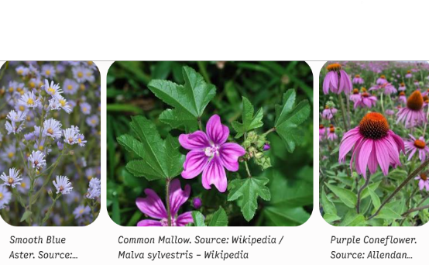
Classic Display Using Native Plants

-

When using perennials and grasses, remember that they develop deep, resilient root systems (especially the Echinacea – Purple Coneflower and Symphyotrichum – Smooth Blue Aster ) their container time is limited and they must transition topermanent garden beds by early autumn so the roots can establish before the winter ground freeze. In this container, the Purple Coneflower is already showing signs of too close quarters.
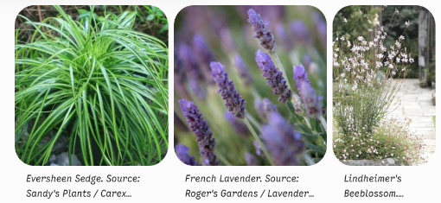

When arranging the three in a single container, they naturally follow a classic design structure:
- The Filler / Structure: French Lavender provides a sturdy, aromatic, grey-green mound with upright purple spikes that anchor the mid-section.
- The Spiller / Texture: Eversheen Sedge cascades over the rim, offering a bright pop of arching lime-and-gold variegated blades that illuminate the base.
- The Thriller: Lindheimer's Beeblossom sends up wispy, delicate stems that float above the other foliage like tiny butterflies, adding height, movement, and a whimsical texture.

Container 2: Native & Transplant Highlights
Plant Name | Mature Height | Bloom Time
Smooth Blue Aster (Symphyotrichum laeve) | 2 to 4 feet | Late Summer to Fall (August – October)
Purple Coneflower (Echinacea purpurea) | 2 to 4 feet | Summer (June – August)
Lindheimer's Beeblossom (Gaura lindheimeri) | 2 to 5 feet | Early Summer to First Frost (May – October)
Common Mallow (Malva sylvestris) | 2 to 4 feet | Summer to Early Fall (June – September)
French Lavender (Lavandula dentata) | 2 to 3 feet | Late Spring to Summer (May – August)
Eversheen Sedge (Carex oshimensis 'Eversheen') | 10 to 12 inches | Insignificant (Grown for year-round gold foliage)

