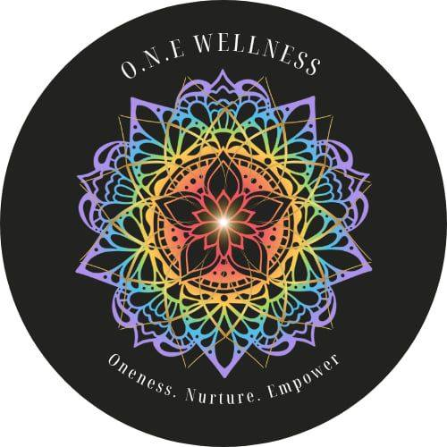

Awareness of Breathing

Breathing is easily one of the most important things that we do in our day. Without it we cannot survive. Our breath not only keeps us alive; it can also greatly affect how we feel. Creating awareness of breath can be very helpful in decreasing anxiety, inducing calmness, and helping you feel centered and balanced.

If you are feeling anxious or have racing thoughts, check in with your breath. Is it fast and shallow? Are you holding your breath? Fast rapid breathing increases energy in your body and can increase anxiety. To stop this, bring awareness to your breath, slow it down and take some big slow deep breaths.

Deep belly breathing is breathing with the diaphragm. It creates space for deeper, more cleansing breath. It stimulates the vagus nerve and parasympathetic nervous system. It promotes calm and it can also be helpful in decreasing anxiety. It is a learned practice that takes time and awareness. Have patience with yourself and be proud of yourself for taking steps to help yourself feel better and become more aware of your breath.

You can practice this exercise any time or any place you need to if it is safe to do so. You can also practice deep breathing in the morning to center yourself and start your day off with some self-care or in the evening to promote relaxation and a good night's sleep. The more you do it the more natural and easier it will become. Remember to be patient with yourself in learning this new activity!

Breath Awareness Exercise

Place one hand on your chest and the other on your belly.

Set a soft gaze or close your eyes if you are comfortable to do so.

Any thoughts that come into your mind, just acknowledge them and let it pass.

Bring your awareness to your breath and how it feels in your body.

Now deepen your breath and fill your lungs even more.

As you exhale release and let go of anything that no longer serves you.

Now when you breathe, focus on your bottom hand, is it moving when you breathe?

Breathe into that space.

Take quite a few more deep belly breaths, observing your bottom hand gently moving.

Continue as long as you need.

Return to a comfortable breathing.

Open your eyes if they are shut.

Thank yourself for showing up for yourself today.

