Bringing water challenges to target groups, the key role played by water utilities.

By Céline Hervé-Bazin, Ph D – CELSA / GRIPIC, France
celinehervebazin@gmail.com

Biographical data
Dr Céline Hervé-Bazin is both invited teacher and consultant specialised on communication about water. Céline has been working in several companies operating in the water sector as communication manager for 8 years before working as consultant. She holds a PhD in Information and Communication from the Sorbonne University and Top School of communication (CELSA). She wrote several scientific papers for conferences and peer-reviewed Journals. She published three books related to water resource management and public perceptions. Her last book Water Communication is dedicated to communication campaigns in the water sector (IWA Publishing). She teaches environmental communication and gender issues at the CELSA and communication methodology in various universities (CNAM, ISEPP, EST Littoral).

Key words
Water communication, Local-Regional communication, Interface, Public perceptions

In November 2012, the European Environment Agency (EEA) announced that only 52 % of water bodies were predicted to achieve the good ecological status set by the European Water Framework Directive (WFD) by 2015. This directive was adopted on 23 October 2000 with the aim of guaranteeing good water quality to European citizens worried about water pollution. The European Union (EU) pushed for the involvement of Member States (MS) and water users into the implementation of the directive:
“Member States shall encourage the active involvement of all interested parties in the implementation of this Directive, in particular in the production, review and updating of the river basin management plans. Member States shall ensure that, for each river basin district, they publish and make available for comments to the public, including users.” (Directive 2000/60/EC, article 14.1)

Early the same year, the EU published the new edition of the Eurobarometer “Attitudes of Europeans towards water” concluding "that almost 75% of Europeans consider that the EU should propose additional measures to address water problems in Europe with the main focus of such measures on water pollution from industry and agriculture. As many as 68% of the population recognise that water-related problems are serious and worry equally about water quantity and quality.” (European Commission, 2012) More importantly, the barometer revealed, "fewer than four out of ten respondents feel well or very well informed (37%) about problems facing groundwater, lakes, rivers and coastal waters in their country" (Eurobarometer 2012: 6). In France, 89% citizens consider water quality a serious problem for their country but only 60% agree with the idea of raising water prices if their use has a greater impact on water resources (the EU average is 62%). Europeans also believe more information can be a way of tackling water problems.
The process of communicating about water issues is recognised as a primordial approach to water resources management at all levels. According to the International Water Association (IWA) Specialist Group on Public and Customer Communication “information and communication is the key to successful water management”. Communication on water is recognised as a crucial component to planning, implementation, and operational decisions to optimise water resources and water cycle management. This recognition is the result of multiple processes influencing the water cycle management e.g. the incorporation of economics, politics, governance, and social sciences. As a realm of social sciences, information and communication sciences can be legitimately combined with water resources management. It also considers the specificities of each type of stakeholders from international to the local level. The Awwa Research Foundation underlined the role played by water utilities to make the public understand the value of water and water services.
"Customers are less likely to think about the value of water utility services because they typically take for granted that safe water will be available whenever they open a tap. The value of water utility services becomes more apparent when delivery is compromised by a natural calamity (e.g., flooding of the water plant) or some other disruption in supplies. As a prerequisite to delivering messages about the value of water, utilities need to establish credibility within the community. Community members must trust the utility and its employees in order to trust its messages." (Awwa 2008: xviii)

Water utilities have a strong potential to bring key messages to water users e.g. beneficiaries or non-state actors who will usually join to manage water resources more effectively or based on participation of end-users. Water utilities have the possibility to convey local messages and to organise events that can generate changes. In this frame, they are important leaders for water communication. They usually lack of budget to conduct efficient campaigns on water resources, they also lack of trained people or adequate resources to inform, educate and disseminate messages. How to better communication on water resources management at the utilities level? What are the current practices and main campaigns? Which topics do they usually target and towards which target groups do they usually design their communication campaigns?
Our main research interest is to consider the constraints to the communication of utilities on water resources; to provide theoretical concepts and analysis of actual practices in order to highlight its main characteristics; and to further study messages and the integration of targets groups throughout communication processes related to water issues. The main purpose of this publication is to analyse the specificities of communication by water utilities on water management resources and how they interact with their different target groups. We want to provide practical case studies from information and communication campaigns conducted by water utilities and want to characterise their main challenges to further understand their communication needs and barriers. For this study, we focused on French water utilities as concrete examples incorporated in the larger scope of the EU legislative framework to better EU water resources management and famous campaigns by water utilities worldwide.

THEORICAL BACKGROUND
Information and Communication Sciences cover a variety of subjects, methodologies and techniques. They aim at analysing processes, interactions and dialogues. They embrace activities from organisations and individuals. They look at messages, discourses, slogans, campaigns, codes, rituals, events and uses of technologies. They examine symbolic meanings and interpretations. They consider impacts from information and communication technologies, mass media, mass culture and mass products. They examine strategies and effects on people’s awareness, knowledge, attitudes, behaviours, perceptions and beliefs. Information and communication sciences provide keys to define strategies to address public opinion, and to form organisations’ interactions. They have different impacts depending on media, strategies, tools and interactions.
Communication on water resources can be designated as “water communication” covering all communication processes related to water as a natural resource (physical good) and a human resource (including services, uses, perceptions and beliefs). Water communication recognises that all processes communicating on water have set up specific languages, discourses, lexicography, media planning and campaigns, practices, knowledge transfer or education and engagement. The construction of communication about water is influenced by different elements. At first, the specificity of water itself as a natural resource. Its cycle, its qualities, its management and services have an impact on the content and topics of communication campaigns. Secondly, major components influence discourses, codes, messages and strategies such as religious and personal beliefs towards the representations of water; the many cultural references about water including myths, uses, and history; and social codes implying water shared behaviours, attitudes and perceptions. We summarised such a process in the figure 1 showing also how water communication is at the centre of many influences from various fields of communication: environmental communication, health communication, public communication, risk communication, science communication and responsible communication (Herve-Bazin et al, 2014).

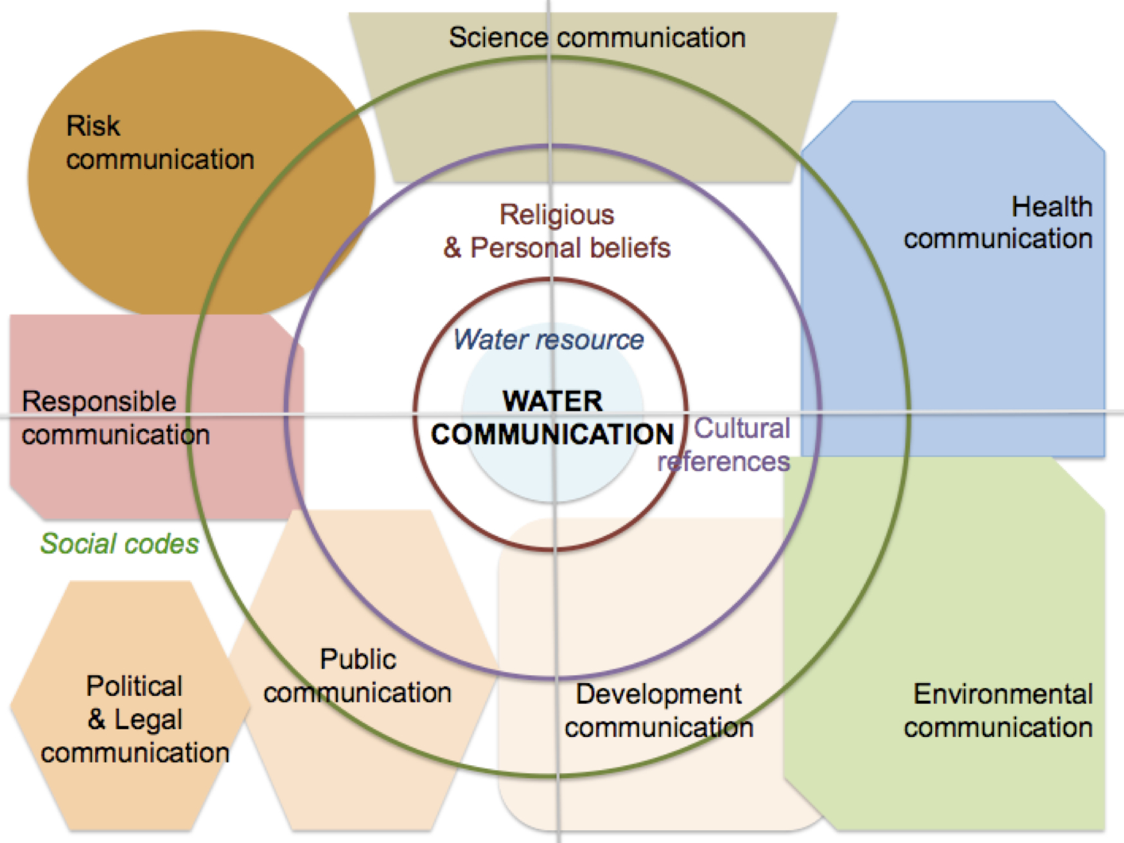
Figure 1: The building of water communication (Herve-Bazin et al, 2014)
Water communication is influenced by the construction of communication into the public space and several social elements part of communication processes e.g. social codes and cultural references. Religious and personal beliefs are particularly relevant to individuals’ relationships with water since water acts as a symbol and ritual worldwide and throughout civilisations.

Another important characteristic of water communication is the building of messages and campaigns by and from key contributions of many organisations acting at the local level.
The water sector is known to be fragmented and wide. Many stakeholders are involved in water cycle management. Based on the classification of stakeholders established by Poirier (Poirier, 2012), we considered the following including international policy actors (United Nations, World Bank…); inter-water actors (mostly networks such as the Global Water Partnership, the International Water Association); research and companies actors; national, regional, local and cities actors; humanitarian actors (e.g. non-profit associations); water figures (from Matt Damon to Paul Reiter or Peter Wilderer); and major events (World Water Forum, Stockholm World Water Week, Water Week in Singapore, etc.). Water users are their ultimate target groups, they play a key role to implement water resource management and can be divided into four major groups: farmers/agriculture, industry/companies, cities/utilities and individuals-citizens/general public.
These numerous communities need and seek mediation and interfacing. Each community holds their own priority of usages and agenda. These different groups need to adapt their language and methodologies to reach better water resources management and knowledge brokerage for the public good and protection of water. They interact depending on different geographical scales identified from local implementation (individuals, cities/utilities), regional, national, inter-national (basin levels, cooperation between States on shared water) and global scale (including institutional mechanisms such as the programs from the United Nations or medias). At the local scale, communication about water from utilities towards the public and in relation with other scales remains rarely studied and analysed.
The concept of “scales” is based on a geographical approach of the territory. Tröger (2010) developed a land-based vision of water resources management in order to develop socio-economic analysis of water resources management. She argues that the actual location of water resources (stream, flow, mouth) has an impact on the administration of water resources management. She particularly underlines the role of the local scale for a better water resources management (Tröger, 2010). These specificities are suggesting several “scales” to water resources management from the local to the global level. Such an organisation creates the need for interfacing between the actors involves at the different scales. We established different scales and different water stakeholders acting at these scales (Figure 2).
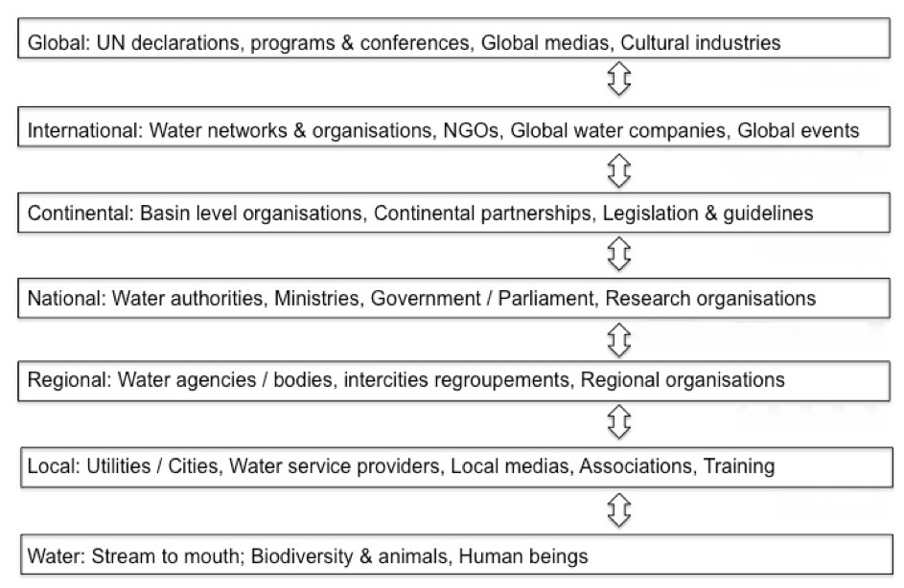
Figure 2: The water sector, various scales for shared water resources management
The concept of “scale” shows how the different profiles of stakeholders bring messages at different levels and depending on the impacts of their messages e.g. the UN acts at the global level framing water resources management at the international level and providing guidelines worldwide. At the local level, utilities have a direct impact on individuals and on the management of water resources at the stream or the mouth.

These actors are interfacing with one another and several researchers pointed out the need of interfacing between scales for greater integration and cohesion at the local level. Other researchers argue for a stronger mediation between target groups involved in water resources management such as Philippe Quevauviller. He identified a gap between science, research and policy makers when implementing the WFD. He observed the misunderstanding between policy managers at utilities’ level with policy managers from European institutions showing barriers between the local/regional level with the European scale. He also remarked the absence of communication between the research community providing scientific recommendations and analysis to European institutions and local utilities, and the gap between policy makers and the scientific community on water priority issues. This disparity had a major impact on implementing the WFD at the local level. Many policy makers will reject or reluctantly apply its principles. The European Commission developed its own initiative to facilitate a “science-policy interface” (Quevauviller, 2009). Quevauviller considered different types of transfer to better manage interactions between the different target groups to disseminate knowledge and to facilitate implementation of EU directives (Figure 3).

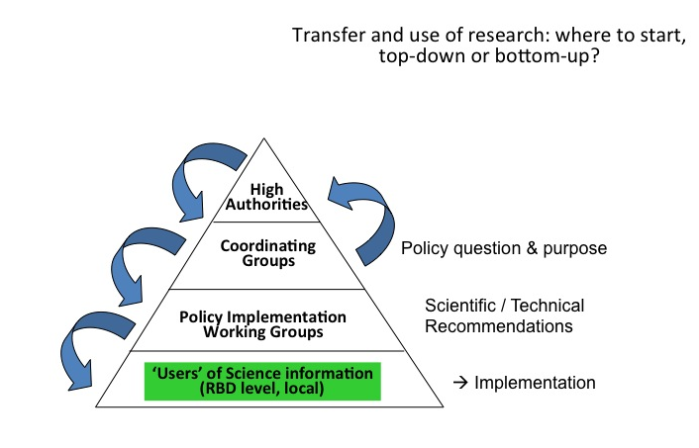
Figure 3: Research transfer, different levels and groups (Quevauviller, 2009)
Quevauviller suggests guaranteeing top/down and bottom-up communication to facilitate knowledge transfer and dissemination of information at all scales and towards all water stakeholders.

In this frame, water utilities represent a key interfaces between water users e.g. farmers, industries, citizens and among cities/utilities. Water utilities are considered as “the whole set of organisations processes activities, means and resources necessary for abstracting, treating, distributing or supplying drinking water and/or for collecting, treating and disposing of wastewater and for providing the associated services.” (EUREAU, 2008) They hold some common key features:
"(a) To provide drinking water services or wastewater services or both, (b) its physical area of responsibility and the population within this area, (c) its responsible body, (d) its general organisation with the function of operator being carried out by the responsible body, or by legally distinct operator(s), and (e) its type of physical systems used for providing the services, with various degrees of centralisation." (EUREAU, 2008)

Water utilities present a particularly interesting position for the study of water communication. They interact with many target groups: water users, EU Parliament and Commission, national governments, researchers and the scientific community, specialised networks and associations, etc.
In this frame, we want to analyse how communication campaigns led by water utilities are setting strategies and tools to address their target groups. The aim of this publication is to examine who are their main target groups and how water utilities are addressing information and communication constraints related to water resources management.

METHODOLOGY
This paper examines communication strategies and campaigns by water utilities considering the concept of “scale”. To answer to our research question, we needed to base our work on the analysis of communication campaigns by water utilities considering their diverse profiles (water authorities, water agencies, basin authorities, water services within municipalities, association of water utilities, water unions) the wide range of topics (prices, drinking water quality, water bathing, preservation of water ecosystems and pollution, infrastructures, water management, EU legislation) and the different communication materials used (TV, Radio, Internet, Social medias, etc.).
We surveyed a total of 25 French water utilities that produced several communication campaigns at the local and regional scales from 2000 to 2013 and completed the study with campaigns from the five continents. For each campaign, we studied TV spots, radio broadcastings, brochures, flyers, reports and websites produced. We conducted several interviews with communication managers of water utilities. This paper is part of a larger research on communication and water management published in Water Communication. Analysis of Strategies and Campaigns from the Water Sector that includes the analysis of 165 communication campaigns from various organisations worldwide but mainly based in France, Europe and North America.
We selected our referent materials based on the profiles listed earlier but also applying the following criteria: a) the number and the variety of communication campaigns to be able to gain a sufficient number of materials; b) the representativeness of target groups to analyse campaigns that addressed different publics (policy makers, mayors, citizens); and c) the impacts of their campaigns. We considered campaigns with strong impacts based on the number of materials disseminated, the presence in media (local journals, social media, websites, national TV, etc.) and if campaigns were known within the water community. To establish this information, we conducted a survey towards 70 water professionals with communication activities from 22 countries (2012). We complemented our selection based on campaigns or organisations mentioned in books, magazines and Internet. We also considered the size of the utility, the covered area and number of inhabitants.
We selected the following French organisations: public water utilities (Eau de Paris for the city of Paris, the cities of Besancon and Mulhouse), water utilities in contract with private companies (cities of Dijon, Bordeaux, Lyon and Lille), water unions (the SEDIF, the French union for water in the Parisian area, the SICASIL, the union for drinking water in Cannes area); regional councils engaged into water awareness (the regional council in Seine and Marne, Parisian area; the regional council in Morbihan, West France; the regional council in Picardie, centre North of France); water basins (“Les Agences de l’eau” e.g. water agencies, the entity gathering the 6 French water basins the Rhône Mediterranean basin covering West-Southern France; the Seine-Normandy Basin covering Paris area and Normandy, the Rhine-Meuse basin covering Eastern France); association of water utilities and mayors (the FP2E, the French organisation of private companies providing water services to 45 millions French inhabitants, the AMF, the association of French Mayors that has a thematic group on water and sanitation); water authorities (the ONEMA, the authority for aquatic ecosystems and natural environment, the CNE, the national committee for water); and association of water users (Eau & Rivières association for the preservation of rivers; the ARF, the association of rivers’ inhabitants; the FENARIVE in charge of resolving issues related to industrial water; the Agricultural Chamber with its subgroup about water resources management; the AFEPTB the national association of public territorial infrastructures). We extended our study to the CIEAU and the OIEAU, two networks dedicated to water and playing a role in communication efforts about water resources in France at both local and national levels. The benchmark of campaigns from other European countries included: the city of London, and the regions of Scotland and Yorkshire (UK), Stockholm (Sweden), Barcelona (Spain) and Geneva (Switzerland). Several campaigns outside Europe included Casablanca (Morocco), Singapore, States of Colorado and California (United States), Papeete (French Polynesia) and two national campaigns in Peru (Lima and rural areas).
We followed several steps for the analysis of the collected materials.
- First, we identified the subject based on a classification of main topics: 1) drinking water quality; 2) pollution of ecosystems; 3) information on the water cycle, 4) legislation requirements and its challenges; 5) prices and costs; 6) practical advices for water users).
- We then conducted an analysis of discourse in several targeted campaigns based on a list of recurring terms that we interpreted depending on the profile of organisations producing the discursive content and its interactions with other entities. The construction of discourse is based on pluridisciplinary approach and depends on the analysis of discourses that organisations are disseminating rather than the interpretation of their discourses by the public (Krieg-Planque, 2007).
- We established which target groups the water utility was aiming at based on this analysis. We further studied what types of messages and relationships the organisation was trying to convey with its target. We identified three major target groups: policy makers, water users focusing on industries and farmers, and citizens that we considered separately.
- We analysed the use of visuals and colours used by campaigns materials and their relationships with words, slogans, longer texts looking if campaigns played on shared cultural background, social believes, perceptions or stereotypes. We further considered how campaigns were linked with the framing of water wars by medias.
- We established comparison of campaigns based on three main target groups and considered how each water utility was bringing awareness, information, mediation and encouraging the implementation of new water resources management methods, behaviours or legal requirements such as the WFD.
This discourse analysis aimed at highlighting the context of production of communication campaigns and its discursive and visual content from the “senders” (e.g. water utilities) in order to point out the production of symbols, texts, strategies that are impacting the public sphere and public perceptions of water challenges.

RESULTS AND ANALYSIS
From the examination of different campaigns, we characterised the types of campaigns in comparison with the typology of involved stakeholders and target groups. We identified three main characteristics to water utilities’ campaigns:
- Interfacing: water utilities play a key role in providing tools, frameworks, or events that facilitate dialogues between water users, stakeholders and utilities.
- Proving: water utilities are important actor in managing local to global information to different target groups in particular beyond medias controversies developing simpler scientific-based reports and materials.
- Changing: water utilities play a larger responsibility to bring general awareness about water towards policy-makers, medias or citizens.

(1) Interfacing: providing opportunities for dialogues
Water utilities play a role in providing water and/or wastewater services and as responsible body; they are in charge of implementing legal requirements over water quality, provision of services, etc. In Europe, they are particularly responsible regarding the implementation of the Water Framework Directive within their area. If Quevauviller observed a research-policy gap (Quevauviller, 2009), he wanted to highlight the need for better information, communication and mediation at the European level between water stakeholders. The creation of the science-policy interface by the EU actually revealed the need for better understanding between various water stakeholders and brings clearer governance, discussions, and participation. At the utilities level, various tools and campaigns have been developed to ensure such interfaces between users, institutions, authorities or enterprises.
In France, the ONEMA released in 2012 a video explaining the organisation of the water sector. It comprised the description of main water basins, the four main water laws, and participatory methods to involve water stakeholders. This video is an interesting case of vulgarisation using graphic design, symbols, visual animations and key numbers to concretely explain the French water policy towards a wide variety of stakeholders. This video is a direct answer to fill the gap between policy makers, implementers, researchers and water users.
Similarly, the six French Water Basin Agencies (Agences de l’Eau) conducted three public consultations on the perceptions of rivers and ecosystems since 2005. Each campaign served at gaining information from water users in particular, farmers, industries and individuals. The first consultation mainly consisted in a mail campaign; the second in organising local events; and the last one was managed through Internet and social media. These public consultations serve for collecting perceptions but also, initiating dialogues and debates on the regulation.
In 2005, results were limited due to its format, a paper survey sent by mail. In 2008 and 2013, the initiative received more feedbacks. In 2008, events organised by the different basin agencies allowed for direct debates. According to the Philippe Clappé, manager of foreign relationships at the Agency for the region of the Rhone, the Mediterranean Sea and Corsica (Agence Rhône Méditerranée Corse), “the public consultations were a concrete way to make very different groups talk to each others. We observed that many end-users, in particular farmers, had false perceptions of legal requirements.” He considered such public events were more productive and interesting rather than the use of social media that “didn’t really allow direct dialogues between users.” Physical debates facilitate understanding of each other’s perceptions and start negotiation about their water usages. It illustrates how mediation can concretely help to improve water resources management. In 2013, social media however allowed for more participation from the public. Thanks to publications on blogs, Facebook pages or online answers, individuals with no particular links with the water sector reacted or asked questions confirming the need of organising public consultations and ways to improve citizen’s engagement.
In Peru, the National Water Agency (Agencia Nacional del Agua, the ANA) created its own department to follow up on the participation by the public, partners and institutions. This department established a common methodology to all projects and actions in order to ensure the dialogue with all stakeholders at the local scale. They monitor their actions through a table and map of their projects at the national scale. The team regularly updated their monitoring tools classifying how participation is conducted and identifying risks in the dialogue (legal, technical, public perceptions, etc.). This methodology answer to several problems, the first being the acceptance by the public but with time, they realised its interest and efficiency in building strong relationships with the cities and among partners. It smoothed their daily relationships with local authorities in particular for implementing new legal requirements. This approach is based on regular contacts with partners can be considered institutional relationships rather than communication strategies. However, the ANA developed communication tools that facilitated the implementation and follow-up with partners. They considered their work as part of a communication and mediation process.
In Morocco, a similar approach was developed between water services providers and the city of Casablanca to engage stakeholders, in particular citizens. The largest city of the country is known for its constant population increase. New inhabitants arrive daily in this dynamic urban centre to settle in shantytowns. In order to promote water and sanitation access in these informal areas, several issues had to be taken into consideration: technical, legal, health, community acceptance, etc. Lydec, the water services provider of Casablanca, started two simultaneous communication campaigns: one towards local authorities and the other towards inhabitants. The aim was to inform on the price, the conditions and duration in developing water access. They used simple communication tools to gain the trust of both party, the main objective was to resolve legal issues related to property. Eventually, they gain agreements from both sides to construct the water networks and install water meters. Their methodology was again based on mediation between communities with the support of communication materials.
The dialogues between various water professionals appear to be essential at the local level to facilitate the implementation of legal requirements, the development of new networks or the construction of water plants. It is however usually, based on simple communication tools that are not brought up to the public or only in limited circumstances. If such strategies are efficient at the local level, they might repeat methodologies learnt by other water entities elsewhere in the world (and conduct to duplication) or in reverse, tend to be isolated for the others (absence of knowledge transfer). They also reduce their impacts towards the public who need to be better informed on such relevant initiative in particular, regarding water uses.

In short, communication strategies towards scientists, experts, policy makers and citizens involved in water resources management are usually characterised by the mediation between positions and concerns in order to achieve a better water resources management. It is also the illustration of a transversal communication between global, European, national, regional and local scales. It facilitates the dissemination of information providing with key knowledge about water resources.

(2) Proving: disseminating key information beyond controversies
Many controversies characterised the water sector and generally known as “water wars”, e.g. conflicts over shared water resources (Gleick, 1993). The challenge of organising the repartition of shared waters questions water resources management, relates to the overexploitation of water resources, water pollution, or prices. Medias brought discourses over “water wars” through documentaries, headlines, web documentaries or TV shows. They usually focus on world water consumption and food, goods and energy production. These water wars articulate global figures with local challenges.
Worldwide, the main water user is “agriculture”. At the national scale, agriculture usually represents from 65 to 70% of the total national water resources consumption. Looking at the history of communication on water and agriculture, a strong pressure was put on farmers to make them reduce their use of water resources. Later, the concept of virtual water brought information on the links between farming and food production lowered negative perceptions of farmers. It brought more and more consideration for the development of new technologies and methods such as the drop-by-drop irrigation system or the use of reclaimed water. The other main user also condemned for its use of water resources was the industry. Industries were perceived as a major water polluter and therefore, main discourses drawn the public attention on the preservation of water resources, and therefore, its quality. Today, the impacts of industries are still negatively perceived and many companies are trying to communicate on their reduced environmental impact. For both target groups, communication campaigns, strategies and materials from utilities are usually focused or closely interlinked with a campaign targeting citizens. With a strong territorial presence, water utilities tend to minimise water wars and controversies by giving information, figures, simplified materials and reports to prove the importance of implementing a better water resources management and to answer to medias framing.
The French agricultural chamber produced videos, organised events or local action programmes to promote the implementation of water plans to agricultural practices since 2011. This engagement by the agricultural chamber encouraged regional chambers to develop information and communication materials synthetizing scientific data to accompany decision-making. For instance, the agricultural chamber of Provence (the PACA region on the Mediterranean Sea) released a integrated database about irrigation early 2012 or the agricultural chamber of Tarn (south of France close to Pyrenean mountains) designed a pedagogic video to explain about irrigation aiming at explain administrative and technical steps to water resources management. The agricultural chamber provided evidences to highlight the engagement by farmers to lower the water consumption or water pollution through key priority topics: nitrates, buffer zones, water efficiency… The aim of all these materials is to support the sector to answer to water challenges but also to be organised when water challenges raise such as criticisms about agricultural practices (for instance, an informational brochure about the engagement for water quality in December 2013) or inconsistency to the implementation of the Water Framework Directive (press release about nitrate published in September 2014). The communication by the agricultural chamber show how information campaigns can address specific target groups and be linked to larger targets and challenges.
The State of Colorado organised a campaign called “Keep it clean”. Looking at the design, the mascot and website, there are two main targets: the public, in particular, younger generations, and water users particularly farmers and industries. For the former, the strategy is based on bringing awareness to kids in classrooms or thanks to events. For the latter, the communication is more acute and diverse: leaflets, information on regulation, direct relationships with adapted objectives, training sessions. When examining the detailed report on results from this initiative, it reached 260,000 inhabitants; 17,000 individuals, 500 businesses, and 3,000 visitors on the website in 2012. The initiative worked with each community setting different ways to reach them and initiate changes. For farmers, the emphasis was put on training and information regarding regulation and its implementation. For industries, the main aim was to set up quotas and work on technologies based on reused water. If the most visible part of the campaign is related to raising awareness of kids and their parents, the communication campaign clearly implemented a multi-targeted group strategy with adapted content to each target.
In Singapore, the world famous case study of “Newater” is well known due to its large publicity, and the strong political involvement from the State and political representative. To gain its independence from Malaysia in terms of water resources, the city-state of Singapore heavily invested in this technology that transforms reuse water into drinking tap water. The public regularly informed, directly involved thanks to the promotion of national pride. Many actions were taken to educate kids but most of all, citizens. The promotion campaign advertised drinking “Newater” by providing information on water composition or technological processes. The ambition was to rapidly change drinking habits and perceptions so that people will drink tap water produced from reused water. At the level of industry (there are limited farmers’ activities in Singapore), enterprises were also pushed to implement new technologies limiting their water uses. To broaden the impacts of the program, several panels mention pipes underneath the walkway or the distance of the Changi reservoir; water meters are visible in gardens or walls indicate pipes, valves, water meters or heaters, etc. Few cities in the world actually use this territorial presence to bring visibility on water infrastructures that will show to people, the services behind water access at the tap. This visibility participates to a constant education by giving concrete data, figures and ways to access to the complex technologies behind water services.
In Peru, the Pronasar program aimed at promoting water access in rural areas. The Ministry supported the initiative with the partnership of a funding agency (the World Bank) and a local association in charge of implementing the campaigns. The team had regular contacts, events and training sessions with local representatives and authorities, citizens and medias. The communication campaign was built around the mascot and various communication materials for three target groups: water users (farmers and industries), policy makers at the local level and citizens. The combination of the communication campaigns with regular relationships, events and distribution of materials allowed the program to bring information to farmers and industries and to reach its objectives of developing water access in rural areas.
The Agency for the region of the Rhone, the Mediterranean Sea and Corsica launched a phone application to give information on the status of the different rivers of the basin. The tool was designed to accompany the implementation of the Water Framework Directive, the different EU regulations and water policies. It was particularly targeting farmers, industries and local policy makers in order to bring them information and awareness of the status of the area. The setting of this tool implied the collaboration from cities to collect data and to develop such an integrated vision of the basin. This territorial mapping concretely embodies the relevance of communication tool to provide science-based data to water users and help them to better manage water resources.

In short, communication strategies by utilities combine tools to facilitate the dissemination of key information towards three major users: farmers, industries and citizens. They focus on information and technological specificities with the objective of promoting water education, the implementation of water laws and national policy, the understanding of water prices and the water cycle. These initiatives provide precise data accompanying large meaningful campaign designed for the general awareness raising.

(3) Changing: Raising general awareness and responsibilities
Over the last 10 years, water utilities investigated discourses and campaigns mainly to raise awareness on water resources preservation with two main topics: (a) water quantity and (b) drinking water consumption. They engaged various target groups on their way of perceiving water services and consumptions in order to engage their responsibility and create a public dialogue over water resources management.

(a) Water quantity: Lowering water consumption
Looking at water quantity, major events such as droughts and hot waves of temperatures in Europe or tempests and flooding created an increasing awareness by the public towards the issues of water quantity in Europe. It represented a shift considering that water pollution (e.g. water quality) was usually more discussed during the 80s and 90s. It was mainly due to environmentalists and major reports issues by NGOs.
Starting the 2000s, climate changes impacted Europe in several major hydro climatic episodes. In 2012, the campaign by Thames Water “We are in drought” remains a symbolic and successful campaign. How come people living in London could ever know water scarcity? London and England are known for regular rain and subjects of regular jokes and stereotypes. In 2012, the South East of the UK however had experienced two years of dry weather heading towards water shortage during the summer. There was a real threat of water resources management is the public would not be lowering its water uses. Thames Water launched the campaign, they wanted to use simple words “nothing fancy or clever”, something that would address consumers in a direct way. They designed the campaign on a simple phrase “We are in drought”. The campaign was widely disseminated thanks to outdoor posters, digital escalator panels and underground projections, radio spots, ads in the local press, etc. A survey by Beyond Communications Agency (2012) showed that almost half of Thames Water customers have been using less water after seeing the ads. The company pursued her efforts by setting a dedicated website targeting customers. The website “Waterwisely” is designed as a video game and visitors can meet characters from the community who are using water wisely.
The General Authority of Seine and Marne (Conseil Général de Seine et Marne) also launched a campaign to raise awareness on water consumption during the summer. They used a visual (street campaign) reproducing a bottle of perfume with a catchy headline: “Water is not a luxury?” The campaign was successful and shared through the social media and several articles by journalists debating on the concept around key issues such as water prices, water services and the use of water by individuals. The non-profit foundation France Libertés, famous for her engagement against privatisation, used this campaign that water should not be a luxury and at a very low price. Several other companies are using the argument of pricing to justify their competences and added value. For instance, the SICASIL conducted a complementary campaign about water prices and water quality. The materials include brochures, visuals printed and published online and in the area covered by the SICASIL.
Along with information or visuals materials, water utilities tend to promote to their citizens the diminution or the low level of water prices to illustrate the engagement by the city for the comfort and economic welfare of its citizens. Ultimately, pricing has been a long public debate over water gratuity reverse water waste. Today, utilities promote a reasonable water tariff justified by the service provided, in particular, the quality of drinking tap water.

(2) Drinking tap water: Marketing values of citizenship
Over the last 10 years, tap water consumption has become a strong marketing battle. In France, many utilities are famous for their engagement for the promotion of tap water starting 2004. The SEDIF, the French union for water in Paris area initiated a key campaign using labels to advocate for tap water.
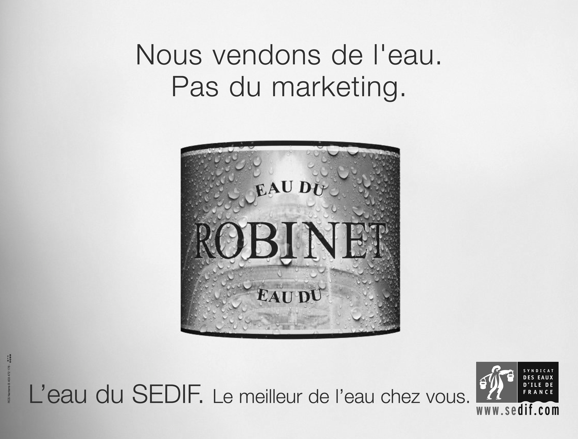
Figure 4: “We sell water. Not marketing. The water from SEDIF, the best of water at your home” (Credits: Syndicat des Eaux d’Ile-de-France / agence BBDO)

This campaign created a public debate on the price of water, the quality of tap water and waste related to water bottles. In 2005, with a similar approach to promote tap water, the city of Paris was the first to distribute water carafes in France. The event was well covered by medias thanks to two key elements: an in-situ event organised on the main place in front of the city hall, and the design of the bottle. The bottle was created by a designer and presented as a new trendy way of drinking tap water. It included blue inscriptions on the bottle and later, Eau de Paris developed further printed messages on the bottle to sell new branded bottle. Today, each district has its own branded bottle and Parisian can but them online. Such a public relation operation started the debate about drinking tap water in France over bottled water. Such initiatives became nation-wide.
In 2006, Besancon was the first city to produce and sell its own bottled water with the support of a distribution company and supermarkets. This public utility decided to put tap water into a glass bottle and to sell it in at a very cheap price in supermarkets. They named the bottle “the Bisontine”. When questioning the manager of this operation, he explains that the city of Besancon wanted to promote its tap water since it was very good quality water. They also wanted to reduce plastic waste, to bring cheaper bottled water and to bring awareness from citizens about producing tap water. The operation was not profitable itself but was considered as an innovative way to promote a stronger sense of citizenship and pride from inhabitants. The Bisontine was a local product that helped people to feel part of the city and to have their own symbol.
In 2010, the city of Mulhouse also used tap water to promote the image of the city towards both foreigners and local inhabitants. The town distributed a water bottle designed by a local artist representing one of the most famous flat of the city. The objective was to both promote arts and tap water in the region. Today, many French cities have their own water carafes and promote tap water such Dijon, Lille, Marseille. It became a general trend that can be observed in many other European major and worldwide.
Such initiatives are part of a general global movement. In 2003, Vandejong, an Amsterdam-based advertising bureau initiated Neau, a water bottle, as a joke: “Neau makes you pay again for water that you already paid for?” They created a bottle to use tap water in the office. In 2005, the advertising bureau organised a major campaign in Amsterdam to promote the consumption of tap water and to raise awareness of citizens on the alternative of drinking tap water rather than bottled water. They initiated partnership with several companies including Ikea and distributed 5,000 bottles to their employees. They also sold thousands of bottles to several festivals. This initiative is considered to be one of the first initiatives to promote tap water against bottle water (Gleick, 2011).
In Switzerland, the city of Geneva intensively promotes its public water. The city has created its bottle, developed partnership with UNICEF, street event including the operation “Water is a present” with giant fountains in crafted paper. They organised media campaigns with famous actors to continue promoting tap water.
In the USA, Craig Zucker, a young entrepreneur created a buzz by selling its NY tap water in 2008. The bottle became heavily successful and represented the “water of New York City”. The branding played a key role in the success of the bottle. It first played with words as reference to NY’s slang and the famous logo “I love NY”. The double representation of pipes in building shapes introduced codes of the city famous skyline. Then, messages played with the opposition with bottled water with key phrases such as “No glaciers were harmed making this water” or “Not from the top of some far away mountain”. The approach is to against traditional slogans of bottled water.
In the UK, Give me tap has successfully developed a tap water bottle to Londoners in 2011. Edwin Broni-Mensah, a PhD student launched this initiative after missing tap water on his university campus, working with cafes and restaurants. The initiative is widely disseminated through the emblematic figure of the founder. The initiative also dedicates 70% of its revenues to humanitarian cause pleading for the general interest. The slogan “Making our world a fountain” is simple and conveys the values of sharing around the symbolic representation of a fountain. Fountains are public infrastructures. They used to be important point of meeting in medieval times (Caulier, 1990). It gives a sense of citizenship and sharing.
All those initiatives are playing with the codes of bottled water, health communication and relation to risk. They however add codes from Environmental Communication, sustainability and responsibility. They started a war between bottled and tap water. In March 2010, the Story of Bottled Water summarised the conceptual approach to drinking tap water as opposed to Bottled water. It also clearly advocated for new consumption habits and relations to natural resources (www.storyofstuff.org). Later in July 2010, the initiative Bottled Water Matters (www.bottledwatermatters.org) released a similar type of TV spot to contradict the arguments of “The Story of Bottled Water”. Both spots summarised the wars over tap versus bottled water.
Several utilities (Paris, Besancon, Geneva…) wanted to show their added value as a service provider and entered the public sphere using marketing strategies. The engagement to promote tap water is usually combined to a political vision and way of considering water services. The latest European Citizen Initiative about the right to water is one of the examples of using water resources as an ideological discourse. Many utilities in France, Paris being the main symbol; advocated for tap water as a public water service promoting the value of citizenship and environmental responsibility rather than buying water, symbol of capitalism. The marketing of tap water over mineral water initiated new consumers' identities and practices: drinking tap water is not only about prices, it's now about how one sees its society and way of consumption.

In short, communication campaigns about water quality and quantity question individuals about their relationships with their cities and territory. They are promoting engagement and new responsibilities towards water services and water resources. The issues of quality or quantity are building discourses related to a way of consuming water and relates to values and behaviours.

CONCLUSION
Today, many consider that water utilities have direct access to their customers and to citizens. They can have a strong local impact when looking at changing people’s behaviours. The most efficient and adapted communication for the water cause is at the local scale. It supposes to involve communities and to integrate multiple criteria in particular cultural, socio-economical and political background and specificities. There is a strong need for utilities and water managers to further communicate to their public about water resources management and water services.
In terms of local and regional interfaces, these results show the importance of implementing communication approach to better manage water resources but also to bring further public awareness and behavioural changes. The later need time, interaction and mediation, the implication of different stakeholders for multi-targeted types of campaigns. It underlines the importance of integrating communication and social sciences into the cycle of water resource management as part of its management. Utilities, Basin Agencies or Regional States can develop this competence thanks to their own department of communication in cooperation and the support of Regional and National funding. In terms of management, it also suggests building specific competences and skills based on the expertise of communicating about environmental resources, and more specifically water resources.
The emergence of “water communication” as a specific skill can facilitate the work of both local authorities and regional organisations. It participates to engage citizens at the local scale, individuals tend to be more aware of environmental issues and the role played by their cities. Local campaigns from water utilities create dialogues between water users at different scales, they articulate local and global scales bringing clearer understanding of local water management compared to general trends. This research shows the multiplicity of existing communication tools developed by water utilities and how they play various roles. They are particularly interesting in creating social cohesion and sense of responsibility towards both natural resources and territory. Water utilities can support the development of citizenship, local engagement and preservation of local water resources, a key to improve water resources management.

BIBLIOGRAPHY
Boutelet, M, Larceneux, A, Barczak, A. (2010) Gouvernance de l’eau. Intercommunalités et recomposition des territoires, Editions universitaires de Dijon, France.
Casciarri, B., Van Aken, M. (2013) Anthropologie et Eau(x), dans Journal des anthropologues, n°132-133.
De Vanssay, B. (2003) Les citadins et l’eau dans le monde. Représentations et comportements à Jakarta, Ouagadougou, Brasilia, Madrid, Munich et Osaka [Citizens and water in the world. Representations and behaviors in Jakarta, Ouagadougou, Brasilia, Madrid, Munich and Osaka], in VertigO : La revue en sciences de l’environnement, N°4 (3), p. 1-6.
Directive 2000/60/EC (2000) “Establishing a framework for Community action in the field of water policy”, Official Journal of the European Communities, 22.12.2000, L. 327/I.
Eurobarometer (2012) “Attitudes of Europeans towards water – related issues”, European Commission, Flash Eurobarometer 344, TNS Political & Social, Flash Eurobameter 344.
Eurobarometer (2009) “Flash Eurobarometer on water. Analytical report”, European Commission, Flash EB Series #261, The GALLUP organisation, Flash Eurobameter 295.
Eurobarometer (2008) “Attitudes of European citizens towards the environment”, European Commission, Special Eurobarometer 295/ Wave 68.2, TNS Opinion & Social, Eurobameter 295.
European Commission (2012) “Environment: Europeans call for stronger EU action on Water”, IP/12/289, 22/03/2012.
EUREAU (2008) EUREAU Statistics Overview on Water and Wastewater in Europe, Brussels, Belgium.
Gleick, P. (1993) “Water and Conflict. Fresh Water Resources and International Security” in International Security, Vol. 18, No 1, Summer 1993, pp. 79-112.
Gleick, P. (2011) Bottled and Sold. The Story Behind Our Obsession with Bottled Water, Island Press, Washington D.C., USA.
Krieg-Planque, A. (2007) «Les discours dans la pluridisciplinarité. Exemples d’une « manière de faire » en analyse du discours » dans Bonnafous, S., M., Temmar, Analyse du discours et sciences humaines et sociales, Ophrys, Paris, pp. 57-71.
Jambes, J.-P. (2000) « Territoire en questions : doutes et réponses de la géographie », in Territoires sous influence, L’Harmattan, Paris, France.
Le Net, M. (1993) Communication publique : Pratique des campagnes d’information, Les Études de la documentation Française, France.
Libaert, T. (1992) La communication verte, Editions Liaisons, Paris : France.
Libaert, T. (2010) Communication et environnement, le pacte impossible, PUF, Paris, France.
Mayer, P.W., DeOreo, W.B. et al. (1999) Residential End Uses of Water, American Water Works Association, Denver, Colorado, USA.
Poirier, J.-P. (2012) L’eau, objectif du millénaire ou l’incurie des Etats, Autre Temps Editions, Paris, France.
Quevauviller, P. (2009) Water System Science and Policy Interfacing, Royal Society of Chemistry, London, UK.
Tournier, M. (1985) Texte « propagandiste » et cooccurrences. Hypothèses et méthodes pour l'étude de la sloganisation, dans Mots, n°11, p. 155-187
Turgeon, S., Rodriguez, M. J., Thériault, M., and Levallois, P. (2004). Perception of drinking water in the Quebec City region (Canada): The influence of water quality and consumer location in the distribution system, in Journal of Environmental Management, n° 70(4), p. 363-373.

? Phone interview, June 2013.
? Seminar of communication, "Communications, Disputes and Participatory Monitory from Quality Direction", ANA, 21st June 2013.
? The cost of the campaign: £120,000 / 150,000 €. For the full cas study, www.effectivedesign.org.uk
? www.thameswater.co.uk/waterwisely

