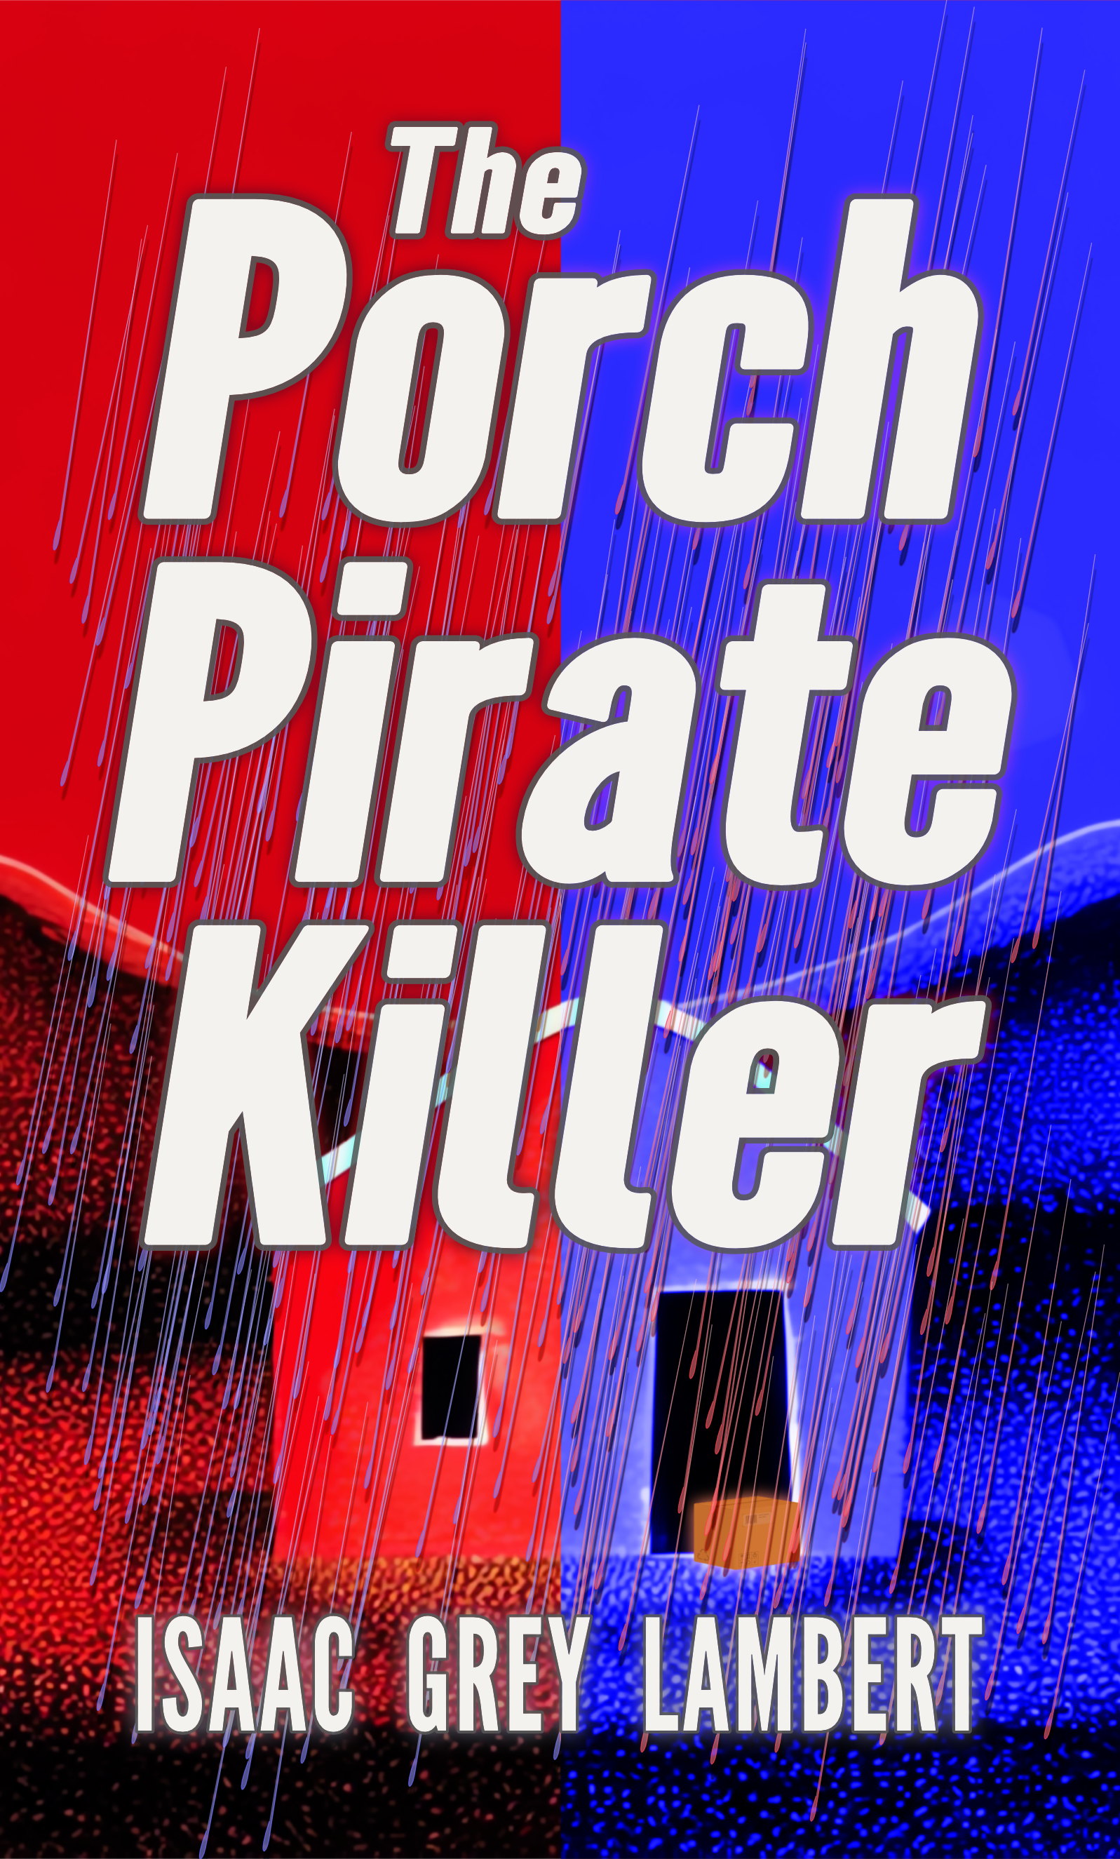
FOR IMMEDIATE RELEASE

HEADLINE

“The Porch Pirate Killer” drives a new wedge through the heart of a nation scarred by partisan division.

SUBHEADING
Author Issac Grey Lambert finally speaks.

DATELINE
The United States of America, September 2025.

INTRODUCTION
The world stands divided over author Issac Grey Lambert’s uncompromising new thriller “The Porch Pirate Killer”.
In today’s unprecedented cost-of-living crisis, petty crimes have become commonplace, almost to the point of normalcy. In “The Porch Pirate Killer”, an ordinary citizen unleashes a vicious, bloody retribution on those criminals, with far-ranging consequences, plunging a nation already fractured by partisan hostility into open conflict.
Readers are in bitter opposition. Some applaud the killer’s actions, seeing justice delivered, however brutally so. Others see only a murderer, regardless of the justification. If someone were to steal from you, how far would you go?

AUTHOR QUOTATION
“The novel takes no stance on the righteousness of the Porch Pirate Killer, nor does it justify violence in an arena, or is it a diatribe on perceived or actual socio-political failings. My role is to tell the story; these issues are for the reader to decide. What is apparent today is the fractious, partisan nature of politics in the United States. Where these factions collide so fiercely, a void forms where reactionary individuals, like the killer in this story, can flourish and grow.”

MINI AUTHOR BIO
Issac Grey Lambert is the visionary author of “The Porch Pirate Killer”, and the Bloody Colony book series. His executive editor, a local cat who drops by to supervise his writing efforts, is almost certainly using mind control to ensure a steady supply of fishy treats.

BOOK. INFORMATION
Terrorising the American Midwest, a prolific serial killer is targeting the small-time criminals law enforcement has long since ignored.
The news media dub him the ‘Porch Pirate Killer’.
To some, he is the embodiment of societal frustration at the normalisation of petty crime; to others, a terrorist bent on death and chaos.
Conflict between supporters and critics of the PPK’s crusade drives a new wedge through a nation scarred by partisan division. As rival factions become increasingly unstable, violence spills out onto the streets, triggering fears of civil war.
When the president places their political agenda above the capture of the Porch Pirate Killer, the FBI diverts all resources into protecting the president’s narrative. Empowered to murder without restraint, only an inexperienced team of academics and a disgraced former agent stand in the way of the killer’s brutal rampage.

CHARACTER QUOTE
“Mass murder is messy business; some collateral damage is inevitable.” - Professor Heinrich Sabine.

CONTACT DETAILS
For review copies, contact: requests@quahx.com. View the media kit at: https://quahx.com/theporchpiratekillermediakit. The author is available for interviews and podcasts.

CALL TO ACTION
Find out what side you are on! “The Porch Pirate Killer” is a crime thriller by Issac Grey Lambert. Available in digital and print only from Amazon Books from September 24 2025.

###

