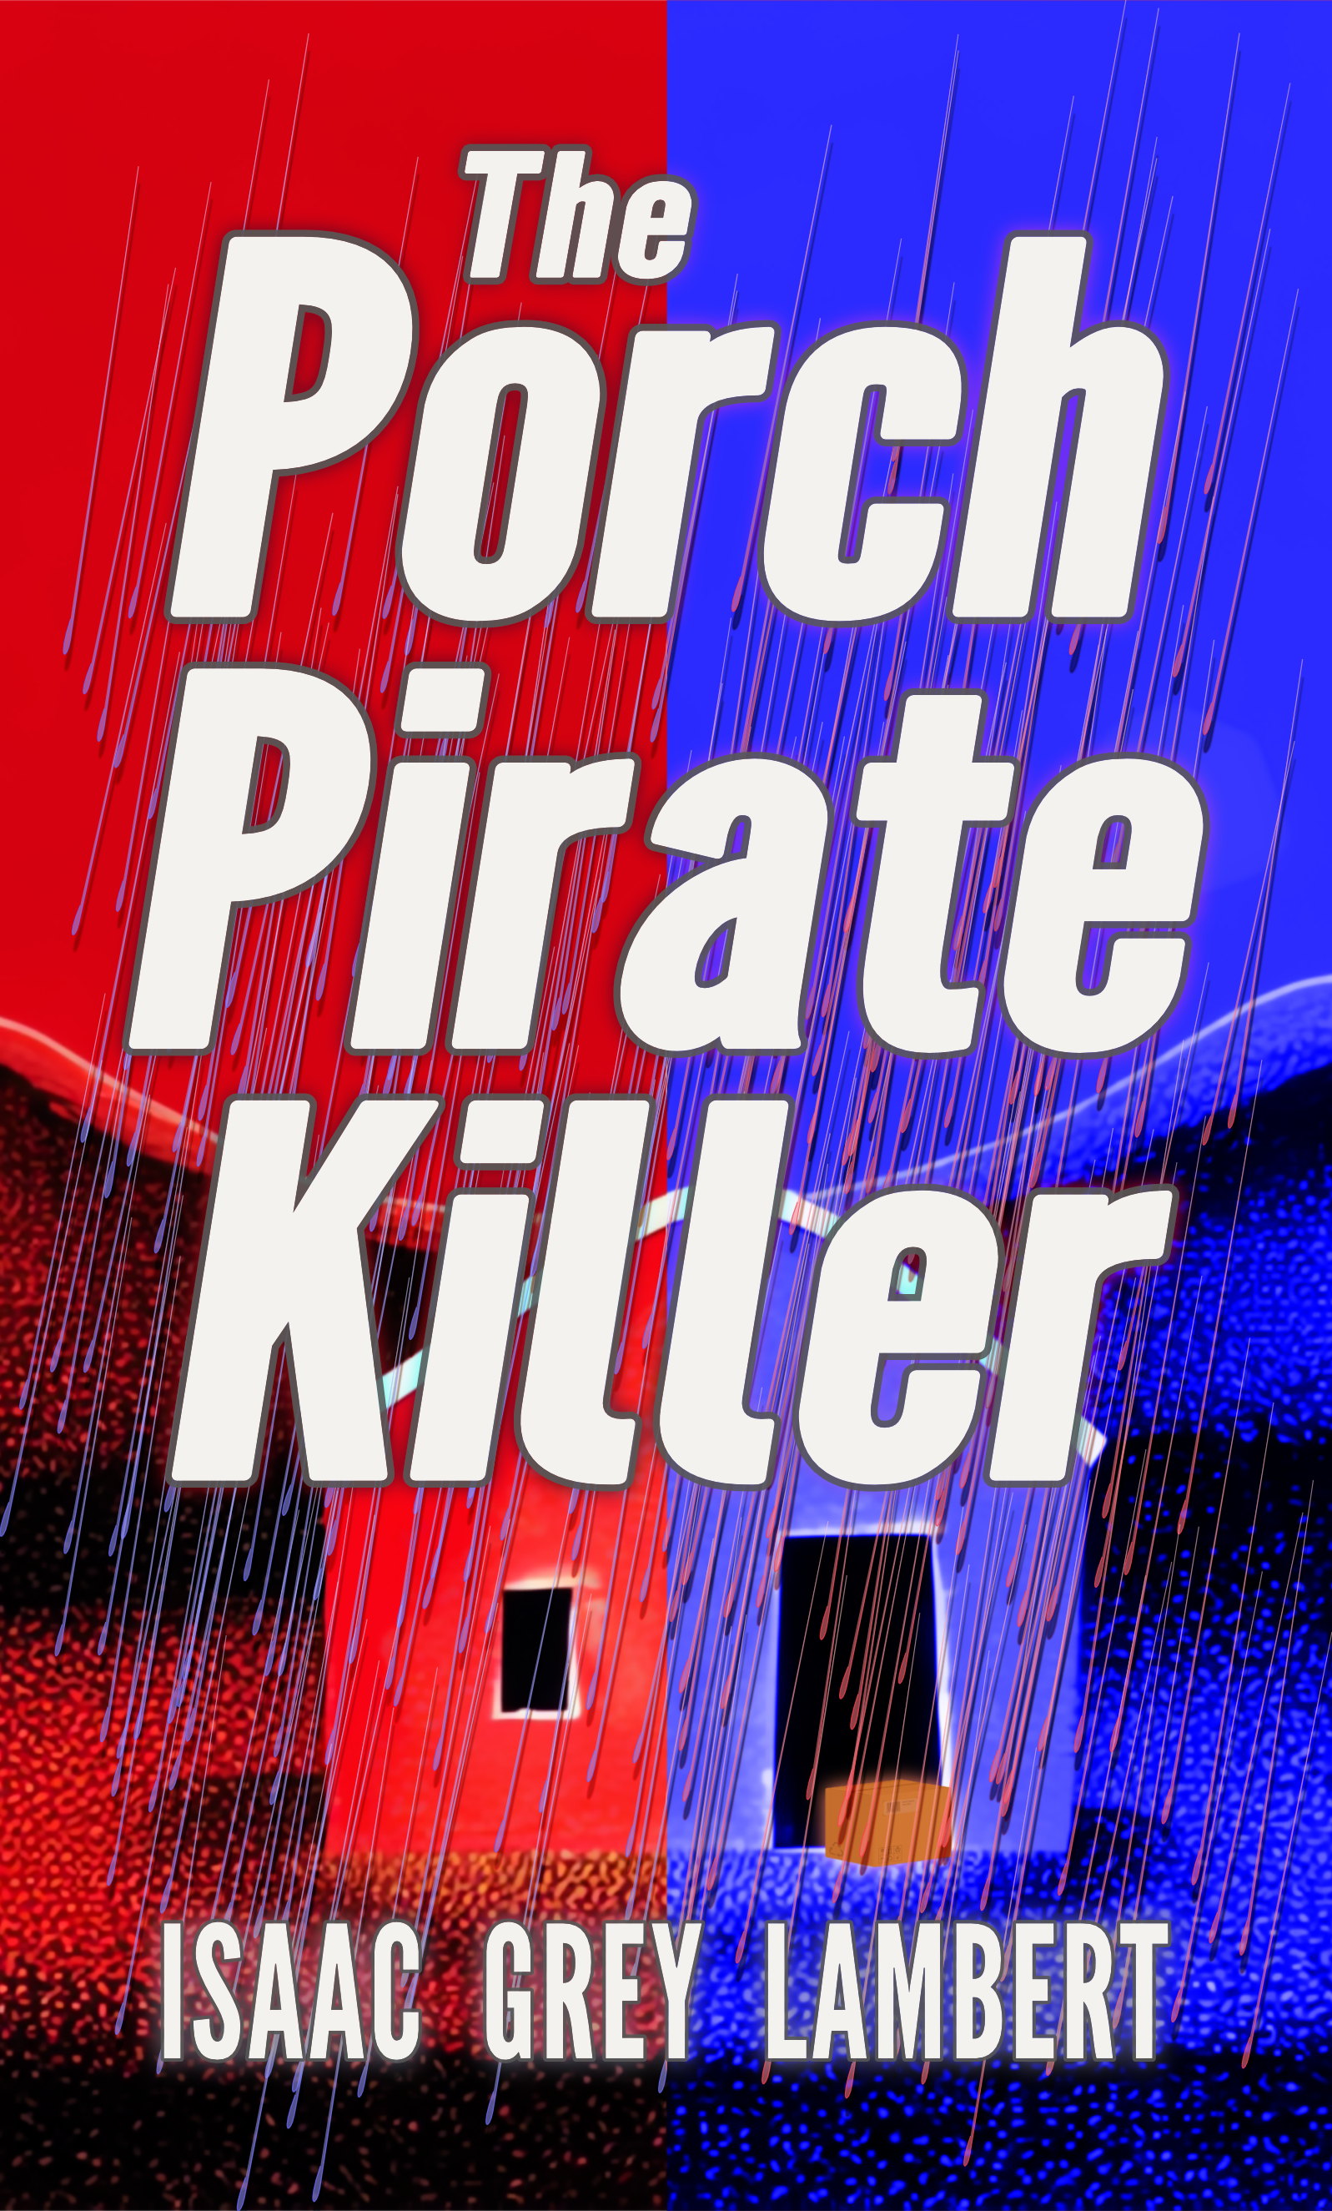
BOOK EXCERPT

BOOK

“The Porch Pirate Killer”.

AUTHOR
Issac Grey Lambert

COPYRIGHT
Copyright © 2025 Quahx Limited. All rights reserved. This excerpt is provided for promotional and media purposes only. No part of this excerpt may be reproduced, distributed, or transmitted in any form or by any means without the prior written permission of the copyright holder, except for brief quotations used in reviews or media features, under fair use.

EXCERPT
The opening prologue chapter.

The Porch Pirate Killer
Issac Grey Lambert

Cold Open
——————

“Just get in the car.”
“This ain’t my thing no more.”
Isaiah leaned over the hood. “Making money — that ain’t your thing? Oh, please, you think King Fed is gonna gift wrap you a solid gold toilet seat? Get in, I need your fast legs.”
“Nah, I gotta stay straight.”
“Straight ain’t gonna feed your crumb snatchers, or buy cred.”
After tussling with indecision, Jaden finally found the door handle. “You’re a total clown, man.”
“Now, that’s more like it. You never know how strong you can be unless you have something to fight against.” At the third crank, the Chevrolet Malibu spluttered into life, if noisily so.
Only two miles of travel brought them to North Philadelphia. Although early, the acrid reek of burning asphalt already washed through the car windows. The vehicle rumbled over the Reading abandoned freight line, closed before either of them were born, now only useful as a token moat around North Philadelphia.
“Where’s this?”
“Hunting Park.”
“You know there’s booty?”
“I got the four-one-one.”
“Your pal out west?”
“Yeah. Cost me though.”
“Huh.” Jaden peered nervously from the passenger seat. “Don’t you worry about the bad news?”
“Not that Porch Pirate Killer hawk tuah, again. Jay, boy, there ain’t no PPK. It’s a smokescreen created by the machine to keep you in a little box, a little box this big, far away from the American dream.”
“This is the American dream?”
“Free enterprise, my friend, nothing more American than that.”
“Even swipe?”
“Especially swipe. It’s what billionaires do. You wanna get rich, don’t you? Then act like the rich.”
“True.”
North Broad Street ran ahead under the morning shadows. Faded day-glow signage announced the gratuitously overpriced fast-food eatery ahead well before the letters could be read. The restaurant further announced its presence with gratuitously pumped artificial cooking smells, meant to engender hunger, in the way Pavlov’s dog salivates at the sound of a bell. Overhead, billboards screamed the latest products anyone could aspire to, but few could afford.
Crossing the junction with West Hunting, Isaiah drummed the steering wheel. “There, that’s what I am talking about.” Ahead, caught in the busy street, a dark grey delivery vehicle queued in traffic.
“And now?” Jaden allowed a tinge of faux naïveté to escape.
“The chase is on!”
Oblivious of their presence, the van driver began a circuitous path through Logan and into Olney. The first few stops proved fruitless, with recipients eager to open up and gratefully accept the packages offered.
The next drop provided more potential. The courier lingered at the door, rang the bell a second, and then a third time. Convinced no one was home, the driver found a new home for the package behind a boxwood plant pot and returned to his cab.
Isaiah ground a wheel along the kerb. “Ready?”
“Uh-huh.”
The van circled out of sight. “Go!”
At a swift pace, Jaden easily vaulted the picket fence and ran for the front door. Seconds later, having driven further up the street, Isaiah idled long enough for his cohort to jump back in.
Accelerated back into the chase, the van soon came back into view. “What have we got?”
“Pay dirt. Kitchen mixer in stainless steel.”
“Sweet.”
“Whoa!”
Aggressively braking, Isaiah wished he’d secured the seatbelt. “Unbelievable.” He stretched out the syllables as if they were trying to escape.
A large white pickup truck had cut in front, drawing to a screeching halt.
“You gonna take that?” Jayden demanded. “What an asshole.”
“No. Wait. Look.”
Alighting with a swagger, the driver retrieved a branded box. Halfway up the path to the nearest house, he deposited the delivery, then scribbled on a clipboard.
“Now that’s so yesterday.”
“And lazy as hell. The door is right there. Lame.”
Without acknowledging them, the pickup driver exited at the top of the street.
“Go, go, go!”
Running out and back, having already torn through the outer packaging, Jaden appeared excited. “Laptop, super high-end, for scientists or some shit. Must be worth five thousand at least.”
“Nice. That’s a whole damn day, right there.”
“We lost the van?”
“No matter. We can get this down to Gregory. With the mixer, that’s at least four hundred each.” Isaiah conjured the onward chain, the knock-on effects. Greg offloads to the reseller, who would list it online, or run it through another fence. The buyer, blinded by the bargain, would not care if it was stolen, considering how it might help their studies, career, or gaming rep. Someone might even steal it during delivery, creating a beautiful cycle of opportunity. More than that, he imagined the drug-fuelled night ahead, the women he could afford, and the kudos having some money to splash around would buy. He might end up face down in the canal, of course, but that is an acceptable risk for anyone dropping Philly dope. His dealer, flushed with cash, would make bigger and more lucrative deals, eventually opening a new cartel drug corridor. It will kill hundreds, if not thousands, but heck, no one cares about expired urban campers, except as litter. For Jaden, he imagined him arriving home with shopping bags brimming with diapers and formula as a conquering hero. His kids would attend Princeton, or some such, become lawyers or veterinarians, something cool like that. One might even become President or Vice President, if not quite popular enough.
“Hey, he’s back.” Jayden pointed to the turn at the head of the road.
“Well, he ain’t getting it back. Rules of the road, buddy.” Isaiah made a gun gesture over the steering wheel. “Go on, scram if you know what’s good for you.”
The driver of the pickup gazed directly at them. A look only enlivened with dismay or exasperation. Not like the disappointment at a mischievous child, or the groaning response to a terrible dad joke, but the kind that communicated pity, or a shared regret.
Jaden regarded the box in his hands as if it contained every poison, bacteria, and virus known to man.
Blankly, tearless, the anonymous driver curiously watched the Chevrolet Malibu wrench with an ear-shattering crack, then mushroom with flame-bordered smoulder. Raging flames lashed the windows into ashen smears, stifling the cries within. A rolling stench of burning flesh washed over more quickly than expected. The watching driver drew in the smell as if savouring the bouquet of a fine wine.
Senseless seconds stretched time itself until a figure emerged, roughly human-shaped, from the Malibu driver’s side. Screaming, consumed in roaring flame, it crumpled to the asphalt.
Doubled into a pugilistic pose, caving to the pressure of fiercely contracting muscles, bones audibly snapped. Released body fluids washed like a fetid comber, rolling between pocketing crops of heat.
Isaiah’s last breaths only drew further fire into his lungs.
Once the twitching body became still, the watcher drove away.

###

