FOR IMMEDIATE RELEASE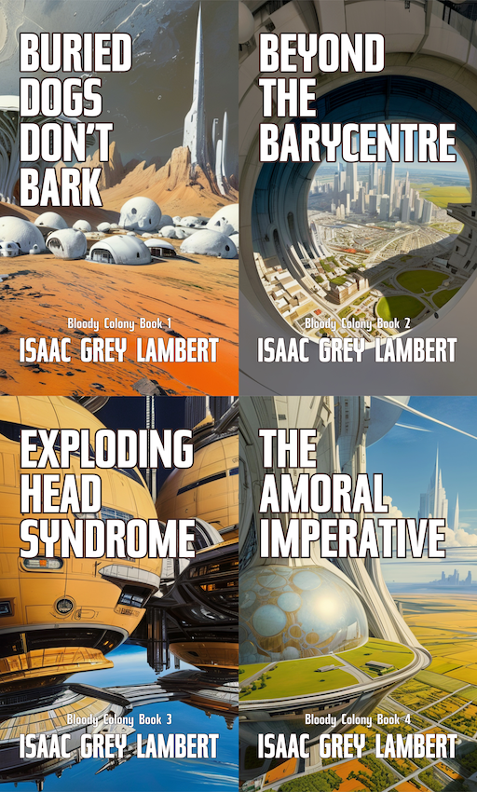

## HEADLINE

# Death, hubris, and the unfathomable dread of outer space: A journey to the worlds of the “Bloody Colony” book series.

## SUBHEADING

Author Issac Grey Lambert on building a universe.

## DATELINE

The United States of America, September 2025.

## INTRODUCTION

Across four volumes, author Issac Grey Lambert explores a potential future in the human colonisation of space.

The series charts a fictional future of human colonisation. From the driving forces on Earth that propel humankind into space, to life on the savage outer colonies, each story contributes to the mosaic of human advancement.

With powerful imagery and shocking twists at every turn, Bloody Colony is a must-read for fans of sci-fi horror. From brutal alien encounters to impossible choices, these stories take you on a journey through the darkest corners of human nature and out into the savagery of the unknown.

## AUTHOR QUOTATION

“The colonisation of space by humans is a certainty; we will conquer the stars. The problem is, as we venture into the unknown, we must also take the worst aspects of humanity with us; our greed, vanity, arrogance, and depravity.”

## MINI AUTHOR BIO

Issac Grey Lambert is the visionary author of “The Porch Pirate Killer” and the Bloody Colony book series. His executive editor, a local cat who drops by to supervise his writing efforts, is almost certainly using mind control to ensure a steady supply of fishy treats.

## BOOK INFORMATION

Death, hubris, and the unfathomable dread of outer space. Welcome to the twisted worlds of Bloody Colony. Tales of science fiction horror from the future of space exploration.

Space is vast, cold, and indifferent. In the Bloody Colony series, it is also grotesque, treacherous, and terrifyingly human. With stories that twist like a knife and imagery that burns itself into the mind, this is science fiction horror at its most uncompromising.

What makes this series extraordinary is its blend of pulp thrills with literary depth. The gore is vivid, the scares relentless, but behind every scream lies a question: What happens when human ambition outruns human morality? Fans of Black Mirror, The Twilight Zone, and The Expanse will feel right at home, yet this is no imitation.

The series is in twenty stories across four volumes: "[Buried Dogs Don’t Bark](https://www.amazon.co.uk/dp/B0DCT4X61N)", "[Beyond the Barycentre](https://www.amazon.com/dp/B0DCQQQ764)", "[Exploding Head Syndrome](https://www.amazon.com/dp/B0DCT1ZP3Q)", and "[The Amoral Imperative](https://www.amazon.com/dp/B0DCT38Q4J)".

## CHARACTER QUOTE

“The cold of space does not discriminate, has no interest in what memories bring you solace, what debts you owe, or which cause brought you to this place. It only cares how you die.” - Emily Angstrom.

## CONTACT DETAILS

For review copies, contact: [requests@quahx.com](mailto:requests@quahx.com). View the media kit at: <https://quahx.com/bloodycolonymediakit>. The author is available for interviews and podcasts.

## CALL TO ACTION

Join the crew! “[Bloody Colony](https://www.amazon.com/dp/B0DCT3WZN7?binding=kindle_edition&ref=dbs_dp_rwt_sb_pc_tkin)” is a science fiction horror series by Issac Grey Lambert. Available in digital and print only from Amazon Books from August 10 2024.

# ###