BOOK EXCERPT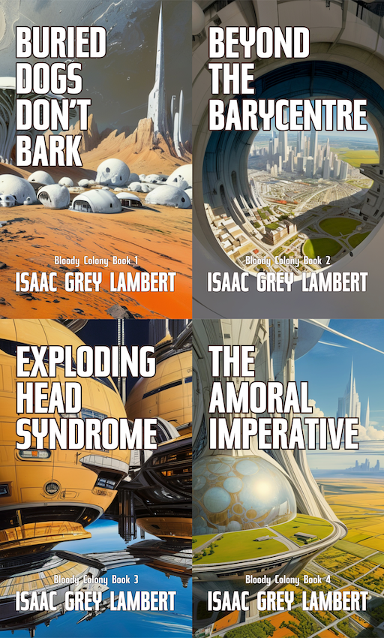

## BOOK SERIES

# “Bloody Colony”.

## AUTHOR

Issac Grey Lambert

## COPYRIGHT

Copyright © 2025 Quahx Limited. All rights reserved. This excerpt is provided for promotional and media purposes only. No part of this excerpt may be reproduced, distributed, or transmitted in any form or by any means without the prior written permission of the copyright holder, except for brief quotations used in reviews or media features, under fair use.

## EXCERPT

The opening chapter of the first story in the series.

# Buried Dogs Don’t Bark

Issac Grey Lambert

Grav(e)

——————

Taller than most men, Inspector Burr Lagerfelt unfolded from the driver’s seat. The wind whisked away exhaled air before a frosty breath could form. Fortunately, the trunk yielded a heavy overcoat and a pair of dark green Hunter boots. Now steeled against the blasting snow, he carefully trudged toward the crime scene.

The twisting street, semi-rural and bordered by hedgerows, aped the establishing shot of a horror film. Houses, designed by an architect’s roll of the dice, screamed mundanity. The home opposite, bedecked in migraine-inducing yuletide decorations, threw reds and greens across the yard. The tour de force, an actual size Santa sleigh in dazzling lights, leaped daringly from the roof as if trying to escape.

The white stuff fell in sparse but sizeable clumps. Burr pulled through the twenty plus words for snow in Swedish, settling like the flakes on ‘Drivsnö’. The banking drifts confirmed it, but fortunately, someone had recently ploughed the road. A longing haze gripped the distance, partitioning the neighbourhood from the rest of the world.

Hair hastily stuffed into a beanie hat, Sergeant Cristina Stelig watched his approach, guarded against frigidity by two steaming coffee cups.

“Where the hell did you get those out here, Stelig?”

“I pulled over a delivery boy and took them.”

“Funny. I guess you just got here?”

“The coffee temperature?”

Lagerfelt laughed. “No, you haven’t bitched about the cold yet.”

“Give me time.”

A young officer he didn’t recognise eyed his warrant card, then lifted the crime scene tape stretched across the front of the building. The officer saluted unnecessarily. A rookie, clearly.

The house carved a crooked line between land and sky. Unusually steep rooflines, even for the northerly climate, drew the eye up to a large cross pinioned upon the highest tower. Perched at the corners, gargoyles poured scorn upon passersby. Far away, clouds rolled into the darkness, chased by bitter, southerly winds. A picket fence caught the snow in a drift, defiantly masquerading the landscape.

A placard declared the residence to be ‘137 Kopplingsväg, Mastema Hus’.

As they drew near, decked in pristine white protective gear, a ghostly figure materialised against the doorway.

“Jesus, Anna, you look like someone buried your dog.”

“In a sense, they did.” Anna Livgren, Senior Crime Scene Investigator, tugged at her suit, allowing the chilly night air to permeate. “Welcome to the home of the esteemed Professor Pip Briar.”

“Why are we here, Livgren?” Stelig started to feel the cold. “Dispatch said suicide. We, as you know, are murder cops.”

Anna looked directly at the inspector. “That’s not why I called you.”

Burr roved from consternation to intrigue in seconds, furtiveness not usually one of Anna’s foremost traits.

“Other than you two being on the roster.” Anna sought to explain. “I had to tell someone. Show someone.”

Cristina and Burr exchanged glances.

“Ditch the caffeine. You won’t need it to stay awake. Wear these.” The C.S.I. handed him a disposable forensic suit packed in clear plastic. “Follow me.”

Cristina took Burr’s coffee, thumbed the lid, poured it into her own. “I’ll canvas the, er, neighbourhood, I guess.”

Briar’s house, although expensively furnished, had seen better days. The portico opened into an opulent foyer, adorned with tall portraits, each gazing disapprovingly at the latest trespass. Dust begrimed every surface, accumulated over what must have been decades. Modernity had wisely found somewhere else to live, displeased at the strewn mess of antiques and obsolescence.

Large reception rooms flanked the entrance, replete with uncoordinated tables and chairs. Corners hoarded piles of papers and books, making inviting homes for opportune rodents. Widening at the final steps, the main staircase wound slowly, arriving at a hanging balcony. On either side, corridors led the eye further inside. An alcove housed an ancient telephone, complete with a writing pad and a pen secured by a length of string. A side room gave Burr cause to stop: a small chapel with pews and a tall stained-glass window depicting Christ’s ascension in a triptych.

Anna stepped gracefully on the scene-preserving stepping plates, as if playing hopscotch. Earned in equal parts at the Oslo Ballet School and years carefully navigating crime scenes.

Cleanliness spent the past few years giving the kitchen a hard pass. Half-eaten pizza and fast food containers littered the surfaces. An open gherkin jar festered with what appeared to be an entirely new species of life. Bulging dog poop bags spilled from a dustbin.

The good professor seldom hosted dinner parties.

Burr gagged at the miasma. “Did you find the dog alive, at least?”

“No. There’s no dog, alive, buried, or otherwise.”

“Oh.”

At the rear of a laundry room, an alcove transitioned into a stairway, leading down to a cellar or basement of some sort. Burr almost expected Dante to appear dressed as an usher.

“After you.” Anna handed Burr a torch. “There are no lights until…”

“Until?”

“You afraid of a little mystery?”

“I’m not one for guessing.” He attempted to hide a rising irritation.

The scientist paused, the pause where someone would usually find somewhere to sit, but no one sits at a crime scene. “I need someone to tell me honestly, directly, if I am going insane.”

If Burr had been sitting, he would have stood up. “Let’s find out, shall we?”

Burr found the stairs narrow but well-built. When he expected the steps to end, a landing provided a further descending flight. The staircase snaked around an assemblage of pipes and ducts, the purpose of which was not immediately apparent. Audible sounds weirdly failed to echo, as if dampened somehow. Burr turned the light backwards to ensure Anna still followed. If this was some kind of elaborate practical joke, it was pretty fucking good.

A chilling draught rose from below. Noticing him shiver, Anna volunteered: “The lower levels are temperature controlled.”

“Lower levels?”

Finally, the stairwell turned into a short tunnel, then widened into a cavernous open space.

“How deep are we?” the inspector demanded.

“Seven stories, twenty-five metres, give or take.”

Burr’s nose wrinkled.

“Yeah, even the best air conditioning can’t fully eliminate decomp.”

As they ventured further, tables of scientific instruments ringed the room. Strange apparatus, spotlessly clean, glinted in the artificial light. Taking up the entire furthest wall, a complex machine hummed quietly. Large cylinders, like the pipes of a cathedral organ, reached to the ceiling.

Burr could feel the floor vibrating in concert with the device, even through the thick soles of his wellingtons. He fished a police notepad from a jacket pocket but returned it. After all, how could words describe such a place?

Whiteboards formed a corralling circle, replete with incomprehensible equations and schematics. Stacks of technical manuals heaped in Jenga towers stood ready to topple. An ancient computer made from glass valves hogged a corner, daring any casual visitor to decipher its purpose. Fragile chemistry apparatus covered an entire bench. Liquids of differing colours competed to win the race to be dripped into the final beaker.

“Secret underground lab.” Burr turned slowly on the heels of his boots. “Scratch that one from the bucket list.”

In the centre, a fresh corpse slouched in a high-back Kahazy armchair, the kind more usually found in the dusty library of a stately home. The cadaver’s expression seemed accepting, almost nonchalant. An occasional table with a decanter of whiskey and a single glass stood to one side. The body still clutched a shiny revolver.

Burr appreciated the cliché, even if a little too on the nose.

“Colt Anaconda.” Anna observed. “One of the world’s most powerful handguns.”

“Well, if you want a job done well, choose the right tool.”

“Amen to that.”

“As unique and bewildering as this place might be, it’s not what we are here for, though, is it?”

“It is not.” A tasselled red dust sheet covered a large rectangular shape. Anna pulled the covering away, revealing what appeared to be a tall dressing mirror, but without a reflection. Looms of wires snaked from the mirror pedestal across the floor and into the vast machine. “This is.”

Inside the frame, as if looking into an antique clock, an endless myriad of mechanisms whirred. Cogs, spindles, pinwheels, dials, and cantilevers moved in soundless synchronicity. As Burr moved, so did the nearer parts of the mechanism, as if it had depth.

“You’re experiencing parallaxes.” The crime scene chief drew out the ultimate word as if it might never be said again. “I thought it was some kind of computer monitor at first, but it’s not that.”

“Riddles, Anna? Doesn’t sound very scientific.”

“Huh. Touch it. Go on.”

“Touch what?”

“The surface. Touch it.”

Burr felt his patience reservoir run dry. “Where is this going?”

“Touch it, then you’ll know.”

More to appease than to overcome reluctance, Burr palmed the surface. The texture, sharply rough to the hand, surprised him. “Weird. I thought this was glass.”

She pointed to the bench next to the inspector. “Hand me that mitten, would you?”

Although piling confusion on surprise, he complied, handing over a long sleeve glove.

Standing before the frame, Anna donned the mitten, then slowly, deliberately, plunged her arm *into* it.

# ###