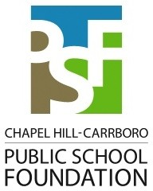Yes, I/we want to create opportunities for students and teachers. Enclosed is our donation for:

$25 $50 $100 $250 $50  $1 

Other Amount: $

0

000

I have enclosed a check for my gift. Please make checks payable to: **Chapel Hill-Carrboro Public School Foundation, PO Box 877, Carrboro, NC 27510.**

I prefer to pay with Visa MasterCard Card Number:

Exp. Date:

Signature:

DM4

Name(s):

My gift will be matched by my or my spouse’s employer. The matching gift form from the employer is enclosed.

I would like to make a gift of stock; please contact me about how to arrange such a gift.

Donations to the Public School Foundation are tax-deductible. Please make checks payable to: Chapel Hill-Carrboro **Public School Foundation, PO Box 877, Carrboro, NC 27510.**