How Choosing a Healthier Lifestyle Can Transform Your Smile
I have been obsessed with teeth for as long as I can remember, in fact one of my first conscious thoughts was about my smile. During my brother’s communion photos in 1985 (see below), the photographer asked us all to smile for the camera and what I said in my head was ‘You’d better not smile now because nobody wants to see your ugly teeth’. Imagine! Poor little 5-year-old me thinking that. You see my teeth we in fact ugly. I had been on medication for pneumonia that stained my teeth and my front baby teeth were noticeably discoloured. So, thus began my life long search for perfect teeth!
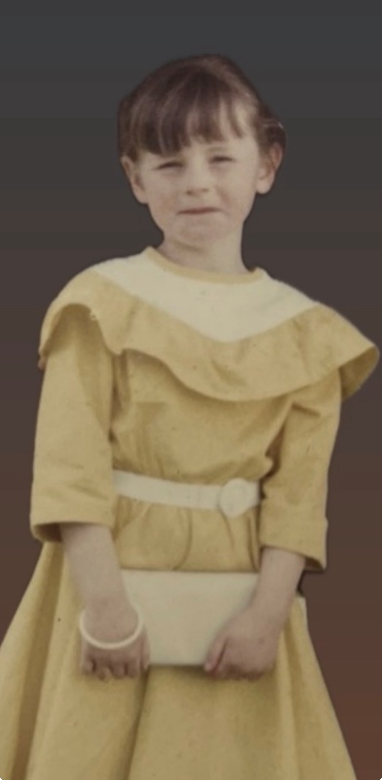
Roll on 2026, when DentiCare Dublin asked me to be a ‘smile ambassador’ and collaborate with them, I nearly took the hand off them with their offer of some cleaning and whitening! After braces, crowns, periodontic treatment, composite bonding and spending thousands on my teeth over the years this seemed like a collab made in heaven! So off I went to Phibsborough to get a cleaning and some whitening. My composite bonding is about 4 years old and I didn’t think much improvement would be made but it turns out that they specialise in cleaning composite bonding and I couldn’t be happier with the result. I had thought about getting composite bonding on the bottom, but they suggested that whitening would suffice and I’m so glad I listened to them because the results are incredible! I am truly delighted with how both my top and bottom teeth have been enhanced with both treatments.
But it turns out that an alcohol free lifestyle can benefit not just our physical and mental health but our oral health too. DentiCare Dublin have listed below how giving up alcohol can not only improve our physical and mental health but our oral health too.
The benefits of an alcohol-free lifestyle on our oral health.
When we think about cutting back on alcohol or embracing an alcohol-free lifestyle, we usually focus on the benefits for our liver, sleep and mental clarity. However, there is one incredible transformation that often goes unnoticed until you look in the mirror: your oral health.
As we embark on a journey toward holistic well-being, understanding the connection between what we drink and our dental health is a vital piece of the puzzle. At DentiCare Dublin, we’ve seen firsthand how lifestyle shifts can lead to a more confident, radiant smile.
The Hidden Connection: Alcohol and Your Mouth
It’s no secret that many alcoholic beverages are high in sugar and acidity, but the real "silent" issue is dehydration. Alcohol leads to a dry moutt, and without enough saliva to wash away bacteria, the risk of decay and gum disease increases. By choosing a healthier lifestyle, you’re giving your teeth a chance to thrive.
Why Your Smile Matters in Your Wellness Journey
- Reduced Inflammation: Cutting back on toxins reduces inflammation throughout the body, including your gums.
- Brighter Teeth: Red wine and dark spirits stain enamel. A cleaner lifestyle leads to a naturally whiter smile.
- The Ultimate Glow-Up: When you feel good on the inside, you want your outside to reflect that. A healthy smile is the perfect complement to radiant, hydrated skin.
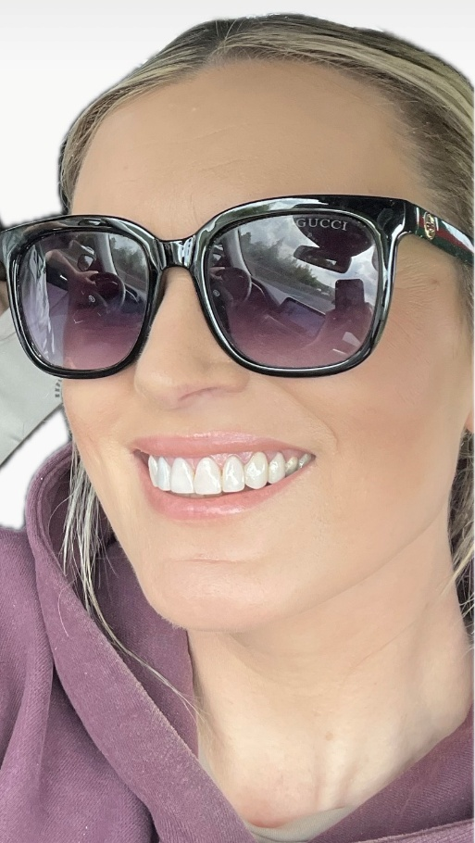
I am absolutely thrilled with my teethal glow up!
(BTW one of my nicknames for years was Teethal Weapon!)
Exclusive Offer for readers!
We want to support you on your path to a healthier version of yourself. As a special gift to this community, we are offering an exclusive "Glow-Up" package:
- FREE Dental Consultation at DentiCare Phibsborough.
- 10% DISCOUNT on all dental treatments!
How to redeem: Simply mention “Olivia Farrelly” when booking your appointment via phone or at our front desk.
Whether you need a routine cleaning or want to explore dental service pricing for a full smile makeover, our team is here to support your journey in a judgment-free environment.

Contact Details:
- Website: www.denticare.ie
- Email: info@denticare.ie
- Phone: 087 415 4835
- Address: 340A N Circular Rd, Phibsborough, Dublin 7, D07 C9HE

