**Article Title**

**Surname N.P.1*, Surname N.P.2 and Surname N.P.3**

*1 Institution, city, country*

*2 Institution, city, country*

*3 Institution, city, country*

*e-mail:* [*author@institute.xxx*](mailto:author@institute.xxx)

**Abstract.** Short description of the topic of the article in 250 to 300 words.

**Keywords:** minimum of 5, maximum of 7 words.

**Introduction**

This section presents the rationale behind the author's choice of topic and a critical analysis of the findings and conclusions drawn from previous research in this field area.

**Methods**

This section should provide a detailed account of the methods, tools and techniques employed in the study, along with a comprehensive description of the process of data collection, processing and analysis.

**Results and discussion**

This section presents a summary of the study's findings, a comparison with previous studies, and an identification of promising areas of research on the topic. This section enables readers to gain a deeper understanding of the scientific and practical significance of the study.

**Conclusions (if any)**

This section may include recommendations regarding the object and subject of the study.

**References**

This section presents a comprehensive account of the resources utilized in the research paper.

**Məqalə adı**

**Soyadı A.A., Soyadı A.A., Soyadı A.A.**

**Xülasə.** Məqalənin mahiyyətinə dair 250-300 sözdən ibarət qısa məlumat.

**Açar sözlər:** minimum 5, maksimum 7 açar söz

The text of the article should be submitted in Azerbaijani, English or Russian language, in 'MS Word' (.docx) format, line spacing 1.0, A4 size, Times New Roman 12 font, 2 cm margins. The total length of the article should be up to 5 pages.

For articles in Azerbaijani and Russian, it is also necessary to submit a brief summary (abstract) of the article in English with the title of the article and the surname, first name and patronymic of the author(s). For articles in English, it is necessary to submit a brief summary (abstract) of the article in Azerbaijani or Russian.

**Table example:**

**Table 1.** Description of table

|  |  |  |  |  |  |
| --- | --- | --- | --- | --- | --- |
| A | B | C | D | E | F |
|  |  |  |  |  |  |

**Figure example:**

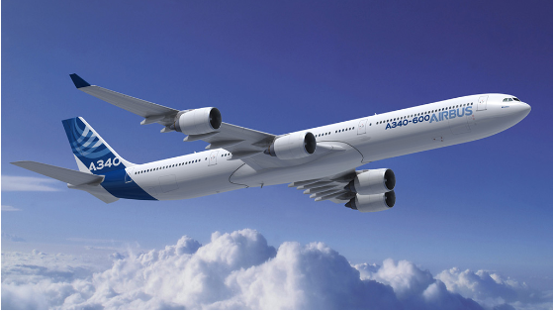

**Figure 1.** Description of figure

**References example:**

[1]Ligorio G., Sabatini A.M., Dealing with magnetic disturbances in human motion capture: a survey of techniques, Micromachines **7**, 1, (2016).

[2] Zakrzewski, R., Sadok, M., and Zeliff, B., “Video-Based Cargo Fire Verification System for Commercial Aircraft,” Goodrich Corporation, USA, *AUBE 2004 Conference*, 291, (2004).

[3] Ring P, and Schuck P, The nuclear many-body problem, New York, USA: Springer Science, (2004).

[4] <https://www.boeing.com/commercial/aeromagazine/articles/2011_q4/4/>