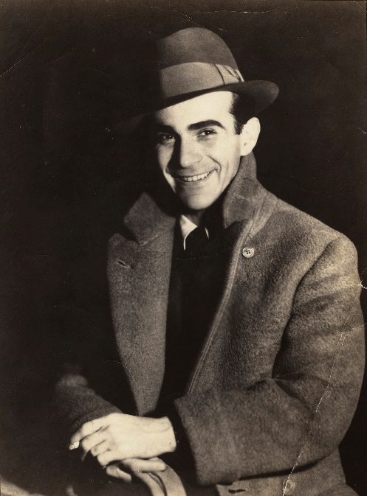

Edgar Snow (July 19, 1905 – February 15, 1972)

愛德加·史諾

Wrote the famous book, “Red Star Over China”

First western journalist to interview Mao Zedong.

<https://www.iqiyi.com/v_19rrnkl7s8.html?vfm=2008_aldbd>