Catalog
  - Special Discount Available for Bulk Quantities
Date

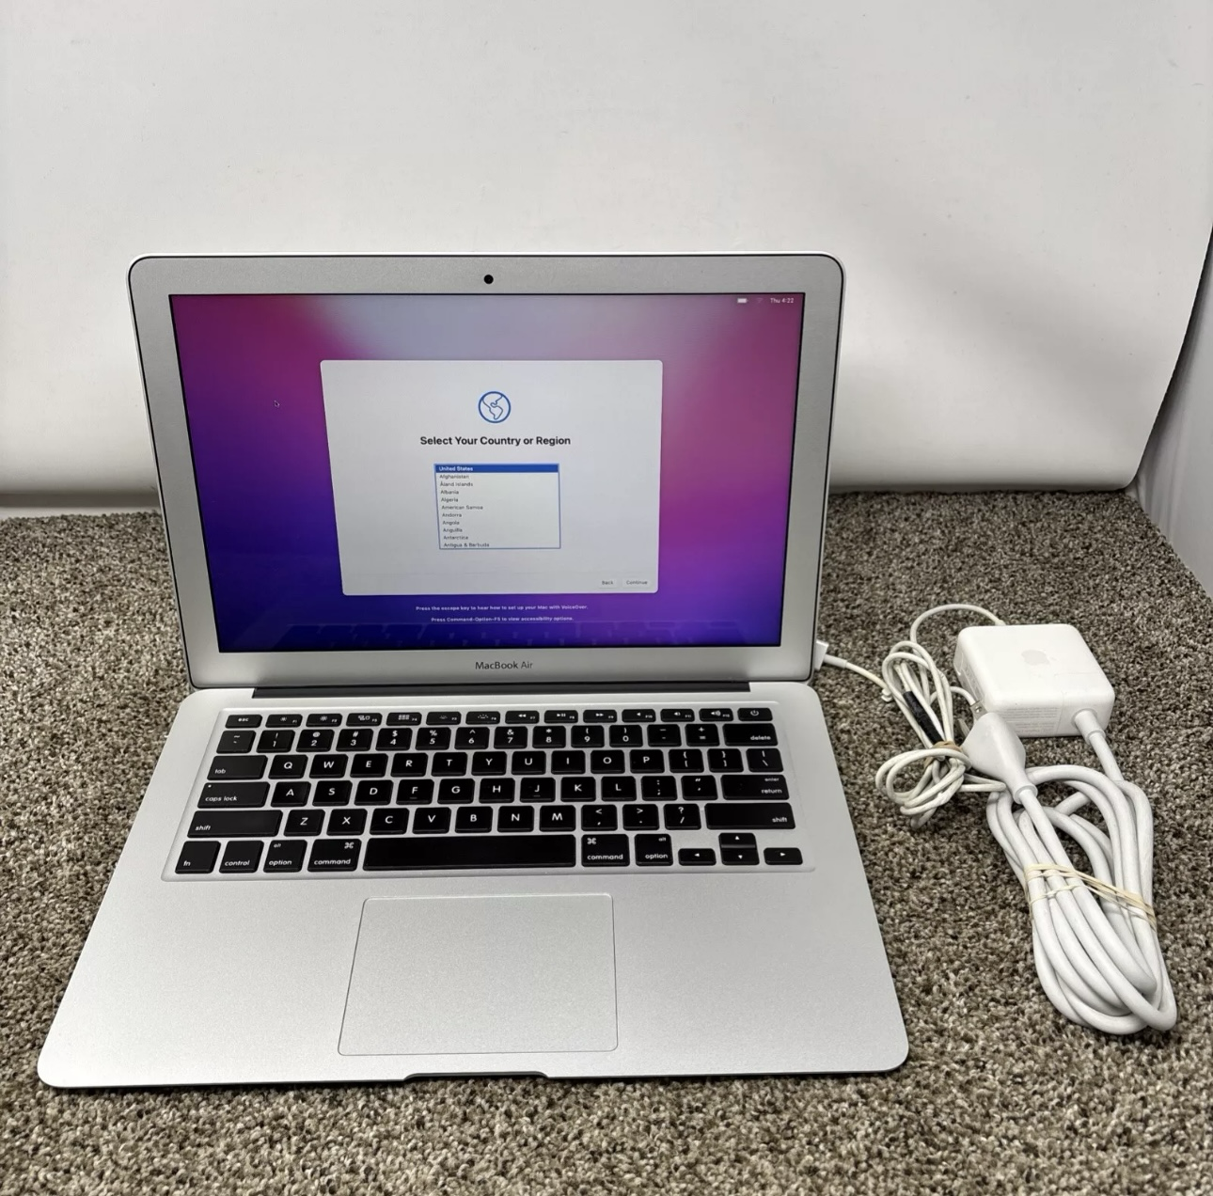
Macbook Air 13”- (2015)
$170- PER UNIT

STORAGE
64 GB +$0
128 GB +$20
256 GB +$35

