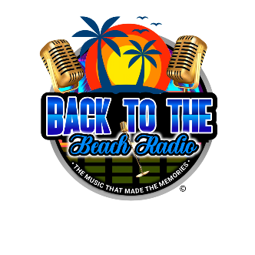
Back to the Beach Radio Sponsorship Application

Thank you for your interest in supporting Back to the Beach Radio! Your sponsorship helps us continue to provide great music and entertainment to our listeners. Please complete this application to secure your sponsorship level.

Sponsor Information

Name/Organization: _______________________________________
Contact Person: _________________________________________
Phone Number: __________________________________________
Email Address: __________________________________________
Sponsorship Levels
Please select your sponsorship level:
Bronze Sponsor - $100
Includes recognition on our website with your logo and a link to your business, mention in one live broadcast per month and one social media shoutout.
Silver Sponsor - $250
Includes Bronze benefits plus, your business name mentioned twice during live broadcasts each month, featured post about your business on social media, inclusion in our monthly e-newsletter as a Silver Sponsor.
Gold Sponsor - $400
Includes Silver benefits plus, your logo included in promotional materials, business featured in a 15-second customized ad played twice a week, and the opportunity to offer an exclusive discount or promotion to our audience through our channels.

Platinum Sponsor - $500
Includes Gold benefits plus logo placement on the website and event promotions. Plus, personalized 30 second ad spots played during prime time shows for one month. Spotlight article on our website showcasing your business, co-branding opportunities during special events or shows, priority logo placement in all materials and broadcasts, back to the beach radio Swag Package (T-shirt, Mug, Hat, etc.)

Payment Information

Payment Method:
• Check (Payable to Back to the Beach Radio)
• Credit/Debit Card
Card Number: ____________________________________________
Expiration Date: ______ / ______ CVV: ________

Billing Address:

Additional Information

If you have a specific message, ad, or request, please provide details:

Agreement
By signing below, you agree to sponsor Back to the Beach Radio at the selected level. You acknowledge that sponsorship benefits are non-transferable and non-refundable.

Signature: ____________________________________________
Date: _______________

Thank you for your support!
For questions or assistance, please contact us at [backtothebeachradio@gmail.com] or (813) 525-2213.

Return Completed Copy to: backtothebeachradio@gmail.com
Mail:
Rock Hall
4053 Lioncrest Lane
Thompsons Station, TN 37179

