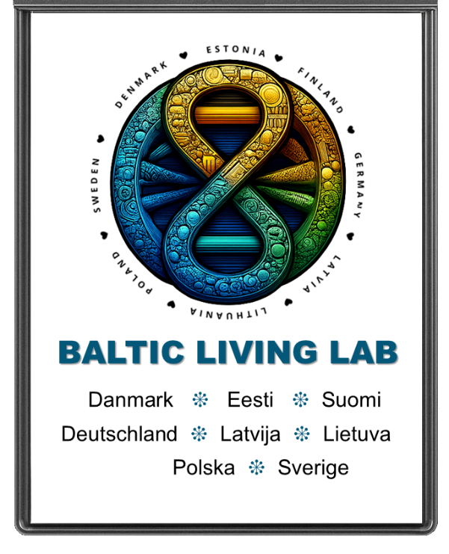

***“ Connecting communities for a sustainable Baltic Sea Region via Education, Innovation, and Collaboration”***

Visit us online at www.BalticLivingLab.org

Email: info@BalticLivingLab.org

Greetings! We are pleased that you are considering applying for membership in the Baltic Living Lab.

**Mission:** The Baltic Living Lab is a non-profit, multi-stakeholder resource hub established to unite the eight EU countries of the Baltic Sea Region in collaborative action for sustainability and resilience of the Baltic Sea Region. Originally launched under the Horizon SHORE project, it now serves as a permanent platform to empower schools, researchers, local authorities, NGOs, and communities to co-create solutions for the Baltic Sea’s most pressing environmental challenges.

Through open schooling, citizen science, and digital innovation, the Baltic Living Lab fosters cross-border cooperation, blue literacy, and inclusive participation—ensuring that all voices, especially those of youth and educators, are engaged in shaping a more resilient future for our shared sea. BLL is dedicated to fostering the long-term health and sustainability of the Baltic Sea by catalyzing community-driven solutions and collaborative action. Our mission centers on supporting environmental stewardship and the responsible use of natural resources to benefit both current and future generations. We approach change through a systems-thinking lens—recognizing that lasting impact requires not only immediate outcomes but also deep, structural transformation. Our initiatives are grounded in inclusive engagement, aiming to empower individuals and organizations to become active contributors to solutions rather than passive observers of environmental degradation.

As a transnational platform, the Baltic Living Lab operates across national borders and sectors, bridging local fieldwork with policy-level dialogue. Through dynamic partnerships with schools, civil society, researchers, municipalities, and industry, we create pathways for shared learning, innovation, and policy influence. By promoting open collaboration, disseminating knowledge, and encouraging strategic dialogue, BLL supports a resilient Baltic ecosystem—one that nurtures biodiversity, strengthens community well-being, and advances a just and thriving Blue Economy.

Becoming a Member of the Baltic Living Lab’s network of stakeholders signifies a willingness to be actively engaged in connecting to Blue Literacy activities that shape collaborative actions. Three Membership Levels are made available to interested parties:

**INSTITUTIONAL MEMBERSHIP** is for public or private organizations with the capacity to engage as partners in multilateral funding. These include:

☑ **Public Authorities**: Municipalities, regional governments, national environmental agencies, or public departments responsible for education, fisheries, coastal development, or sustainability.

☑ **Formal Education Institutions**: universities (HEIs), vocational education centers (VET), applied science and research institutions, schools and school networks (primary, secondary, school consortia, etc.)

☑ **Non-Governmental Organizations**: Civil society organizations (NGOs) working in environmental protection, youth engagement, citizen science, education, or coastal community resilience, Local Action Groups (LAGs), university extension centers, social innovation organizations, etc.

☑ **Private Sector Enterprises** (SMEs or Corporations), especially those in the blue economy (e.g., eco-tourism, fisheries, marine tech, sustainable food systems) with interest in innovation and community engagement. Includes Industry Associations & Clusters, Chambers of Commerce, Business Coalitions in fisheries, hospitality, marine tech, or renewable energy sectors seeking dialogue on responsible practices and green transition alignment.

☑ **Innovation Centers**: Organizations focused on climate adaptation, environmental monitoring, or digital co-creation tools that align with Baltic Sea protection goals.

Intergovernmental and Cross-Border Platforms: regional cooperation entities or multilateral frameworks promoting environmental and policy coordination in the Baltic Sea Region.

☑**Informal Education Providers**: Science centers, aquariums, youth camps, or eco-tourism operators offering experiential learning related to marine and environmental themes.

☑**Cultural and Creative Organizations**: Art collectives, media producers, or cultural networks exploring environmental storytelling, digital media, and public engagement in coastal issues.

All institutional members must have the capacity and interest to engage in multilateral funding partnerships (e.g., Horizon Europe, Erasmus+, LIFE, Interreg, etc.), contribute to shared objectives, and uphold principles of collaboration, transparency, and community empowerment.

**OBSERVERSHIP** is designed for organizations, coalitions, or clusters that wish to contribute to and benefit from the network without the full responsibilities of partnership in multilateral funding projects. These members typically support the mission and activities of the Baltic Living Lab, participate in knowledge exchange, and may collaborate informally or on a project-by-project basis. Observers help broaden the Baltic Living Lab’s reach and inclusivity, offering valuable perspectives and laying the groundwork for future formal collaboration. These include:

✅ **Regulatory Agencies**: National or regional environmental, education, or maritime agencies can contribute insights on policy, compliance, and impact monitoring without being bound to implement project activities directly. They can provide valuable alignment with national strategies, data standards, and policy frameworks.

✅ **Intergovernmental Organizations (IGOs**): Act as key knowledge brokers and facilitators of regional cooperation. Their observer status allows for strategic alignment without compromising neutrality or regulatory independence with advisory input on project design and alignment with regional strategies. IGOs provide access to data and indicators that help monitor progress toward shared goals and support building bridges between civil society, science, and governance layers with visibility and dissemination through official platforms and networks. Observer membership is ideal for organizations that operate at the intersection of governance and practice, value cross-sectoral innovation but must remain independent of project execution, and wish to stay engaged, informed, and influential in shaping initiatives.

✅ **Local Community Groups & Grassroots Initiatives**: Environmental clubs, citizen science groups, youth collectives, or volunteer-led coastal initiatives interested in Blue Literacy and Baltic Sea sustainability.

✅ **Philanthropic Foundations and Think Tank organizations** with interest in Baltic resilience, climate action, or youth empowerment that wish to monitor activities and explore future collaboration.

✅ **Educational Networks or Teaching Alliances** such as teacher associations, curriculum developers, or educational platforms that want to share practices or pilot open schooling approaches without committing to full partnership roles.

✅ **Municipalities or Regions in Early Engagement Stages** that include local governments interested in joining the network but not yet positioned to take on institutional responsibilities (e.g., due to funding cycles or internal readiness).

There are no formal obligations for Observerhip Members to participate in EU-funded projects. They do, however, receive updates, access events, and may contribute to pilot initiatives. Ideal entry point for emerging stakeholders in the Baltic Sea Region that can build capacity for future full membership.

**INITIATIVES / INDIVIDUALS** with no legal entity or individuals are also welcome to apply where they can demonstrate relevant ongoing and future relevant activities.

Please return this application form to us at [info@livinglab.org](mailto:info@livinglab.org) with a high-resolution image of the organization represented:

Type of Membership Requested

❑ Institutional

❑ Observership

❑ Individual / non-legal entity (skip organizational information requested)

ORGANIZATION NAME:

Website:

Type of Organization (e.g., NGO, university, public authority, SME, etc.):

Country:

Contact Person:

Email Address:

Phone Number:

Brief Description of Your Organization’s Work Relevant to the Baltic Sea Region:

Experience in EU-Funded or Multilateral Projects (if any):

Reason for Interest in Joining the Baltic Living Lab Network:

How do you envision your organization participating in BLL Activities:

Preferred Areas of Collaboration (e.g., education, policy, marine science, citizen engagement, etc.):

Additional Comments or Information:

We would also like you to describe how you view your role in LLB, what activities of yours could be connected to CCB activities and how the mission of your organization fits into the mission of the Baltic Living Lab.

Thank you for your application – we will be in touch soon! Inquiries? Send us a note at info@balticlivinglab.org