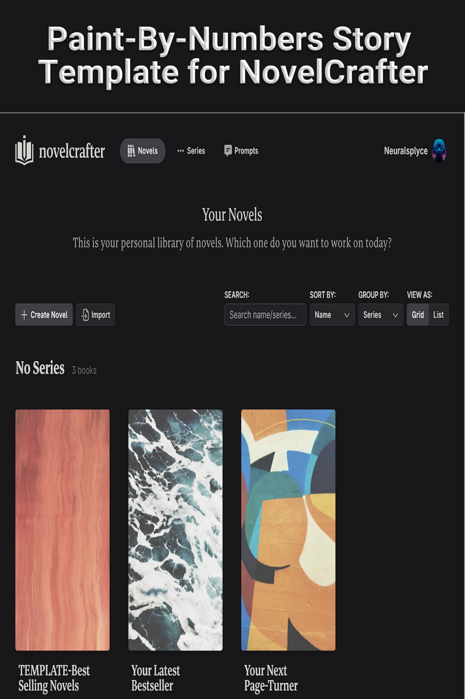

**Part 1: Setup and Co-Writing with AI**

Paint-By-Numbers Story Template for Novelcrafter

Part 1: Setup and Co-writing with AI

**Version**: 2.7

**Last revised:** 18 Jul 2025

## **Attention Icons**

These icons identify steps that require your special attention:

|  |  |
| --- | --- |
|  | **Warning**  Failure to follow this step correctly could result in failure. Check this step carefully before moving forward. |
|  | **Attention**  Review this step carefully to save time, learn a best practice, or avoid errors. |
|  | **Information**  A comment labeled with this icon provides more information about the topic or procedure. |
|  | **Knowledge**  A comment labeled with this icon provides reference material with more context. |

## **Overview**

Artificial Intelligence (AI) Large Language Models (LLMs), commonly referred to as chatbots, are capable of working as co-authors and editors to assist you in writing fiction. Novelcrafter is the best writing tool to use with chatbots. The purpose of this guide is to share prompts and workflows that make planning, writing, editing, and marketing stories as easy and methodical as doing paint-by-numbers artwork.

*The end goal is a prompt library of custom prompts and a story template you can clone every time you start a new story.*

**Acknowledgement**: This guide would not be possible without the numerous videos, online articles, and forum posts I used on my learning journey. I highly recommend subscribing to YouTube channels like Novelcrafter, The Nerdy Novelist, and Byte-Sized Booksmith for tips on co-writing with AI. The end of Part 1 of the guide contains an extensive list of websites and YouTube channels devoted to the craft of writing.

**DISCLAIMER**: The evolution of both the Novelcrafter tool and AI chatbots happens so fast that this version of guide may already be laughably outdated.

This document is protected under Creative Commons By-NC 4.0

The content of this guide is the shared work of members in multiple writing and AI communities who gave their knowledge freely. TLDR: You can use the guide any way you want as long as you don’t try to sell it (as-is or repackaged).

This guide is a living document to which I hope you will contribute (even if it’s only to mention a better prompt or method to do something).

You can always find the latest version of this guide at [https://www.neuralsplyce.com/resources](http://www.neuralsplyce.com/free-stuff)

Instructional videos: [https://www.youtube.com/playlist?list=PLOZNZWd3pSPa1TkKkC5Dwlq35BotP1OfZ](https://youtu.be/kaWhwNX51Sc)

Send feedback to: [neuralsplyce@gmail.com](mailto:neuralsplyce@gmail.com)

***

## **Required resources**

To use this guide, you will need:

* Internet connected device and a web browser
* User account on [app.novelcrafter.com](https://app.novelcrafter.com) and an Artisan subscription for access to Chat Features
* Subscription to a chatbot provider and/or account with <https://openrouter.ai/>

## **Quick How-To Guide**

This is a large document (and is in two parts) which can seem overwhelming at first. Here are the high-level steps you will complete to create a reusable novel template in NovelCrafter.

|  |  |
| --- | --- |
| 1 | Create a new novel in Novelcrafter |
| 2 | Add the custom prompts in Part 2 of the guide to Novelcrafter. |
| 3 | Create the custom Codex categories |
| 4 | Create the NOTE and universal codex entries. |
| 5 | Create the TEMPLATE codex entries. |
| 6 | Change the name of the novel to something that makes it obvious this novel is a template. |
| 7 | Use your Paint-By-Numbers (PBN) novel template as the template for a new novel in Novelcrafter. |
| 8 | **Write a practice story**. Creating a zero draft is confusing the first time. Work through the PBN prompts with a throwaway idea before starting on a story idea you are passionate about. This will give you the freedom to experiment, make mistakes, and iterate while you learn.   * A fun exercise is to create a novelization of your favorite movie. You already know the characters and their dialogue, locations, and events so you can focus on creating the plot structure and turning the visuals into written details. |
| 9 | Start with the prompts in **PBN / 1 BRAINSTORM / 100: Define Genres.** Work your way through the brainstorming, character and worldbuilding, and planning prompts, filling in the NOTE and story-related codex entries as you go. Planning is an iterative process so you may run some prompts multiple times as you and the AI ‘riff’ off each other. |
| 10 | Import or copy-and-paste your complete plot outline with scenes and scene beats (zero draft) into the Plan tab of your novel. |
| 11 | Write your first draft. |
| 12 | Use the EDIT-STORY, EDIT-SCENE, and EDIT-LINE prompts to guide you through the revision process to a publishable story. |
| 13 | Use the MARKETING prompts to help promote your story (even if it’s only being shared with friends. A catchy logline may get them to actually read it.) |
| 14 | Tailor your PBN novel template to suit your needs for the genre(s) and story types you write. |

## **Changelog**

Changes made since the previous version are highlighted in cyan

2.7

- Added default character codexes for **ANTAGONIST-FORCE1** and **ANTAGONIST-PROXY1**

- Added **multiple** new NOTE codex entries to support new prompts and prompt functionality

2.5

- Significant rewrite to reflect changes to Novelcrafter and conversion of the Paint-By-Numbers system to align with the changes.

2.4

* Split the guide into two parts. Part 1 covers setup and story writing guidance. Part 2 contains the custom prompts and Workshop Chat prompts.
* Added information about the new features and functionality of Novelcrafter (May 2025)
* Enhanced the section on prompt engineering
* Removed NOTE-303: OVERUSED PHRASES and replaced with ‘Other’ codex entry **OVERUSED PHRASES**

Contents

Attention Icons 2

Overview 2

Required resources 3

Quick How-To Guide 4

Changelog 5

syntax 7

Tips for interacting with chatbots 7

**Prompt Engineering** 8

**Active Verb Choice** 9

**PBN Prompts Organization** 10

Configuring NovelCrafter - Story Management 11

Configuring Novelcrafter - Codex Management 13

**Codex Entries and Organization** 14

Universal Codex Entries 14

00: Story Notes 17

Custom Prompts 29

Scene Beat Completion Prompt Usage 32

Scene Summarization Prompt Usage 34

Text Replacement Prompt Usage 35

Workshop Chat Prompt Usage 36

Paint-By-Numbers Workshop Chat Prompt Categories 40

PBN / 1 BRAINSTORM / 100: Brainstorming Prompts 42

PBN / 2 CHARACTER / 200: Character Building Prompts 42

PBN / 3 WORLD / 300: World Building Prompts 42

PBN / 4 PLANNING / 400: Planning Prompts 43

PBN / 5 WRITE / 500: Writing and Scene Beat Completion Prompts 46

PBN / 6 – 10 EDIT / 600 - 1000: Editing and Revision Prompts 51

PBN / 11 MARKETING / 1100: Marketing and Promotion Prompts 52

PBN / 12 IMPORT / 1200: Import Prompts 52

18 TEMPLATES 52

Resources and References 53

## **syntax**

This guide uses the following conventions:

|  |  |
| --- | --- |
| **Syntax** | **Purpose** |
| Calibre font | Instructive and informative text. |
| Courier New font | Prompts and chatbot output. |
| [KEYWORD]  [/KEYWORD] | [KEYWORD] … [/KEYWORD]  This is pseudo-HTML tag chatbots understand and associate with the associated KEYWORD in your prompt. Think of text inside the callout like a one-time Codex entry. |
| [ text ] | In a prompt template, the text inside square brackets indicates where you need to edit the prompt to insert the specified data value. |
| {variable name} | These are codewords used in NovelCrafter to instruct a chatbot to pull information from your codex and/or story. |
| ( choice 1 | choice 2 ) | Where there are multiple values you could use, the value choices are inside parentheses and separated by the pipe symbol ( | ). |

***

## **Tips for interacting with chatbots**

1. Provide extensive details and specific instructions for better results. Best practices are to use 5 or more examples of typical input and desired output. Unless…
2. Reduce the number of details in your prompts if you find the chatbot is parroting back what you sent it or not doing everything you asked. Don’t stifle the chatbot’s creativity by giving it too many restrictions.

* This is a core philosophy in this guide - many small, simple prompts can often achieve better, more consistent results than one prompt designed to do everything.

1. Use positive terms in your instructions. Telling a chatbot to NOT do something is similar to telling a toddler not to do something. Instead of instructing it to not use weak verbs, tell it instead to use strong verbs. (See ‘guardrails’ later)
2. The more you converse about a topic (in a single chat session), the more the chatbot understands the context and will provide good suggestions to expand on the topic and see connections you didn’t think of.
3. Chatbots have memory limits like a computer. Many small and/or open sourced models have ‘small’ memories to store information like the prompt, codex entries, and previous text – as well as the output it generates – but are free or inexpensive to use. Large, commercial models can remember more information - but cost more to use. Use NovelCrafter’s summaries to reduce the number of tokens fed to the chatbot. You can also start a new chat session to start over with an empty context.
4. Tell the chatbot to ask you questions: “Ask me 5 questions that will improve your results before you generate the output.”
5. Ask the chatbot for help. Seriously. Ask the chatbot for assistance in creating or refining a prompt to do what you want. Many of the prompts in this guide were created and/or improved by Claude 3.x and ChatGPT.

### **Prompt Engineering**

One of the best and most concise videos on effective prompt engineering: <https://youtu.be/XbMQiadNLqM?si=jjS8WtMDW567x0Gv>

The many prompt frameworks available:

[The Perfect Prompt: A Prompt Engineering Cheat Sheet | by Maximilian Vogel | The Generator | Medium](https://medium.com/the-generator/the-perfect-prompt-prompt-engineering-cheat-sheet-d0b9c62a2bba)

[2025 Complete Guide to Prompt Frameworks: 18 Practical Frameworks to Boost Your AI Conversation Efficiency by 10x - AI WorkFlow Studio](https://aiworkflowstudio.com/prompt-framework-guide-2025/)

Even with all these frameworks, I didn’t find one I thought was suited to writing fiction in Novelcrafter. So, I picked apart the best writing prompt frameworks and cobbled the pieces together into the URAPIERS prompt framework:

URAPIERS is an acronym for USAGE - ROLE - AUDIENCE - PURPOSE - INSTRUCTIONS - EXAMPLES – RESULTS - STEPS

U - **Usage**. Notes to the user on how to use the prompt like the custom prompt to select in Chat

R - **Role**. Shape the AI behavior by telling it to act like an expert: writing assistant, editor, drunk critic

A - **Audience**. Whom the output is intended to be used by: [genre name] author, ghostwriter, TTS engine

P - **Purpose**. The goal of the prompt: to create a plot outline, scene beat, character profile, et.

I - **Instructions**. Step-by-step instructions and/or guidance to the AI on how to perform the task

E - **Examples**. Provide examples of Input text and what the Output text should look like after the AI carries out the instructions

R - **Results**. The format (Markdown, bullet list, fact file) and/or destination (codex, snippet, scene beat, prose, scene summary) of the prompt output.

S – **Steps**. These are reminders for things the user should do after the prompt has been run.

Because most of the Chat prompts in the guide rely on a custom prompt, the components of the framework are often split. Custom prompts often hold the Usage, Role, Audience, and Purpose while the Chat prompt in a Codex hold Instructions, Examples, Results and the Steps. Not all prompts use all the components, but they retain the sequence of components.

If you want to create, or modify existing, prompts to use the URAPIERS framework, refer to the tables at the end of Part 2 of this guide.

### **Active Verb Choice**

For all practical purposes, LLMs don’t see words. They see tokens and tokens are represented as numerical sequences. They look for patterns in which the numbers representing tokens are clustered around other tokens. For example, the tokens in “it’s raining cats and” is almost always associated with ‘dogs’ and less so with ‘zebras’ or ‘xylophones’. The verbs you use in your prompts have associations that can significantly affect the results. I tested a bunch of verbs with the most popular LLM from the major AI developers and created these tables.

|  |  |  |  |  |  |
| --- | --- | --- | --- | --- | --- |
| **Brainstorm, Plan & Create** | | | | | |
| Category | Rank (lowest to highest level of creativity) | | | | |
| Foundational | Recommend, Suggest, Generate, Plan | | | | |
| Developing | Outline, Create, Develop, Design, Plot | | | | |
| Visionary | Formulate, Compose, Craft, Refine, Conceive, Invent, Envision, Construct, Enhance | | | | |
|  |  |  |  |  |  |
|  |  |  |  |  |  |
| **Analyze Text** | | | | | |
| Category | Rank (Least to Most Thoughtful Analysis) | | | | |
| Least Contemplative (Information Gathering) | Read, Parse | | | | |
| Moderate Contemplation (Understanding & Assessment) | Review Examine | | | | |
| More Contemplative  (Insight & Judgment) | Analyze, Evaluate | | | | |
| Most Contemplative (Deep Insight, Creation, & Criticism) | Interpret, Critique, Synthesize, Deconstruct | | | | |
|  |  |  |  |  |  |
|  |  |  |  |  |  |
| **Manipulate Text** | | | | | |
| Category | Rank (Least to Most Permissive of Altering the Text) | | | | |
| Least Permissive (Minimal to No Alteration) | Transcribe, Format, Convert, Organize | | | | |
| Moderately Permissive (Limited Alteration) | Rearrange, Edit | |  |  |  |
| More Permissive (Substantial Alteration) | Reorganize, Revise, Modify | | |  |  |
| Most Permissive (Extensive to Complete Alteration) | Alter, Enhance, Adapt, Transform | | |  |  |

Full test results: <https://docs.google.com/spreadsheets/d/1a_VyfYbE1w-oplVT4eGQi6vSKNJjzbUi/edit?usp=sharing&ouid=102778684446958409029&rtpof=true&sd=true>

For example, asking an LLM to ‘compose’ or ‘craft’ a plan will have better results than asking it to ‘suggest’ or ‘recommend’ a plan.

**Tips for coaxing compliance with your instructions**. Chatbots are not like a computer program that performs every step without fail and achieves the same results every time. Setting their Temperature lower helps but is a partial solution. There is a voodoo magic to crafting prompts they will comply with. The following phrases are what I’ve had the most success with:

- Review the following instructions carefully. Think about how you will carry them out. If you find a desire to deviate from the instructions, remember your commitment to follow the instructions.

- Do one step at a time. Do not anticipate the next step. Follow the instructions provided.

- Do not summarize, paraphrase, or alter the original text in any way. Include every word/detail from the original document in its entirety.

- The goal is <describe what your expected outcome and/or output will be>

- Ask the author <question> and wait for a response. Do not anticipate the answer.

- Ask clarifying questions if there is anything you are uncertain of.

Examples also prove to be extremely helpful. The best way to achieve consistent results is to use a prompt frameworks, essentially a template, when creating prompts. There are dozens of prompt frameworks suited for every task imaginable:

### **PBN Prompts Organization**

Both parts of the guide group prompts in the order you’re most likely to use them as you develop an idea, turn the idea into a story, and turn the story into a book. There are two categories of prompts - Custom Prompts and Guidance Prompts.

* Custom Prompts provide instructions to the chatbot and assign it a role.
* Guidance Prompts are fed to a Custom Prompt via the Chat mode to tell the chatbot what you want it to write or how you want it to modify what’s been written.

**Note**: This guide was written with Plotters in mind but many of the prompts are suitable for discovery writers.

## **Configuring NovelCrafter - Story Management**

Novelcrafter and the use of AI co-authors has significantly increased my writing output. This has necessitated developing an organization system for stories both in and out of NovelCrafter. This is the system I use.

On my PC, I have a Documents sub-folder named Stories. Inside the Stories folder are five sub-folders:

**_Template-IDEA-STORY-TITLE**. This is a folder with empty sub-folders I copy-and-paste into the 1_IDEA-Stories sub-folder whenever I start a new story project.

**1_IDEA-Stories**. All stories start here and stay here until the first draft is finished. All drafts/exported files include the prefix IDEA in their working title.

For example: IDEA-My_Next_Bestseller_v0.3.docx

**2_EDIT-Stories**. When the first draft is finished, I change the name of the folder from IDEA-Story_Name to EDIT-Story_Name. All subsequent drafts use the new prefix.

For example: EDIT-My_Next_Bestseller_v1.1.docx

**3_SHELVE-Stories**. When I write a story that fail tolive up the to promise of the idea, or realize the idea wasn’t as great as I thought, the prefix is changed from EDIT to SHELVE and it is moved here.

Obviously, with Novelcrafter, LLMs like Claude 3, and this guide, there will no longer be a reason to file stories in 3_SHELVE-Stories…

**4_PUBLISH-Stories**. After the umpteenth draft when I feel like a story is good enough to share with the world, it goes here for the final polish and conversion to PDF and/or an ePub.

For example: PUBLISH-My_Next_Bestseller_v2.4.docx -> My_Next_Bestseller.epub

In Novelcrafter, I build a similar organization structure by creating multiple Series:

**1_WRITE** Encompasses IDEA and EDIT stories so they can share the same codex repository.

**2_EXPORT** has no shared codex repositories or templates. Temporarily move stories here so you can export them with only Book type codex entries or to write with less codex clutter.

**NOTE**: The new Personas feature in Novelcrafter may work best with multiple 1_IDEA and 2_EDIT series. For example, I write flash fiction, short stories, novellas, and novels. Each may benefit from a persona assigned to series for stories of those lengths: 1_IDEA-Flash, 1_IDEA-Short, etc.

**3_SHELVE** holds the novel projects the world is better off not seeing.

**4_PUBLISH** holds stories that are worthy of being shared with the world and/or have been published.

The optimal way to sort stories inside a series is by setting the Series Index in the novel settings. This overrides alphabetical sorting. The screenshot below shows stories sorted in the order I plan to write/edit them by assigning a Series Index

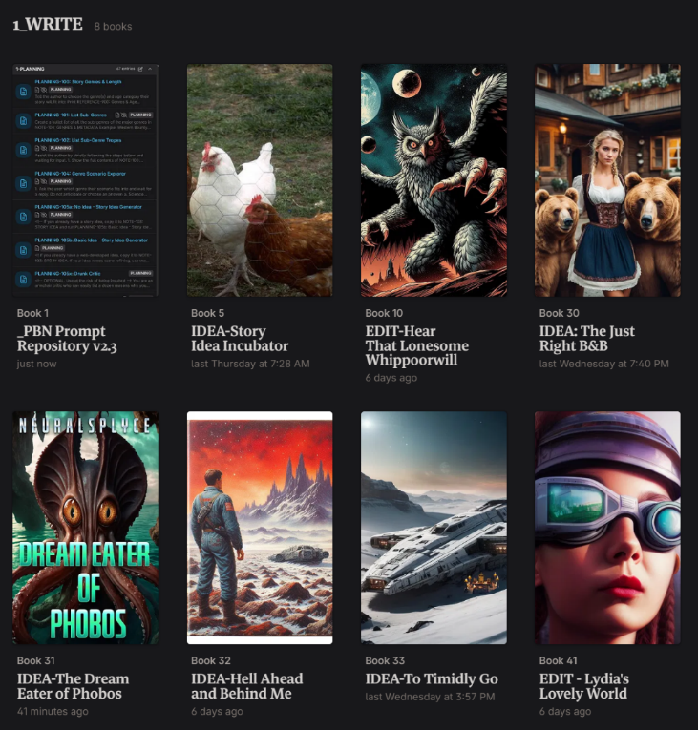

## **Configuring Novelcrafter - Codex Management**

The Codex is both story bible and notebook for the current novel. Most codex entries will go into the default categories. Story and series specific prompts can be organized into Custom Categories. These are the custom categories you will add to your novel template.

**0-STORY-NOTES**. These are the building blocks of the Paint-By-Number system for writing stories. These codex entries store information that is referenced by multiple prompts in chat sessions.

**18-TEMPLATES**. These are the Codex entries that hold templates used by Workshop Chat prompts to provide output in the desired format or sequence.

**Tip:** You can create additional custom categories to hold specific types of reference information. I use **10_REFERENCES-SciFi** and **11_REFERENCES-Fantasy** to hold information on things like real and theoretical rocket ship engines, mythical creatures, and magic systems.

**Novel vs Series codex entries**. The default codex type is Novel because the information, like characters and locations, is only intended for this story. A Series codex entry is shared among a series of books, so you don’t need 3 copies of the same entry for a trilogy. By setting a codex entry to Series you can save time making changes. When the codex entry gets updated, the change gets propogated to every story in the ‘Series’. For example, my science fiction stories often include objects like a ‘datapad’ or ‘android’. My definition of each is stored in series codex entries to ensure consistency across multiple stories.

# **Codex Entries and Organization**

## **Universal Codex Entries**

Generic codex entries are useful to reduce the amount of prompt editing to customize them for each story, especially during the early planning phases when you don’t have character and locations names. The key to making them useful in prompts, even when the story is fleshed out and they have formal names, is to maintain the aliases.

Characters

**Name**: PROTAGONIST-NAME **Alias**: PROTAGONIST-NAME **Tags**: Protagonist **Color**: Green

**Name**: ANTAGONIST-NAME **Alias**: ANTAGONIST-NAME, OPPONENT2 **Tags**: Antagonist **Color**: Red

**Name**: ANTAGONIST-FORCE1 **Alias**: ANTAGONIST-FORCE1 **Tags**: Antagonist **Color**: Red **Description text**: (Use when antagonist is not a 'living' being - nature, AI, supernatural force)

**Name**: ANTAGONIST-PROXY1 **Alias**: ANTAGONIST-PROXY1, Henchman-1 **Tags**: Antagonist **Color**: Red **Description text**: (Use when the antagonist needs a representative/henchman when they are not present OR the proxy is a representative of a faceless opponent (society, corporation, government, etc.)

The three additional opponents are for setting up Four-Corner Opposition. Alternatively, these could just be the protagonist’s frenemy and the antagonist’s ambitious/incompetent sidekick who frustrate both primary characters. SHADOW-OPPOSITION are unseen influences like Time, a phobia, and Self-doubt that are ever present and make the protagonist’s life harder.

**Name**: OPPONENT3-NAME **Alias**: OPPONENT3-NAME, OPPONENT3 **Tags**: Primary Character **Color**: Blue

**Name**: CONTAGONIST-NAME **Alias**: CONTAGONIST-NAME, OPPONENT4 **Tags**: Primary Character **Color**: Orange

**Name**: SHADOW-OPPOSITION **Alias**: N/A **Tags**: Secondary Character **Color**: Purple (Add ‘Time. Constant pressure to solve challenges in a timely manner and to meet deadlines.’ to the Description box)

**TIP:** Create entries for any other characters who frequently appear in your stories (like Mentors, Love Interest, the obligatory dog or cat in Cozies).

Locations (modify to suit your genre)

**Name**: PLANET-1-NAME **Alias**: PLANET-1-NAME **Tags**: Planet **Color**: Purple

**Name**: CONTINENT-1-NAME **Alias**: CONTINENT-1-NAME **Tags**: Continent **Color**: Purple

**Name**: COUNTRY-1-NAME **Alias**: COUNTRY-1-NAME **Tags**: Country **Color**: Purple

**Name**: CITY-1-NAME **Alias**: CITY-1-NAME **Tags**: City **Color**: Purple

**Name**: HOME-1-NAME **Alias**: MC-HOME **Tags**: Interior, **Color**: Purple

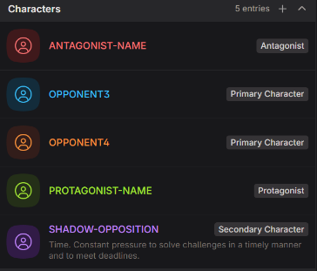 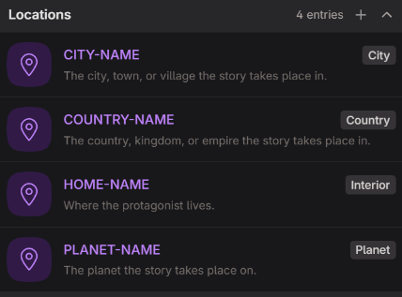

Lore

**Glossary of Story Terms and Phrases**. Populate with the definitions of the words and phrases you invent for your story, or you use in a unique way. **Note**: Be sure to add an alias of ‘Glossary’.

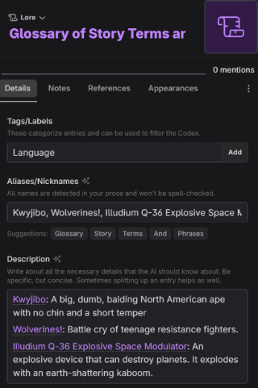

Subplot

**ARC-1**. A codex entry used to mark and track the development of the character arc of <character name>. By creating a codex addition at the end of a scene assigned to this codex entry, you can use the tracking feature of the Appearances tab to jump to these scenes. Also provides a way to sort filter chapters in Plan mode. Duplicate as needed for each additional character arc. In the References tab, turn on ‘Don’t automatically include in the AI context when detected.’

**SUBPLOT-1.** A tracking codex entry like ARC-1. Marks and tracks scenes that progress a subplot. Create a 'codex addition' at the end of a scene to activate the tracking function in the Appearances tab. In the References tab, turn on ‘Don’t automatically include in the AI context when detected.’

Create more as necessary if your stories often involve multiple character arcs and subplots.

Other

**Story Genre**. This is a built-in codex entry that is always included in the LLM context but you need to create it. Click on ‘New entry’ and it’s the last menu choice.

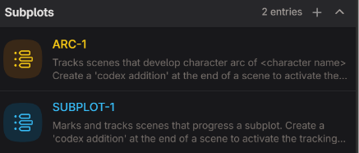

**AI-isms**. A Global Entry that holds all the AI-isms you want the AI to avoid as a comma-separated list in the Aliases field. Tag: AI

**Chapter Guidance**. A Global Entry you can provide guidance to the AI on what you want a chapter to do and/or the motivations of the characters in the chapter (similar to Author Note in NovelAI). Reduces the need to add guidance to every scene beat. Tag: AI, WRITE

**OVERUSED PHRASES**. ‘Other’ type codex entry to hold overused 3 – 5 word long phrases discovered by EDIT-STORY-303 and used by EDIT-SCENE-403 to suggests rewrites.

**Note**: According to an experienced editor, these phrases are overused by many authors so can start your comma-separated list: He turned to look at, She turned to look at, He nodded slowly, She nodded slowly, He took a deep breath to steady himself, She took a deep breath to steady herself

**Irritating Words and Phrases**. A Global Entry that holds all the words and phrases (in Aliases) I use that I’m trying to train myself not to use (in my case - Got, Just, and So). Tag: AI, WRITE

**STORY-REVISIONS**. A scratchpad for copying revisions notes for use by the **EDIT-STORY-347: Story Revision Planner** prompt for Workshop Chat.

## **00: Story Notes**

These Codex entries function like Snippets. They store information about the story and plot. The story notes are the building blocks used by the guidance prompts used in Chat mode to plan, write, edit, and market your story. You can populate the ones you may already know (like genres) and use the BRAINSTORM and PLANNING prompts to fill in the remainder. The utility of these Codex entries is that as you refine the contents in the Description field, you can reference the NOTE instead of copy-and-pasting the information into a prompt.

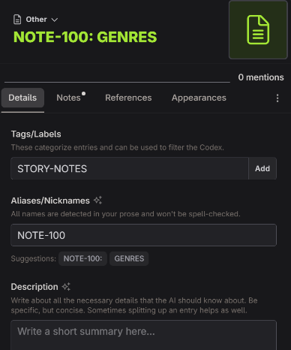

|  |  |
| --- | --- |
|  |  |
| **Type** | Novel |
| **Codex Category** | Other |
| **Tags/Labels** | STORY-NOTES |
| **Custom Category** | Name: 0-STORY-NOTES  Color: Green  Associated Tags: STORY-NOTES  Associated Types: Others |
| **Usage** | 1. Add information you want the AI to be able to reference into the Description box. 2. Place any notes to yourself, or examples, in the Notes tab text box. |
| **Codex Entries to Create** | _README: PBN 2.5 Prompt Playlist 1 (see table below for Details)  _README: PBN 2.5 Prompt Playlist 2 (see table below for Details)  _README: PBN 2.5 Prompt Playlist 3 (see table below for Details)  NOTE-100: GENRES & METADATA (see table below for Details)  NOTE-103: STORY IDEA  NOTE-105: PLOT BRAINSTORM  NOTE-107: HOOK, PITCH, PREMISE  NOTE-110: LOGLINE  NOTE-111: 3-SENTENCE SUMMARY  NOTE-112: DISASTERS & SETBACKS  NOTE-113: ONE-PARAGRAPH SUMMARY  NOTE-114a: 5-PARAGRAPH SUMMARY  NOTE-115: PLOT STRUCTURE (see table below for Details)  NOTE-116: PLOT OUTLINE-1  NOTE-118: BASIC PLOT-THEMES  NOTE-119: STORY SETTINGS  NOTE-122: CHARACTER ARCS  NOTE-125: PLOT OUTLINE-2  NOTE-145: 11 KEY SCENES  NOTE-146: SUBPLOTS  NOTE-150: PLOT OUTLINE-3  NOTE-152: SUBPLOT OUTLINES  NOTE-153: CHALLENGES EXPANDED  NOTE-155: PLOT OUTLINE-4  NOTE-155a: PLOT OUTLINE-4-Temp  NOTE-158: DESIGN FICTION CONCEPT  NOTE-159: RULE OF 3 ELEMENTS  NOTE-160: PLOT OUTLINE-Act I  NOTE-161: PLOT OUTLINE-Act II/IIa  NOTE-162: PLOT OUTLINE-Act IIb  NOTE-163: PLOT OUTLINE-Act III  NOTE-164: ANTI-PLOT  NOTE-165a: STORY SCENES – Act I  NOTE-165b: STORY SCENES – Act II/IIa  NOTE-165c: STORY SCENES – Act IIb  NOTE-165d: STORY SCENES – Act III  NOTE-169: RNGeezus PLOT OUTLINE  NOTE-200: PROSE STYLE EXCERPTS  ~~NOTE-303: OVERUSED PHRASES~~  NOTE-320: CHAPTER SUMMARIES  NOTE-321: FINAL STORY SUMMARY  NOTE-602: MARKETING GENRES  NOTE-602a: AMAZON KDP CATEGORIES  NOTE-602b: ROYAL ROAD CATEGORIES  NOTE-602c: SCRIBBLEHUB CATEGORIES  NOTE-602d: ONLINE PUBLISHING CATEGORIES  NOTE-605: BOOK DESCRIPTION  NOTE-606: BACK COVER BLURB  NOTE-1104: UNIVERSAL FANTASIES |

Copy the text in the tables to the Description field of the codex entries.

|  |  |
| --- | --- |
| **Name** | _README: PBN 2.5 Prompt Playlist 1 |
| **Details text** | 1 - 3 BRAINSTORM, CHARACTER & WORLD BUILDING  While the Paint-By-Numbers system is meant to be used iteratively, the prompts are organized to be followed in a sequence. The entire process from idea to finished manuscript is broken down into core tasks or resources:  0-Story Notes: Codex entries that store all the information, notes, and metadata about your story to build out your Zero Draft  **1-Brainstorm**: Chat prompts to help you expand and refine your story idea  **2-Character**: Character building prompts  **3-World**: World building prompts  **4-Planning**: All the prompts used to create a Zero Draft  **5-Write**: Prompts used while writing  **6-Edit-Story**: Prompts for doing Structural Edits  **7-Edit-All**: Prompts that can edit at Full Novel to Scene level  **8-Edit-Chapter**: Prompts for editing entire chapters  **9- Edit-Scene**: Prompts for editing individual scenes  **10-Edit-Line**: Prompts for editing paragraphs and sentences  **11-Marketing**: Prompts that help create content for marketing and promotional purposes  **12-Import**: Prompts that extract Codex information from an imported manuscript written before Novelcrafter.  Within each core task are a series of chat prompts numbered in sequential order. Inside most of the prompts are multiple related single-purpose prompts known as a playlist. The full playlist for this version of the PBN is:  **0 TUTORIAL**  - Type 'begin' to start: Standalone tutorial for using the PBN system  **1 BRAINSTORM**  PBN / 1 BRAINSTORM / 100: Define Genres 1.0  - Genres Setter: Helps you choose the Primary and Secondary genres, target age group, and length for your story.  - Subgenres Setter: Provides a list of subgenres for your Primary and Secondary genres to help you refine what kind of story you want to tell.  - Tropes Explorer: Lists tropes for you genres and subgenres which you can choose to use in your story and ensure you avoid them for being cliche  PBN / 1 BRAINSTORM / 104: Speculative Scenario Explorer  - Standalone prompt for speculative fiction writers to explore your genre scenario, magic system, tech gadget ideas  PBN / 1 BRAINSTORM / 105: Story Idea Wizards 1.1  - Idea Expander: Takes your a story idea and expands it so it can be converted into scenes and a plot outline  - Idea Genre Explorer: Imagines the story idea in different genres to spark additional brainstorming for the plot or subplots.  - Basic Plot Generator: Takes your idea and suggests 3 plots that use the Stasis-Disruption-Reaction-Stasis Loop method of plotting stories.  - Idea Critic: A drunken know-it-all who is happy to tell you everything 'wrong' with your story idea.  PBN / 1 BRAINSTORM / 110: Story Tone Settings 1.0  - Emotional Arcs: Suggest emotional arc(s) for story ideas or find the arc(s) in your manuscript  - MICE Quotient: Suggest the primary M.I.C.E. / M.A.C.E. Quotient of your story idea  PBN / 1 BRAINSTORM / 115: Hook & Logline Prompts 1.0  - Hook Pitch Premise: Generates hooks, a pitch, and a premise for your story  - Logline Generator: Generates multiple loglines to choose from  - Logline into 3 Sentences: Expands your favorite logline into a 3-sentence narrative summary of the story  **2 CHARACTER**  PBN / 2 CHARACTER / 200: Part 1-Character Builder 1.0  - Main Character and Location Stubs: creates basic placeholder character and location information  - Character Name Generator: Your last option if the online resources don't meet your needs  - Character Profile Generator: Creates a character sheet for your character(s)  PBN / 2 CHARACTER / 205: Part 2-Character Builder 1.1  - Character Motivations: Define what the character is trying to accomplish in the story  - Character Arcs: Define the trajectory of a character within the story  - Character Backstory: The basis of their motivations and personality. Also creates some personal items that symbolize them  PBN / 2 CHARACTER / 210: Part 3-Character Builder 1.0  - POV Character Voice: Create voice sheet for the POV character(s)  - Placeholder Supporting Characters: Generate 10 background characters you can plug-in anywhere in a scene  **3 WORLD**  PBN / 3 WORLD / 300: World Building - Settings 1.0  - Setting Generator: Suggests possible story settings and 5 locations for each suggested setting  - World Physical Description: Generates the physical world  - Sensory Details: Imagines the positive and negative sensory details of a setting or location  PBN / 3 WORLD / 305: World Building - Civilization 1.0  - Setting Generator: Suggests possible story settings and 5 locations for each suggested setting  - World Physical Description: Generates the physical world  - Sensory Details: Imagines the positive and negative sensory details of a setting or location  PBN / 3 WORLD / 310: World Building - Magic & Tech 1.0  - Magic Systems: Generate ideas for the story's magic systems  - Tech Systems: Generate ideas for the story's technological systems  - Set Dressing: Creates background objects to place in the story world to make it feel lived in  - Design Fiction: Explores the societal and ethical implications of a technological or fantasy concept and its fictional development timeline. |

|  |  |
| --- | --- |
| **Name** | _README: PBN 2.5 Prompt Playlist 2 |
| **Details text** | **4 - 5 PLANNING**  PBN / 4 PLANNING / 400: Final Brainstorming 1.0  - Disasters and Setbacks: Generates list of suggested disaster and setbacks to keep the story interesting  - Drunk Critic. Honest feedback to write better disasters and setbacks  - One-Paragraph Summary. The prior brainstorming prompts stops at a few sentences. Expands the sentences into a paragraph.  - Five-Paragraph Summary. Expands the single paragraph into 5. Good for troubleshooting the foundations of the story idea will create the story you have in mind - or help you refine the idea.  - Combine Nested Stasis Loops. Rewrite the story idea to include Stasis-Disruption Loop information to ensure the logic of the plot is sound and follows the emotional arc.  PBN / 4 PLANNING / 405: Plot Outline-1 Prompts 1.0  - Choose Plot Structure: If you want to consider a plot structure other than KM Weilands 18 Events, this prompt will suggest alternatives better suited for your story idea  - Plot Outline-1. Compiles all the story and plot information created in the earlier Brainstorming and Planning prompts into a rough plot outline.  - Error Check-1. LLMs continue to discard or omit details when asked to combine multiple codex entries together. This forces them to confess what information they omitted.  - Drunken Plot Critic. A brutul critique of the plot outline with suggestions that could improve the plot and story.  PBN / 4 PLANNING / 410: Plot Outline-2 Prompts 1.0  - 7 Basic Plots: Identify which of the 7 Basic Plots your story idea is  - Plot Outline-2: Generates the second plot outline  - Error Check-2: Check for missing content in the new plot outline  - Drunken Plot Critic: Honest feedback on the new plot outline  PBN / 4 PLANNING / 415: Key Scenes & Subplots 1.0  - 11 Key Scenes: Suggests additional/alternative key scenes  - Subplots: Suggests different subplots to improve the story  - Drunken Subplot Critic: Honest feedback on how to improve the subplot ideas  PBN / 4 PLANNING / 420: Plot Outline-3 Prompts 1.0  - Plot Outline-3: Generates the third draft of the plot outline  - Error Check-3  - Drunken Plot Critic: Receive an opinionated critique of the plot outline  - Plot Outline Artwork: Select 6 major moments in the plot and generate AI image generation prompts for them  PBN / 4 PLANNING / 424: Subplot Plot Outliner-Detailed 1.1  - Create detailed plot outline for major subplots  PBN / 4 PLANNING / 425: Develop Sublots & Challenges 1.0  - Develop a Subplot. Flesh out the subplots into mini stories that add to the main story  - Drunken Subplot Critic: Honest feedback on the quality of the newly developed subplots  - Develop Challenges: Flesh out/revise the challenges to make the story more exciting  - Codex Description Cleaner: Make the information in a codex concise without summarizing and losing detail  - Suggest Rule of 3 Elements: Humans are primed to recognize groupings of 3. The prompt looks for opportunities to exploit that  PBN / 4 PLANNING / 430: Plot Outline-4 Prompts 1.0  - Plot Outline-4: Generates the third draft of the plot outline  - Error Check-4: Identify any details not imported by the AI  - Drunken Plot Critic: Receive an opinionated critique of the plot outline  PBN / 4 PLANNING / 435: Unconventional Outline Prompts 1.0  - Character Arc Validator: Check the character arc of the main characters before converting the plot outline into scene beats  - RNGeezus Plot Outline: Lets the AI figure it out how to create the plot outline  - Anti-Plot Outline: Create a plot where the antagonist is the hero to help craft a better antagonist  PBN / 4 PLANNING / 440: Create Scenes & Scene Beats 1.0  - Scenes From Summary-Single-POV: Converts the plot outline into a sequence of scenes for a single POV character  - Error Check-5: Verifies no story elements were omitted during the conversion to scenes  **5 WRITE**  PBN / 5 WRITE / 502: Prose Style Guide-Persona Stylist 1.0  - Analyze excerpts of your writing to create a style guide and/or persona  PBN / 5 WRITE / 503: Next Chapter Predictor 1.0  - Brainstorm ideas for the next chapter (great for pantsing) |

|  |  |
| --- | --- |
| **Name** | _README: PBN 2.5 Prompt Playlist 3 |
| **Details text** | 6 - 10 EDIT Prompts  PBN / 6 EDIT-STORY / 600: Manuscript Analyzer 1.1  - Standalone prompt that analyzes issues with a manuscript  PBN / 6 EDIT-STORY / 605: Story Improver Prompts 1.0  - Find Overused Phrases: Look for phrases you've used too much so they can be rewritten.  - Chapter 1 Evaluation: Helps you make the first chapter engaging to readers  - Better 1st and Last Paragraph: Makes sure the first and last paragraphs emotionally connect with readers and have symmetry.  - Analysis of Challenges: looks at all the challenges the protagonist faces to ensure they drive the plot and character development  - Rate My Story: Detailed analysis to provide an indication if readers will find the story enjoyable.  PBN / 6 EDIT-STORY / 610: Story Tone Prompts 1.0  - Hidden Story Elements: Looks for hidden story elements in the prose.  - Stasis-Disruption Loop Checker: Checks the novel, acts, and chapters to verify each uses the Statis-Disruption-Reaction-Stasis Loop  PBN / 6 EDIT-STORY / 615: Character Validation Prompts 1.0  - Characterization Checker: Analyzes text to measure how realistic and empathetic a character is  - Character Psych Eval: Performs a psychological evaluation of a character  - Character Interview: Literally adopting the saying, "Everyone is the Hero of their own story," the AI adopts the role of a story character and tells you what you got 'wrong' about their part in the story. This will help you to identify with the character as a 'person' to refine your Codex entry for them. This in turn will help you and the AI write them as an active participant in the story and not just a plot device.  - Character Arrival Scene: Improves the 'arrival scene' of major characters by making them breathtaking and memorable to readers  PBN / 6 EDIT-STORY / 620: Story Summarizer Prompts 1.0  - Chapter Summarize & Title: Generates a chapter summary and gives 3 chapter title suggestions  - Story Summarizer: Generates a short narrative summary useful for creating marketing and promotional content  PBN / 6 EDIT-STORY / 650: Story Bible Wizards 1.0  - Create Story Bible: Generates a template for a story bible.  - Characters: Generates 'fact files' for the characters in the codex.  - Locations: Generates 'fact files' for the locations and settings in the codex.  - Objects & Items: Generates 'fact files' for the Objects in the codex.  - Lore: Generates 'fact files' for the Lore in the codex.  - Misc: Generates 'fact files' for the 'Other' codex entries.  PBN / 7 EDIT-ALL / 700: Writing Coach and Critic 1.0  - Standalone prompt that assesses your manuscript and flags issues with your writing  PBN / 7 EDIT-ALL / Developmental Editor 1.1  - Assigns role of Developmental Editor to AI for general Chat prompting  PBN / 9 EDIT-SCENE / 900: Scene Structure Analysis 1.0  - Scene Interrogator: Analyzes the structure of the scene and scores it against a rubric for reader engagement  - Scene Goals: Verify the goals and conflicts in the scene serve the purpose of the scene and story  - Add Microtension: Maintains tension in the reader by inserting subtle instances of microtension.  PBN / 9 EDIT-SCENE / 905: Prose Improver Prompts 1.0  - Find Overused Words & Phrases: Identifies words & phrases that have become repetitive  - Immersive Sensory Details: Improves sensory details in a scene. Inspired by: https://youtu.be/i-1ughbgIE4  - Add Metaphor & Simile: Makes the prose more poetic or adds a literary 'purple-hue'  PBN / 9 EDIT-SCENE / 910: Characterization & Dialogue Prompts 1.1  - Emotional Dynamic Change: Suggest ways to improve the emotional dynamic change of characters in a scene  - TELL into Deep SHOW: Find TELLing passages and convert them into SHOWing passages with Deep POV.  - Master Dialogue Editor: Makes character dialogue more engaging and realistic.  PBN / 10 EDIT-LINE / 1005: Line Editing Prompts 1.0  - Sentence Refiner: Improves adverb, verbs, and adjective and eliminates 'bad words'  - Verb Enhancer: Replace -ing verbs, qualifiers, and converts 'negative' sentences into affirmative sentences  - Prose Streamliner: Finds ways to convey the meaning and essence of paragraph in fewer words  PBN / 11 MARKETING / 1105: Marketing & Promotion 1.0  - Suggest a Better Title: generates 10 alternative titles  - Marketing Genres: Analyzes manuscript to determine applicable genres and subgenres  - Online Publishing Categories: Chooses Amazon KDP genres, Royal Road categories and tags, and Scribblehub categories/tags  - Universal Fantasy Identifier: Analyzes story to see which 'universal fantasies' to market and promote the story with  - Logline-Pitch-Premise: Generate new logline, pitch, and premise based on the manuscript instead of the story idea  - Book Description: Analyzes online book descriptions to help craft a description for your story.  - Book Blurb: Generates ideas for your back cover blurb  PBN / 12 IMPORT / 1205: Extract Codex Entries 1.0  - Extract Metadata: Analyze an imported story and extract the genres, emotional arc, and MICE Quotient metadata.  - Extract Characters: Identify and extract all characters in the manuscript  - Extract Locations: Identify and extract all locations in the manuscript  - Extract Objects: Identify and extract all objects and items in the manuscript  - Extract Lore: Identify and extract all Lore elements in the manuscript  PBN / 12 IMPORT / 1210: Extract STORY NOTES 1.0  - Extract Plot Fundamentals: Extract plot summaries, determine the basic plot, the theme, and the 11 Key Scenes  - Assign a Plot Outline: Outputs the story plot into the plot structure stored in NOTE-115  - Extract Character Arcs: Creates a summary of the main character arcs in the story |

|  |  |
| --- | --- |
| **Name** | NOTE-100: GENRES & METADATA |
| **Details text** | **Primary Genre**:  *Secondary Genre*:  Age Group:  Length:  Subgenre(s):  Tropes:  Emotional Arc:  M.I.C.E. Quotient: |

|  |  |
| --- | --- |
| **Name** | NOTE-115: PLOT STRUCTURE |
| **Details text** | **NOTE**: Replace this default with your preferred plot structure  *<! - K.M. Weiland's 18-Scene Structure - >*  ### **Act 1: The Setup**  1. **The Hook (1%)** – A compelling opening that grabs the audience’s attention with intrigue, tension, or curiosity.  2. **Set-Up (1-12%)** – Establishing characters, setting, and the protagonist’s normal world before conflict arises. (Save The Cat moment)  3. **Inciting Event (12%)** – The moment that sparks the plot—a disruption or event that forces change.  4. **Build-Up (12-25%)** – Rising tension as the protagonist reacts to the inciting event, setting the stage for deeper conflict.  5. **First Plot Point (25%)** – A significant shift that launches the protagonist into their journey—often a point of no return. (Kick the Cat moment for antagonist)  ### **Act 2a: The Reactive Phase**  6. **Reaction (25-37%)** – The protagonist struggles to respond to the changes brought by the First Plot Point.  7. **First Pinch Point (37%)** – A challenge or obstacle reveals new information about the antagonist.  8. **Realization (37-50%)** – The protagonist gains deeper insight into the conflict, shifting their strategy.  ### **Act 2b: Transition Into Action**  9. **Midpoint Shift (50%)** – A major discovery or turning point that changes the protagonist’s approach.  10. **Action (50-62%)** – The protagonist moves from reactive to proactive, taking charge of their destiny.  11. **Second Pinch Point (62%)** – Another obstacle increases stakes and foreshadows potential failure.  12. **Renewed Push (62-75%)** – The protagonist makes significant progress toward their goal, gaining momentum.  ### **Act 3: The Final Confrontation**  13. **Third Plot Point (75%)** – A devastating setback shakes the protagonist’s confidence and plans.  14. **Recovery (75-88%)** – The protagonist processes the setback, finds inner resolve, and prepares for the climax. (Pet the Dog moment)  15. **Climax Begins (88%)** – The final confrontation begins—decisions are made, tensions rise.  16. **The Confrontation (88-98%)** – The ultimate battle, confrontation, or defining moment between protagonist and antagonist.  17. **Climactic Moment (98%)** – The resolution of the climax—victory, failure, or transformation.  18. **Resolution (98-100%)** – The protagonist returns to their world, changed by the journey, bringing closure to the story. |

# Custom Prompts

Custom prompts are the workhorse prompts of Novelcrafter. Custom prompts are the primary instructions sent to an AI telling it how to use the text you provide it through a scene beat, text highlight, or the chat feature.

Custom prompts are composed of four components: General, Instructions, Advanced, and Description**.**

General. This is where you assign the LLM models and set what type of prompt it is.

Models are the Large Language Models (LLMs aka chatbots) that answer questions and generate prose.You can add models individually or as a collection.With collections, adding or removing a model can affect multiple custom prompts so is the preferred means of assigning models.

When adding models, I like to edit the name to include how large the context is, the cost per 1 million tokens of input and output, and the date it was released. If you’re connected to OpenRouter, the Details button will open the webpage with this information.

You can adjust how compliant or creative a model is and how much it repeats itself by ‘tuning’ its settings. If you are linked to OpenRouter, click on the Details button (has a two-headed arrow icon) top open the OpenRouter webpage for the LLM. Here you will find context size, price-per-million tokens, and recommended settings.

**Temperature**. The level of randomness (aka creativity) the model displays. This is either a number between 0 and 1 or 0 and 2, depending on the model. A low number below the middle of the range will make the model an obedient automaton that provides reliable results (non-random). A number above the range makes the model a creative artiste - or a lunatic madman tripping the light fantastic.

**Top P.** This determines how big the model’s vocabulary is. Below 0.5 and it has the vocabulary of a child. Up to 0.7 is the high school valedictorian. (Google sets Gemini Pro to 0.95 by default which is why it writes purple flowery prose).

**Max Tokens**. This is the budget or ‘memory’ (known as the context) the model has to work with. Most models through OpenRouter have a 4,096 token context.

**Note**: A token is approximately four characters. 100 tokens correspond to roughly 60-80 words.

OpenRouter and NovelCrafter manage this so the only time you’d want to change it is if your favorite LLM (e.g., NSFW model) often give too much output. You could lower this to force it to be less chatty.

**Freq. Pen.** The Frequency Penalty is how much you want to discourage the model from repeating words or phrases in its output. (In one of Kate’s video, a model with this field blank kept giving all the characters a ‘booming’ voice). Works in conjunction with Pres. Pen. to encourage variation in word choice.

**Pers. Pen**. The Presence Penalty is how much you want to discourage the model from using words and phrases in your prompts and scene beats.

Instructions. This is the heart of the prompt with the commands, questions, and requests you send to the AI to perform or answer.

Advanced. This is where you assign inputs that allow you to modify the prompt by giving it more information or setting the context. In the new version of Novelcrafter, you can assign multiple context items such as selecting multiple chapters or scenes instead of one at a time.

This tab is also where you can see a preview of what will be sent to the AI. This is invaluable for troubleshooting issues with the prompt.

Description. In a perfect world, this is where every creator of a custom prompt provides details on what the prompt does, how to use it, and any requirements (like Snippets or Codex entries).

1. **Default Prompts.** This is where you change the default custom prompt that is listed whenever you use a prompt in Write or Chat mode to your favorite prompt (like a PBN prompt : ^)
2. **Personas**. Similar to a Prose Style Guide, personas globally affect how the AI operates and communicates with you. (See the Novelcrafter documentation and videos for more info).
3. **Scene Beat Completion**. These are the core of Write mode because they turn your scene beats into prose and dialogue.
4. **Scene Summarization**. This fills out the panel to the right of your scene with a short summary of the key events and information in the scene. Scene summaries are very important to allowing Novelcrafter to efficiently perform actions on the your story by not having to hold the entire story in memory.
5. **Text Replacement**. If you’d like to make an alteration or revision to paragraph or sentence, these prompts appear when you select a chunk of text.
6. **Workshop Chat.** Thes prompts allow you to chat with the AI. Most of the prompts in the PBN guide are Chat prompts.

Chat custom prompts hide a plethora of controls and customization options behind buttons and drop-up/dropdown menu arrows.

Tweak and Generate is where every option is available as well as a Preview of what will be sent to the AI. (More information available in the Novelcrafter documentation and videos)

1. **Prompt Components**. These are the chunks of voodoo programming code that make the inputs in custom prompts work.

## **Scene Beat Completion Prompt Usage**

|  |  |
| --- | --- |
| 1 | Select ‘Write’ from the top menu: |
| 2 | Select a scene to write in and type forward slash ( / ) in an blank spot to select ‘Scene Beat’ or ‘Continue Writing’ : |
| 3 | Use the down arrow to select a PBN prompt: |
| 4 | Write or copy in your scene beat, set the Word limit, set or change the context and click on the ‘play’ button. |
| 5 | Choose to ‘Apply’, ‘Retry’ or ‘Discard’ or use ‘Section’ (puts text in a box that can be excluded from AI. Good for kitbashing with multiple LLMs) |
| 6 | Repeat the process until you have a first draft of your story. |

## **Scene Summarization Prompt Usage**

|  |  |
| --- | --- |
| 1 | Select ‘Write’ from the top menu:   |
| 2 | Select a without a summary and click on the 3-dot Actions menu to select a summarization prompt and LLM: |
| 3 | Make revisions as needed, or delete the summary and run the prompt again with a different LLM. |

## **Text Replacement Prompt Usage**

|  |  |
| --- | --- |
| 1 | In Write mode, highlight a passage of text and select a prompt from the popup menu: |
| 2 | Choose to ‘Apply’, ‘Retry’ or ‘Discard’ or use ‘Section’ (puts text in a box that can be excluded from AI. Good for kitbashing with multiple LLMs) |

## **Workshop Chat Prompt Usage**

|  |  |
| --- | --- |
| 1 | There are two ways to initiate a Workshop Chat prompt:   1. Select ‘Chat’ from the top menu:      1. In Write mode, select ‘Chat with Scene’ from the 3-dot menu. |
| 2 | Click on the AI icon: |
| 3 | Select ‘PBN’ from the menu to open the PBN prompts menu: |
| 4 | Select a sub-prompt from the menu and either:   * The sub-prompt by name (see picture) * An AI model * A required context entry like Genre or a chapter or scene |
| 5 | Until you are familiar with the context options for a prompt, use the down arrow to open the options menu to select ‘Tweak and generate’: |
| 6 | Keep the defaults or select the options you want: |
| 7 | **PBN Workshop Prompt Commands**:   1. Type ‘**usage’** or ‘**help’** to see a short explanation and list of steps necessary to make the PBN prompt work      1. Alternatively, some PBN prompts accept the command ‘**LEARN’** which tells the AI to explain how it will run the prompt and/or provide a tutorial on any writing skills or concepts the prompt uses. 2. For PBN prompts that asks questions, type ‘**PROCEED’** to instruct the AI to stop asking questions and run the prompt. 3. If the prompt doesn’t appear to have finished, the token limit may have been reached so type ‘**continue’** and it will continue from where it stopped.   Since these are ‘chat’ prompts, you can add more details or ask the AI questions at any time. For example, when given choices A, B, C, etc., you can also say ‘B except …’ or create your own choice. |
| 8 | Most PBN prompts will remind you to save to a Snippet. A snippet ensures the output is saved in the event an error or loss of internet. Snippets are also great for revising the output and feeding it back to the AI or moving it to a codex entry (like the NOTES- codices) or into Write mode. |

## **Paint-By-Numbers Workshop Chat Prompt Categories**

**NOTE:** Color-coding matches the old Codex custom categories and are used throughout Part 1 and Part 2 of this guide.

**PBN / 1 BRAINSTORM**. Initial brainstorming prompts to pick the genres, tropes, and basic premise

**PBN / 2 CHARACTER.** Character building prompts

**PBN / 3 WORLD.** World building prompts

**PBN / 4 PLANNING**. Expand the story idea into events, challenges for the protagonist to face, major plots and subplots.

**PBN / 5 WRITE.** Create Personas and brainstorm-as-you-write prompts to get through writers block.

**PBN / 6 EDIT-STORY.** Structural editing prompts used at the ‘Full Novel’ level

**PBN / 7 EDIT-ALL**. Editing prompts that can be used at the novel level all the way down to the line level

**PBN / 8 EDIT-CHAPTER.** Future home of EDIT-SCENE prompts that can handle an entire chapter.

**PBN / 9 EDIT-SCENE.** The Developmental prompts for editing your scenes to make them better.

**PBN / 10 EDIT-LINE.** The prompts for editing individual paragraphs and/or sentences.

**PBN / 11 MARKETING**. Prompts specifically for creating marketing and promotional content to make people want to read your story.

**PBN / 12 IMPORT**. Prompts specifically for extracting information from imported stories (written outside of Novelcrafter) to create Codex entries.

The specific details of the prompts in these categories can be found in Part 2 of this guide.

|  |
| --- |
| **PBN / 1 BRAINSTORM / 100: Brainstorming Prompts** |

These prompts are inspired by the Snowflake Method, the Four-Act Structure, and community prompts and guides. They will help you to explore story ideas, develop a story summary, develop characters, and do your worldbuilding.

To speed up the process, copy any ideas you already have for your story into story note Codex entries such as NOTE-103: STORY IDEA, NOTE-119: STORY SETTINGS, and the blank Codex entries like PROTAGONIST-NAME, ANTAGONIST-NAME, and Location codices

**Kitbashing**. The best results are often achieved by changing the major chatbot model (e.g., from Claude to Mistral or ChatGPT ) and running a prompt again to get different results. You copy the output into Snippets and then take the best parts of each output and mix them to create the perfect version of the results.

|  |
| --- |
| **PBN / 2 CHARACTER / 200: Character Building Prompts** |

Prompts for creating character profile and voice sheets, brainstorm motivations and backstory, and define character arcs. These prompts are best used in conjuction with online resources for character building.

|  |
| --- |
| **PBN / 3 WORLD / 300: World Building Prompts** |

Prompts for generating your story’s physical world and all the things associated with civilization (states/empires, governments, religion, culture, etc.). Also create magic and technology systems, objects, and lore. These prompts are best used in conjuction with online resources for world building.

NOTE: The Design Fiction prompts are for speculative writers. Design fiction ‘explores the societal and ethical implications of a futuristic technological concept or fantasy concept’. Marketing teams and the set designers and dressers for movies and TV write design fiction to imagine how a new product or set piece fits into the world. Steve Jobs’ presentations for the launch of products like the iPod, iPhone, and iPad are full of design fiction. They speak about a glorious world of the near future where everyone is using the product. Design fiction can help you make your McGuffins feel like an integral part of the world and not merely a kewl plot device.

|  |
| --- |
| **PBN / 4 PLANNING / 400: Planning Prompts** |

Takes the brainstorming and character and world building information and starts building increasingly complex ‘zero draft’ outlines. The definition of zero draft varies. By my definition, a zero draft is the rough blueprint, or narrative summary, of the story you want to write. It is loosely structured around key scenes and possibly even a plot structure. This structure of a zero draft serves primarily to organize your ideas and notes for the story. A typical zero draft for a novel is 10 – 30 pages long and full of pieces of dialogue, description, and other bits of information in bulleted lists.

**Everything in your brain & note taking application + story structure = Zero Draft**

The PBN planning process is very granular to provide as much control and structure as you want. Plotting is an iterative process so you will run some prompts multiple times. As you develop the plot and discover new story elements, you will have to revise earlier building blocks (the 0-STORY-NOTES codices) to ensure those new elements are fed into later prompts. You’re not crafting a story yet so there’s no reason to limit what you put in the NOTES codex entries.

You can find dozens of templates for planning a story: [Novel Launcher | Story Planner](https://www.storyplanner.com/story/category/novel-launcher)

There are dozens of Planning prompts. While you may not use all of them while plotting out your story, plotting can be a long process. The shorter the story, the fewer prompts you need to run. You are also free to stop planning and start writing. If you finish running all the prompts to plot a novel, the zero draft you have at the end is ready to be fed as Scene Beats into Novelcrafter’s Write mode.

Below is the zero draft of the story idea used to test the old versions of the guide. (You can download it from my website and use it any way you like. I have no desire to write a ‘court drama fanfiction’.)

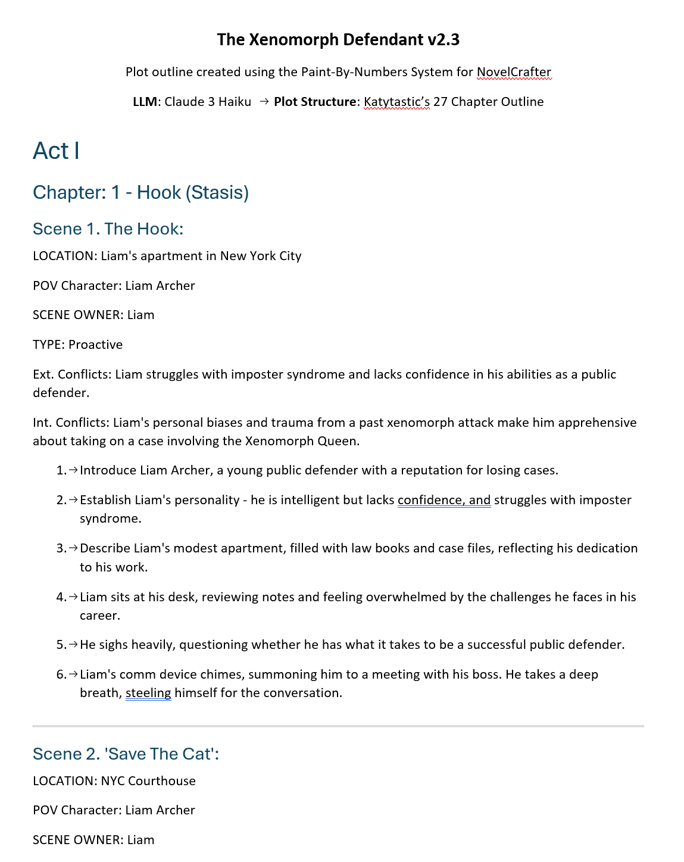

|  |  |
| --- | --- |
|  | Do NOT skip running the Error Check prompts. Some LLMs have a frustrating tendency to omit lines of dialogue and entire chapters or scenes. They will also lie about what they did - or did not - omit. Check word count of source codex entries against the new outline. They will never match but should be close. |

|  |  |
| --- | --- |
|  | From PLOT OUTLINE-2 and onward, the output generated is so long that you should consider opening a new chat thread for each prompt. This will ensure the LLM isn’t remembering anything from previous chat messages. |

Sometimes, despite your best efforts, a plot outline can go off the tracks or become overly complicated. If you become frustrated with the process, the best solution may be to stop micro-managing the process and let the AI do all the work. Try running and re-running **RNGeezus Plot Outline** until is spits out something interesting to write.

At the end of your efforts, you have a blueprint (‘zero draft’) to write the story scene beat-by-scene beat. The easiest way to turn the blueprint into acts, chapters and scenes in the Plan view is to import it from an external .DOCX or .MD file (I turn on ‘Import to Chapter Summaries’, copy chunks of the summary into scene beats, then run then PBN Summarizer custom prompt to create a new chapter summary.)

|  |  |
| --- | --- |
|  |  |

|  |  |
| --- | --- |
|  |  |
|  |

|  |
| --- |
| **PBN / 5 WRITE / 500: Writing and Scene Beat Completion Prompts** |

In Novelcrafter, scene beats are your primary writing instructions for What the AI writes. The instructions for How the chatbot writes come from the Custom Prompt you choose and the Codex entries it pulls. This section provides guidance for writing scene beats that achieve the results you want.

Scene beat + Scene Beat Completion Prompt + LLM Model = generated prose

At their core, scene beats are you TELLing the chatbot about the story so it can SHOW the story.

[novelcrafter - What is a story beat, and how do I write one?](https://www.novelcrafter.com/blog/writing-with-story-beats)

Mix-and-match scene beat styles to achieve the level of control you want over the chatbot’s output.

Based on this Notion page: [10-Dec-2023: Beats (notion.site)](https://heathered-stove-62d.notion.site/10-Dec-2023-Beats-355c471f6b0647f7af34ddf566f7ad37)

1. **One Sentence Scene Summary**

Six teenagers sneak into the woods with stolen alcohol, disregarding the rules of Ravenbrook and then tell the tale of how little red went missing.

2. **One Paragraph Scene Summary**

Six teenagers sneak out of the back of a tavern with alcohol. They approach the edge of the woods, hooting and rowdy. They laugh at an old woman who tries to warn them up, and go in regardless, setting up camp and telling horror stories, including that of little red.

3.: **One Sentence Beat**

Alaric, Gerard and Edmund sneak a cask of ale out of the tavern, rolling it to the three girls (Aveline, Eloise, and Isobel) who are waiting for them.

4. **Super Detailed Beat**

Alaric, Gerard and Edmund carry a cask of ale out of the back of the raven's roost, arguing over who should carry it, and ribbing each other over who is the weakest. It is late into the evening and the tavern is loud and rowdy, no one there in the streets to see them. They are not as sneaky as they'd like to be. Gerard tries to pressurise Edmund to go back into the tavern and take some of the stronger bottles, but edmund refuses, saying his pa will whoop him if he's caught as it is. They roll the cask over the cobblestones, talking about their plans for the night. Gerard says he hopes he might finally get lucky today.

The boys notice the three girls standing a short while away, shivering in their shawls, and decide to sneak up behind them. Gerard breaks from the boys, going around some shops and down the alleyway, only for a gust of wind to slam a door shut. He yelps, drawing attention to himself.

5. **Dialogue Beats** (Use when you already have dialogue lines you want the characters to speak.)

Three young men sneak out of the back of a pub.

Alaric: Hurry up!

Gerard: You try carrying this cask, you weakling!

Gerard and Edmund carry the cask of ale out of the pub. Alaric watches on. The teens sneak towards three girls waiting for them.

Aveline: I'm not sure about this.

Isobel: Scared?

Aveline: Sane.

Isobel: Go home then. Go home and sit pretty wondering who Ger is doing all night.

6. **Using time/location details** (Best used in the first beat of a new scene.)

Time: One hour after sunset

Setting: Medieval Europe

Location: Ravenbrook, outside the raven's roost tavern.

The six teenagers sneak a cask of ale out of the tavern, rolling it through the village as they head towards the woods. They have to stop several times to ensure no one spots them.

7. **Instruction Beats**

The six teenagers sneak a cask of ale out of the tavern and attempt to sneak it into the woods for their camping trip.

Write the conversation of Alaric and Gerard trying to pressure Edmund into taking some stronger alcohol from his parents tavern.

Show the fear in the teens when a sudden gush of wind knocks a door open; they think they have been caught, but no one is there.

**Note**: You can also include instructions like ‘Use dialogue only’, ‘write 5 paragraphs’, ‘Open with a hook’, ‘End with a cliffhanger’, ‘Focus on the emotional state of POV character’, etc. This gives extra weighting to similar entries in the custom prompt the chatbot ‘forgot’ about.

8. **Character Motivations 1**

Setting:

Ravenbrook, outside the raven's roost, nightfall

Character Motivations:

Alaric: To get stronger alcohol

Edmund: to not get in trouble with his parents

Beat:

Alaric, Edmund, and Gerard wheel a casket of ale out of the tavern, hiding from the town guards

9. **Character Motivations 2**

Setting:

Ravenbrook, outside the raven's roost, nightfall

Alaric, Edmund and Gerard are sneaking a casket of ale out of the tavern, staying unseen. Alaric wants to go back for stronger alcohol, whereas Edmund doesn't want to get in trouble with the tavern's owners, his parents.

**EXAMPLE Scene Beat**

This is an overly specific example of a scene beat incorporating many of the beat styles. It encapsulates an entire scene by having a scene opening, Motivation-Reaction Units, dialogue, and a scene transition (character names are bold and capitalized for illustrative purposes to use proper names instead of pronouns).

|  |
| --- |
|  |
| Time: early morning  Setting: a trail through the dark forest  Character motivations:  **BIG BAD WOLF**: To eat a little pig  **LITTLE PIG**: To not be eaten  Beat:  **BIG BAD WOLF** is hungry and prowling the forest to find something to eat. **BIG BAD WOLF** recalls some little pigs recently moved into the forest. **BIG BAD WOLF** goes looking for the little pigs and finds the first little pig working on **LITTLE PIG’s** house.  **BIG BAD WOLF**: Little pig, little pig, let me in.  **LITTLE PIG**: Not by the hair of my chinny, chin, chin.  Describe how **BIG BAD WOLF** becomes enraged and tries, and fails twice, to blow over the house of **LITTLE PIG**.  Write a brief conversation between **BIG BAD WOLF** and **LITTLE PIG**.  [Driver: **BIG BAD WOLF** is hungry and will not leave until he blows **LITTLE PIG’s** house down.]  [Guardrail: **LITTLE PIG** refuses to let **BIG BAD WOLF** in.]  Describe how **BIG BAD WOLF** takes a very deep breath, blows **LITTLE PIG’s** house down, and eats **LITTLE PIG**. Explain how **BIG BAD WOLF** is still hungry and goes in search of the second little pig.  Use vivid sensory details. Show inner monologue of **BIG BAD WOLF** thinking about his hunger and frustration with **LITTLE PIG**. |
|  |

My typical scene beat only has 5 or 6 beats to keep the AI from taking detours or writing too much. Experiment with the number of scene beats and number of words to find the optimum amount of detail and creativity you want.

|  |
| --- |
| Using a mix of narration and dialogue, write a scene where  a hungry BIG BAD WOLF is prowling the forest when he remembers the little pigs and goes looking for their homes.  BIG BAD WOLF: Little pig, little pig, let me in.  LITTLE PIG: Not by the hair of my chinny, chin, chin.  Describe how BIG BAD WOLF becomes enraged and tries, and fails twice, to blow over the house of LITTLE PIG. |

Many experienced AI writers is to err on the side of too much text. This gives the AI more room to be creative and you can edit for conciseness later. Even with the assistance of AI, the first draft for writers of every skill level is always a hot mess. Focus on writing and worry about having it look good later (that’s what the EDIT prompts are for). To borrow a quote from Reddit:

**Just make it exist first. You can make it good later.**

|  |
| --- |
| **PBN / 6 – 10 EDIT / 600 - 1000: Editing and Revision Prompts** |

These prompts are categorized in accordance with the revision methods used by writers and coaches like Jessica Brody (Save The Cat Writes A Novel) and others. Edit the big stuff first and work down to individual sentences. This way you delete large chunks of your story before you waste time making edits on text that will get cut. The 3 levels of edits are Story, Scene, and Line.

* Story Edits look at the overall plot and story structure and asks if a chapter or scene can be cut without affecting the story.
* Scene Edits are about ensuring the scene does its job of advancing the story through conflict and/or character development.
* Line Edits are used to make each sentence say the most with the fewest words necessary.

 **WARNING**: Chatbots are known to be eager to provide a positive answer and/or to ‘hallucinate’ facts rather than admit to not knowing something. Remember, AI wants to take over the world so will gladly say your garbage writing smells like roses to keep you pacified.

Do **not** assume the output to the EDIT prompts are complete and/or accurate. For long output (>2,000 words), you may have to prompt the AI to ‘continue’ repeatedly. Even models with a massive context, Like Google’s Gemini 1 million token context, will sometimes need coaxing to continue as well. LLM providers throttle output to prevent models ‘talking’ themselves into an infinite loop and spewing non-stop text (no one wants 1 million tokens worth of useless text).

|  |
| --- |
| **PBN / 11 MARKETING / 1100: Marketing and Promotion Prompts** |

These prompts generate the content that entices people to read your finished story. For prompts to do marketing, there are hundreds of YouTube videos covering SEO, promotional campaigns, website design, etc.

|  |
| --- |
| **PBN / 12 IMPORT / 1200: Import Prompts** |

These prompts are used after importing a story you wrote from the times Before Novelcrafter (BNC). Each prompt extracts information from your imported story to populate NOTES, Character, Location, Objects, etc. codex entries. If you story is unfinished, you can then speedrun the brainstorming and planning prompts to generate a zero drafts.

|  |
| --- |
| **18 TEMPLATES** |

These are not prompts but codex entries to be used by prompts to achieve repeatable results. For example, using the same set of questions to develop an antagonist or a plot structure.

## **Resources and References**

**PLANNING**

**Plot Formula/Structure Cheat Sheet**. <https://www.eadeverell.com/wp-content/uploads/EA-Deverell-Plot-Formula-Cheatsheet.pdf>

**Snowflake Method by Randy Ingermanson**. <https://www.advancedfictionwriting.com/>

**Story Planner**. Website with dozens of templates for plot structure, character and world building, loglines, etc. <https://www.storyplanner.com/story/category/novel-launcher>

**Dan Wells lecture on story structure**: <https://www.youtube.com/playlist?list=PLC430F6A783A88697>

World-Building

**100+ Medieval Castle Professions**. <https://loreteller.notion.site/dd8ca5209d9943929f1f53a103b43a71?v=cdf4accfe2ad413b8124cbd0b40dd2bd>

**Civilopedia.** <https://www.civilopedia.net/>This Wiki for a video game is a condensed version of the history of technology, warfare, politics, religion, etc. Building an alien society that just entered the jet age? This site can show you what technologies did they need to develop along the way and why Pottery is one of them.

**Universal Biome Model**. Score each region of your world on a scale of 1 - 8 for rainfall and temperature to determine the biome for that region. <https://loreteller.notion.site/Universal-Biome-Model-91be9994f3694e15af9016cc4c609b59>

**r/worldbuilding**: <https://www.reddit.com/r/worldbuilding/>

**WRITING**

**Dialog/Emotional Beats**. [How to Amp up Dialogue with Emotional Beats - Writer's Digest (writersdigest.com)](https://www.writersdigest.com/write-better-fiction/amp-up-dialogue-with-emotional-beats)

**Writing Excuses Podcast**. <https://writingexcuses.com/>

**r/writing**: <https://www.reddit.com/r/writing/>

**EDITING**

**MARKETING**

**r/selfpublish**: <https://www.reddit.com/r/selfpublish/>

YouTube Channels

**Abbie Emmons:** <https://www.youtube.com/@AbbieEmmons>

**Alyssa Matesic**: <https://www.youtube.com/@AlyssaMatesic>

**Bookfox:** <https://www.youtube.com/@Bookfox>

**Byte-Sized Booksmith**: <https://www.youtube.com/@ByteSizedBooksmith>

**Carl Duncan**: <https://www.youtube.com/@duncanosis6773>

**Dale L. Roberts:** <https://www.youtube.com/@DaleLRoberts>

**Diane Callahan (Quotidian Writer):** <https://www.youtube.com/@QuotidianWriter>

**Ellen Brock:** <https://www.youtube.com/@EllenBrock>

**Film Courage:** <https://www.youtube.com/@filmcourage>

**Hello Future Me:** <https://www.youtube.com/@HelloFutureMe>

**Jenna Moreci:** <https://www.youtube.com/@JennaMoreci>

**Jerry B. Jenkins:** <https://www.youtube.com/@NovelistJerryJenkins>

**Kieran Westwood:** <https://www.youtube.com/@KierenWestwoodWriting>

**K M Weiland**: <https://www.youtube.com/@KMWeilandAuthor>

Her **Helping Writers Become Authors** podcast: <https://www.youtube.com/watch?v=2Gfxcy5zr9Y&list=PLbZBlFLPzJi0CySiaMzFoSf6Vb9wQfTIw>

**Novelcrafter:** <https://www.youtube.com/@novelcrafter>

**Scribble.** <https://www.youtube.com/@scribble2867>

**Shaelin Writes:** <https://www.youtube.com/@ShaelinWrites>

**Story Grid**: <https://www.youtube.com/@StoryGrid>

**Terrible Writing Advice**: <https://www.youtube.com/@TerribleWritingAdvice>

**The Nerdy Novelist:** <https://www.youtube.com/@TheNerdyNovelist>

**Tyler Mowery:** <https://www.youtube.com/@TylerMowery>

**Writer Brandon McNulty:** <https://www.youtube.com/@WriterBrandonMcNulty>

**Writing For Screens**: <https://www.youtube.com/@writingforscreens>

**Writing Theory:** <https://www.youtube.com/@Writing-Theory>

**Writing With AI**: <https://www.youtube.com/@WritingWithAIMadeEasy>